Beautiful Savior Lutheran Church



September 22, 2024 – Eighteenth Sunday after Pentecost

service theme: followers of christ are humbled servants

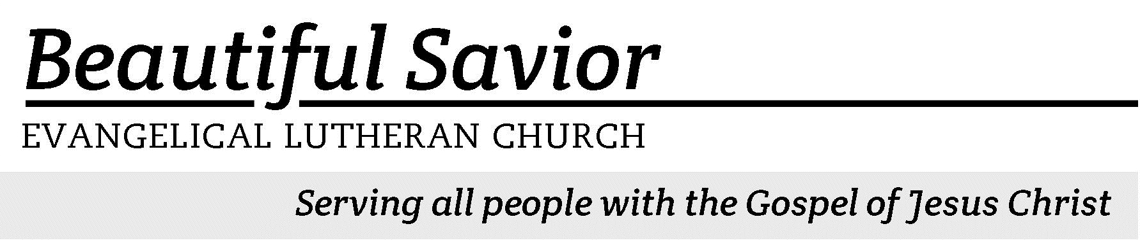


Welcome-- We are glad you could join us today! It is our hope that this service is a blessing to you. Please join us for worship again soon.

· Please save the last two rows of pews for parents with small children.

· Parents with little ones: We are excited to offer a nursery for your use. It is to the left as you exit the sanctuary. If your child becomes restless during the service, that’s okay… We’re glad they’re here, and Jesus is pleased when they are brought to hear his Word: “Let the little children come to me.”

· Five minutes before the worship service begins the usher will light the candles. This is our signal to quiet down and prepare our hearts for worship.

· Restrooms are conveniently located to the left as you exit the sanctuary.

· Please silence your cell phone before the start of the service.

Prayer for Worship
Heavenly Father, bless my time of worship today. Give me the courage to come to you with everything in my life. Make me bold to pray with the confidence that you will hear me and answer my prayers, according to your loving and wise will for me. Amen.

Beautiful Savior Lutheran Church
2526 Whitfield Road
Clarksville, TN 37040
931-905-1400
Website: www.bslclarksville.com
Kent Holz, Pastor
Bslc.clarksville@gmail.com
Barbara Noon, Preschool Director
beautifulsaviorpreschool@gmail.com

737 Lord, Help Us Walk Your Servant Way CW 737 sts. 1–3
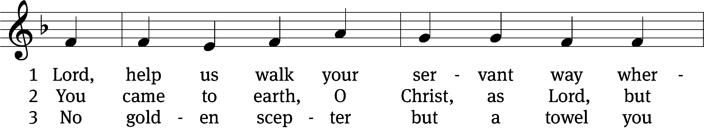
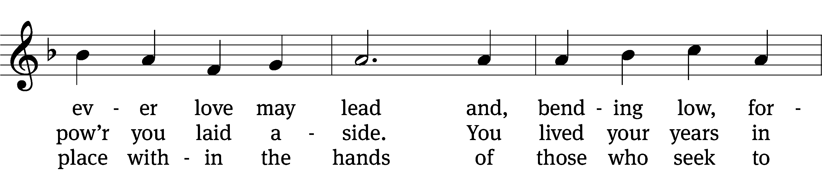
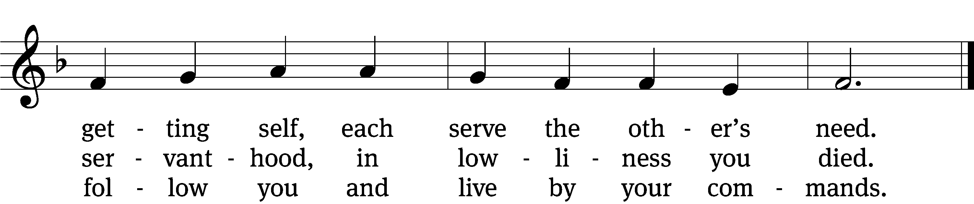
Text: Herman G. Stuempfle, Jr., 1923–2007
Tune: The Whole Book of Psalmes, London, 1562
Text: © 1997 GIA Publications, Inc. Used by permission: OneLicense no. 716626
Tune: Public domain

Please Stand

In the name of the Father and of the T Son and of the Holy Spirit.
Amen.
Confession
Have mercy on me O God, according to your unfailing love.
According to your great compassion, blot out my transgressions.

Wash away all my iniquity and cleanse me from all sin.
For I know my transgressions and my sin is always before me.

Against you, you only have I sinned and done what is evil in your sight.
So that you are proved right when you speak and justified when you judge.

Surely I was sinful at birth, sinful from the time my mother conceived me.
Cleanse me with hyssop and I will be clean.

Wash me and I will be whiter than snow.
Let me hear joy and gladness.

Let the bones you have crushed rejoice.
Hide your face from my sins and blot out all my iniquity.

Our Lord is a compassionate and gracious God, slow to anger, abounding in love and faithfulness. Maintaining love to thousands and forgiving wickedness, rebellion, and sin. Because of Jesus, God does not treat us as our sins deserve, or repay us according to our iniquities. For as high as the heavens are above the earth, so great is His love for those who fear him. And as far as the east is from the west, so far has he removed our transgressions from us.
Amen.

In the peace of our forgiveness, let us praise the Lord.

737 Lord, Help Us Walk Your Servant Way CW 737 sts. 4–5
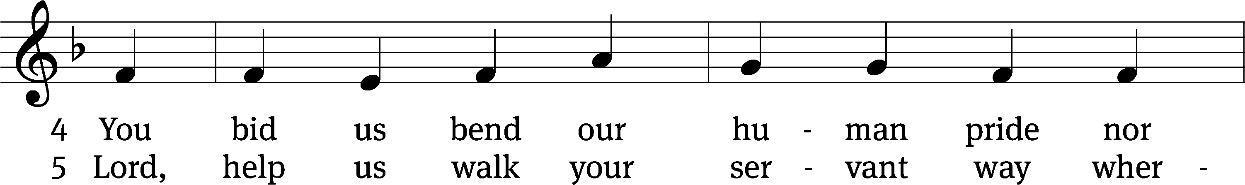
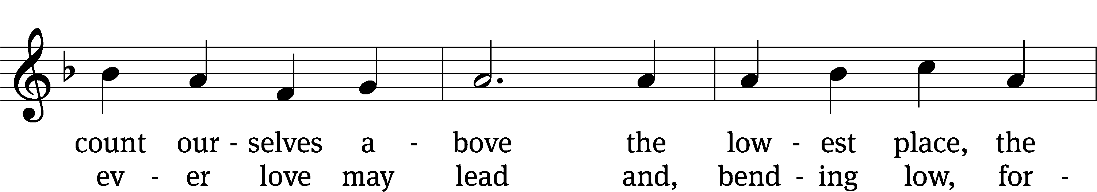
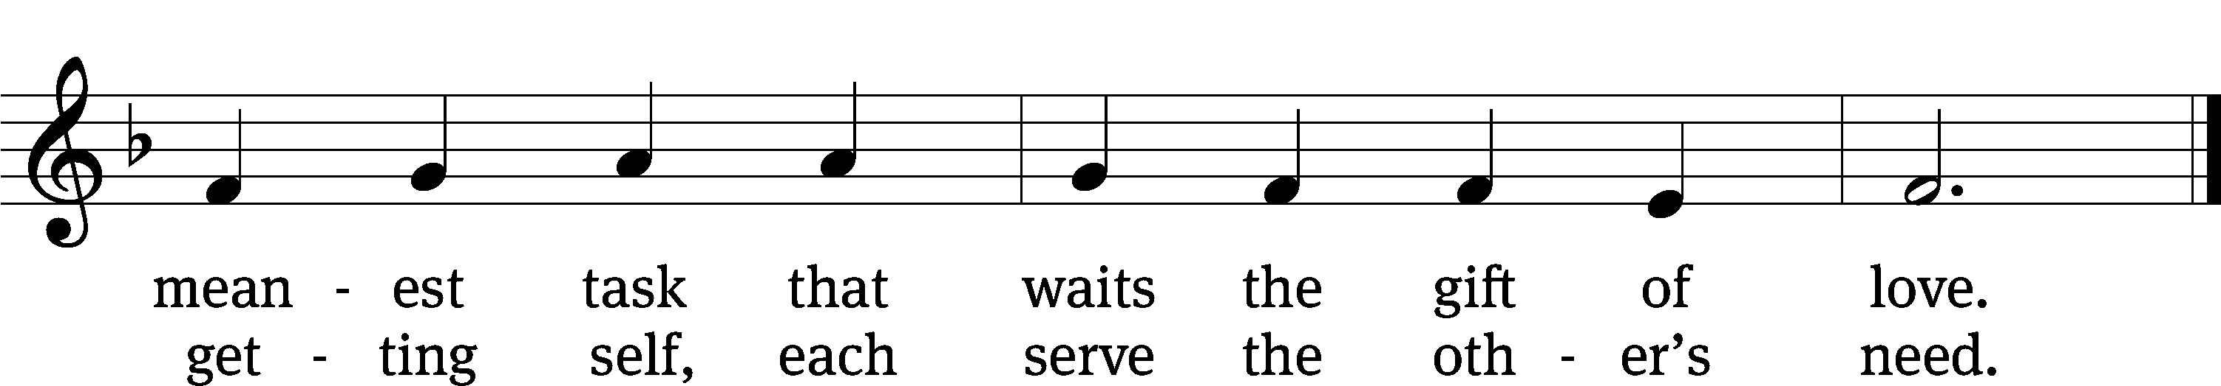
Text: Herman G. Stuempfle, Jr., 1923–2007
Tune: The Whole Book of Psalmes, London, 1562
Text: © 1997 GIA Publications, Inc. Used by permission: OneLicense no. 716626
Tune: Public domain

The Word
The Lord be with you.
And also with you.
Prayer of the Day
Let us pray.

Mercifully grant, O God, that your Holy Spirit may in all things direct and rule our hearts, for without your help we are unable to please you; through your Son, Jesus Christ our Lord, who lives and reigns with you and the Holy Spirit, one God, now and forever.
Amen.

Please be seated
First Reading Numbers 12:1–15
1Miriam and Aaron began to talk against Moses because of his Cushite wife, for he had married a Cushite. 2“Has the Lord spoken only through Moses?” they asked. “Hasn’t he also spoken through us?” And the Lord heard this.
3(Now Moses was a very humble man, more humble than anyone else on the face of the earth.)
4At once the Lord said to Moses, Aaron and Miriam, “Come out to the tent of meeting, all three of you.” So the three of them went out. 5Then the Lord came down in a pillar of cloud; he stood at the entrance to the tent and summoned Aaron and Miriam. When the two of them stepped forward, 6he said, “Listen to my words:
“When there is a prophet among you,
I, the Lord, reveal myself to them in visions,
I speak to them in dreams.
7But this is not true of my servant Moses;
he is faithful in all my house.
8With him I speak face to face,
clearly and not in riddles;
he sees the form of the Lord.
Why then were you not afraid
to speak against my servant Moses?”
9The anger of the Lord burned against them, and he left them.
10When the cloud lifted from above the tent, Miriam’s skin was leprous—it became as white as snow. Aaron turned toward her and saw that she had a defiling skin disease, 11and he said to Moses, “Please, my lord, I ask you not to hold against us the sin we have so foolishly committed. 12Do not let her be like a stillborn infant coming from its mother’s womb with its flesh half eaten away.”
13So Moses cried out to the Lord, “Please, God, heal her!”
14The Lord replied to Moses, “If her father had spit in her face, would she not have been in disgrace for seven days? Confine her outside the camp for seven days; after that she can be brought back.” 15So Miriam was confined outside the camp for seven days, and the people did not move on till she was brought back.

115A Not to Us, O LORD Psalm 115A
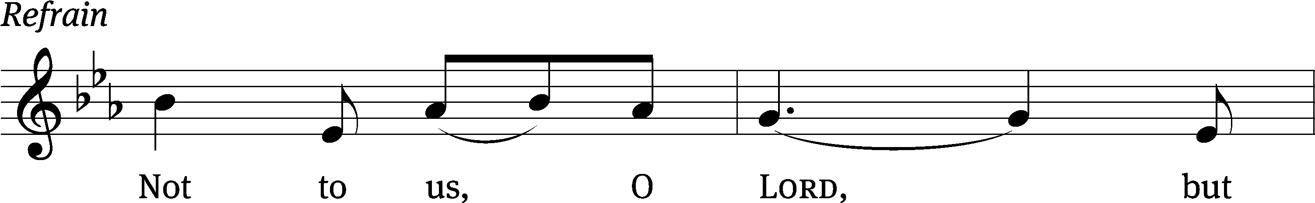



Why do the nations say, “Where / is their God?”
Our God is in heaven; he does whatever / pleases him.
The Lord remembers us and will / bless us:
He will bless his people / Israel,
he will bless those who / fear the Lord—
small and / great alike. Refrain

All you Israelites, trust / in the Lord—
he is their / help and shield.
House of Aaron, trust / in the Lord—
he is their / help and shield.
You who fear him, trust / in the Lord—
he is their / help and shield.
Glory be to the Father and / to the Son
and to the Holy / Spirit,
as it was in the be- / ginning,
is now, and will be forever. / Amen. Refrain
Tune: Michael D. Schultz
Setting: Michael D. Schultz
Music: © 2021 Northwestern Publishing House. Used by permission: OneLicense no. 716626
Second Reading James 3:13–18
13Who is wise and understanding among you? Let them show it by their good life, by deeds done in the humility that comes from wisdom. 14But if you harbor bitter envy and selfish ambition in your hearts, do not boast about it or deny the truth. 15Such “wisdom” does not come down from heaven but is earthly, unspiritual, demonic. 16For where you have envy and selfish ambition, there you find disorder and every evil practice.
17But the wisdom that comes from heaven is first of all pure; then peace-loving, considerate, submissive, full of mercy and good fruit, impartial and sincere. 18Peacemakers who sow in peace reap a harvest of righteousness.

Children’s Devotion Ages 3 through grade 5 are invited to come forward for a Bible lesson.

Children’s Church During the service, parents may choose to take their children (ages 2-5) to Children’s Church. There they will hear a Bible story, and sing songs. They will return to the sanctuary during the offering.

704 Let Us Ever Walk with Jesus CW 704 sts. 1–2, 4
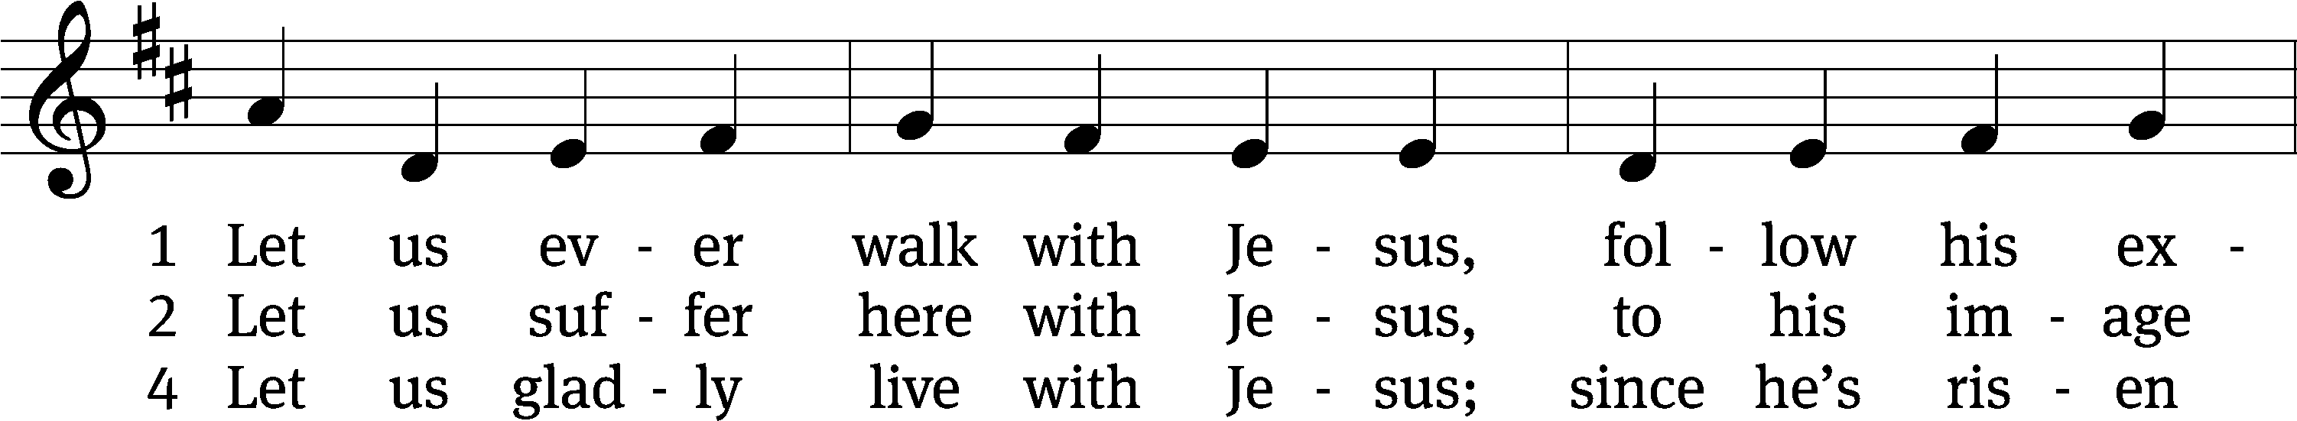
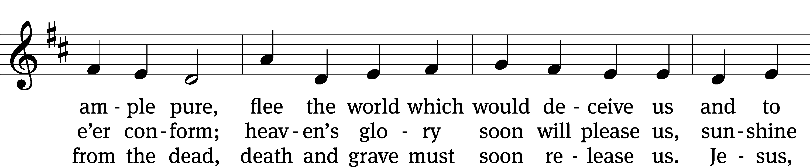
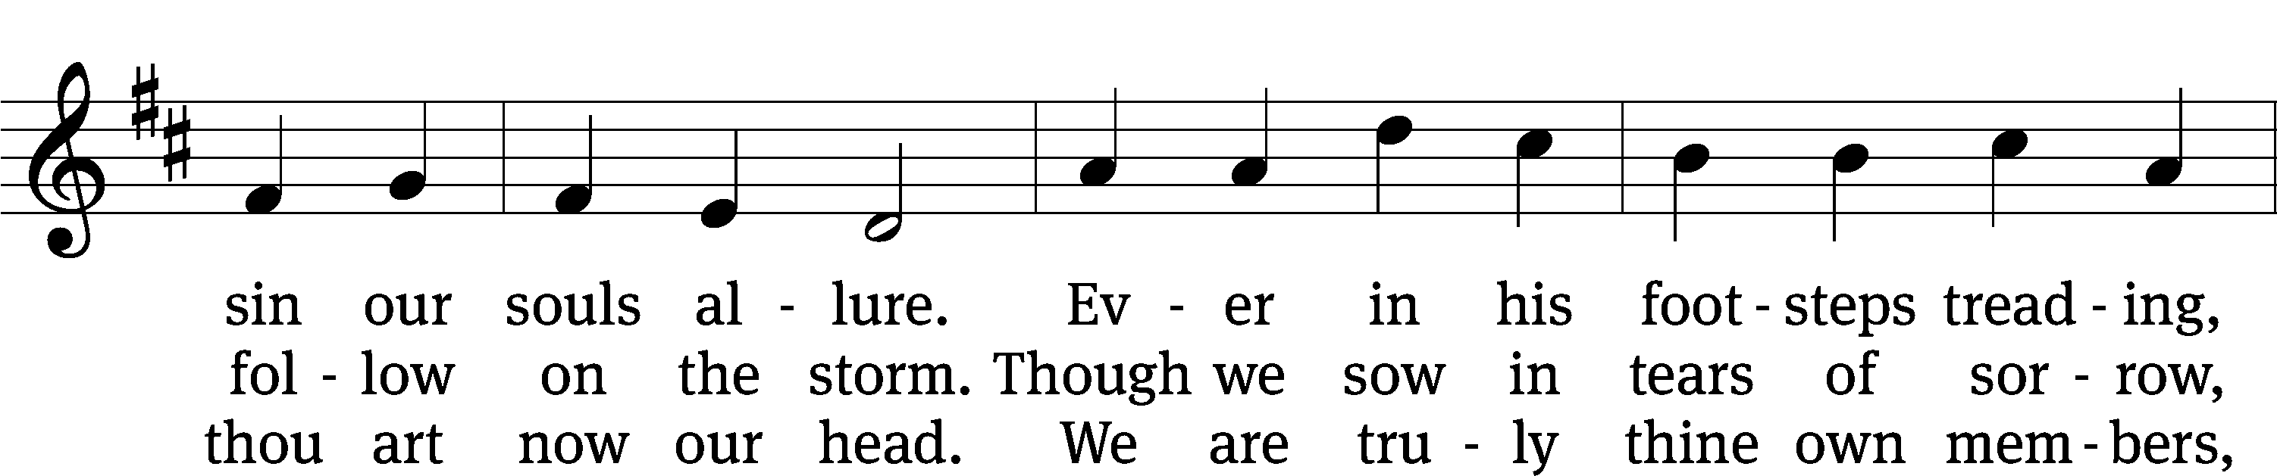
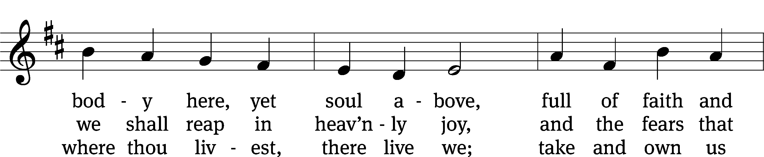
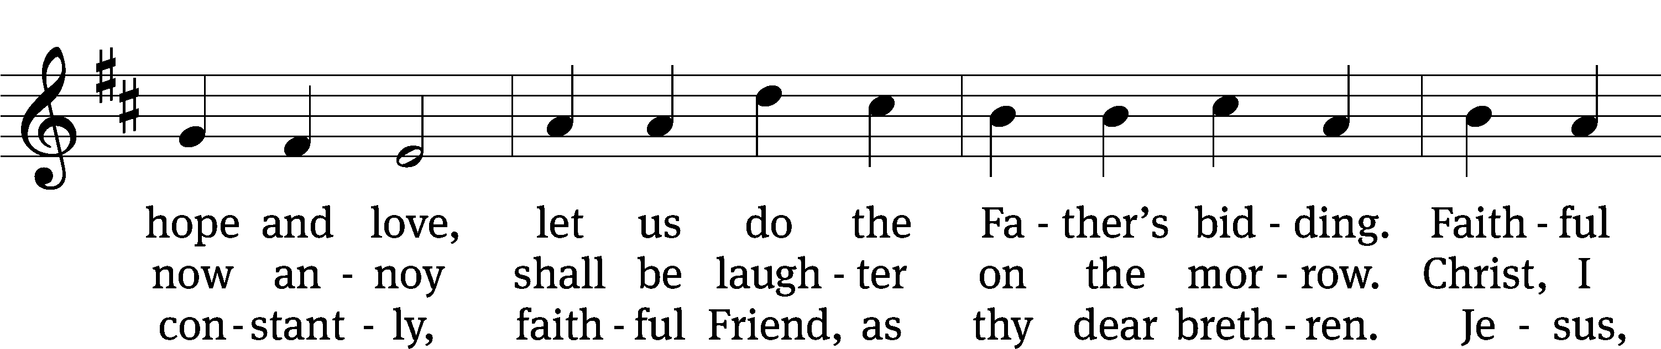
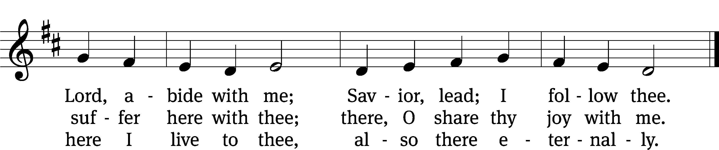
Text: tr. J. Adam Rimbach, 1871–1941, alt.; Sigmund von Birken, 1626–1681
Tune: Georg G. Boltze, 18th cent.
Text and tune: Public domain

Gospel Mark 9:30–37
30They left that place and passed through Galilee. Jesus did not want anyone to know where they were, 31because he was teaching his disciples. He said to them, “The Son of Man is going to be delivered into the hands of men. They will kill him, and after three days he will rise.” 32But they did not understand what he meant and were afraid to ask him about it.
33They came to Capernaum. When he was in the house, he asked them, “What were you arguing about on the road?” 34But they kept quiet because on the way they had argued about who was the greatest.
35Sitting down, Jesus called the Twelve and said, “Anyone who wants to be first must be the very last, and the servant of all.”
36He took a little child whom he placed among them. Taking the child in his arms, he said to them, 37“Whoever welcomes one of these little children in my name welcomes me; and whoever welcomes me does not welcome me but the one who sent me.”

“Greatness in God’s sight”

Apostles’ Creed
I believe in God, the Father Almighty,
maker of heaven and earth.

I believe in Jesus Christ, his only Son, our Lord,
who was conceived by the Holy Spirit,
born of the Virgin Mary,
suffered under Pontius Pilate,
was crucified, died, and was buried.
He descended into hell.
The third day he rose again from the dead.
He ascended into heaven
and is seated at the right hand of God the Father Almighty.
From there he will come to judge the living and the dead.

I believe in the Holy Spirit,
the holy Christian Church,
the communion of saints,
the forgiveness of sins,
the resurrection of the body,
and the life everlasting. Amen.

Offering “We love because he first loved us.” 1Jn 4:19 God’s love in sending Jesus to live, to suffer, and to die for each of us motivates the members of Beautiful Savior to show their love and thanks by returning a portion of their income to the Lord. Through these free will offerings, this congregation and its ministries are maintained.
If you would like to give securely online, scan this code or follow this link: bslclarksville.com
Prayer of the Church
Loving God and Lord, you created the universe that surrounds us and the globe on which we live. You control all things through your Son, who sits at your right hand in glory.
Comfort us with the promise of your eternal presence.

Give your Word power as it works in our hearts and minds. Clear away our confusion, and demolish our doubts. Send your Spirit to strengthen both our confidence in your promises and our desire to live according to your will.
Take away our love of sinning, and restore us each day by your grace.

The signs of the times warn us that the end of time is near. Protect us from scoffers who sneer at your truth. Spare us and Christians around the world from all forms of hate and persecution.
Give us courage to carry the cross with patience and joy.

Instill in the hearts of our children a desire to follow you as they prepare for future days. Help them distinguish between what is passing and what is eternal, between instant thrills and lasting joy. Encourage more young people to prepare for service in the public ministry of the gospel.
Mold us and move us to be good examples for our youth.

Hold in your care, Lord, those who are experiencing physical or emotional pain and all who are afflicted by disease or facing death. Pour out your compassion on the grieving, and comfort the mourners who miss someone they loved.
Move us to pray for these brothers and sisters and to help when we can.

Hear us, Lord, as we pray in silence.

Silent prayer

Whether we pray together or alone, you have promised to hear and answer us. Give us patience to accept your blessings in whatever way you send them. In your love and wisdom, prepare us for the day when you will take us to be with you forever.
Hear us for Jesus’ sake. Amen.

Lord’s Prayer
Our Father, who art in heaven,
hallowed be thy name,
thy kingdom come,
thy will be done
on earth as it is in heaven.
Give us this day our daily bread;
and forgive us our trespasses,
as we forgive those
who trespass against us;
and lead us not into temptation,
but deliver us from evil.
For thine is the kingdom
and the power and the glory
forever and ever. Amen.

735 Before You I Kneel CW 735
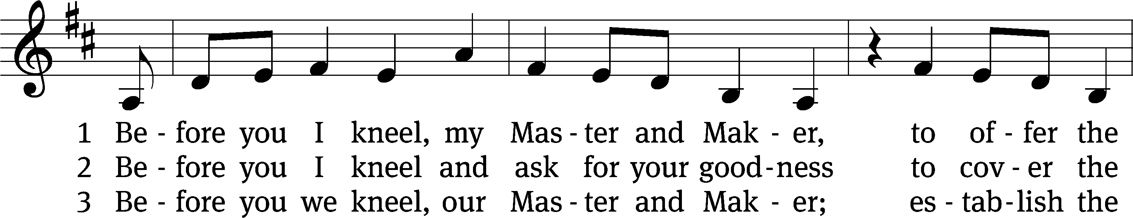
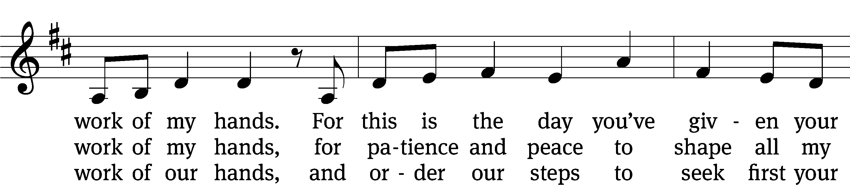
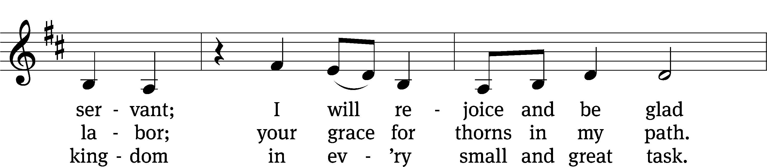
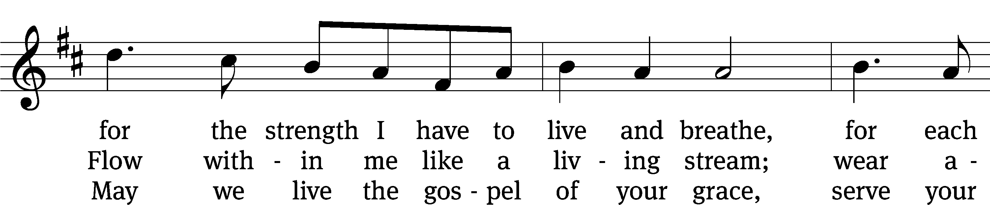
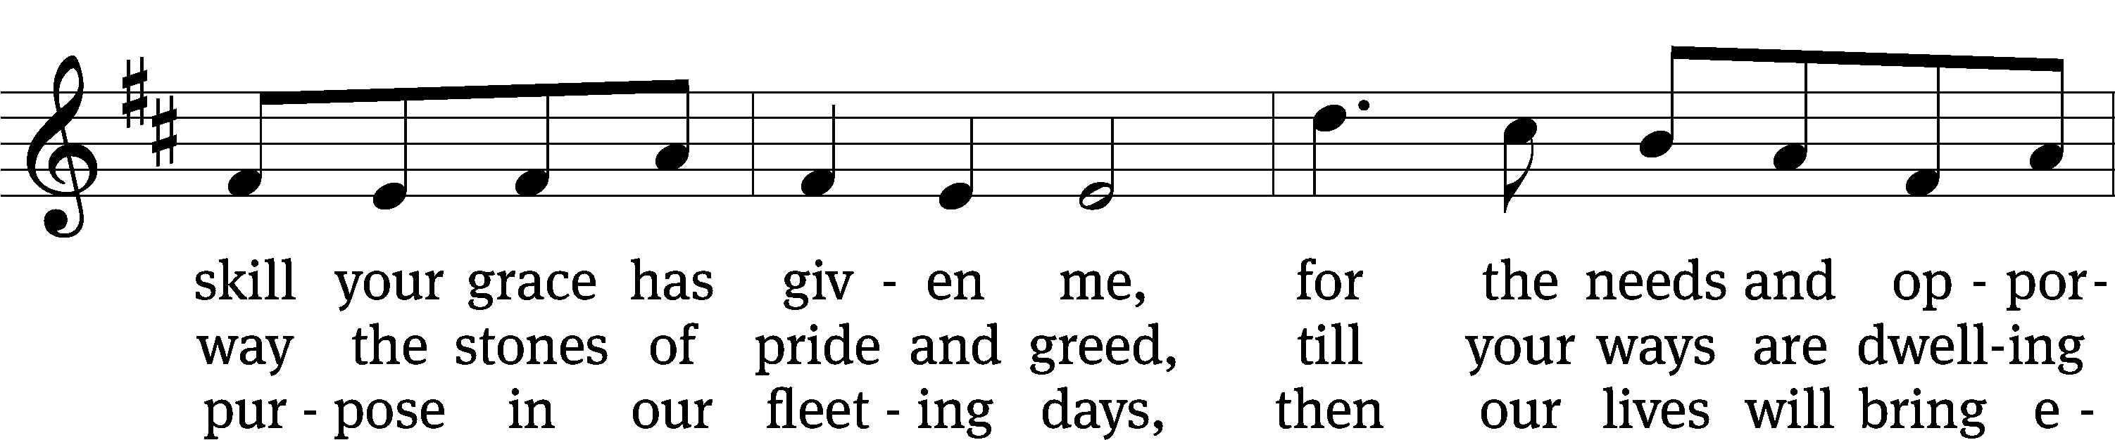
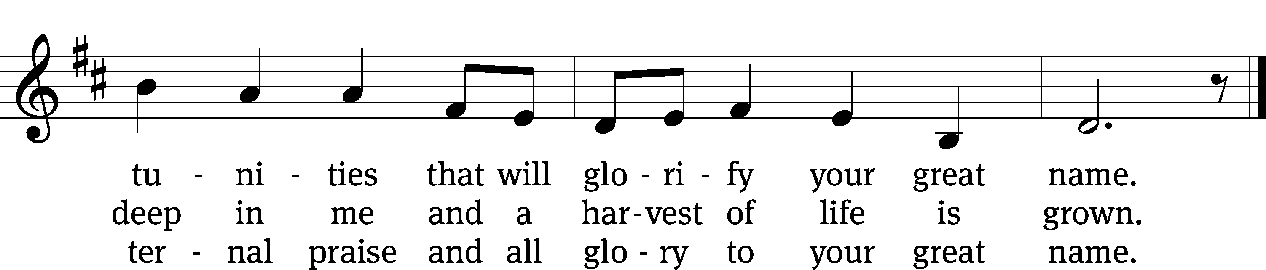
Text: Stuart Townend, b. 1963; Jeff Taylor, b. 1957; Kristyn Getty, b. 1980; Keith Getty, b. 1974
Tune: Stuart Townend, b. 1963; Jeff Taylor, b. 1957; Kristyn Getty, b. 1980; Keith Getty, b. 1974
Text and tune: © 2012 Getty Music and Seek 1st Publishing, admin. MusicServices.org and Townend Music. Used by permission: OneLicense no. 716626
Closing Prayer
Lord God, you give us every good and perfect gift. Strengthen us both in our bodies and our souls so that we do what is pleasing to you and beneficial to all people. Compel us by the self-sacrificing love of Christ to be your witnesses in the world. Empower us by the gifts of your Holy Spirit to conduct our lives to your glory and for our eternal good. Let the words that we have heard and spoken today stay with us in the week ahead. Help us to put them into
practice in our lives. We pray in the name of Jesus, our risen Savior.
Blessing
The Lord bless you and keep you.
The Lord make his face shine on you and be gracious to you.
The Lord look on you with favor and T give you peace.
Amen.

518 Christ Be My Leader CW 518
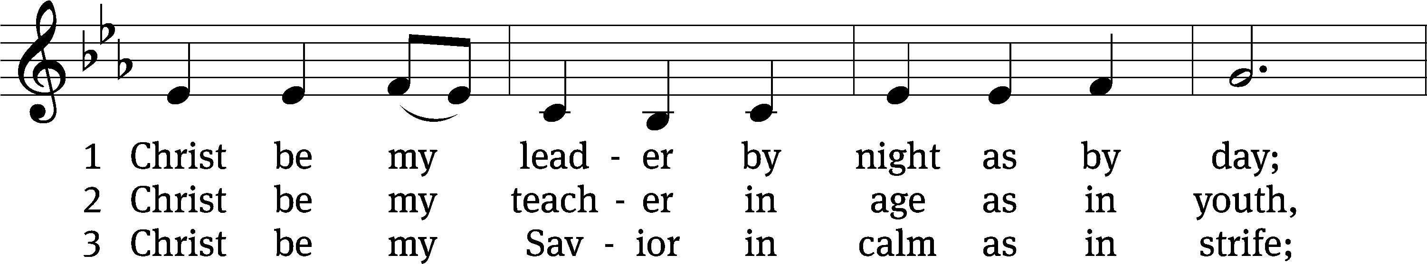
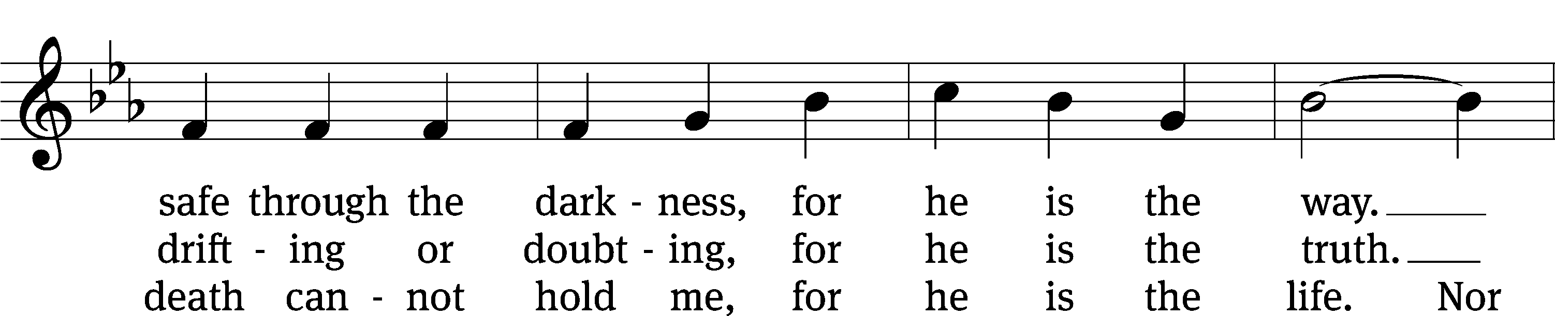
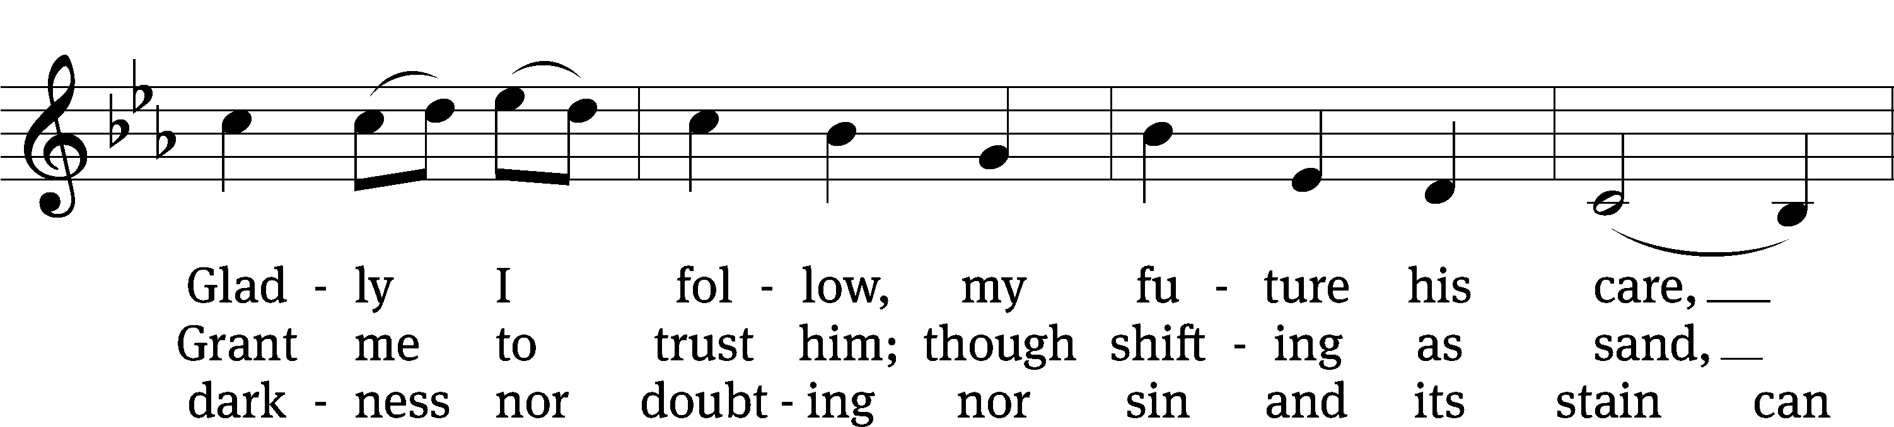
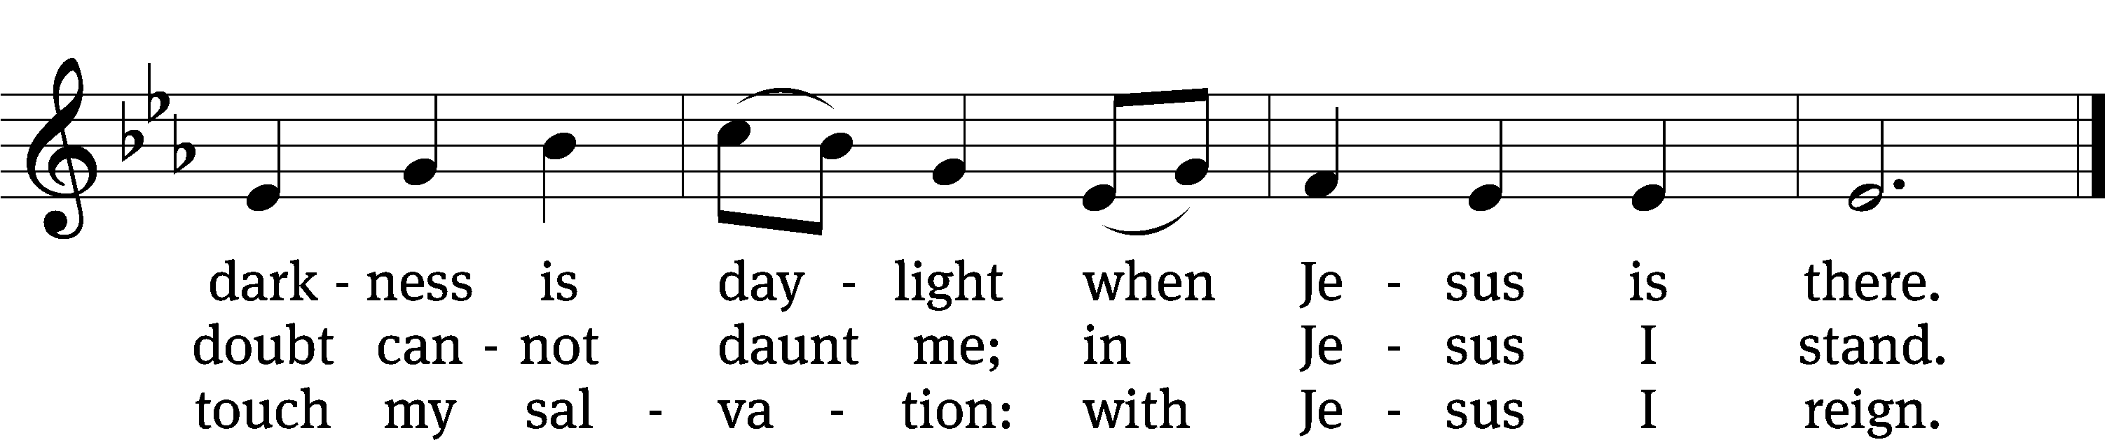
Text: Timothy Dudley-Smith, b. 1926
Tune: Irish
Text: © 1964, ren. 1992 Hope Publishing Co. Used by permission: OneLicense no. 716626
Tune: Public domain
Acknowledgments
Setting One from Christian Worship
Unless otherwise indicated, Scripture quotations are from The Holy Bible, New International Version®, NIV®. Copyright © 1973, 1978, 1984, 2011 by Biblica, Inc.TM Used by permission of Zondervan. All rights reserved worldwide.
Liturgical and musical settings of Scripture based on text from The Holy Bible, New International Version®, NIV®. Copyright © 1973, 1978, 1984, 2011 by Biblica, Inc.TM Used by permission of Zondervan. All rights reserved worldwide.
Software distributed in partnership with Northwestern Publishing House.
Created by Christian Worship: Service Builder © 2024 Concordia Publishing House.

Next Week’s Worship
Our theme for worship: Followers of Christ Celebrate the Service of Others. Our readings will be: Numbers 11:4-6, 10-16, 24-29, James 4: 7-12, and Mark 9:38-50. We will sing the following hymns: 612 How Great Thou Art, 819 If God Himself Be for Me, 738 The Son of God, Our Christ, and 709 Christ the Vine.

THIS WEEK AT BEAUTIFUL SAVIOR
† Today 9:15am Sunday School
10:30am Worship
12pm Confirmation Class
12 pm BIC
† Monday 4pm Board of Ed Meeting
† Wednesday 6pm Bible Study
† Saturday 9am Mary Oak’s Trailhead Hike
† Sunday 9:15am Sunday School
10:30am Worship
12 pm Confirmation Class

New Bible Information Class
A new BIC (Bible Information Class) will begin on Sunday, October 6. What is BIC? It provides an overview of the main themes and message of the Bible. It also serves as our new member class. If you would like to grow in your understanding of God’s Word, please check out the class. It will run 13 weeks, every Sunday after worship. Questions? Please speak with Pastor Holz.

Confirmation Class
Calling all 6th, 7th, and 8th graders! Confirmation classes started last week following the Sunday service. During these classes, we study the basic teachings of the Bible and grow in our knowledge of the Word of God. It also prepares young people for communicant membership at Beautiful Savior. The classes will meet weekly and last for one hour.

Outdoor Club
This Saturday, September 28, there will be an opportunity to enjoy fellowship and fresh air. We are planning a hike on the Clarksville Greenway. Park at the lot at 1101 Pollard Road. We are hoping to walk to the Mary Oak’s Trailhead. This path is all paved. Meet in the parking lot at 9am. Hike will begin at 9:15. The hike is about 4 miles long, but can be made shorter as well. If you have questions, please call Hannah Lacey at: 775-515-2639.

Friday Night Bonfire
On Friday, October 4, we will be having a bonfire night. Bring a chair, any games you would like for the kids, and enjoy some time to fellowship and relax. Hot dogs and s’mores will be provided. The event will start at 6pm.

Pumpkin Patch Work Day
We are starting to make plans for our annual pumpkin patch. Saturday October, 12th we will have a work day starting at 9am. We will be setting up the tents for the pumpkin patch, setting the pallets in place and getting everything ready for the delivery for the pumpkins which will arrive on Sunday, October 13th. Please join in if you are able. Thank you!

Pumpkin Patch Schedule
Saturday, October 12, 9am-12pm – Pumpkin Patch Work Day
Sunday, October 13, 12pm – Pumpkins Arrive!
Tuesday, October 15-Thursday October 31 – Pumpkin Patch open daily 12-6pm
Sunday, October 27- Fall Festival

Children’s Church
We are in need of volunteers to help out with our children’s church. Volunteers will share a brief Bible lesson and activity with young children during the sermon time of the Sunday service. Questions or willing to help out? Please see Barb Noon.

Mornings with Mommy

What is Mornings with Mommy? Mornings with Mommy isn’t preschool and it isn’t childcare. It’s something different. Mornings with Mommy is a fun and easy way for you to enjoy activities with your children and meet other moms. There will be age appropriate activities for infants, toddlers and preschoolers. The best part is, we do all the planning. You just sign up! Moms can mingle with each other and enjoy activities with their children, including: arts and crafts, sensory table, story time, music, educational toys and a snack. The program costs only five dollars per family per session and includes all snacks and activities. Pre-registration is required. If you would like to attend, please go to “Facebook: Mornings with Mommy – Clarksville”. The Mornings with Mommy will meet on Tuesdays at 9am. The schedule is as follows:
Sept 30- At the Farm
Oct 14- Things That Go
Oct 28- Fall Fun
Nov 11- Dinosaurs
Nov 25- Harvest Time
Dec 9- Happy Birthday Jesus

Prayer List
Thank the Lord for the safe return of all the soldiers who recently came home and all soldiers and their families who are facing deployment. Please keep in your prayers this week all soldiers who are currently deployed. Please also remember: Mikaela Watkins, friend of Bob and Judy Mader (lung cancer and surgery); Roger Fox, son of Hilde Fox (cancer); Cynthia Thorington, sister of Brenda Henschen (long-term Covid symptoms); Linda Kiecker, daughter of Selma Noon (pancreatic cancer); Theresa Robinson (recovery from eye surgery); Stacia Gupton, friend of Caryn Mclain, (serious illness); Nita Harris, friend of David & Allison Johnson (cancer/chemo); Teri Lee Dickinson & Family (bereavement); May Holman, mother of Trey Church (abdominal surgery); Christa Trusty (Health Issues); Curt Holz, brother of Pastor Holz (cancer); Bob Housh (Injured in fall); Renate Banks (illness); Marlys Donner, mother of Tim Donner (declining health); Josh Carter, friend of Adam Holz (recovery from car accident); Stacy Schroeder, daughter of Jeff & Eileen Cleveland (melanoma diagnosis); Aimee Gerkhardt, sister in law of Jessica Church (breast cancer); Brandon Vannoy, friend of Mac McCoo (seizures); Sheila Lynch, sister of Gayle Brooks (unable to walk); Drake Robideau, friend of Mary Daniel (strength & wellness); Mike LaFave (back problems); Linda Thomas, sister of Gayle Brooks, (physical rehab after injury); Gidget Tate (Health issues). If you would like to have a name or situation included or if you would like to give an update on a prayer request, please contact Pastor Holz or call the church office at 931-905-1400.

Serving in God’s House

Ushers: Merle Goodall, Ray Mefford
Greeters: Loretta Wilder, Ernie Rautter
Kitchen: Hannah, Mary, Margareta
Piano: Barb Noon
Fellowship: (T-Z)

Serving next week:

Ushers: Mike Rathge, Trey Church
Greeters: Jeff & Eileen Cleveland
Kitchen: Gael I, Loretta W, Mary D
Piano: Barb Noon
Fellowship: (ALL)

Our Mission
By grace, the mission of
Beautiful Savior Evangelical Lutheran Church is
to proclaim the Word of God so that we may praise his name,
grow together in the knowledge of our Savior,
and share with others his message of forgiveness and eternal life.

