Beautiful Savior Lutheran Church

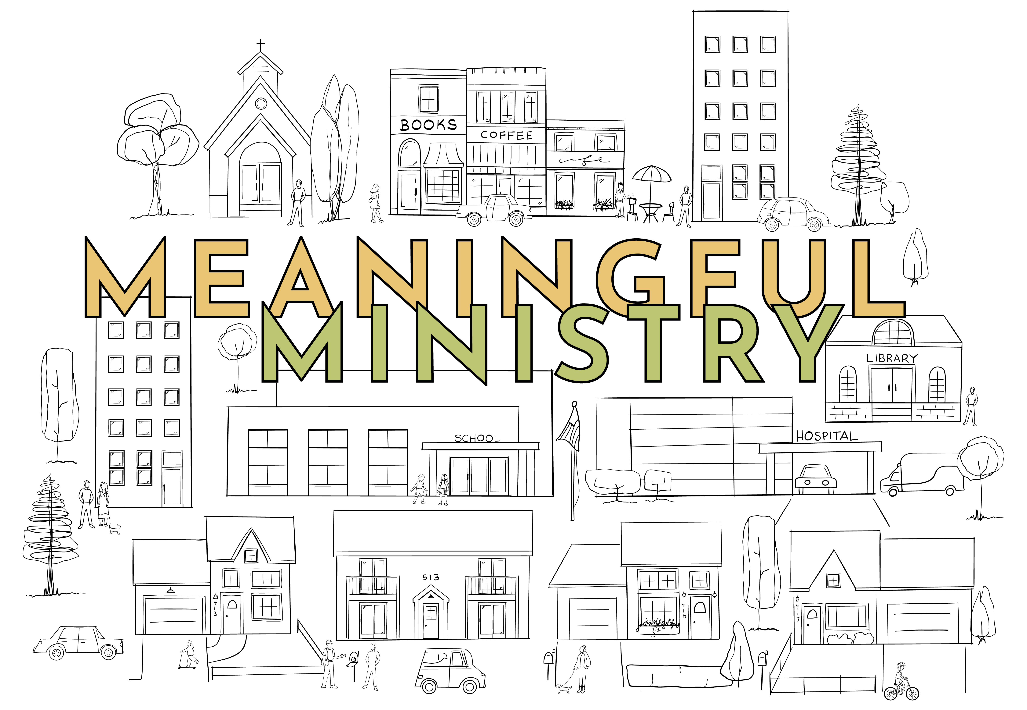

July 28, 2024 – Tenth Sunday after Pentecost

service theme: god meets our need to meet other’s needs

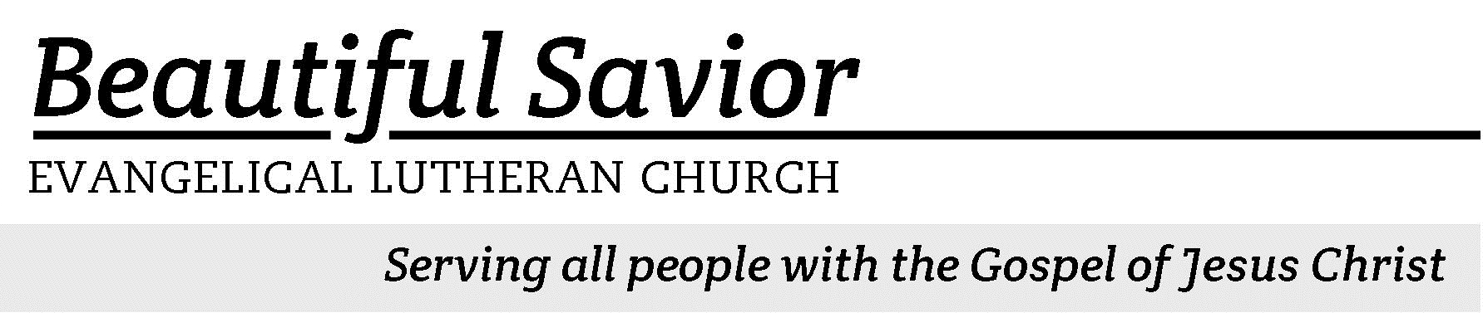


Welcome-- We are glad you could join us today! It is our hope that this service is a blessing to you. Please join us for worship again soon.

· Please save the last two rows of pews for parents with small children.

· Parents with little ones: We are excited to offer a nursery for your use. It is to the left as you exit the sanctuary. If your child becomes restless during the service, that’s okay… We’re glad they’re here, and Jesus is pleased when they are brought to hear his Word: “Let the little children come to me.”

· Five minutes before the worship service begins the usher will light the candles. This is our signal to quiet down and prepare our hearts for worship.

· Restrooms are conveniently located to the left as you exit the sanctuary.

· Please silence your cell phone before the start of the service.

Prayer for Worship
Heavenly Father, I have come to worship you. Draw near to me through your gracious Word, and assure me of your loving plans for me. Curb my wandering thoughts so that with undivided attention, I may hear your voice and sing your praise. Amen.

Beautiful Savior Lutheran Church
2526 Whitfield Road
Clarksville, TN 37040
931-905-1400
Website: www.bslclarksville.com
Kent Holz, Pastor
Bslc.clarksville@gmail.com
Barbara Noon, Preschool Director
beautifulsaviorpreschool@gmail.com
749 God, Whose Giving Knows No Ending CW 749 sts. 1–2
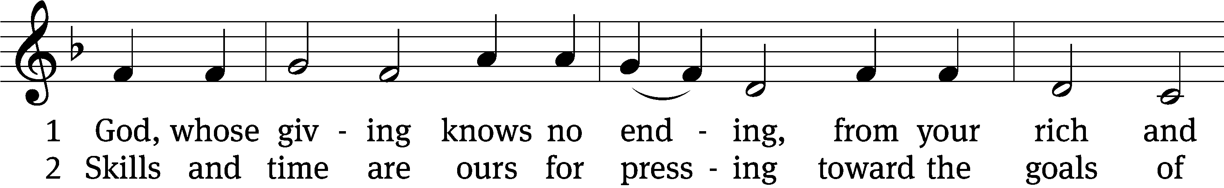
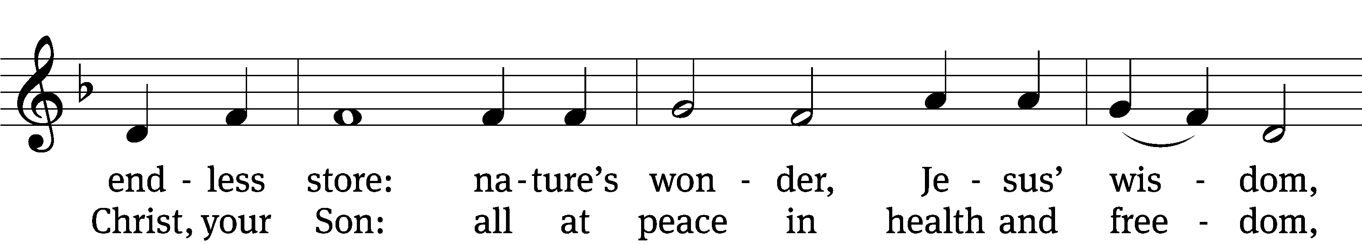
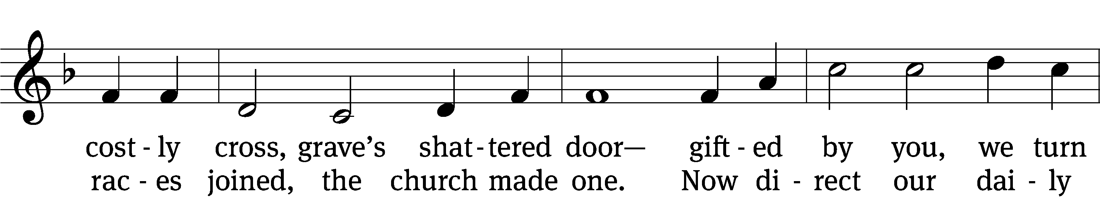
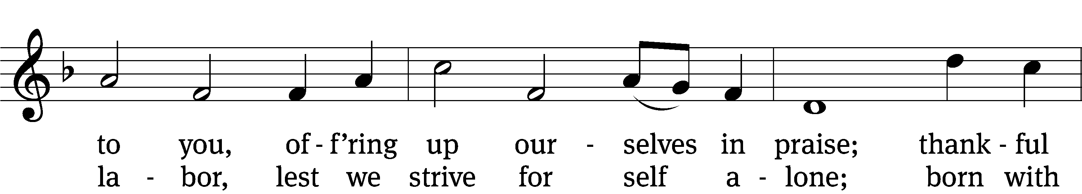
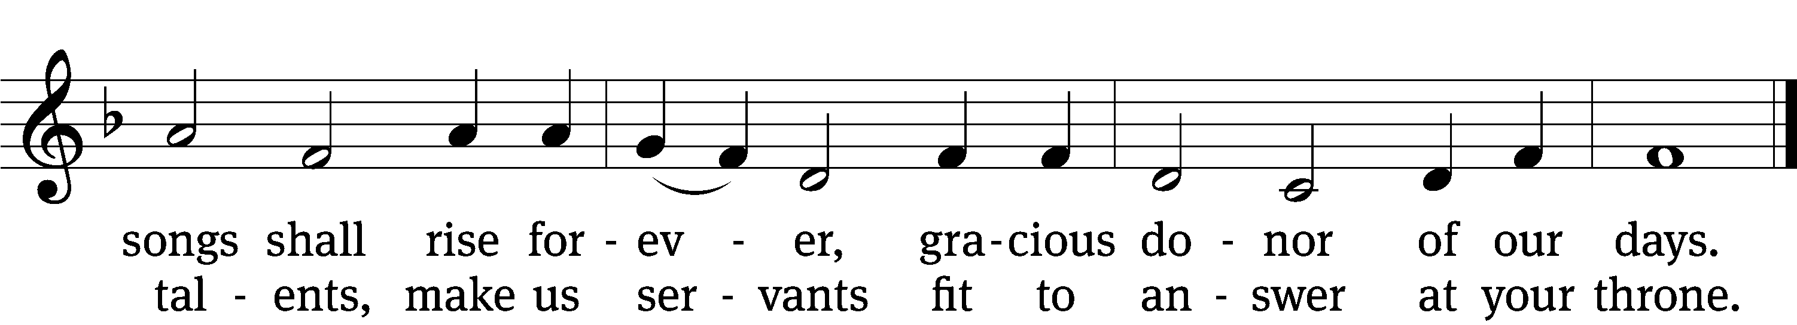
Text: Robert L. Edwards, 1915–2006
Tune: The Sacred Harp, Philadelphia, 1844
Text: © 1961, ren. 1989 The Hymn Society, admin. Hope Publishing Co. Used by permission: OneLicense no. 716626
Tune: Public domain

Holy Baptism
Remain seated

In the name of the Father and of the T Son and of the Holy Spirit.
Amen.
Confession
Our Savior Jesus Christ commanded Baptism when he said, “All authority in heaven and on earth has been given to me. Therefore go and make disciples of all nations, baptizing them in the name of the Father and of the Son and of the Holy Spirit, and teaching them to obey everything I have commanded you. And surely I am with you always, to the very end of the age.”

All of us are born into this world with a deep need for Baptism. From our parents we inherit a sinful nature; we are without true fear of God and true faith in God and are condemned to eternal death. But while we were still sinners, Christ died for us. He took away our sin by giving his life on the cross. In Baptism, he clothes us with the robe of his righteousness and gives us a new life. We recall what Baptism means for our daily lives:

Baptism means that the sinful nature in us
should be drowned by daily sorrow and repentance,
and that all its evil deeds and desires be put to death.
It also means that a new person should daily arise
to live before God in righteousness and purity forever.

As baptized children of God, we confess our sins:
Holy God, gracious Father,
I am sinful by nature
and have sinned against you in my thoughts, words, and actions.
I have not loved you with my whole heart;
I have not loved others as I should.
I deserve your punishment both now and forever.
But Jesus, my Savior, paid for my sins
with his innocent suffering and death.
Trusting in him, I pray: God, have mercy on me, a sinner.

God saved us through the washing of rebirth and renewal by the Holy Spirit and united us to the death and resurrection of Jesus. Every day God forgives your sins, removes your guilt, and strengthens you to defeat Satan’s power. His promise is for you and your children, and he will never forsake you. Your sins are forgiven. You are clothed with Christ. You are at peace with God now and forever.
Amen.

The rite of baptism continues at the font.
Sacrament of Baptism
Do you believe that you were born in sin and therefore eternally lost?
Yes, I believe.

Do you believe that the triune God—the Father, the Son, and the Holy Spirit—planned and carried out your salvation?
Yes, I believe.

Do you believe that God grants you the forgiveness of sins in Holy Baptism?
Yes, I believe.

Do you reject the devil along with all his lies and empty promises?
Yes, I do.

Do you desire to be baptized into the Christian faith?
Yes, I do.

Receive the sign of the cross on the head and heart T to mark you as one redeemed by Christ the crucified.

Adam Brooks, I baptize you in the name of the Father and of the Son and of the Holy Spirit.

The almighty God and Father of our Lord Jesus Christ has given you the new birth of water and the Spirit and has forgiven all your sins. May he strengthen you with his grace all the days of your life. Peace be with you.

Let us pray.

We give thanks, most merciful Father, that you have received Adam as your own child and made him a member of Christ’s body, the church. Now, we pray, grant to him and to all your church on earth that, being dead to sin, we may live to righteousness and, being buried with Christ into his death, we may also share in his resurrection, so that, with all your saints, we may inherit eternal life; through Christ our Lord.
Amen.
749 God, Whose Giving Knows No Ending CW 749 st. 3
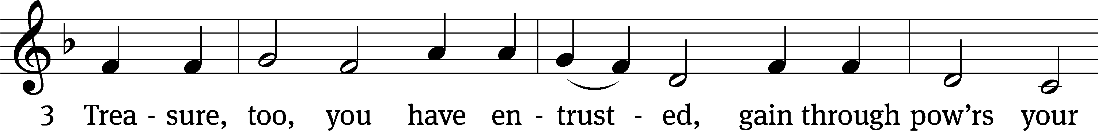
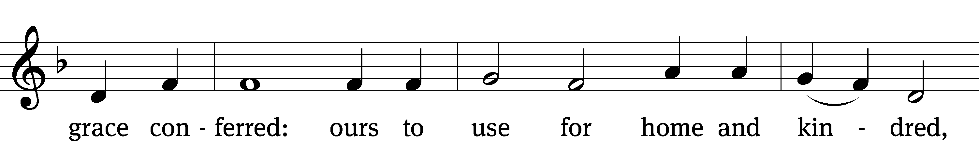
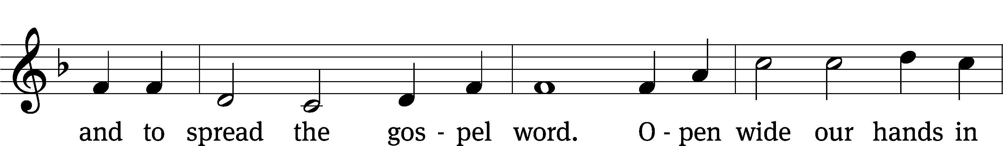
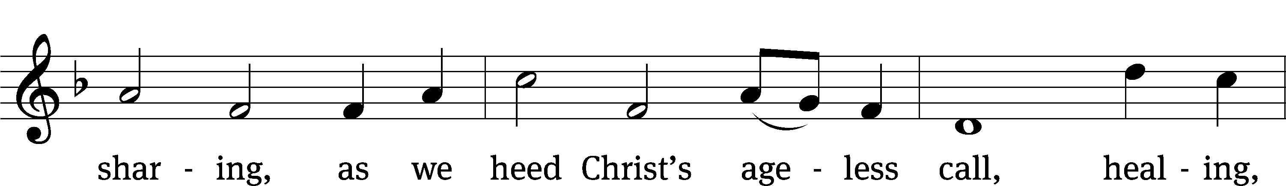
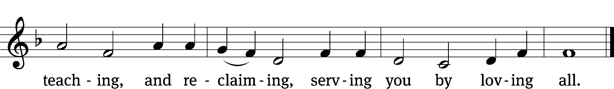
Text: Robert L. Edwards, 1915–2006
Tune: The Sacred Harp, Philadelphia, 1844
Text: © 1961, ren. 1989 The Hymn Society, admin. Hope Publishing Co. Used by permission: OneLicense no. 716626
Tune: Public domain

The Word

The Lord be with you.
And also with you.
Prayer of the Day
Let us pray.

Heavenly Father, though we do not deserve your goodness, still you provide for all our needs of body and soul. Grant us your Holy Spirit that we may acknowledge your gifts, give thanks for all your benefits, and serve you in willing obedience; through your Son, Jesus Christ our Lord, who lives and reigns with you and the Holy Spirit, one God, now and forever.
Amen.

First Reading 2 Corinthians 9:8–11
8And God is able to bless you abundantly, so that in all things at all times, having all that you need, you will abound in every good work. 9As it is written:
“They have freely scattered their gifts to the poor;
their righteousness endures forever.”
10Now he who supplies seed to the sower and bread for food will also supply and increase your store of seed and will enlarge the harvest of your righteousness. 11You will be enriched in every way so that you can be generous on every occasion, and through us your generosity will result in thanksgiving to God.
145B I Will Praise Your Name Forever Psalm 145B
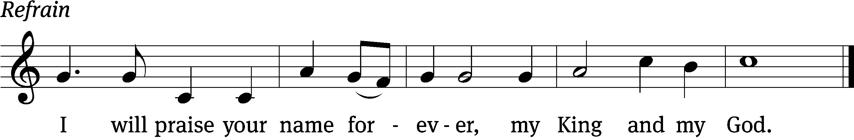


Great is the Lord and most wor- / thy of praise;
his greatness no one can / fathom.
One generation commends your works to an- / other;
they tell of your / mighty acts.
The Lord upholds / all who fall
and lifts up all who are / bowed down. Refrain

The eyes of all look to you, and you give them their food at the / proper time.
You open your hand and satisfy the desires of every / living thing.
The Lord is near to all who / call on him,
to all who call on / him in truth.
He fulfills the desires of those who / fear him;
he hears their cry and / saves them.
Glory be to the Father and / to the Son
and to the Holy / Spirit,
as it was in the be- / ginning,
is now, and will be forever. / Amen. Refrain
Text: Lectionary for Mass
Tune: Lynn Trapp
Setting: Kermit G. Moldenhauer
Text: © 1969, 1981, 1997 ICEL (refain). Used by permission: OneLicense no. 716626
Tune: © 1989 MorningStar Music Publishers. Used by permission: OneLicense no. 716626
Setting: © 1993 Kermit G. Moldenhauer, admin. Northwestern Publishing House. Used by permission: OneLicense no. 716626
Gospel Mark 6:35–44
35By this time it was late in the day, so his disciples came to him. “This is a remote place,” they said, “and it’s already very late. 36Send the people away so that they can go to the surrounding countryside and villages and buy themselves something to eat.”
37But he answered, “You give them something to eat.”
They said to him, “That would take more than half a year’s wages! Are we to go and spend that much on bread and give it to them to eat?”
38“How many loaves do you have?” he asked. “Go and see.”
When they found out, they said, “Five—and two fish.”
39Then Jesus directed them to have all the people sit down in groups on the green grass. 40So they sat down in groups of hundreds and fifties. 41Taking the five loaves and the two fish and looking up to heaven, he gave thanks and broke the loaves. Then he gave them to his disciples to distribute to the people. He also divided the two fish among them all. 42They all ate and were satisfied, 43and the disciples picked up twelve basketfuls of broken pieces of bread and fish. 44The number of the men who had eaten was five thousand.

Children's Devotion Ages 3 through grade 5 are invited to come forward for a Bible lesson.

Children's Church During the service, parents may choose to take their children (ages 2-5) to Children’s Church. There they will hear a Bible story, and sing songs. They will return to the sanctuary during the offering.

752 Gracious God, You Send Great Blessings CW 752
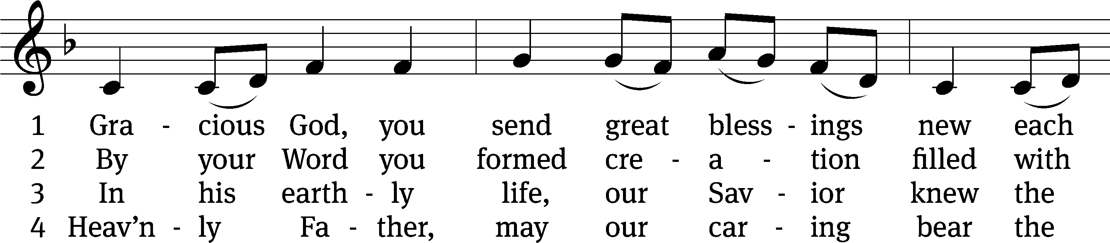
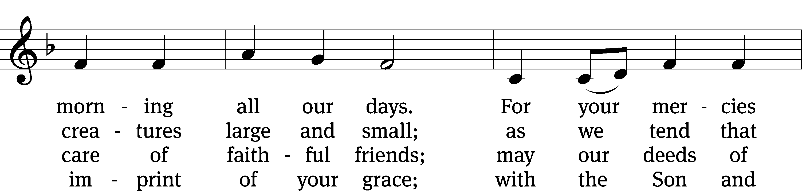
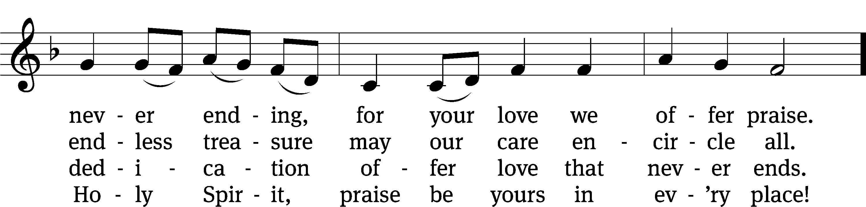
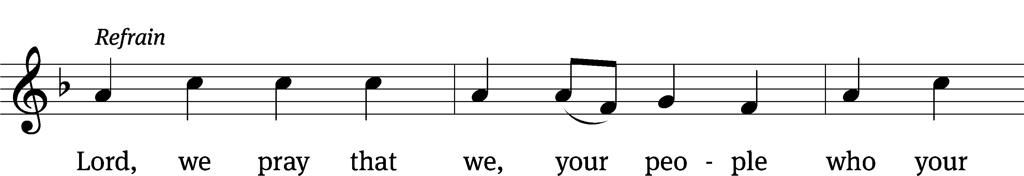
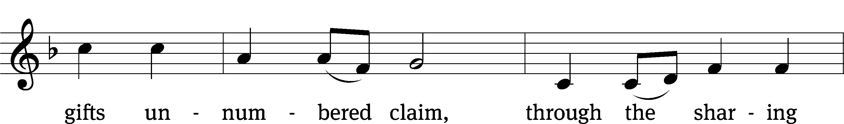

Text: Gregory J. Wismar, b. 1946
Tune: ed. William Moore; Columbian Harmony, Cincinnati, 1825
Text: © 2004 Gregory J. Wismar. Used by permission: OneLicense no. 716626
Tune: Public domain
Sermon Exodus 16:1–15
1The whole Israelite community set out from Elim and came to the Desert of Sin, which is between Elim and Sinai, on the fifteenth day of the second month after they had come out of Egypt. 2In the desert the whole community grumbled against Moses and Aaron. 3The Israelites said to them, “If only we had died by the Lord’s hand in Egypt! There we sat around pots of meat and ate all the food we wanted, but you have brought us out into this desert to starve this entire assembly to death.”
4Then the Lord said to Moses, “I will rain down bread from heaven for you. The people are to go out each day and gather enough for that day. In this way I will test them and see whether they will follow my instructions. 5On the sixth day they are to prepare what they bring in, and that is to be twice as much as they gather on the other days.”
6So Moses and Aaron said to all the Israelites, “In the evening you will know that it was the Lord who brought you out of Egypt, 7and in the morning you will see the glory of the Lord, because he has heard your grumbling against him. Who are we, that you should grumble against us?” 8Moses also said, “You will know that it was the Lord when he gives you meat to eat in the evening and all the bread you want in the morning, because he has heard your grumbling against him. Who are we? You are not grumbling against us, but against the Lord.”
9Then Moses told Aaron, “Say to the entire Israelite community, ‘Come before the Lord, for he has heard your grumbling.’ ”
10While Aaron was speaking to the whole Israelite community, they looked toward the desert, and there was the glory of the Lord appearing in the cloud.
11The Lord said to Moses, 12“I have heard the grumbling of the Israelites. Tell them, ‘At twilight you will eat meat, and in the morning you will be filled with bread. Then you will know that I am the Lord your God.’ ”
13That evening quail came and covered the camp, and in the morning there was a layer of dew around the camp. 14When the dew was gone, thin flakes like frost on the ground appeared on the desert floor. 15When the Israelites saw it, they said to each other, “What is it?” For they did not know what it was.
Moses said to them, “It is the bread the Lord has given you to eat.

“Learn the ‘manna’ lesson!”
Apostles’ Creed
I believe in God, the Father Almighty,
maker of heaven and earth.

I believe in Jesus Christ, his only Son, our Lord,
who was conceived by the Holy Spirit,
born of the Virgin Mary,
suffered under Pontius Pilate,
was crucified, died, and was buried.
He descended into hell.
The third day he rose again from the dead.
He ascended into heaven
and is seated at the right hand of God the Father Almighty.
From there he will come to judge the living and the dead.

I believe in the Holy Spirit,
the holy Christian Church,
the communion of saints,
the forgiveness of sins,
the resurrection of the body,
and the life everlasting. Amen.


Offering “We love because he first loved us.” 1Jn 4:19 God’s love in sending Jesus to live, to suffer, and to die for each of us motivates the members of Beautiful Savior to show their love and thanks by returning a portion of their income to the Lord. Through these free will offerings, this congregation and its ministries are maintained.
If you would like to give securely online, scan this code or follow this link: bslclarksville.com

Prayer of the Church

Loving God and Lord, you created the universe that surrounds us and the globe on which we live. You control all things through your Son, who sits at your right hand in glory.
Comfort us with the promise of your eternal presence.

Give your Word power as it works in our hearts and minds. Clear away our confusion, and demolish our doubts. Send your Spirit to strengthen both our confidence in your promises and our desire to live according to your will.
Take away our love of sinning, and restore us each day by your grace.

The signs of the times warn us that the end of time is near. Protect us from scoffers who sneer at your truth. Spare us and Christians around the world from all forms of hate and persecution.
Give us courage to carry the cross with patience and joy.

Instill in the hearts of our children a desire to follow you as they prepare for future days. Help them distinguish between what is passing and what is eternal, between instant thrills and lasting joy. Encourage more young people to prepare for service in the public ministry of the gospel.
Mold us and move us to be good examples for our youth.

Hold in your care, Lord, those who are experiencing physical or emotional pain and all who are afflicted by disease or facing death. [Especially bless . . . here name the person and the cause of the petition.] Pour out your compassion on the grieving, and comfort the mourners who miss someone they loved.
Move us to pray for these brothers and sisters and to help when we can.

Hear us, Lord, as we pray in silence.

Silent prayer

Whether we pray together or alone, you have promised to hear and answer us. Give us patience to accept your blessings in whatever way you send them. In your love and wisdom, prepare us for the day when you will take us to be with you forever.
Hear us for Jesus’ sake. Amen.

Lord’s Prayer
Our Father, who art in heaven,
hallowed be thy name,
thy kingdom come,
thy will be done
on earth as it is in heaven.
Give us this day our daily bread;
and forgive us our trespasses,
as we forgive those
who trespass against us;
and lead us not into temptation,
but deliver us from evil.
For thine is the kingdom
and the power and the glory
forever and ever. Amen.

506 For the Fruits of His Creation CW 506
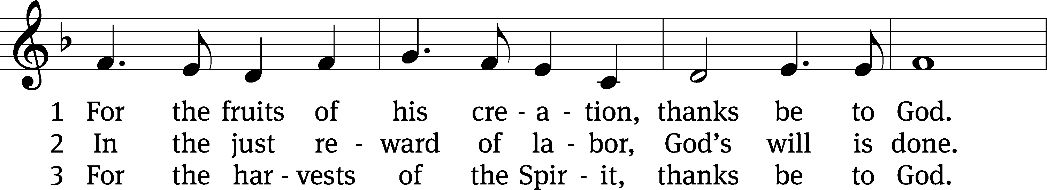
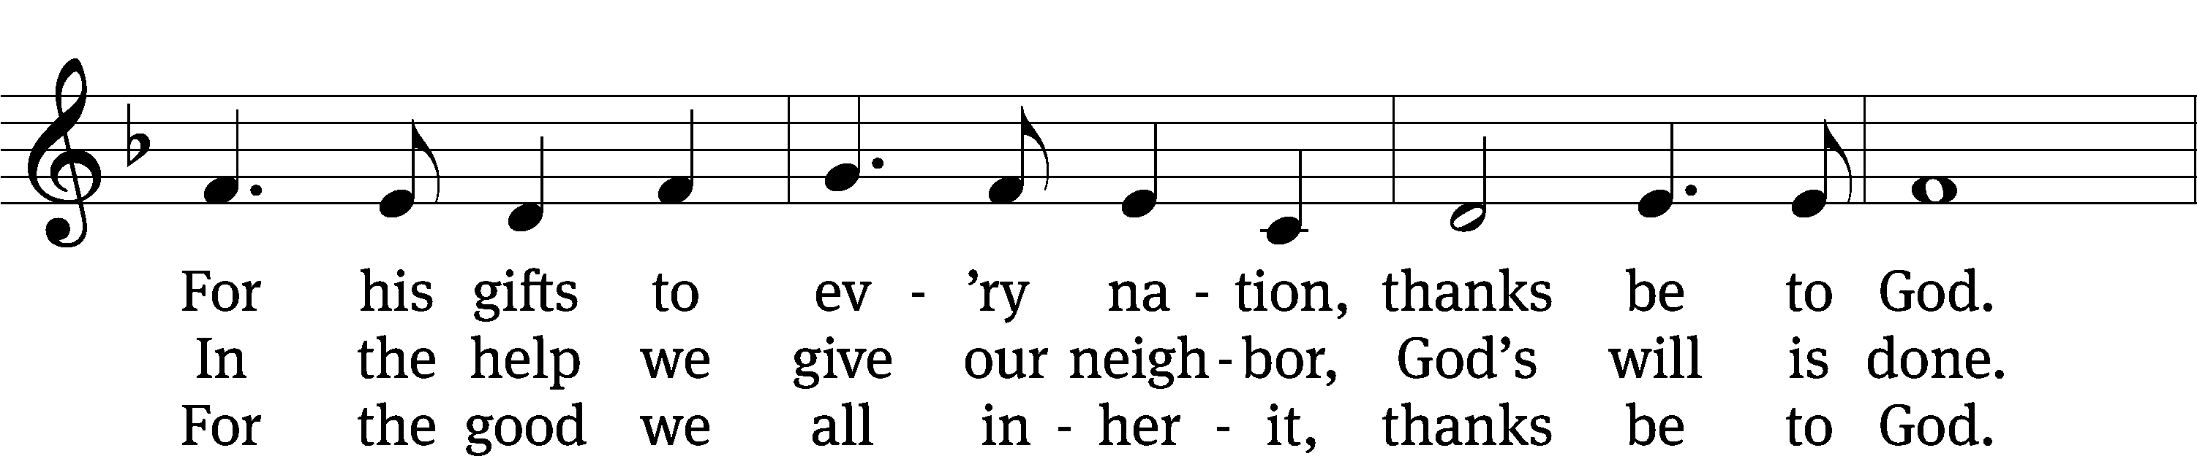
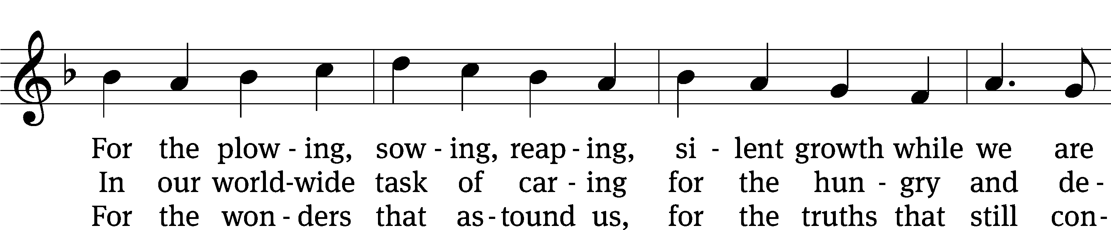
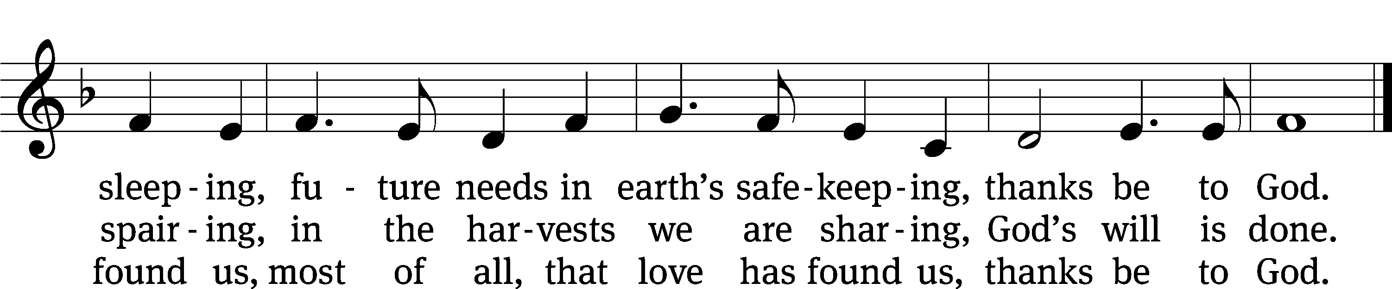
Text: Fred Pratt Green, 1903–2000
Tune: Welsh, 18th cent.
Text: © 1970 Hope Publishing Co. Used by permission: OneLicense no. 716626
Tune: Public domain
Closing Prayer
Merciful God, we thank you for once again having spoken to us through your Word. Let your Word be a light to our path, so that neither the attractions nor the worries of this life may be able to turn our thoughts from the life to come. As we now prepare to leave this house of God, let the Holy Spirit accompany us, so that we may be responsive to your voice speaking to our hearts. Give us forgiveness for yesterday, faith for today, and strength for tomorrow. We ask this of you in the name of Jesus, the name above every name.
Amen.
Blessing
The Lord bless you and keep you.
The Lord make his face shine on you and be gracious to you.
The Lord look on you with favor and T give you peace.
Amen.

507 Let All Things Now Living CW 507
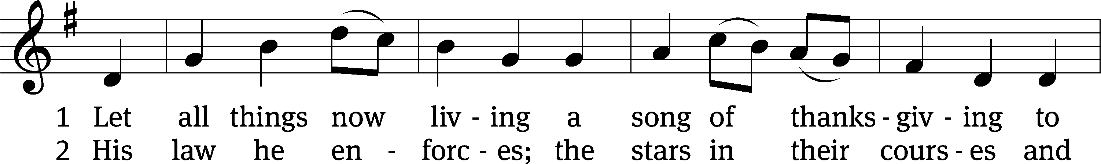
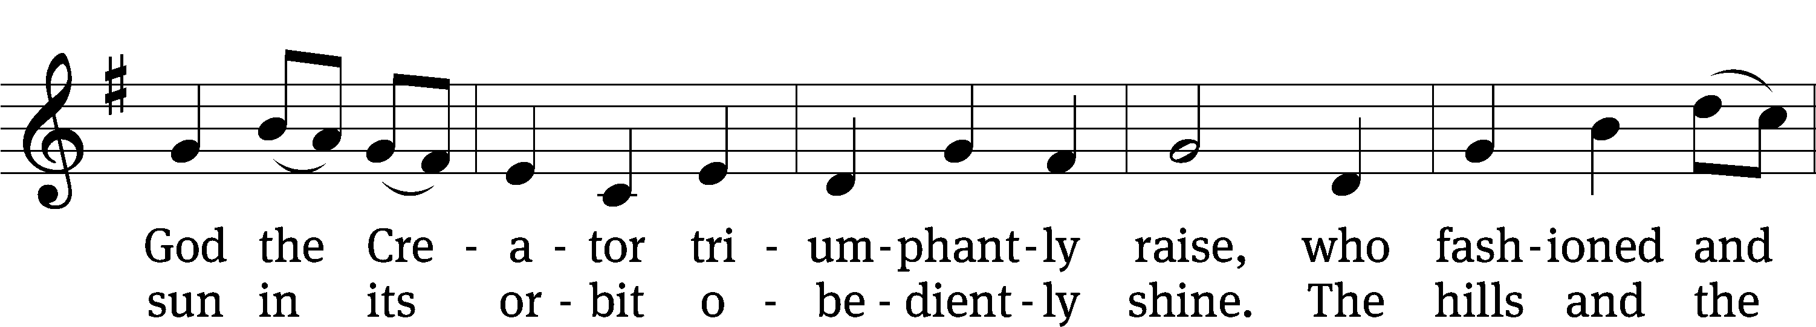
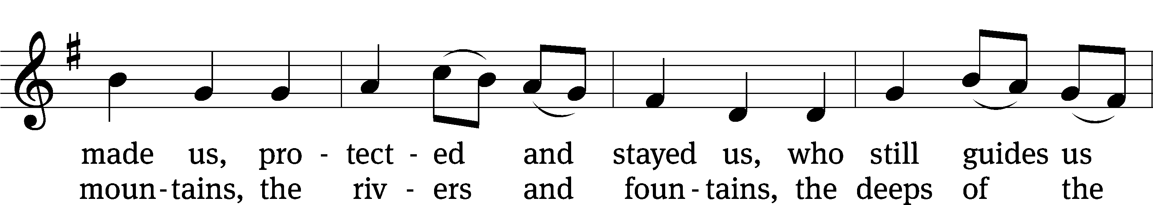
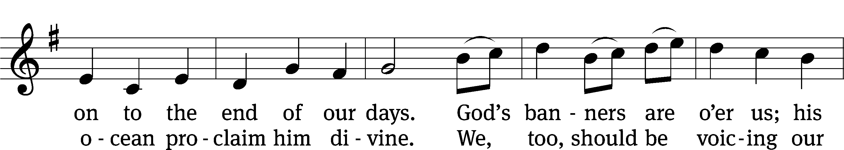
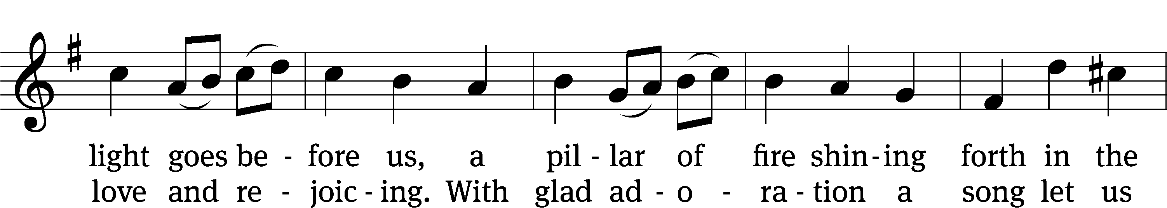
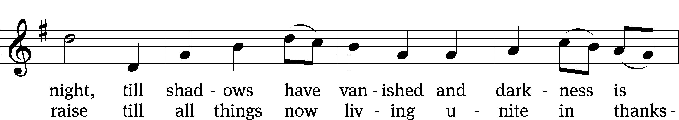
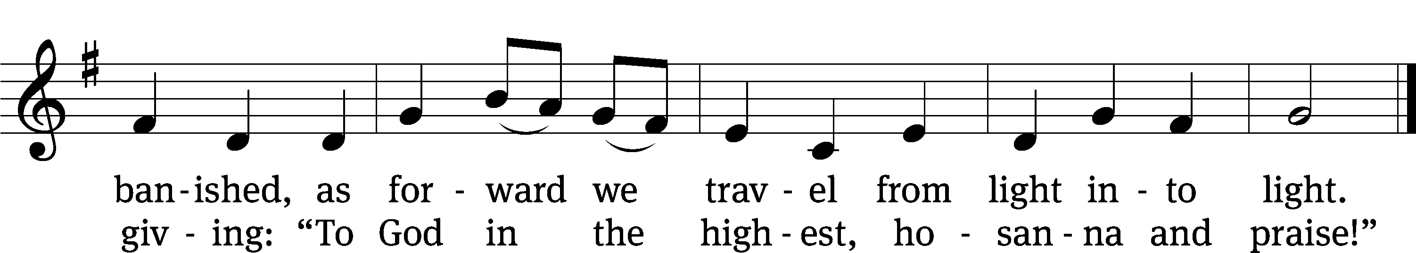
Text: Katherine K. Davis, 1892–1980
Tune: Welsh
Text: © 1939 ren. 1966 E.C.Shirmer Music Company. Used by permission: OneLicense no. 716626
Tune: Public domain

Acknowledgments
Setting One from Christian Worship
Unless otherwise indicated, Scripture quotations are from The Holy Bible, New International Version®, NIV®. Copyright © 1973, 1978, 1984, 2011 by Biblica, Inc.TM Used by permission of Zondervan. All rights reserved worldwide.
Liturgical and musical settings of Scripture based on text from The Holy Bible, New International Version®, NIV®. Copyright © 1973, 1978, 1984, 2011 by Biblica, Inc.TM Used by permission of Zondervan. All rights reserved worldwide.
Software distributed in partnership with Northwestern Publishing House.
Created by Christian Worship: Service Builder © 2024 Concordia Publishing House.

Next Week’s Worship
Our theme for worship: Meaningful Ministry-Fear Not, For the Lord is with You. Our readings will be: 2 Kings 6: 8-17, 2 Timothy 4: 6-8, 16-18, and Mark 6: 45-56. We will sing the following hymns: 820 O God, Our Help in Ages Past, 803 Day by Day, 533 Jesus, Lover of My Soul, and 549 Across the Lands.

THIS WEEK AT BEAUTIFUL SAVIOR
† Today No Sunday School
10:30am Worship
† Monday 10am-12pm Preschool Orientation
† Tuesday 6pm-8pm Preschool Orientation
† Wednesday 10am-12pm Preschool Orientation
6 pm Bible Study
† Thursday 6pm-8pm Preschool Orientation
† Sunday 9:15am Sunday School
10:30am Worship

Congratulations!
Today we are excited to celebrate the baptism of Adam Brooks. We thank God for the blessings of baptism and may God keep Adam and all God’s people in their baptismal grace all the days of their lives.

Classroom Assistant Opening
The preschool has an opening for an Assistant Teacher in the 3-4 year old classroom. Hours are M-F 8am-12pm or M-F 8am-3pm. Please call the office at 931-905-1400 or speak with Miss Noon for more information.

Summer Bible Study Schedule
There will not be adult or youth Bible Study or Sunday School from Sunday, June 23-Sunday, July 28. Sunday School and Bible Study will resume on Sunday, August 4. This break gives a little time off for our teachers and helps us get ready for our Fall Kick-Off.

Sunday School Volunteers
We are in need of volunteers for Sunday School. We are looking for 3 or more people to help teach the children’s Sunday School. We would like to have a 6-7 week rotation. All things needed for teaching the lessons are supplied. If you have any questions, please contact Jennie Geer at (615) 944-2062.

Sunday School Resumes
There is Sunday School for all ages! From adults to little ones, our Sunday School classes will resume on Sunday, August 4, at 9:15 am.

Lawn Maintenance
We are looking for volunteers to cut the grass throughout the summer. We have a zero-turn lawn mower, trimmer, and leaf blower. We even provide the gas! What we need are people willing to spend some time on a Friday or Saturday getting the property ready for church on Sunday. If you would like to help, please see the sign-up sheet in the entry-way. If you have questions, talk to Pastor.

25th Anniversary Special Offering
We will be giving thanks to God for the blessings that we have received through the 25 years of our ministry next summer, June 8, 2025. As we prepare for that day of celebration, we are working on several special projects to improve or update our facilities and property. Among those projects are:

- A new sign for the entryway of our church
- New carpet and paint for the sanctuary
- A/V Updates
- A nursery room
- New paraments
- Meal Catering

Our total goal that we are planning to raise is $50,000. You can see the full list of items and the donations raised so far on the display in the entryway.
If you would like to give a special gift for the 2025 projects, please make sure that you designate the donation for the “25th Anniversary fund” on your envelope or your on-line donation.
We are also excited to announce that there is a 1:1 matching grant that will be given for any gifts given through the anniversary date of June 8, 2025. All donations above our $50,000 goal will be used to reestablish our Emergency Fund and to pay down the principal on our mortgage.
We humbly ask that any donations for the 25th Anniversary be “above and beyond” your regular and gracious support of our ministry.
If you have any questions about the projects or how to give a gift, please speak with Art Ebbinger.

Prayer List
Thank the Lord for the safe return of all the soldiers who recently came home and all soldiers and their families who are facing deployment. Please keep in your prayers this week all soldiers who are currently deployed. Please also remember: Mikaela Watkins, family of Bob and Judy Mader (lung cancer and surgery); Roger Fox, son of Hilde Fox (cancer); Cynthia Thorington, sister of Brenda Henschen (long-term Covid symptoms); Linda Kiecker, daughter of Selma Noon (pancreatic cancer); Theresa Robinson (recovery from eye surgery); Stacia Gupton, friend of Caryn Mclain, (serious illness); Nita Harris, friend of David & Allison Johnson (cancer/chemo); Teri Lee Dickinson & Family (bereavement); May Holman, mother of Trey Church (abdominal surgery); Christa Trusty (Health Issues); Curt Holz, brother of Pastor Holz (cancer); Bob Housh (Injured in fall); Renate Banks (illness); Marlys Donner, mother of Tim Donner (declining health); Josh Carter, friend of Adam Holz (recovery from car accident); Stacy Schroeder, daughter of Jeff & Eileen Cleveland (melanoma diagnosis); Aimee Gerkhardt, sister in law of Jessica Church (breast cancer); Brandon Vannoy, friend of Mac McCoo (seizures); Sheila Lynch, sister of Gayle Brooks (unable to walk); Drake Robideau, friend of Mary Daniel (strength & wellness); Mike LaFave (back problems); Linda Thomas, sister of Gayle Brooks, (physical rehab after injury); Gidget Tate (Health issues). If you would like to have a name or situation included or if you would like to give an update on a prayer request, please contact Pastor Holz or call the church office at 931-905-1400.

Serving in God’s House

Ushers: Art Ebbinger, Ray Mefford
Greeters: Loretta Wilder, Ernie Rautter
Kitchen: Hannah L, Mary D, Margareta S
Piano: Barb Noon
Fellowship: (T-Z)

Serving next week:

Ushers: Mike Rathge, Trey Church
Greeters: Jeff & Eileen Cleveland
Kitchen: Gael I, Loretta W, Mary D
Piano: Deb White
Fellowship: (A-G)

