Beautiful Savior Lutheran Church

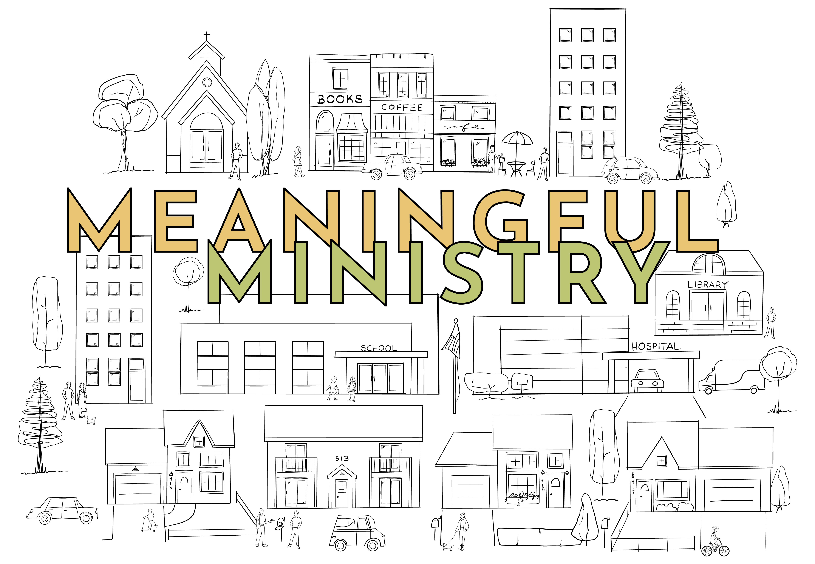

July 21, 2024 – Ninth Sunday after Pentecost

service theme: jesus models a compassionate servant’s heart

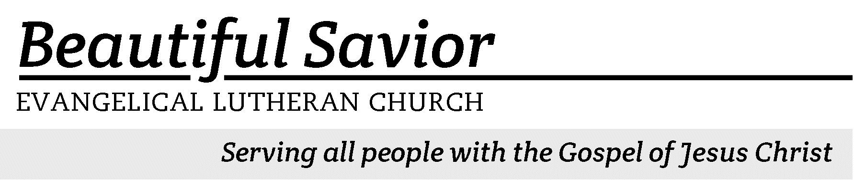


Welcome-- We are glad you could join us today! It is our hope that this service is a blessing to you. Please join us for worship again soon.

· Please save the last two rows of pews for parents with small children.

· Parents with little ones: We are excited to offer a nursery for your use. It is to the left as you exit the sanctuary. If your child becomes restless during the service, that’s okay… We’re glad they’re here, and Jesus is pleased when they are brought to hear his Word: “Let the little children come to me.”

· Five minutes before the worship service begins the usher will light the candles. This is our signal to quiet down and prepare our hearts for worship.

· Restrooms are conveniently located to the left as you exit the sanctuary.

· Please silence your cell phone before the start of the service.

Prayer for Worship
Lord God, in your merciful love you have given me precious promises about my life and my future. Preserve me from the doubts that assail me and increase my faith. When life confuses or disturbs me, teach me to fix my eyes on Jesus and to stand firm in his promise to uphold and deliver me. Amen.

Beautiful Savior Lutheran Church
2526 Whitfield Road
Clarksville, TN 37040
931-905-1400
Website: www.bslclarksville.com
Kent Holz, Pastor
Bslc.clarksville@gmail.com
Barbara Noon, Preschool Director
beautifulsaviorpreschool@gmail.com
553 The Lord’s My Shepherd CW 553 sts. 1–3
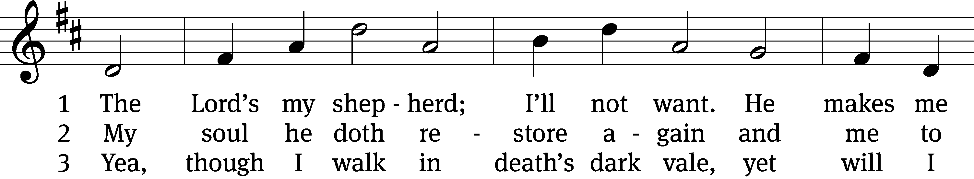
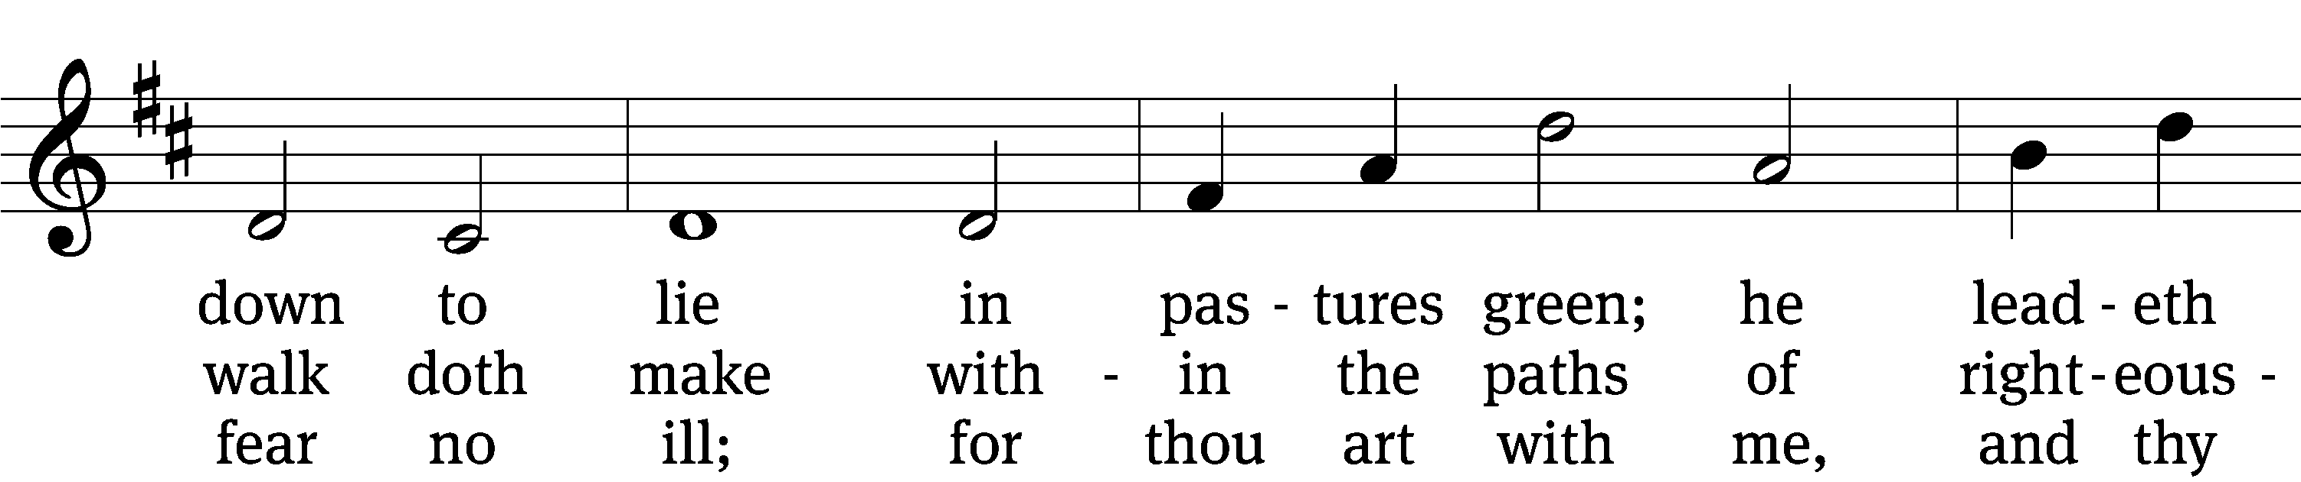
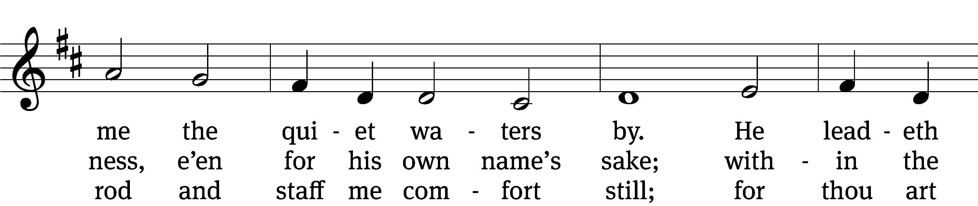
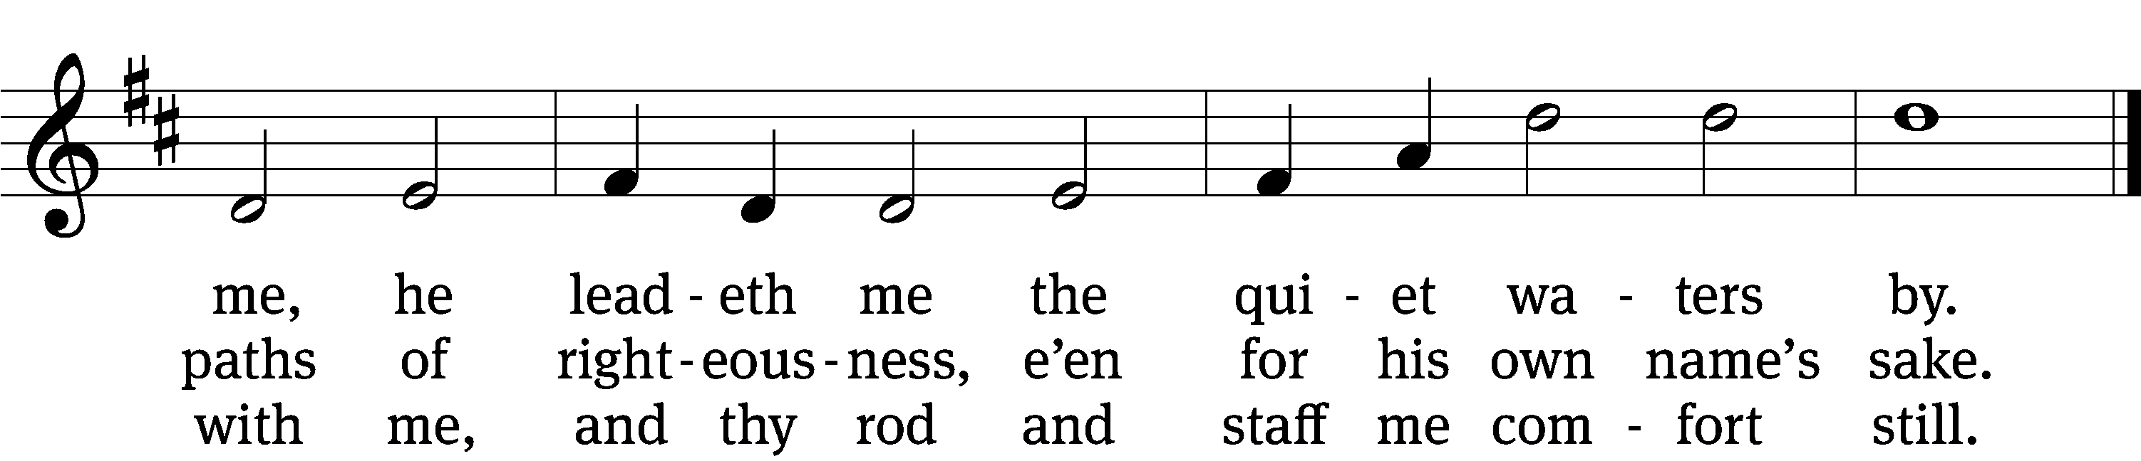
Text: The Psalms of David in Meeter, Edinburgh, 1650
Tune: James L. Macbeth Bain, 1860–1925
Text and tune: Public domain

Please Stand

In the name of the Father and of the T Son and of the Holy Spirit.
Amen.

Confession
If we claim to be without sin, we deceive ourselves and the truth is not in us.
If we confess our sins, God is faithful and just
and will forgive us our sins
and purify us from all unrighteousness.
Let us confess our sins to the Lord.
Holy God, gracious Father,
I am sinful by nature
and have sinned against you in my thoughts, words, and actions.
I have not loved you with my whole heart;
I have not loved others as I should.
I deserve your punishment both now and forever.
But Jesus, my Savior, paid for my sins
with his innocent suffering and death.
Trusting in him, I pray: God, have mercy on me, a sinner.

Our gracious Father in heaven has been merciful to us. He sent his only Son, Jesus Christ, who gave his life as the atoning sacrifice for the sins of the whole world. Therefore, as a called servant of Christ and by his authority, I forgive you all your sins in the name of the Father and of the T Son and of the Holy Spirit.
Amen.

553 The Lord’s My Shepherd CW 553 sts. 4–5
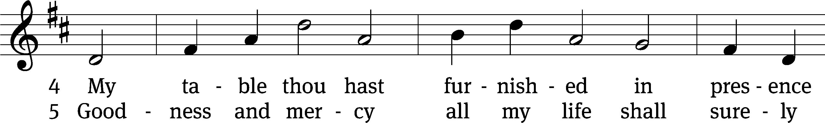
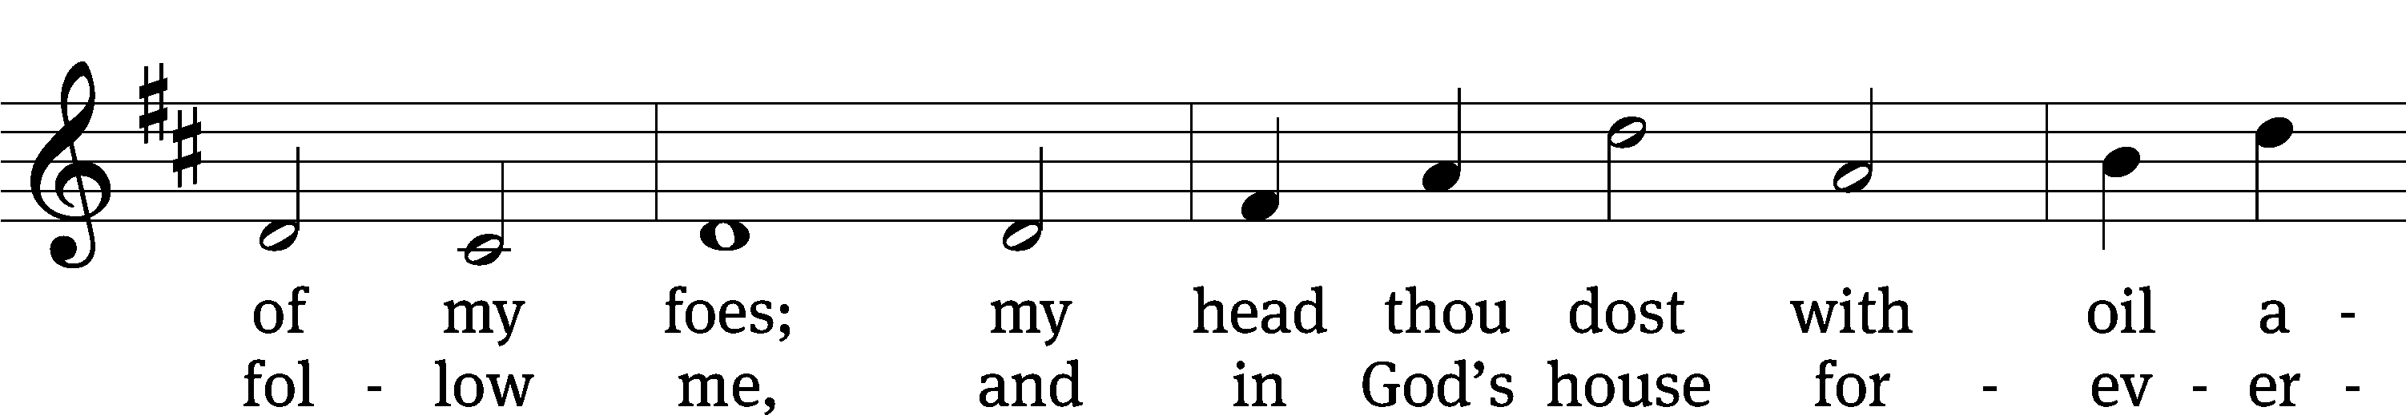
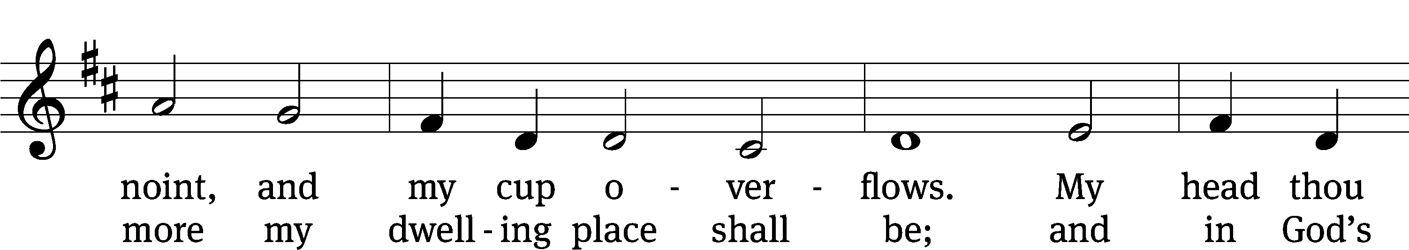
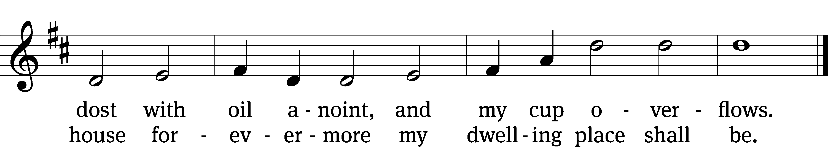
Text: The Psalms of David in Meeter, Edinburgh, 1650
Tune: James L. Macbeth Bain, 1860–1925
Text and tune: Public domain

The Word

The Lord be with you.
And also with you.

Prayer of the Day
Let us pray.

O God, the strength of all who trust in you, mercifully hear our prayers. Be gracious to us in our weakness, and give us strength to keep your commandments in all we say and do; through your Son, Jesus Christ our Lord, who lives and reigns with you and the Holy Spirit, one God, now and forever.
Amen.

Please be seated
First Reading Jeremiah 23:1–6
1“Woe to the shepherds who are destroying and scattering the sheep of my pasture!” declares the Lord. 2Therefore this is what the Lord, the God of Israel, says to the shepherds who tend my people: “Because you have scattered my flock and driven them away and have not bestowed care on them, I will bestow punishment on you for the evil you have done,” declares the Lord. 3“I myself will gather the remnant of my flock out of all the countries where I have driven them and will bring them back to their pasture, where they will be fruitful and increase in number. 4I will place shepherds over them who will tend them, and they will no longer be afraid or terrified, nor will any be missing,” declares the Lord.
5“The days are coming,” declares the Lord,
“when I will raise up for David a righteous Branch,
a King who will reign wisely
and do what is just and right in the land.
6In his days Judah will be saved
and Israel will live in safety.
This is the name by which he will be called:
The Lord Our Righteous Savior.
23A I Will Live in the House of the LORD Psalm 23A
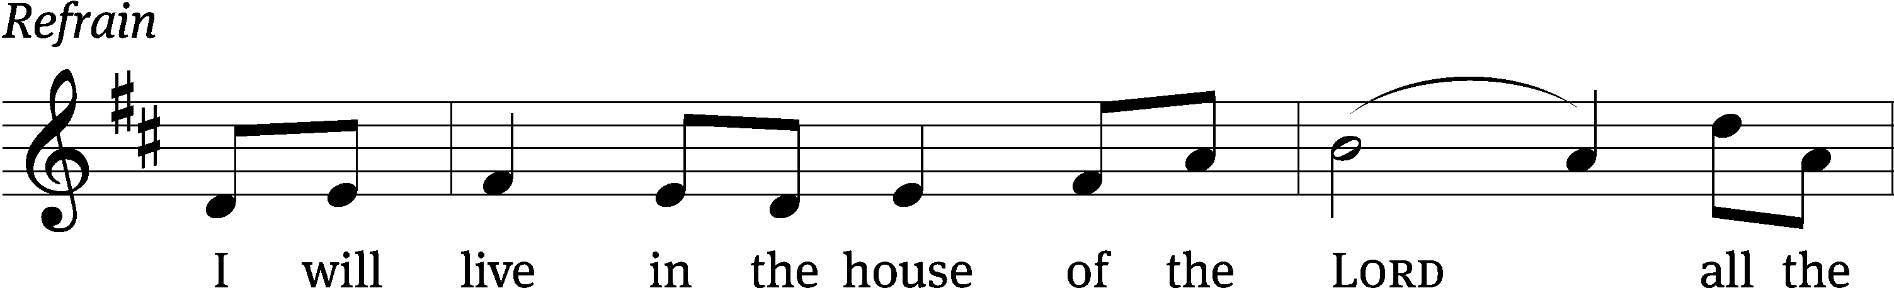
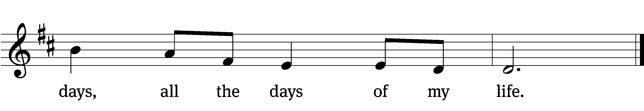


The Lord is my / shepherd,
I lack / nothing.
He makes me lie down in green / pastures,
he leads me beside quiet / waters,
he refreshes / my soul.
He guides me along the right paths for his / name’s sake.
Even though I walk through the valley of the shadow of death, I will fear no / evil,
for you are with me; your rod and your staff, they / comfort me. Refrain

You prepare a table before me in the presence of my / enemies.
You anoint my head with oil; my cup / overflows.
Surely your goodness and love will follow me all the days / of my life,
and I will dwell in the house of the Lord for- / ever.
Glory be to the Father and / to the Son
and to the Holy / Spirit,
as it was in the be- / ginning,
is now, and will be forever. / Amen. Refrain
Tune: Mark Haas
Setting: Mark Haas
Music: © 2014 Mark Haas. Used by permission: OneLicense no. 716626
Second Reading Hebrews 11:7–8, 18–21
7By faith Noah, when warned about things not yet seen, in holy fear built an ark to save his family. By his faith he condemned the world and became heir of the righteousness that is in keeping with faith.
8By faith Abraham, when called to go to a place he would later receive as his inheritance, obeyed and went, even though he did not know where he was going.
18even though God had said to him, “It is through Isaac that your offspring will be reckoned.” 19Abraham reasoned that God could even raise the dead, and so in a manner of speaking he did receive Isaac back from death.
20By faith Isaac blessed Jacob and Esau in regard to their future.
21By faith Jacob, when he was dying, blessed each of Joseph’s sons, and worshiped as he leaned on the top of his staff.

Children's Devotion Ages 3 through grade 5 are invited to come forward for a Bible lesson.

Children's Church During the service, parents may choose to take their children (ages 2-5) to Children’s Church. There they will hear a Bible story, and sing songs. They will return to the sanctuary during the offering.

766 Lord, Whose Love in Humble Service CW 766
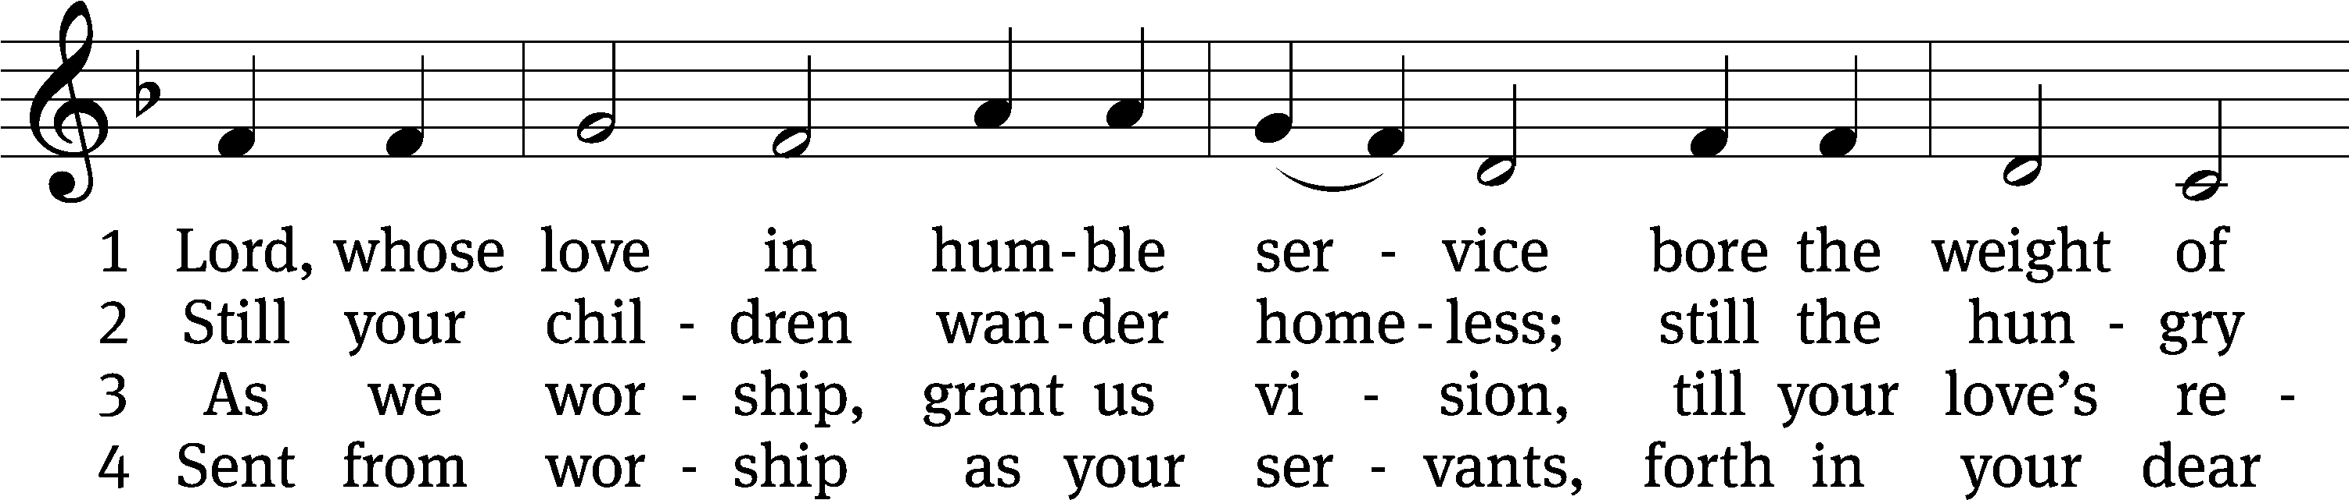
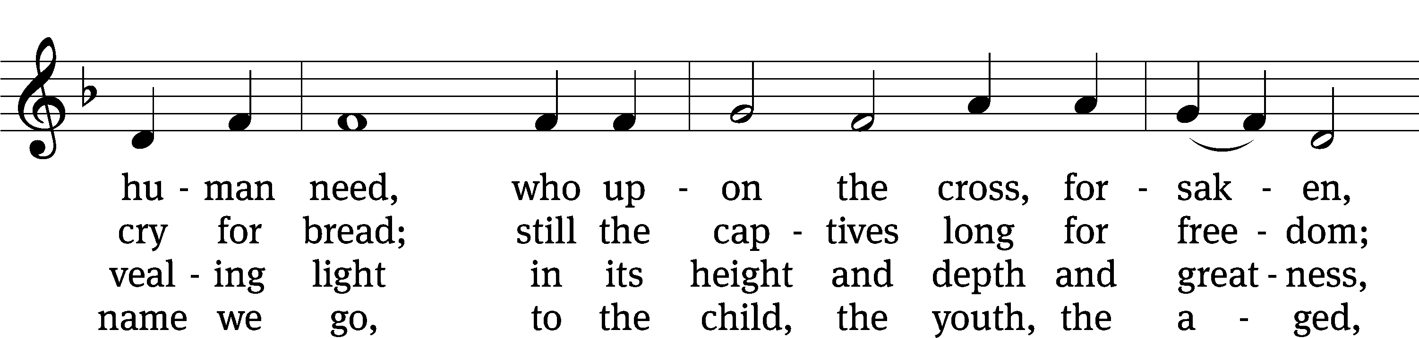
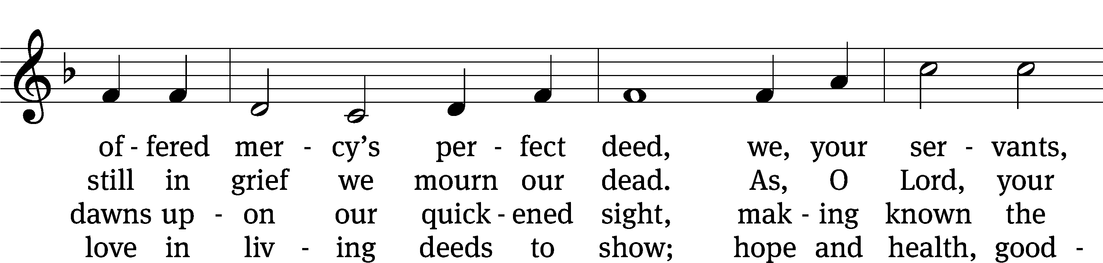
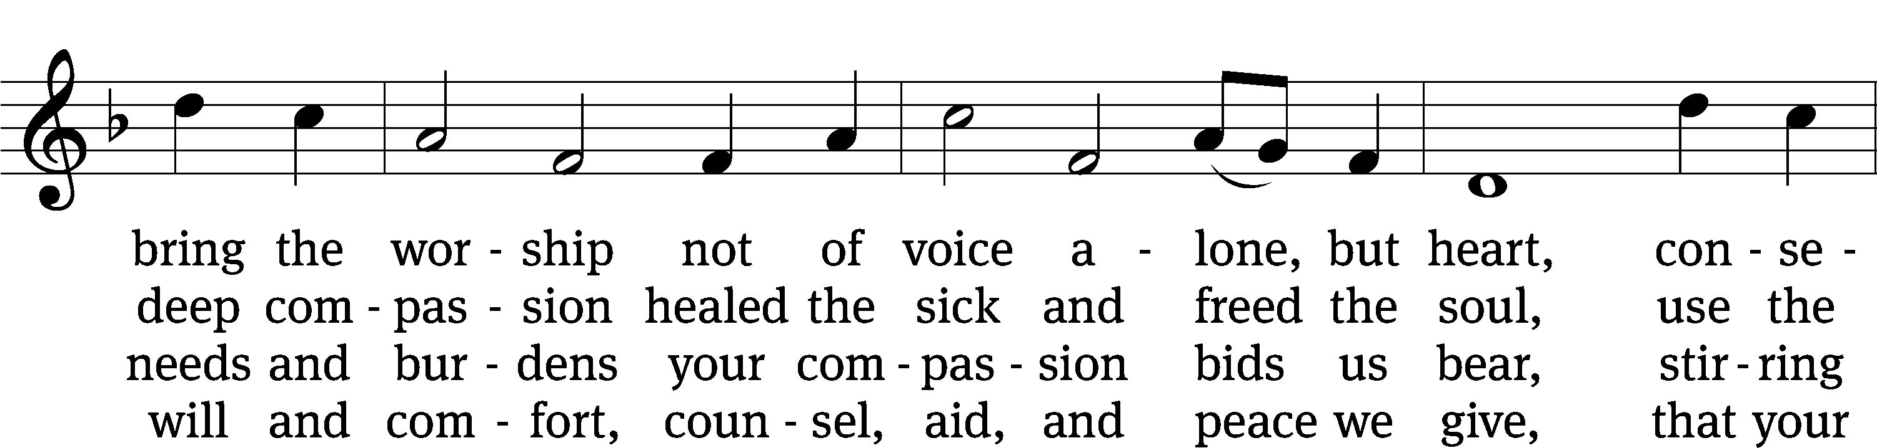
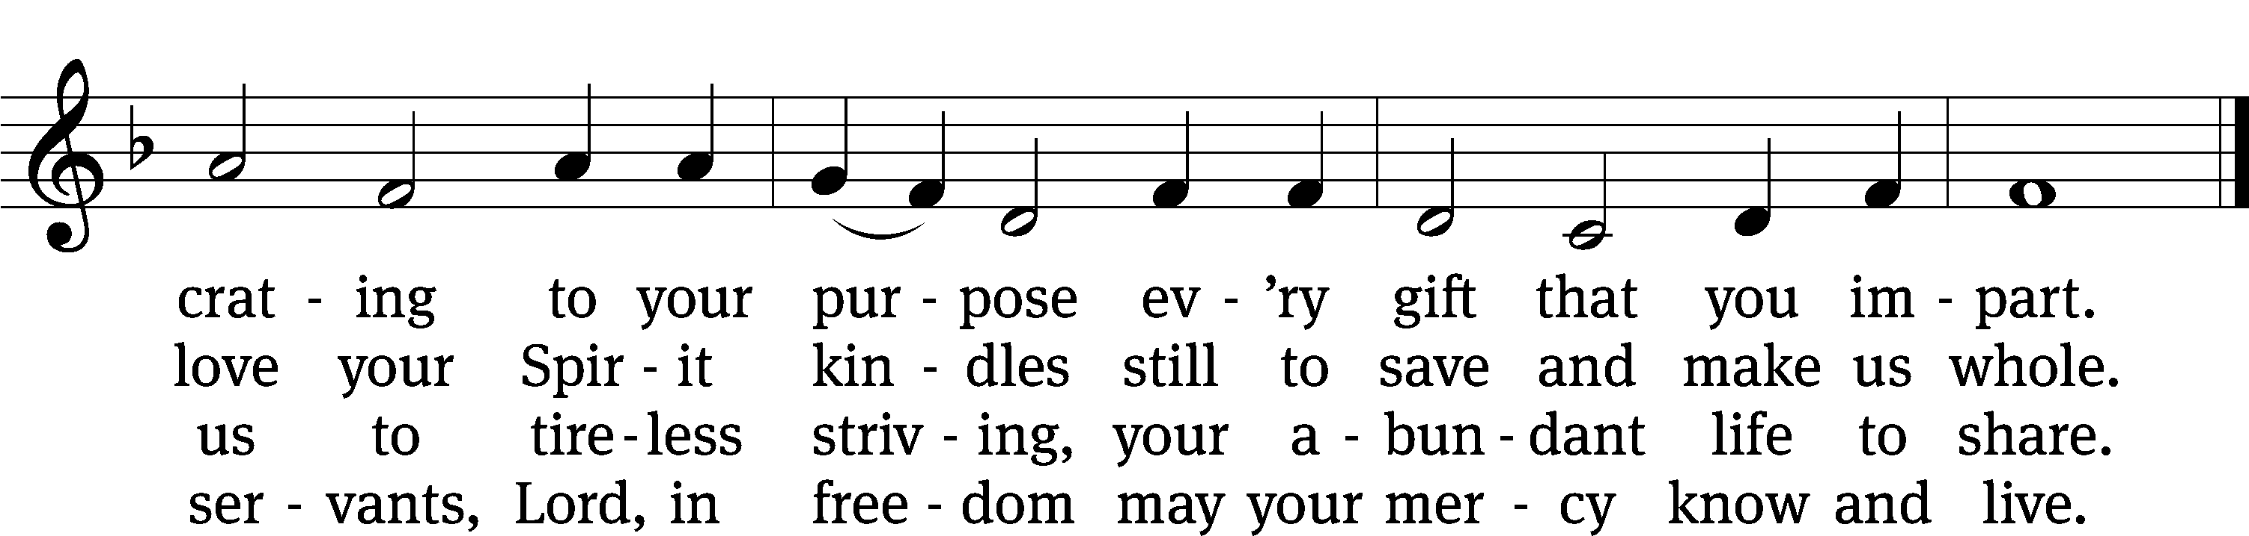
Text: Albert F. Bayly, 1901–1984, alt.
Tune: The Sacred Harp, Philadelphia, 1844
Text: © 1988 Oxford University Press. Used by permission: OneLicense no. 716626
Tune: Public domain

Gospel Mark 6:30–34
30The apostles gathered around Jesus and reported to him all they had done and taught. 31Then, because so many people were coming and going that they did not even have a chance to eat, he said to them, “Come with me by yourselves to a quiet place and get some rest.”
32So they went away by themselves in a boat to a solitary place. 33But many who saw them leaving recognized them and ran on foot from all the towns and got there ahead of them. 34When Jesus landed and saw a large crowd, he had compassion on them, because they were like sheep without a shepherd. So he began teaching them many things.

“Jesus’ heart beats with compassion”
Apostles’ Creed
I believe in God, the Father Almighty,
maker of heaven and earth.

I believe in Jesus Christ, his only Son, our Lord,
who was conceived by the Holy Spirit,
born of the Virgin Mary,
suffered under Pontius Pilate,
was crucified, died, and was buried.
He descended into hell.
The third day he rose again from the dead.
He ascended into heaven
and is seated at the right hand of God the Father Almighty.
From there he will come to judge the living and the dead.

I believe in the Holy Spirit,
the holy Christian Church,
the communion of saints,
the forgiveness of sins,
the resurrection of the body,
and the life everlasting. Amen.

Offering “We love because he first loved us.” 1Jn 4:19 God’s love in sending Jesus to live, to suffer, and to die for each of us motivates the members of Beautiful Savior to show their love and thanks by returning a portion of their income to the Lord. Through these free will offerings, this congregation and its ministries are maintained.
If you would like to give securely online, scan this code or follow this link: bslclarksville.com
Prayer of the Church

Eternal Lord, give us peace as we ponder the good news that you forgive our sins in Christ. Lead us to see clearly the path you have laid out for us.
Work in us so that we believe and live the Word we have heard today.

Provide courage and compassion to all who preach and teach your Word. Fill them with a love like yours as they proclaim your grace to us and all people.
Move us to love all ministers of the Word wherever they serve.

Guard and guide the families of our congregation. Lead husbands and wives to love each other with commitment, respect, and patience. Help parents to grasp the eternal value of keeping their children close to Jesus all their lives. Grant joy to those who are single, and make them a blessing to others.
Protect us from the temptations that surround us; give us pure hearts and minds.

Provide wisdom and insight to those who make laws and set policies. Give us respect for those who protect us from crime. Lead us to value the rights of our fellow citizens and to defend those who cannot defend themselves.
Bless our land with peace and prosperity so that the gospel may be proclaimed to all.

Give us passion to share the story of your love with our family and friends. Overcome unbelief, and open the hearts of people everywhere to believe the good news that Jesus has forgiven their sins and opened the gates of heaven.
Fill us with joy over every sinner who repents and comes to trust in you.

Extend your healing power to those who are sick and suffering in body or mind. Give patience and compassion to all who care for the sick and dying.
Lift the eyes of the distressed to your love in Christ.

Hear us, Lord, as we pray in silence.

Silent prayer

Gracious God, you govern and direct all things and you love all people. Hear our prayers, spoken and silent, and answer them in your wisdom and grace.
In Jesus’ name we pray. Amen.

Lord’s Prayer
Our Father, who art in heaven,
hallowed be thy name,
thy kingdom come,
thy will be done
on earth as it is in heaven.
Give us this day our daily bread;
and forgive us our trespasses,
as we forgive those
who trespass against us;
and lead us not into temptation,
but deliver us from evil.
For thine is the kingdom
and the power and the glory
forever and ever. Amen.
551 Jesus, Shepherd of the Sheep CW 551
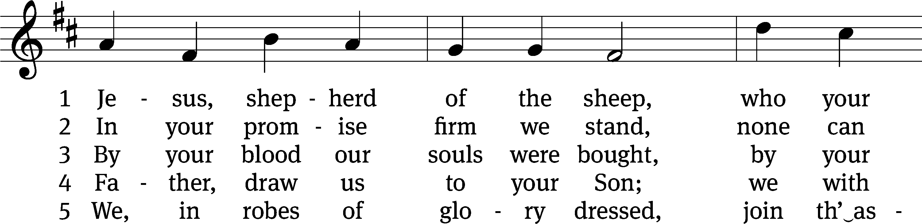
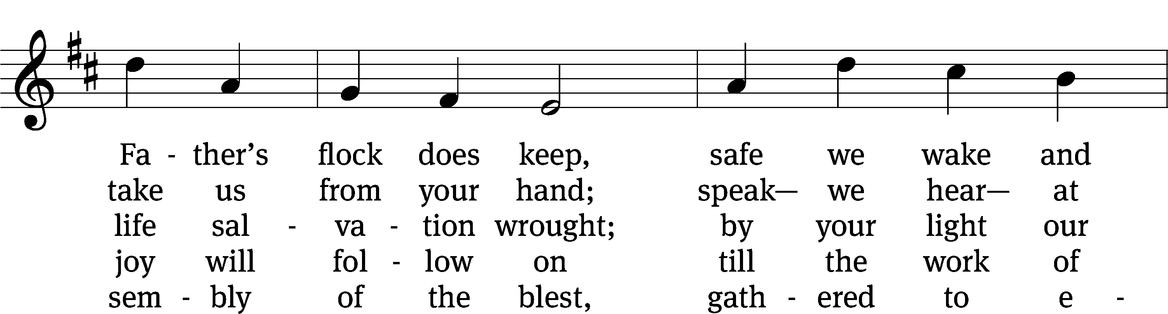
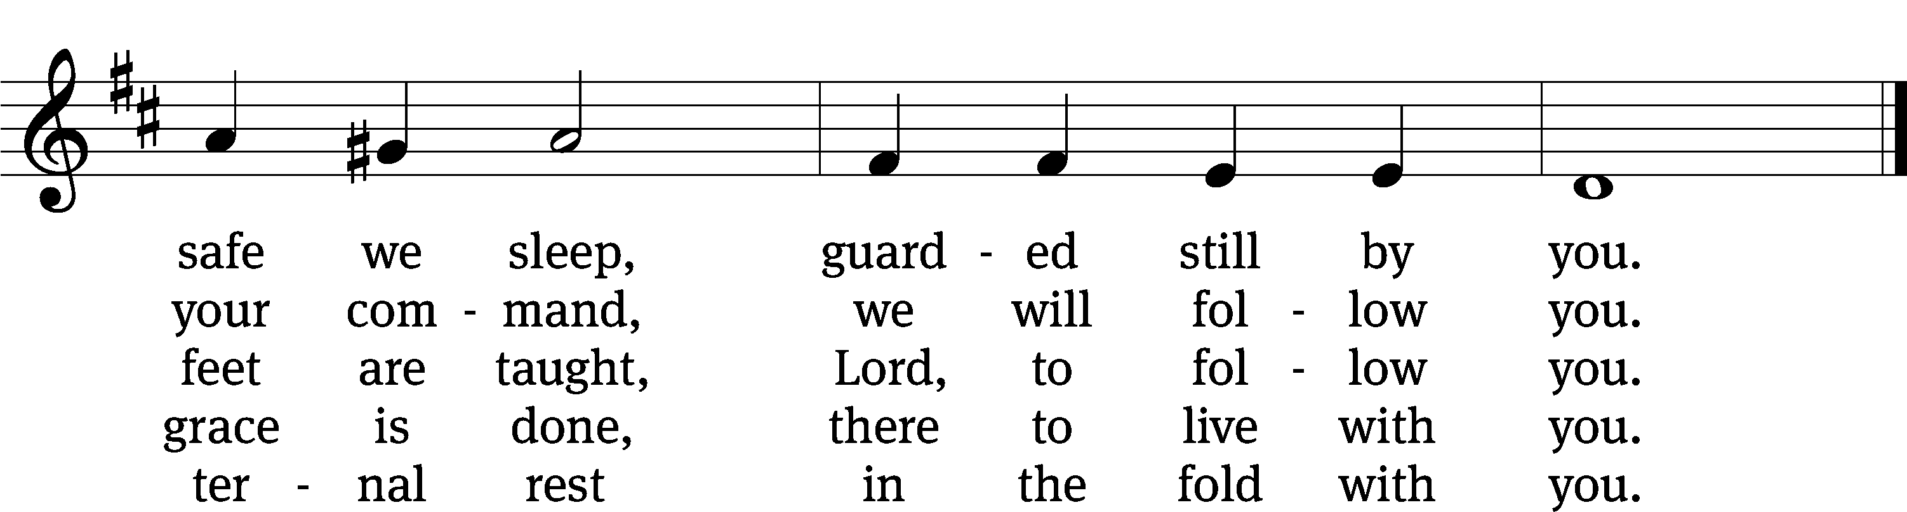
Text: Henry Cook, 1788–1868, alt.
Tune: Friedrich Filitz, 1804–1876
Text and tune: Public domain
Closing Prayer
Merciful God, we thank you for once again having spoken to us through your Word. Let your Word be a light to our path, so that neither the attractions nor the worries of this life may be able to turn our thoughts from the life to come. As we now prepare to leave this house of God, let the Holy Spirit accompany us, so that we may be responsive to your voice speaking to our hearts. Give us forgiveness for yesterday, faith for today, and strength for tomorrow. We ask this of you in the name of Jesus, the name above every name.
Amen.

Blessing
The Lord bless you and keep you.
The Lord make his face shine on you and be gracious to you.
The Lord look on you with favor and T give you peace.
Amen.

736 Lord, You Call Us as Your People CW 736 sts. 1–2, 4
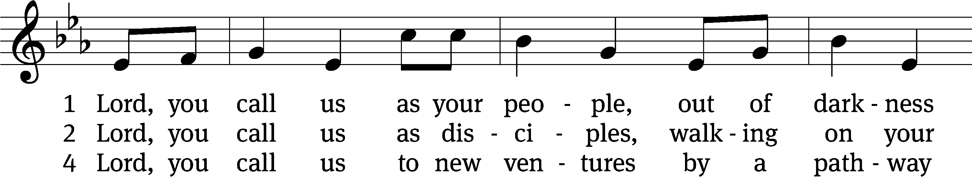
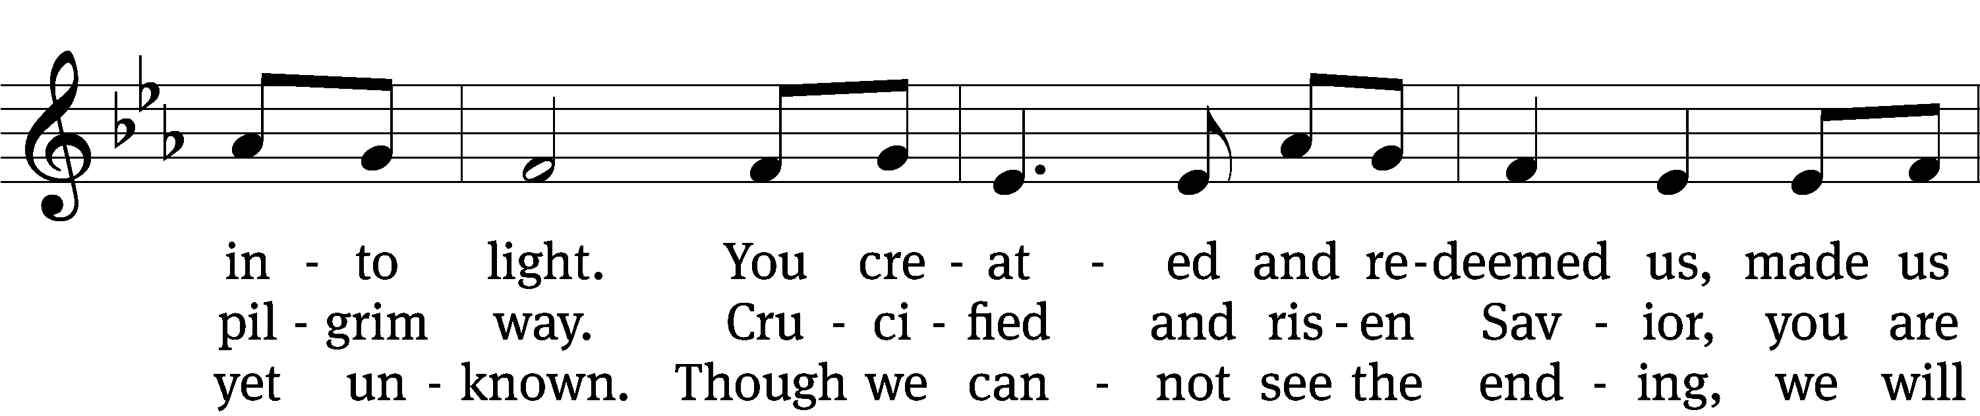
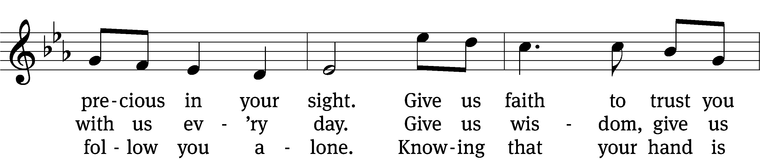
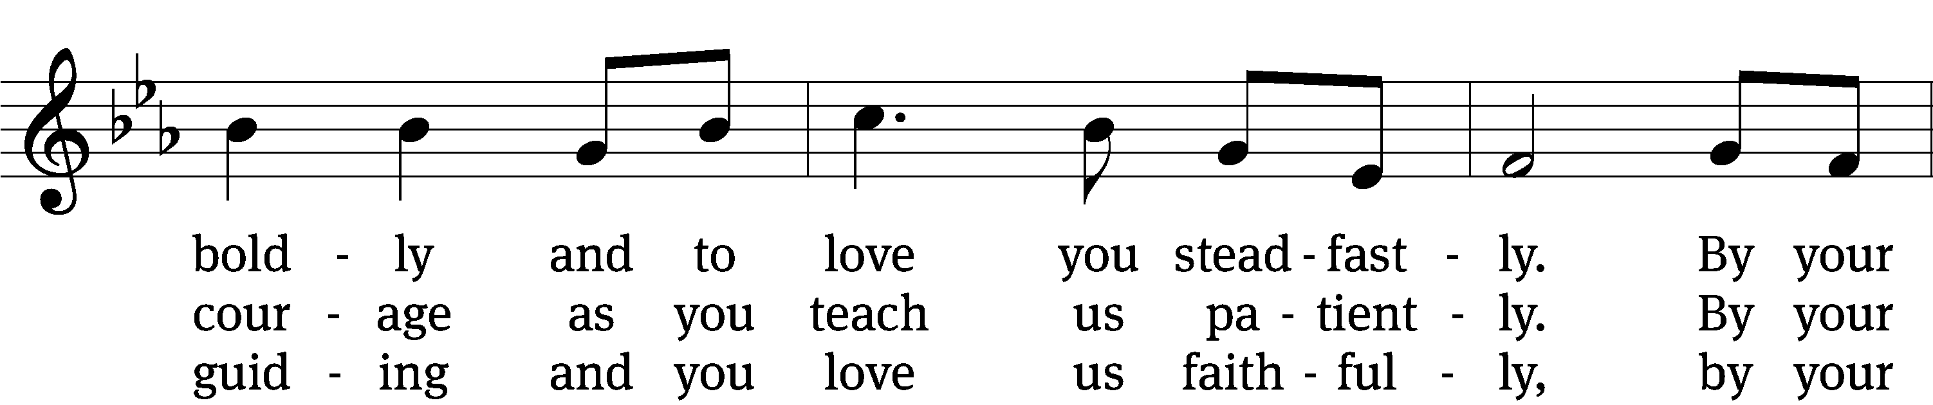
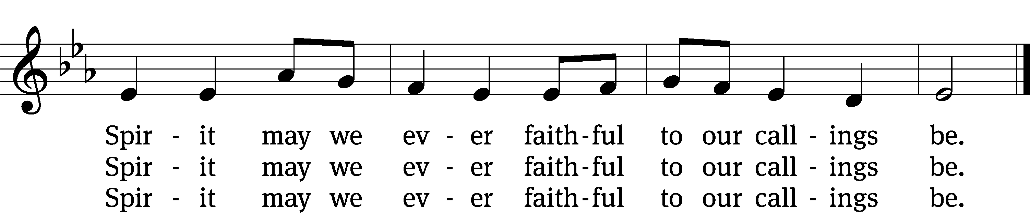
Text: Steven P. Mueller, b. 1964
Tune: Marty Haugen, b. 1950
Text: © 2010 Birnamwood Publications, a div. of MorningStar Music Publishers, Inc. Used by permission: OneLicense no. 716626
Tune: © 1987 GIA Publications, Inc. Used by permission: OneLicense no. 716626

Acknowledgments
Setting One from Christian Worship
Unless otherwise indicated, Scripture quotations are from The Holy Bible, New International Version®, NIV®. Copyright © 1973, 1978, 1984, 2011 by Biblica, Inc.TM Used by permission of Zondervan. All rights reserved worldwide.
Liturgical and musical settings of Scripture based on text from The Holy Bible, New International Version®, NIV®. Copyright © 1973, 1978, 1984, 2011 by Biblica, Inc.TM Used by permission of Zondervan. All rights reserved worldwide.
Software distributed in partnership with Northwestern Publishing House.
Created by Christian Worship: Service Builder © 2024 Concordia Publishing House.

Next Week’s Worship
Our theme for worship: Meaningful Ministry-God Meets Our Need to Meet Others’ Needs. Our readings will be: Exodus 16: 1-15, 2 Corinthians 9: 8-11, Mark 6: 35-44. We will sing the following hymns: 749 God, Whose Giving Knows No Ending, 827 Rejoice, My Heart, Be Glad and Sing, 506 For the Fruits of His Creation, 507 Let All Things Now Living.

THIS WEEK AT BEAUTIFUL SAVIOR
† Today No Sunday School
10:30am Worship
† Wednesday 6 pm Bible Study
† Saturday 9am Narrows of the Harpeth Hike
† Sunday No Sunday School
10:30am Worship

Outdoor Club
Join us for a morning hike and fellowship opportunity at Narrows of the Harpeth Park near Kingston Springs, on Saturday, July 27. This is a park that provides opportunities to see wildlife, hike, splash in the water, and sightseeing. Bring along a snack or a lunch if you would like to stay a while. You may also want to bring along bug spray! We will meet at the main parking lot in the park at 9 am. The address is: 1300 Narrows Of The Harpeth Rd, Kingston Springs, TN 37082.

Classroom Assistant Opening
The preschool has an opening for an Assistant Teacher in the 3-4 year old classroom. Hours are M-F 8am-12pm or M-F 8am-3pm. Please call the office at 931-905-1400 or speak with Miss Noon for more information.

Summer Bible Study Schedule
There will not be adult or youth Bible Study or Sunday School from Sunday, June 23-Sunday, July 28. Sunday School and Bible Study will resume on Sunday, August 4. This break gives a little time off for our teachers and helps us get ready for our Fall Kick-Off.

Sunday School Volunteers
We are in need of volunteers for Sunday School. We are looking for 3 or more people to help teach the children’s Sunday School. We would like to have a 6-7 week rotation. All things needed for teaching the lessons are supplied. If you have any questions, please contact Jennie Geer at (615) 944-2062.

Sunday School Resumes
There is Sunday School for all ages! From adults to little ones, our Sunday School classes will resume on Sunday, August 4, at 9:15 am.

Lawn Maintenance
We are looking for volunteers to cut the grass throughout the summer. We have a zero-turn lawn mower, trimmer, and leaf blower. We even provide the gas! What we need are people willing to spend some time on a Friday or Saturday getting the property ready for church on Sunday. If you would like to help, please see the sign-up sheet in the entry-way. If you have questions, talk to Pastor.
Altar Flower Sign-up
If you would like to provide flowers for a Sunday Service, please see the sign up chart near the entry way table. It can be for a special occasion, or simply to beautify our altar on a Sunday morning. If you have questions, contact Eileen Cleveland at 239-410-6366 or email at thedoll48@gmail.com

25th Anniversary Special Offering
We will be giving thanks to God for the blessings that we have received through the 25 years of our ministry next summer, June 8, 2025. As we prepare for that day of celebration, we are working on several special projects to improve or update our facilities and property. Among those projects are:

- A new sign for the entryway of our church
- New carpet and paint for the sanctuary
- A/V Updates
- A nursery room
- New paraments
- Meal Catering

Our total goal that we are planning to raise is $50,000. You can see the full list of items and the donations raised so far on the display in the entryway.
If you would like to give a special gift for the 2025 projects, please make sure that you designate the donation for the “25th Anniversary fund” on your envelope or your on-line donation.
We are also excited to announce that there is a 1:1 matching grant that will be given for any gifts given through the anniversary date of June 8, 2025. All donations above our $50,000 goal will be used to reestablish our Emergency Fund and to pay down the principal on our mortgage.
We humbly ask that any donations for the 25th Anniversary be “above and beyond” your regular and gracious support of our ministry.
If you have any questions about the projects or how to give a gift, please speak with Art Ebbinger.

Prayer List
Thank the Lord for the safe return of all the soldiers who recently came home and all soldiers and their families who are facing deployment. Please keep in your prayers this week all soldiers who are currently deployed. Please also remember: Mikaela Watkins, family of Bob and Judy Mader (lung cancer and surgery); Roger Fox, son of Hilde Fox (cancer); Cynthia Thorington, sister of Brenda Henschen (long-term Covid symptoms); Linda Kiecker, daughter of Selma Noon (pancreatic cancer); Theresa Robinson (recovery from eye surgery); Stacia Gupton, friend of Caryn Mclain, (serious illness); Nita Harris, friend of David & Allison Johnson (cancer/chemo); Teri Lee Dickinson & Family (bereavement); May Holman, mother of Trey Church (abdominal surgery); Christa Trusty (Health Issues); Curt Holz, brother of Pastor Holz (cancer); Bob Housh (Injured in fall); Renate Banks (illness); Marlys Donner, mother of Tim Donner (declining health); Josh Carter, friend of Adam Holz (recovery from car accident); Stacy Schroeder, daughter of Jeff & Eileen Cleveland (melanoma diagnosis); Aimee Gerkhardt, sister in law of Jessica Church (breast cancer); Brandon Vannoy, friend of Mac McCoo (seizures); Sheila Lynch, sister of Gayle Brooks (unable to walk); Drake Robideau, friend of Mary Daniel (strength & wellness); Mike LaFave (back problems); Linda Thomas, sister of Gayle Brooks, (physical rehab after injury); Gidget Tate (Health issues). If you would like to have a name or situation included or if you would like to give an update on a prayer request, please contact Pastor Holz or call the church office at 931-905-1400.

Serving in God’s House

Ushers: Daniel Lane, Josh Geer
Greeters: Art & Sandy Ebbinger
Kitchen: Charmaine Smith, Mary Daniel
Piano: Deb White
Fellowship: (N-S)

Serving next week:

Ushers: Art Ebbinger, Ray Mefford
Greeters: Loretta Wilder, Ernie Rautter
Kitchen: Hannah L, Mary D, Margareta S
Piano: Barb Noon
Fellowship: (T-Z)

Our Mission
By grace, the mission of
Beautiful Savior Evangelical Lutheran Church is
to proclaim the Word of God so that we may praise his name,
grow together in the knowledge of our Savior,
and share with others his message of forgiveness and eternal life.

