Beautiful Savior Lutheran Church



August 11, 2024 – Twelfth Sunday after Pentecost

service theme: the god-lived life is a life of being a disciple

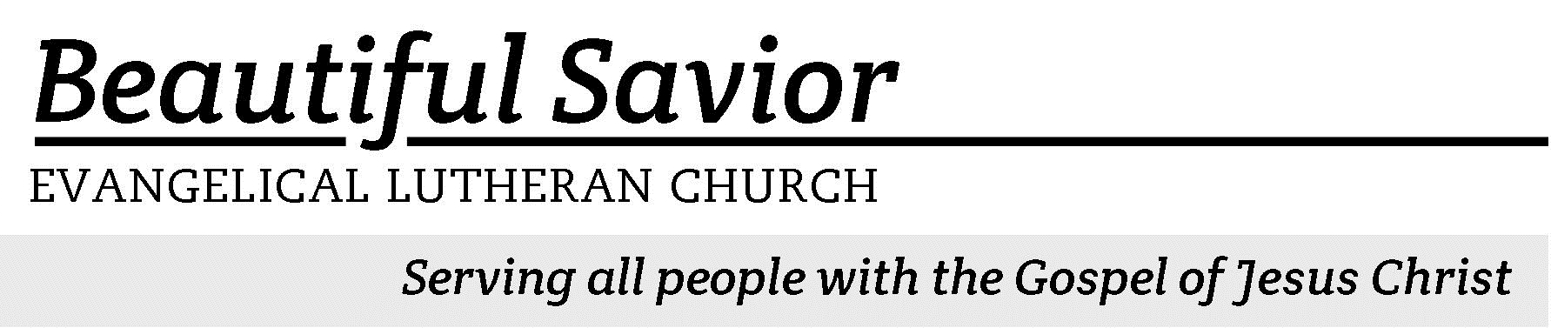


Welcome-- We are glad you could join us today! It is our hope that this service is a blessing to you. Please join us for worship again soon.

· Please save the last two rows of pews for parents with small children.

· Parents with little ones: We are excited to offer a nursery for your use. It is to the left as you exit the sanctuary. If your child becomes restless during the service, that’s okay… We’re glad they’re here, and Jesus is pleased when they are brought to hear his Word: “Let the little children come to me.”

· Five minutes before the worship service begins the usher will light the candles. This is our signal to quiet down and prepare our hearts for worship.

· Restrooms are conveniently located to the left as you exit the sanctuary.

· Please silence your cell phone before the start of the service.

Prayer for Worship
Heavenly Father, your Word is a lamp to my feet and a light for my path. Open my mind so that I may understand your Word clearly and purely, and then help me to pattern my life according to it. I ask this through Jesus, your Son and my Savior. Amen.

Beautiful Savior Lutheran Church
2526 Whitfield Road
Clarksville, TN 37040
931-905-1400
Website: www.bslclarksville.com
Kent Holz, Pastor
Bslc.clarksville@gmail.com
Barbara Noon, Preschool Director
beautifulsaviorpreschool@gmail.com
631 Speak, O Savior, I Am Listening CW 631 sts. 1–3
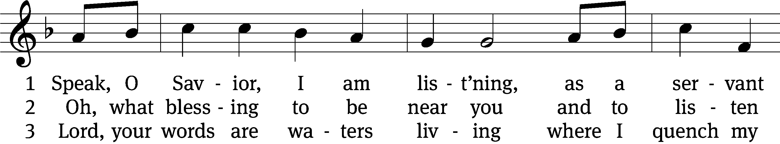
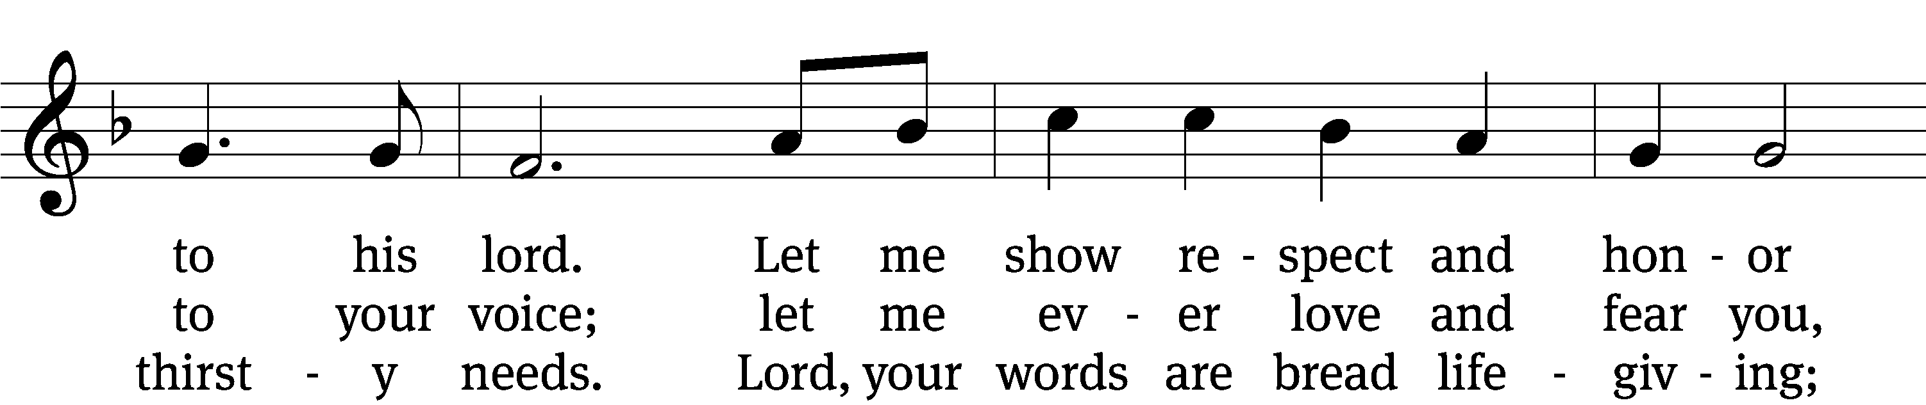
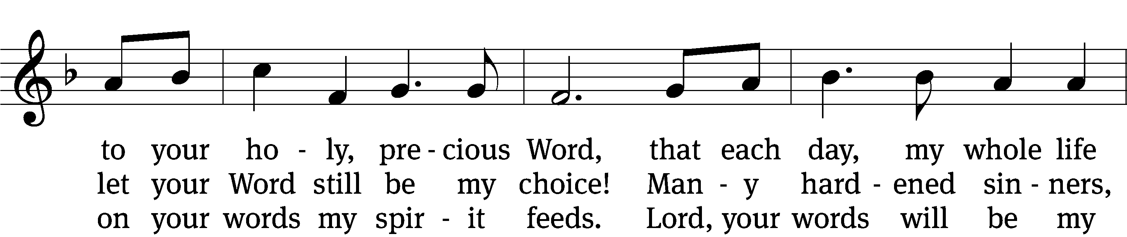
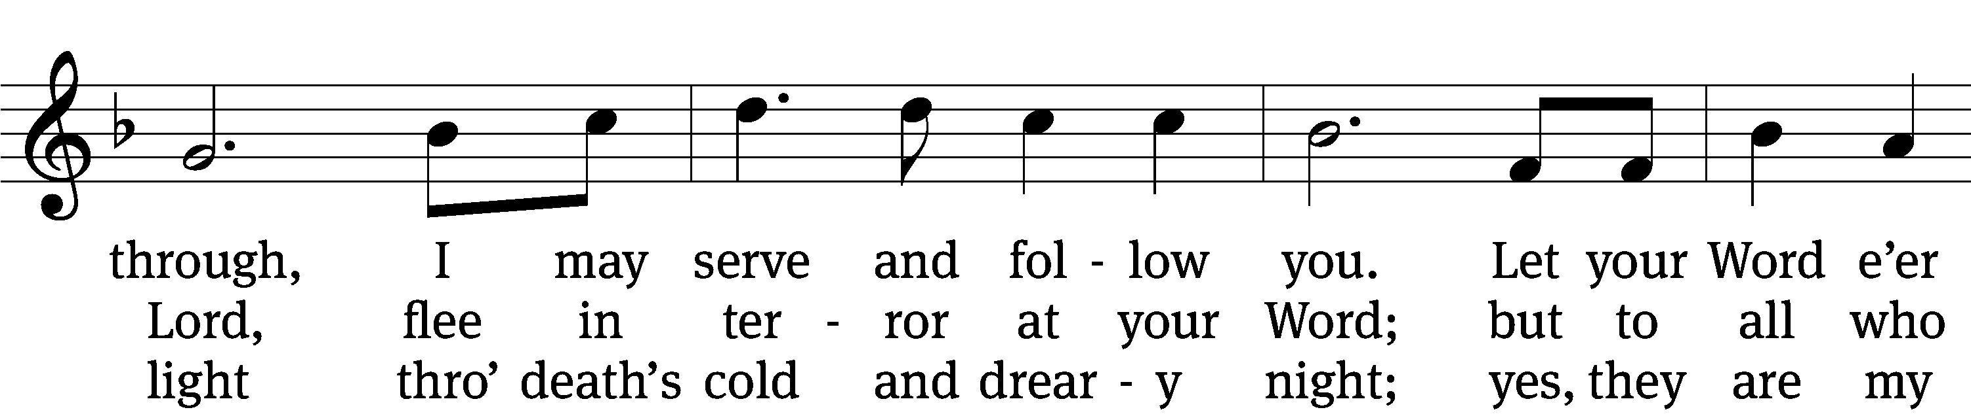
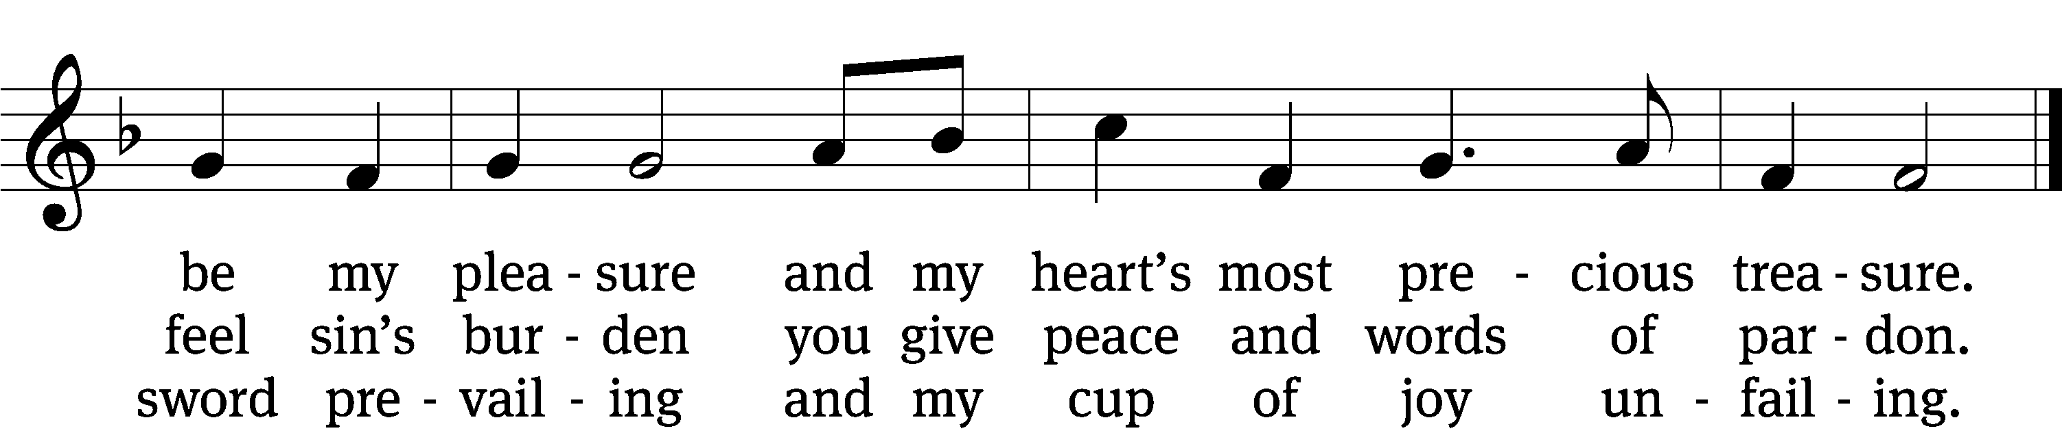
Text: Anna Sophia von Hessen-Darmstadt, 1638–1683; (st. 1): tr. Christian Worship, 1993; (sts. 2–3): tr. George A. T. Rygh, 1860–1942, alt.
Tune: Johann Schop, c. 1590–1667
Text and tune: Public domain

Please Stand

In the name of the Father and of the T Son and of the Holy Spirit.
Amen.

Confession
Dear friends, let us approach God with a true heart and confess our sins, asking him in the name of our Lord Jesus Christ to forgive us.
Forgive my sins, O Lord – forgive the sins of my present and the sins of my past, the sins of my soul and the sins of my body; the sins which I have done to please myself, and the sins which I have done to please others. Forgive my sins of weakness and the sins that I committed deliberately. Forgive me for the sins I remember and the sins I have forgotten, the sins I have tried to hide from others and the sins I long to hide from my own memory. Out of your great mercy, Lord, forgive me of all my wrongs!

Christ has died. Christ is risen. Christ will come again. In his great mercy, God made us alive in Christ even when we were dead in our sins. Hear the word of Christ through his called servant:

I forgive you all your sins in the name of the Father and of the T Son and of the Holy Spirit.
Amen.

631 Speak, O Savior, I Am Listening CW 631 st. 4
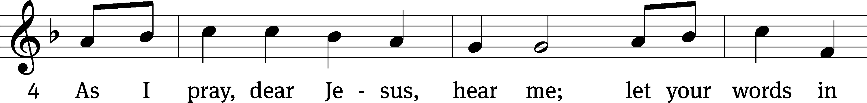
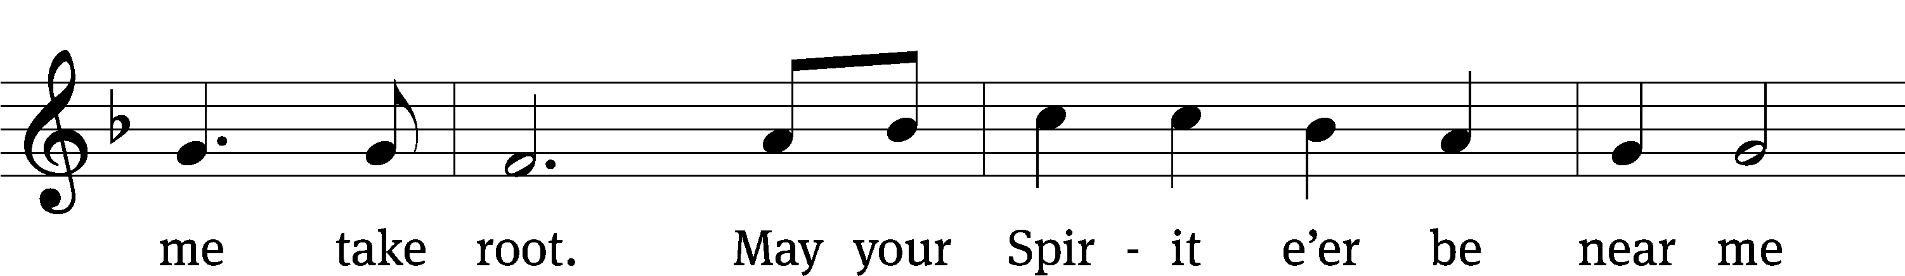
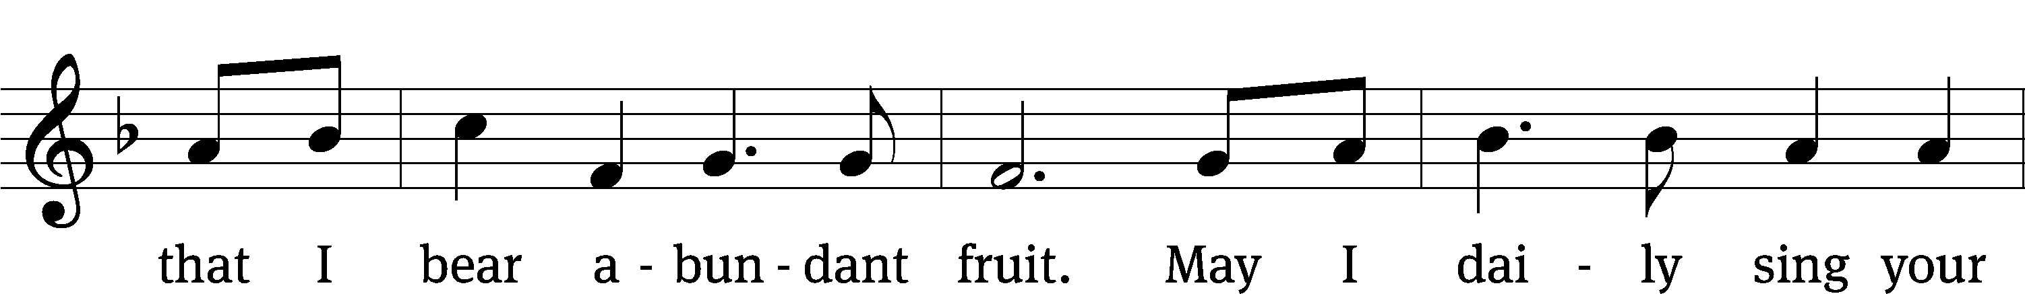
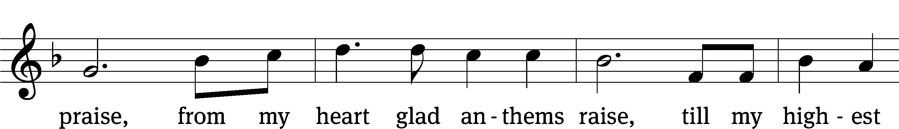
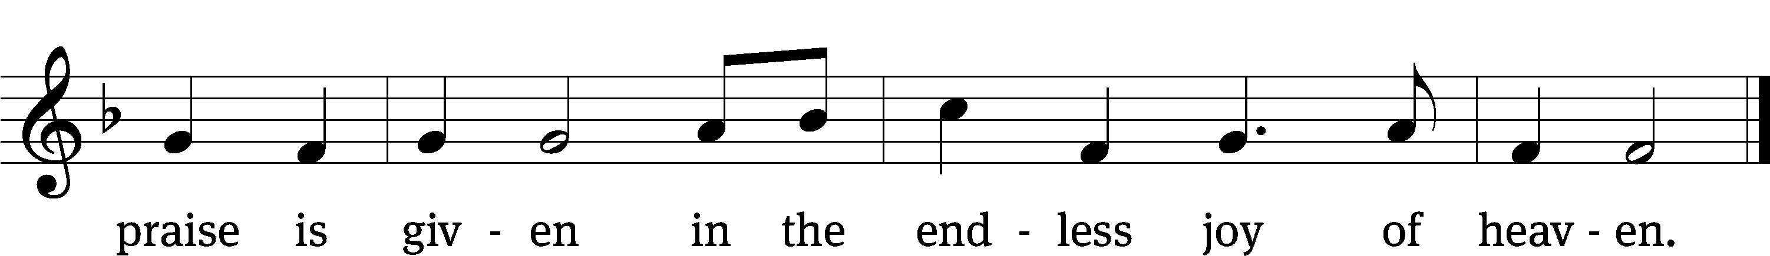
Text: tr. Christian Worship, 1993; Anna Sophia von Hessen-Darmstadt, 1638–1683
Tune: Johann Schop, c. 1590–1667
Text and tune: Public domain

The Word

The Lord be with you.
And also with you.
Prayer of the Day
Let us pray.

Lord, we pray that your mercy and grace may always go before and follow after us that, loving you with undivided hearts, we may glorify you in the way we use the gifts you give us to manage. Help us to live a God-lived life; through your Son, Jesus Christ our Lord, who lives and reigns with you and the Holy Spirit, one God, now and forever.
Amen.

Please be seated
First Reading 2 Chronicles 34:1–2, 14–21, 29–33
1Josiah was eight years old when he became king, and he reigned in Jerusalem thirty-one years. 2He did what was right in the eyes of the Lord and followed the ways of his father David, not turning aside to the right or to the left.
14While they were bringing out the money that had been taken into the temple of the Lord, Hilkiah the priest found the Book of the Law of the Lord that had been given through Moses. 15Hilkiah said to Shaphan the secretary, “I have found the Book of the Law in the temple of the Lord.” He gave it to Shaphan.
16Then Shaphan took the book to the king and reported to him: “Your officials are doing everything that has been committed to them. 17They have paid out the money that was in the temple of the Lord and have entrusted it to the supervisors and workers.” 18Then Shaphan the secretary informed the king, “Hilkiah the priest has given me a book.” And Shaphan read from it in the presence of the king.
19When the king heard the words of the Law, he tore his robes. 20He gave these orders to Hilkiah, Ahikam son of Shaphan, Abdon son of Micah, Shaphan the secretary and Asaiah the king’s attendant: 21“Go and inquire of the Lord for me and for the remnant in Israel and Judah about what is written in this book that has been found. Great is the Lord’s anger that is poured out on us because those who have gone before us have not kept the word of the Lord; they have not acted in accordance with all that is written in this book.”
29Then the king called together all the elders of Judah and Jerusalem. 30He went up to the temple of the Lord with the people of Judah, the inhabitants of Jerusalem, the priests and the Levites—all the people from the least to the greatest. He read in their hearing all the words of the Book of the Covenant, which had been found in the temple of the Lord. 31The king stood by his pillar and renewed the covenant in the presence of the Lord—to follow the Lord and keep his commands, statutes and decrees with all his heart and all his soul, and to obey the words of the covenant written in this book.
32Then he had everyone in Jerusalem and Benjamin pledge themselves to it; the people of Jerusalem did this in accordance with the covenant of God, the God of their ancestors.
33Josiah removed all the detestable idols from all the territory belonging to the Israelites, and he had all who were present in Israel serve the Lord their God. As long as he lived, they did not fail to follow the Lord, the God of their ancestors.
1A Blessed Are They Psalm 1A
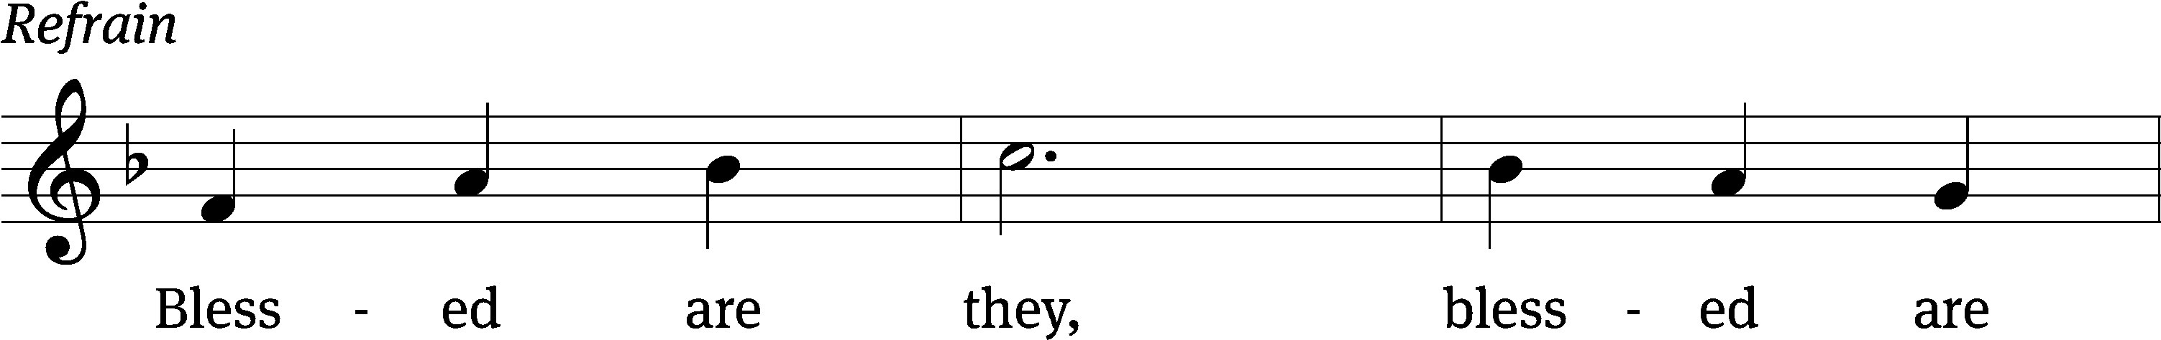



Blessed is the one who / does not walk
in step with the / wicked
or stand in the way that / sinners take
or sit in the company of / mockers,
but whose delight is in the law / of the Lord,
and who meditates on his law / day and night.
That person is like a tree planted by streams of / water,
which yields its fruit in / season
and whose leaf does not / wither—
whatever they do / prospers. Refrain

Not so the / wicked!
They are like chaff that the wind / blows away.
Therefore the wicked will not stand in the / judgment,
nor sinners in the assembly of the / righteous. Refrain

For the Lord watches over the way of the / righteous,
but the way of the wicked leads to de- / struction.
Glory be to the Father and / to the Son
and to the Holy / Spirit,
as it was in the be- / ginning,
is now, and will be forever. / Amen. Refrain
Text: Lectionary for Mass (refrain)
Tune: Michel Guimont
Setting: Michel Guimont
Text: © 1969, 1981, 1997 ICEL (refrain). Used by permission: OneLicense no. 716626
Music: © 1998 GIA Publications, Inc. Used by permission: OneLicense no. 716626
Gospel Luke 18:9–17
9To some who were confident of their own righteousness and looked down on everyone else, Jesus told this parable: 10“Two men went up to the temple to pray, one a Pharisee and the other a tax collector. 11The Pharisee stood by himself and prayed: ‘God, I thank you that I am not like other people—robbers, evildoers, adulterers—or even like this tax collector. 12I fast twice a week and give a tenth of all I get.’
13“But the tax collector stood at a distance. He would not even look up to heaven, but beat his breast and said, ‘God, have mercy on me, a sinner.’
14“I tell you that this man, rather than the other, went home justified before God. For all those who exalt themselves will be humbled, and those who humble themselves will be exalted.”
15People were also bringing babies to Jesus for him to place his hands on them. When the disciples saw this, they rebuked them. 16But Jesus called the children to him and said, “Let the little children come to me, and do not hinder them, for the kingdom of God belongs to such as these. 17Truly I tell you, anyone who will not receive the kingdom of God like a little child will never enter it.”

Children's Devotion Ages 3 through grade 5 are invited to come forward for a Bible lesson.

Children's Church During the service, parents may choose to take their children (ages 2-5) to Children’s Church. There they will hear a Bible story, and sing songs. They will return to the sanctuary during the offering.
633 Speak, O Lord CW 633
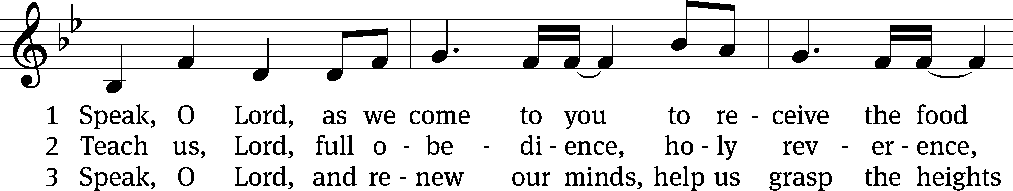
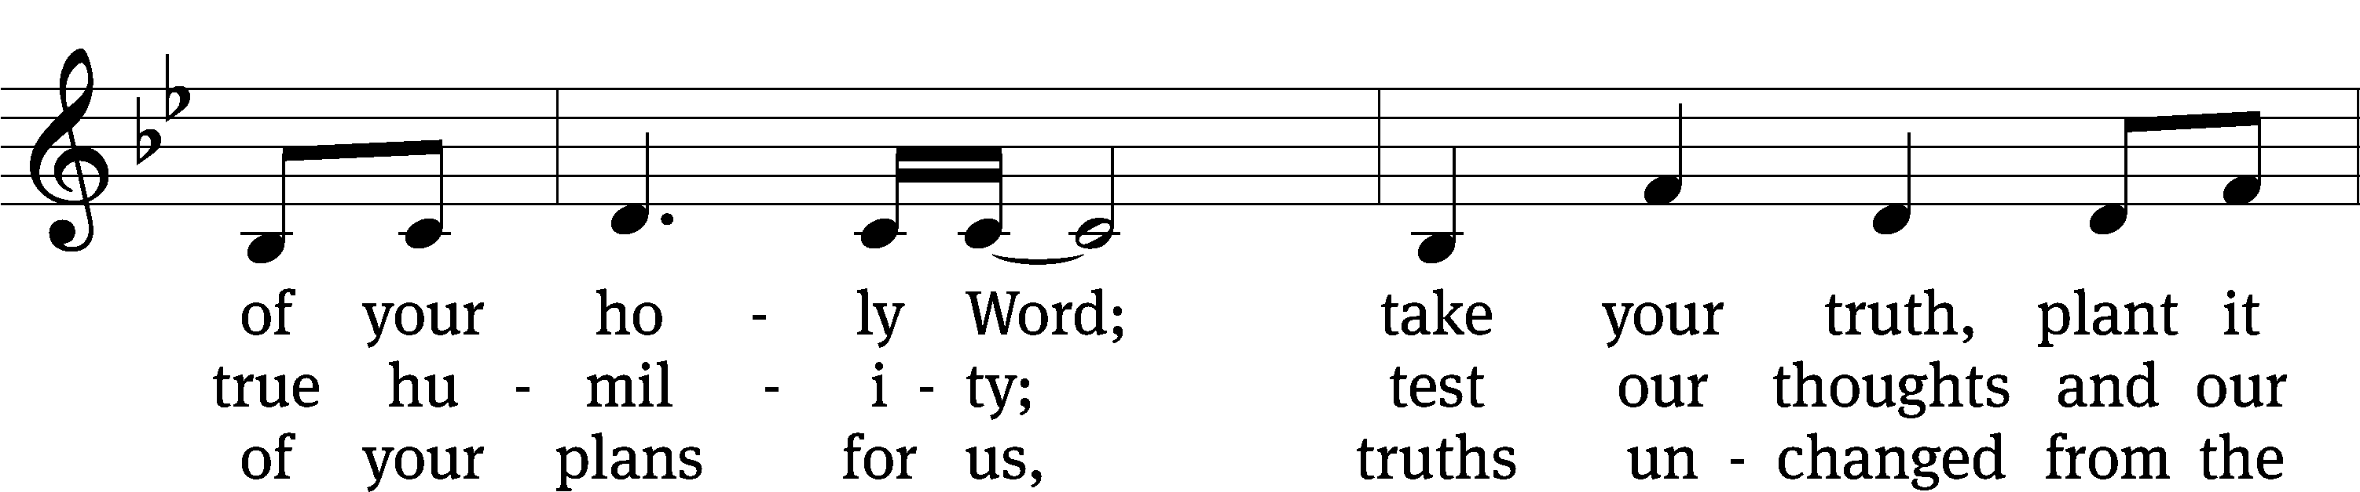
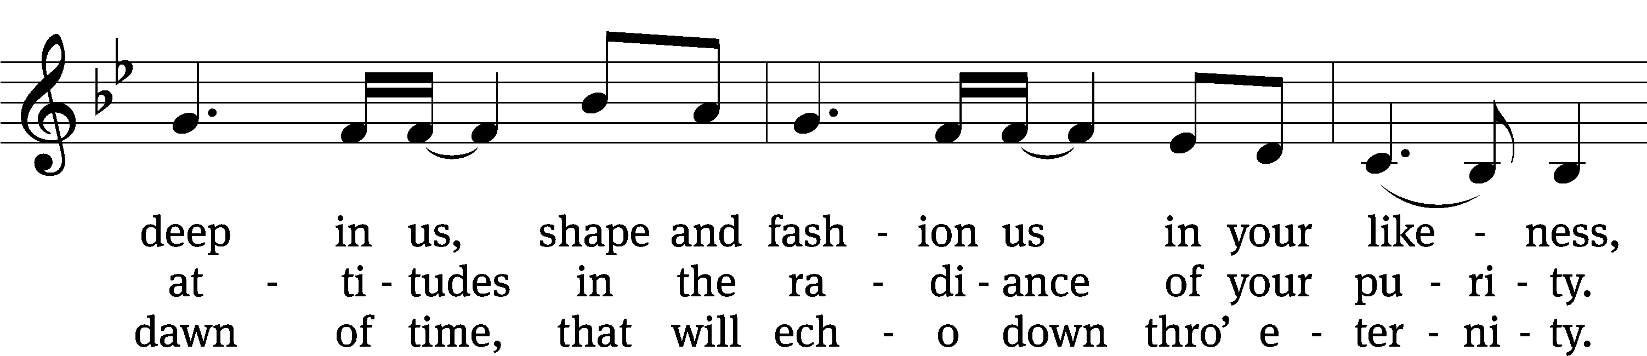
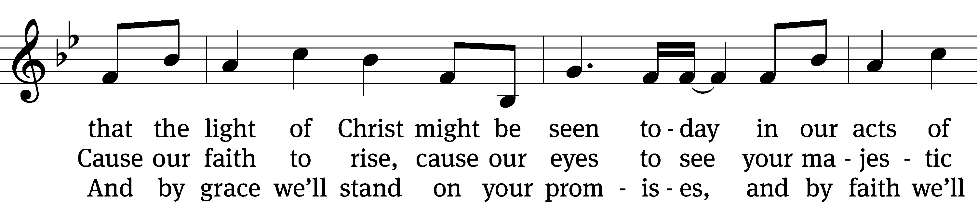
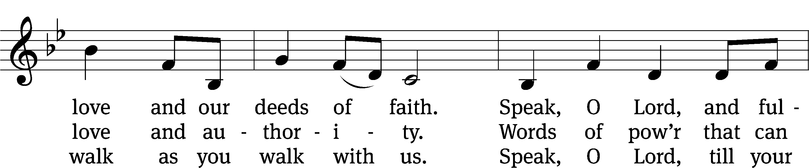
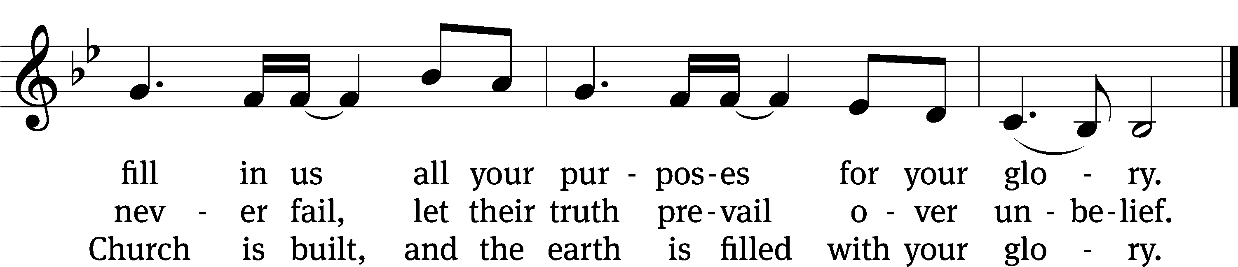
Text: Stuart Townend, b. 1963; Keith Getty, b. 1974
Tune: Stuart Townend, b. 1963; Keith Getty, b. 1974
Text and tune: © 2006 Thankyou Music, admin. CapitolCMGPublishing,com. Used by permission: OneLicense no. 716626

Sermon 1 Peter 1:22—2:3
22Now that you have purified yourselves by obeying the truth so that you have sincere love for each other, love one another deeply, from the heart. 23For you have been born again, not of perishable seed, but of imperishable, through the living and enduring word of God. 24For,
“All people are like grass,
and all their glory is like the flowers of the field;
the grass withers and the flowers fall,
25but the word of the Lord endures forever.”
And this is the word that was preached to you.
1Therefore, rid yourselves of all malice and all deceit, hypocrisy, envy, and slander of every kind. 2Like newborn babies, crave pure spiritual milk, so that by it you may grow up in your salvation, 3now that you have tasted that the Lord is good.

“A God-lived life: Crave the Word”
Apostles’ Creed
I believe in God, the Father Almighty,
maker of heaven and earth.

I believe in Jesus Christ, his only Son, our Lord,
who was conceived by the Holy Spirit,
born of the Virgin Mary,
suffered under Pontius Pilate,
was crucified, died, and was buried.
He descended into hell.
The third day he rose again from the dead.
He ascended into heaven
and is seated at the right hand of God the Father Almighty.
From there he will come to judge the living and the dead.

I believe in the Holy Spirit,
the holy Christian Church,
the communion of saints,
the forgiveness of sins,
the resurrection of the body,
and the life everlasting. Amen.

Offering “We love because he first loved us.” 1Jn 4:19 God’s love in sending Jesus to live, to suffer, and to die for each of us motivates the members of Beautiful Savior to show their love and thanks by returning a portion of their income to the Lord. Through these free will offerings, this congregation and its ministries are maintained.
If you would like to give securely online, scan this code or follow this link: bslclarksville.com
Prayer of the Church
Almighty God, Creator of this world, all good gifts come from you. We give you thanks for all that you have given to us—the bounties of the earth, fruitful labor, meaningful relationships, enjoyment of your gifts, and contentment. We confess that we have not always acknowledged you as the giver of all that is good. We confess that we have not always seen the good in all that you send into our lives. We confess that we have often complained instead of praised. Lord in your mercy
Hear our prayer.

Lamb of God, you take away the sin of the world. We give you thanks that you became man to set us free. You lived a perfect life in our place—living to please our Father, running in the path of his commands, and learning and loving his ways. You died the death we deserved. You rose to ensure our forgiveness and eternal life. Lord, in your mercy
Hear our prayer.

Holy Spirit, you brought and continue to strengthen faith in our hearts through the gospel in Word and sacrament. You send preachers and teachers who teach us your truth. You enlighten our minds, strengthen our hearts, and loosen our tongues to give you praise. Now give us the fervor of seeking you first and your kingdom, O God. Send us godly and faithful ministers and teachers of your Word. Grant us wisdom to daily meditate on your promises. Strengthen us to follow your will and commands. Grow our desire for your truth and your Word that we may better understand your love, your ways and your peace. Lord, in your mercy
Hear our prayer.

Triune God, help us to grow in our stewardship of your blessings. Help us to take the opportunities for each of us to grow in your Word and in our lives of living it. Use us to be a blessing to others. Help us encourage one another in our commitments and grow us in your grace. Lord, in your mercy
Hear our prayer.

Hear us, Lord, as we pray in silence.

Silent prayer

Make us bold to pray, quick to serve, and eager to follow you.
In Jesus’ name we pray. Amen.

Lord’s Prayer
Our Father, who art in heaven,
hallowed be thy name,
thy kingdom come,
thy will be done
on earth as it is in heaven.
Give us this day our daily bread;
and forgive us our trespasses,
as we forgive those
who trespass against us;
and lead us not into temptation,
but deliver us from evil.
For thine is the kingdom
and the power and the glory
forever and ever. Amen.
696 Take My Life and Let It Be CW 696
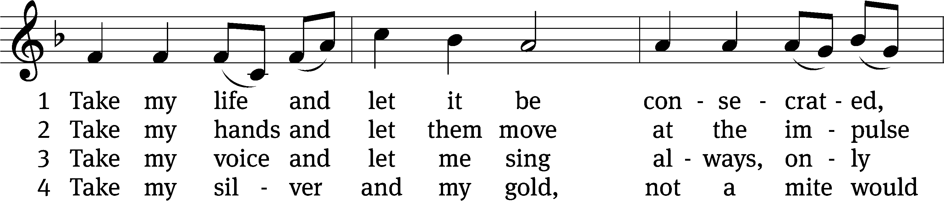
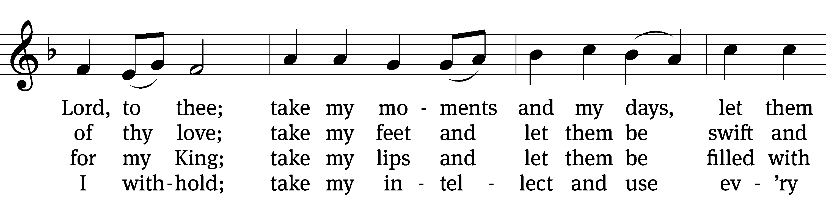
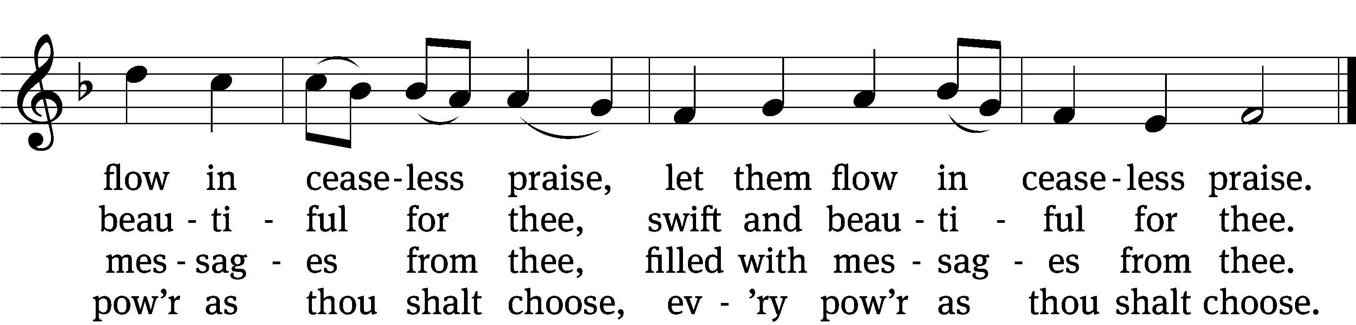

5 Take my will and make it thine,
it shall be no longer mine;
take my heart, it is thine own,
it shall be thy royal throne,
it shall be thy royal throne.

6 Take my love, my Lord, I pour
at thy feet its treasure store;
take myself, and I will be
ever, only, all for thee,
ever, only, all for thee.
Text: Frances R. Havergal, 1836–1879
Tune: Henri A. C. Malan, 1787-1864
Text and tune: Public domain
Closing Prayer
Merciful God, we thank you for once again having spoken to us through your Word. Let your Word be a light to our path, so that neither the attractions nor the worries of this life may be able to turn our thoughts from the life to come. As we now prepare to leave this house of God, let the Holy Spirit accompany us, so that we may be responsive to your voice speaking to our hearts. Give us forgiveness for yesterday, faith for today, and strength for tomorrow. We ask this of you in the name of Jesus, the name above every name.
Amen.
Blessing
The Lord bless you and keep you.
The Lord make his face shine on you and be gracious to you.
The Lord look on you with favor and T give you peace.
Amen.

640 God’s Word Is Our Great Heritage CW 640
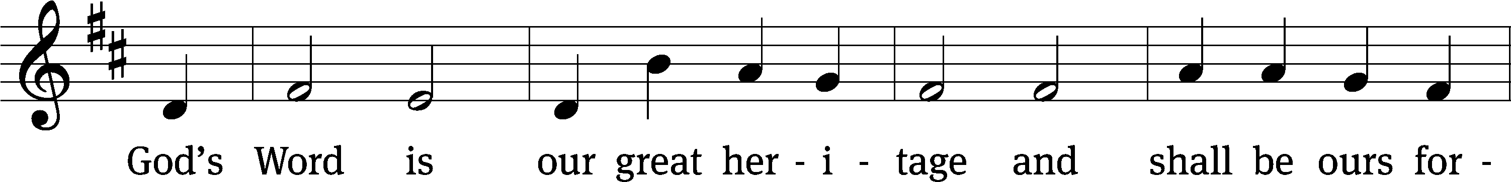
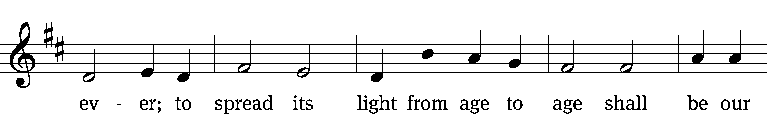
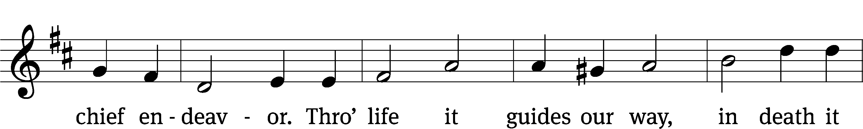
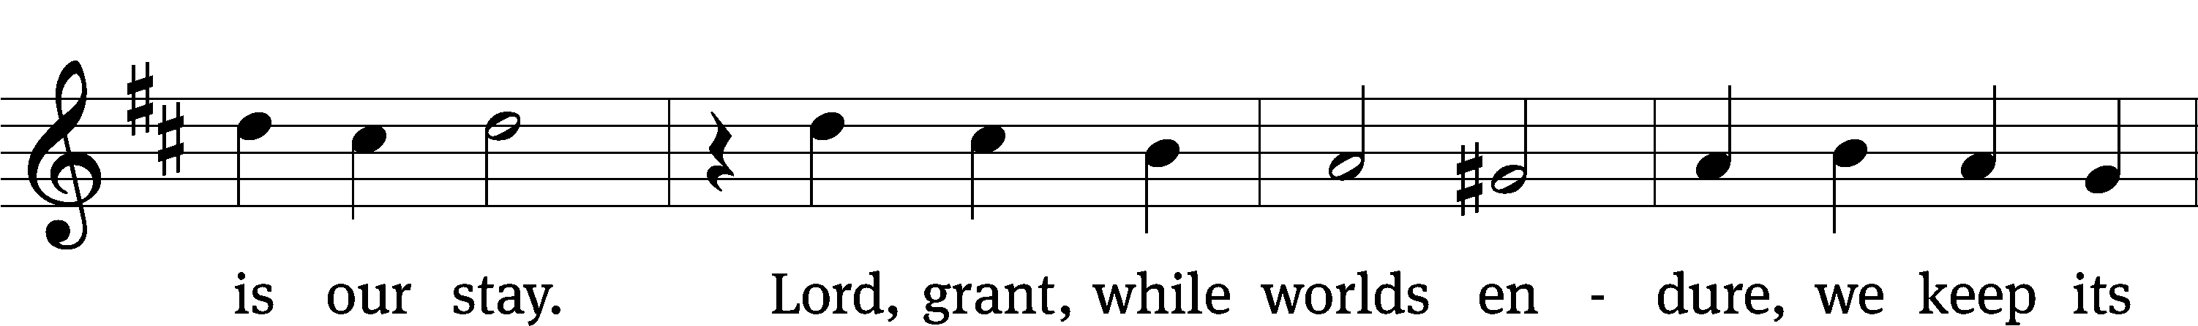
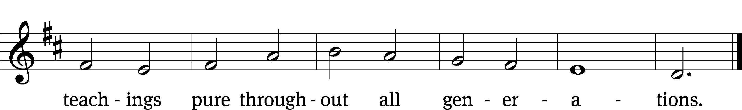
Text: tr. Ole G. Belsheim, alt.; Nikolai F. S. Grundtvig, 1783–1872
Tune: Friedrich O. Reuter, 1863–1924
Text and tune: Public domain
Acknowledgments
Setting One from Christian Worship
Unless otherwise indicated, Scripture quotations are from The Holy Bible, New International Version®, NIV®. Copyright © 1973, 1978, 1984, 2011 by Biblica, Inc.TM Used by permission of Zondervan. All rights reserved worldwide.
Liturgical and musical settings of Scripture based on text from The Holy Bible, New International Version®, NIV®. Copyright © 1973, 1978, 1984, 2011 by Biblica, Inc.TM Used by permission of Zondervan. All rights reserved worldwide.
Software distributed in partnership with Northwestern Publishing House.
Created by Christian Worship: Service Builder © 2024 Concordia Publishing House.

Next Week’s Worship
Our theme for worship: The God-Lived Life is a Life Lived for Others. Our readings will be: Acts 9: 36-42, 1 Thessalonians 4: 9-12, and Luke 10: 25-37. We will sing the following hymns: 627 To God Be the Glory, 767 Lord of Glory, You Have Brought Us, 766 Lord, Whose Love in Humble Service, and 748 Brothers, Sisters, Let Us Gladly.

THIS WEEK AT BEAUTIFUL SAVIOR
† Today 9:15am Sunday School
10:30am Worship
† Monday Preschool classes begin
† Tuesday Preschool classes begin
5pm Nurture & Outreach
† Wednesday 6 pm Bible Study
† Sunday 9:15am Sunday School
10:30am Worship

Sunday School Volunteers
We are in need of volunteers for Sunday School. We are looking for 3 or more people to help teach the children’s Sunday School. We would like to have a 6-7 week rotation. All things needed for teaching the lessons are supplied. If you have any questions, please contact Jennie Geer at (615) 944-2062.

Sunday School Resumes
There is Sunday School for all ages! From adults to little ones, our Sunday School classes will resume on Sunday, August 4, at 9:15 am.
Lawn Maintenance
We are looking for volunteers to cut the grass throughout the summer. We have a zero-turn lawn mower, trimmer, and leaf blower. We even provide the gas! What we need are people willing to spend some time on a Friday or Saturday getting the property ready for church on Sunday. If you would like to help, please see the sign-up sheet in the entry-way. If you have questions, talk to Pastor.
Lunch Bunch
Lunch Bunch will take place Wednesday, August 21, at 11:30am. Lunch will be served here at church for our older and/or retired members and friends. If you would like to attend please sign up so the hosts can get an accurate headcount for the meal preparations. A free will offering will be taken to cover the cost of the meal. After the meal there will be a short devotion. This will be a great opportunity for fellowship and a chance to get to know other people.

Bible Study
It’s likely that most of us have questions related to our faith. Many questions. How does what we believe show itself in our lives? What is the motivation in our lives? In what way are our worship services a product of what we believe? How does our faith influence our relationship to our parents, children, spouse, and neighbors? How does the message of Jesus impact the way we use our time, the offerings we give for the Lord’s work, or even the words we speak to our neighbor?

Living My Life as a Christian guides us to think about how the message of Jesus touches every aspect of our lives. Join us for our Bible study as we contemplate what this message means for each of us and our lives. Join us for Bible Study Sunday mornings at 9:15am.


Nashville Sounds Game
There will be an outing to the Nashville Sounds baseball game on Friday, August 23. Game time is at 6:35pm. If we have 20 people sign up, tickets will be $25.13 each. If we have fewer than 20 tickets, they will be the regular price of $36.05. Please sign up on the sheet by Monday, August 19, so we know how many tickets to purchase.

25th Anniversary Special Offering
We will be giving thanks to God for the blessings that we have received through the 25 years of our ministry next summer, June 8, 2025. As we prepare for that day of celebration, we are working on several special projects to improve or update our facilities and property. Among those projects are:

- A new sign for the entryway of our church
- New carpet and paint for the sanctuary
- A/V Updates
- A nursery room
- New paraments
- Meal Catering

Our total goal that we are planning to raise is $50,000. You can see the full list of items and the donations raised so far on the display in the entryway.
If you would like to give a special gift for the 2025 projects, please make sure that you designate the donation for the “25th Anniversary fund” on your envelope or your on-line donation.
We are also excited to announce that there is a 1:1 matching grant that will be given for any gifts given through the anniversary date of June 8, 2025. All donations above our $50,000 goal will be used to reestablish our Emergency Fund and to pay down the principal on our mortgage.
We humbly ask that any donations for the 25th Anniversary be “above and beyond” your regular and gracious support of our ministry.
If you have any questions about the projects or how to give a gift, please speak with Art Ebbinger.

Prayer List
Thank the Lord for the safe return of all the soldiers who recently came home and all soldiers and their families who are facing deployment. Please keep in your prayers this week all soldiers who are currently deployed. Please also remember: Mikaela Watkins, family of Bob and Judy Mader (lung cancer and surgery); Roger Fox, son of Hilde Fox (cancer); Cynthia Thorington, sister of Brenda Henschen (long-term Covid symptoms); Linda Kiecker, daughter of Selma Noon (pancreatic cancer); Theresa Robinson (recovery from eye surgery); Stacia Gupton, friend of Caryn Mclain, (serious illness); Nita Harris, friend of David & Allison Johnson (cancer/chemo); Teri Lee Dickinson & Family (bereavement); May Holman, mother of Trey Church (abdominal surgery); Christa Trusty (Health Issues); Curt Holz, brother of Pastor Holz (cancer); Bob Housh (Injured in fall); Renate Banks (illness); Marlys Donner, mother of Tim Donner (declining health); Josh Carter, friend of Adam Holz (recovery from car accident); Stacy Schroeder, daughter of Jeff & Eileen Cleveland (melanoma diagnosis); Aimee Gerkhardt, sister in law of Jessica Church (breast cancer); Brandon Vannoy, friend of Mac McCoo (seizures); Sheila Lynch, sister of Gayle Brooks (unable to walk); Drake Robideau, friend of Mary Daniel (strength & wellness); Mike LaFave (back problems); Linda Thomas, sister of Gayle Brooks, (physical rehab after injury); Gidget Tate (Health issues). If you would like to have a name or situation included or if you would like to give an update on a prayer request, please contact Pastor Holz or call the church office at 931-905-1400.

Serving in God’s House

Ushers: David Johnson, Ernie Rautter
Greeters: Doris Harvey, Ray Mefford
Kitchen: Ingeborg H, Hannah L, Mary D
Piano: Barb Noon
Fellowship: (H-M)

Serving next week:

Ushers: Daniel Lane, Josh Geer
Greeters: Art & Sandy Ebbinger
Kitchen: Charmaine Smith, Mary Daniel
Piano: Deb White
Fellowship: (N-S)

Our Mission
By grace, the mission of
Beautiful Savior Evangelical Lutheran Church is
to proclaim the Word of God so that we may praise his name,
grow together in the knowledge of our Savior,
and share with others his message of forgiveness and eternal life.

