Beautiful Savior Lutheran Church



April 28, 2024 – Fifth Sunday of Easter

service theme: the living lord produces active faith

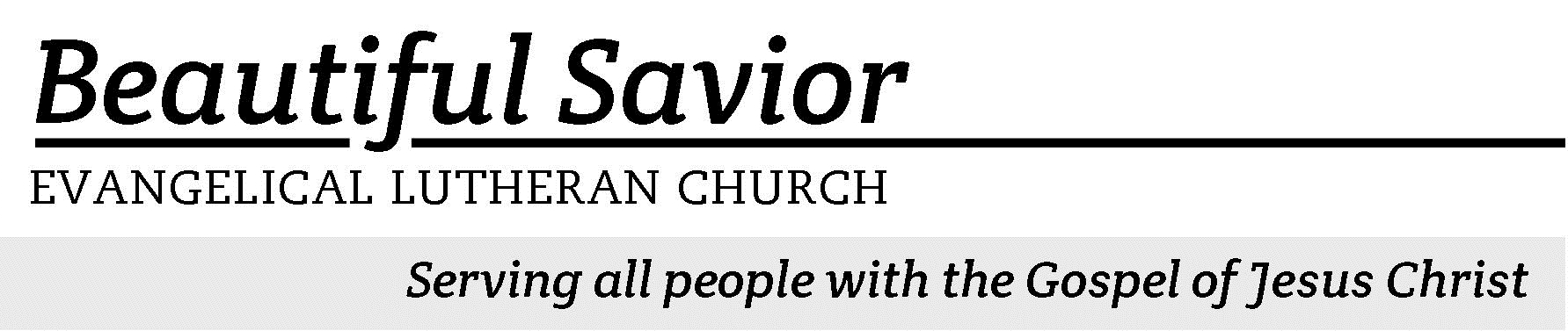


Welcome-- We are glad you could join us today! It is our hope that this service is a blessing to you. Please join us for worship again soon.

· Please save the last two rows of pews for parents with small children.

· Parents with little ones: We are excited to offer a nursery for your use. It is to the left as you exit the sanctuary. If your child becomes restless during the service, that’s okay… We’re glad they’re here, and Jesus is pleased when they are brought to hear his Word: “Let the little children come to me.”

· Five minutes before the worship service begins the usher will light the candles. This is our signal to quiet down and prepare our hearts for worship.

· Restrooms are conveniently located to the left as you exit the sanctuary.

· Please silence your cell phone before the start of the service.

Prayer for Worship
Living Lord and risen Savior, accept my praise and increase my joy that comes from knowing that you are risen from the dead. Comfort me with the assurance that my sins are forgiven and eternal life with you is certain. Help me to let the light of my faith shine brightly as I live on this side of Easter.
Amen.

Beautiful Savior Lutheran Church
2526 Whitfield Road
Clarksville, TN 37040
931-905-1400
Website: www.bslclarksville.com
Kent Holz, Pastor
Bslc.clarksville@gmail.com
Barbara Noon, Preschool Director
beautifulsaviorpreschool@gmail.com
470 Like the Golden Sun Ascending CW 470 sts. 1–3
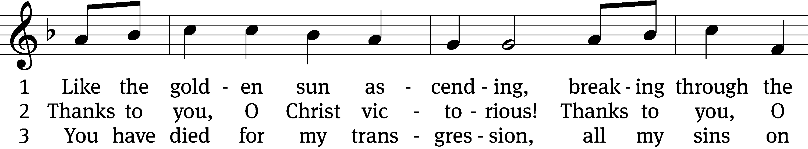
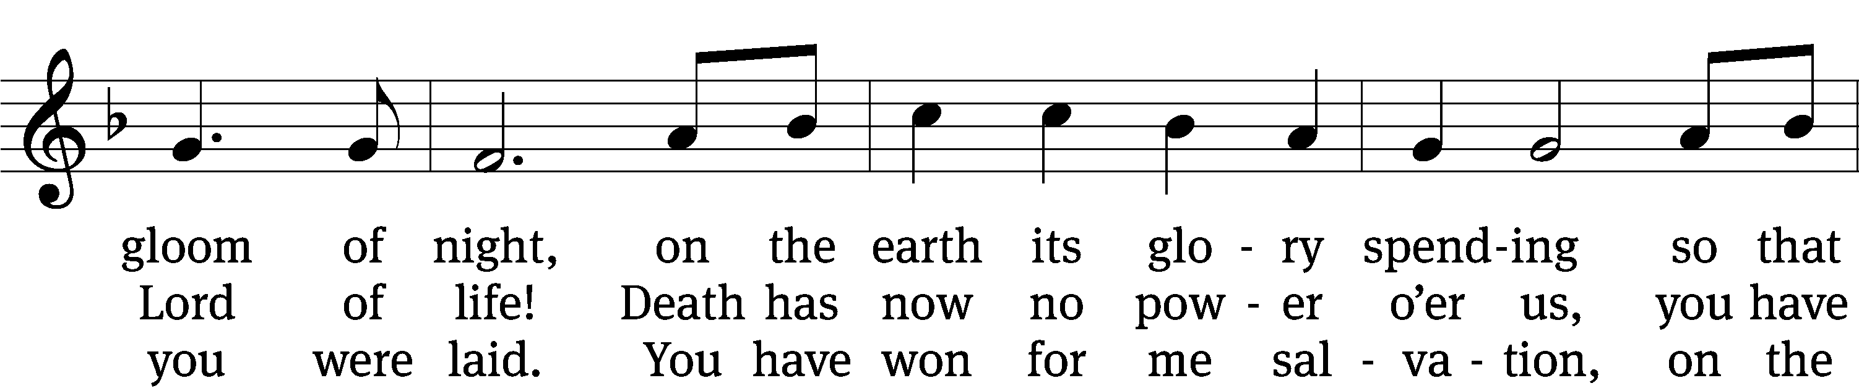
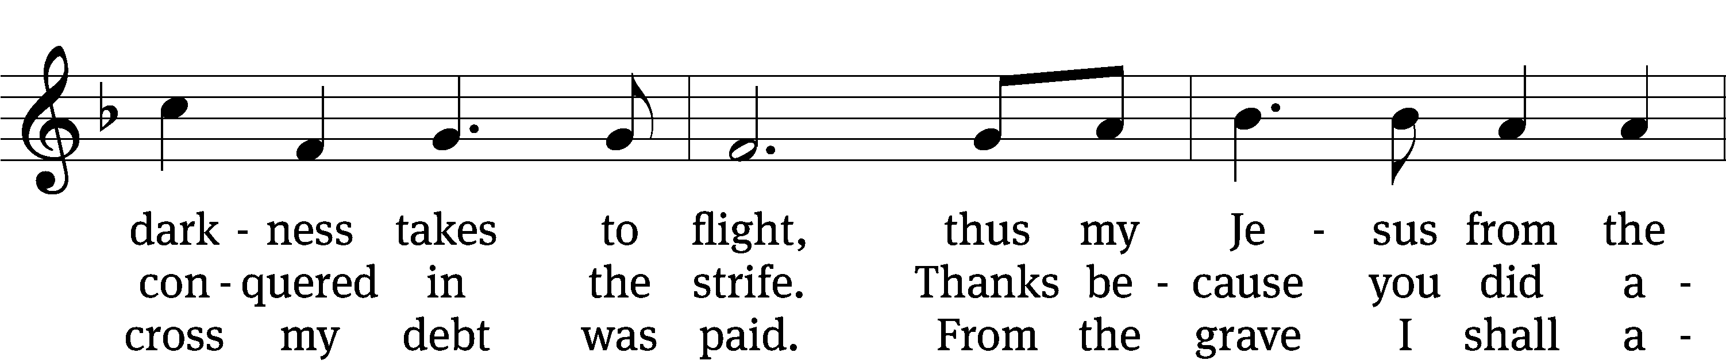
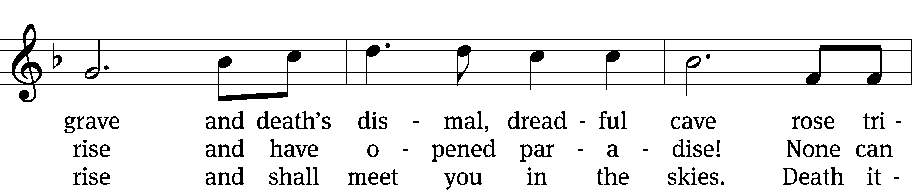
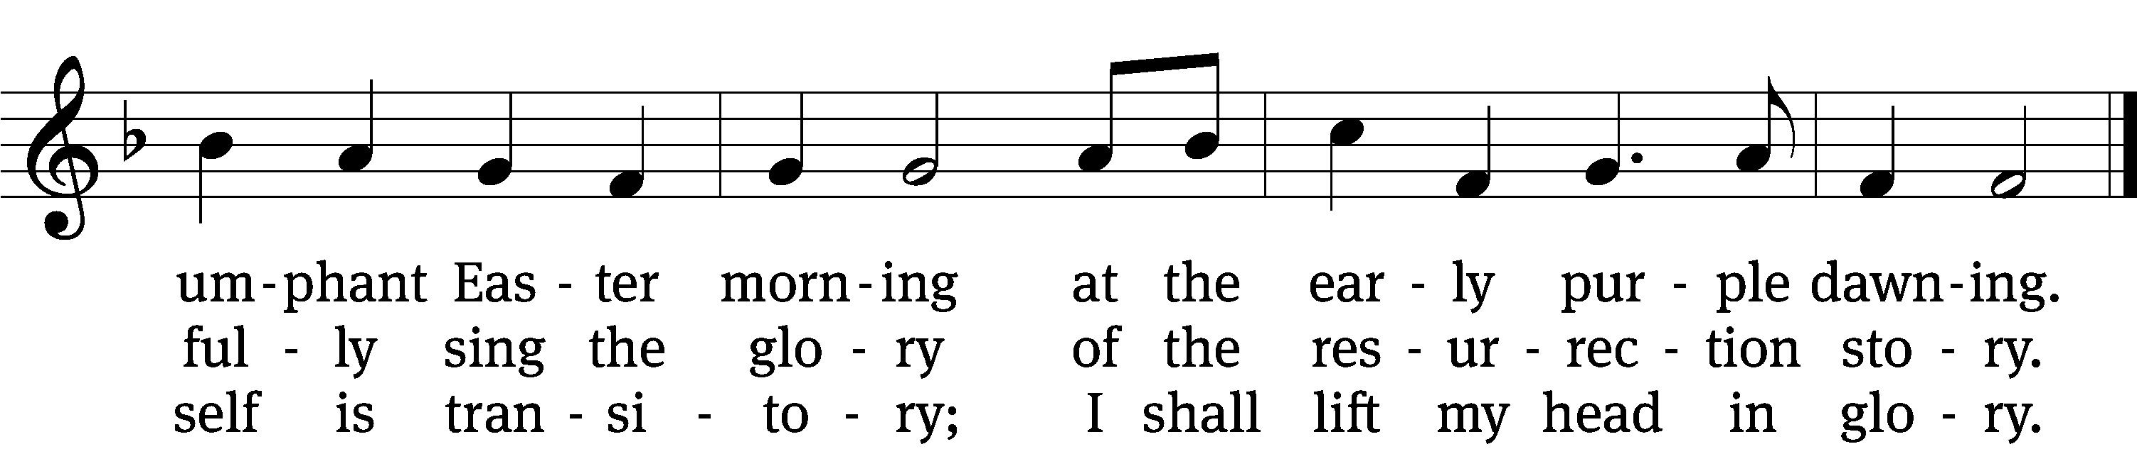
Text: tr. George A. T. Rygh, 1860–1942, alt.; Thomas H. Kingo, 1634–1703, abr.
Tune: Johann Schop, c. 1590–1667
Text and tune: Public domain

Stand

In the name of the Father and of the T Son and of the Holy Spirit.
Amen.

Confession
Blessed are they whose transgressions are forgiven, whose sins are covered.
Blessed are they whose sin the Lord does not count against them.

Let us confess our sins to the Lord.
Almighty and merciful Father,
we have strayed from your ways like lost sheep.
We have followed what we have devised and desired in our hearts.
We have offended you and sinned against your holy law.
We have done those things that we should not have done,
and we have not done those things that we should have done.
Have mercy on us, Lord!
Spare us, forgive us, and restore us,
according to your promises in Christ Jesus.

God, our merciful Father, has forgiven all our sins. He sent his Son, Jesus Christ, to be our Redeemer and Savior. Jesus paid the penalty for our guilt by his death on the cross and freed us from death by his resurrection from the grave. We have peace with God now and forever.
Amen.



470 Like the Golden Sun Ascending CW 470 st. 4
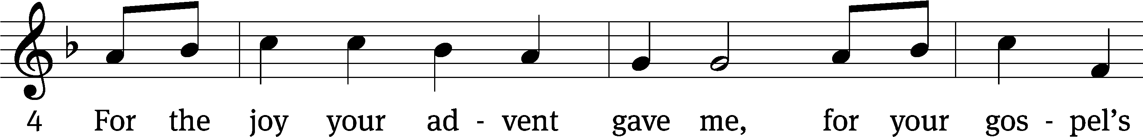

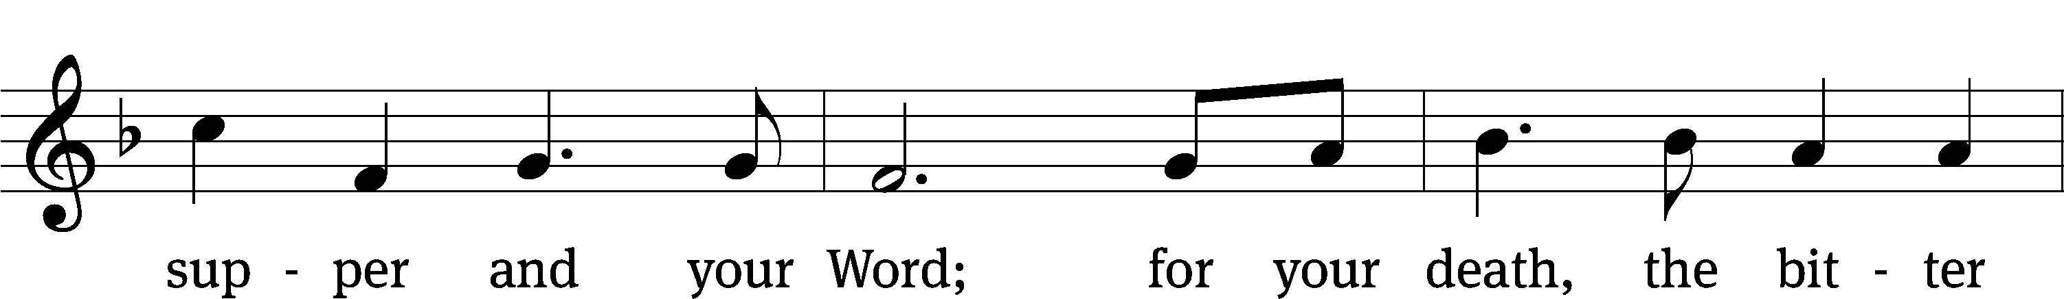
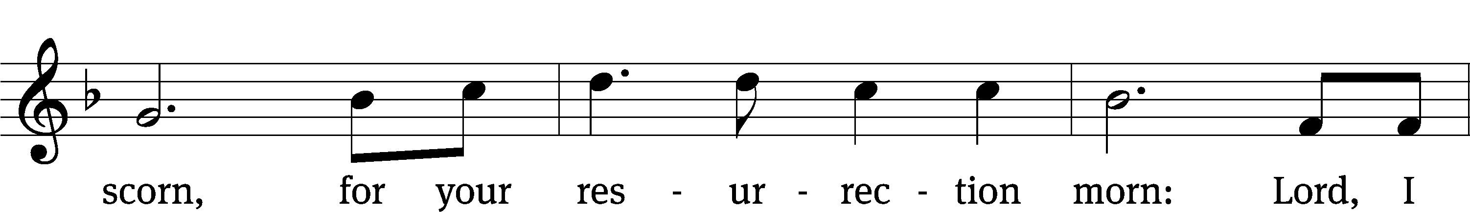
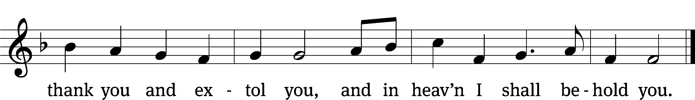
Text: tr. George A. T. Rygh, 1860–1942, alt.; Thomas H. Kingo, 1634–1703, abr.
Tune: Johann Schop, c. 1590–1667
Text and tune: Public domain

The Word

The Lord be with you.
And also with you.

Prayer of the Day
Let us pray.

O God, you form the minds of your faithful people into a single will. Make us love what you command and desire what you promise, that among the many changes of this world, our hearts may ever yearn for the lasting joys of heaven; through your Son, Jesus Christ our Lord, who lives and reigns with you and the Holy Spirit, one God, now and forever.
Amen.

Be seated

First Reading 1 John 3:18–24
18Dear children, let us not love with words or speech but with actions and in truth.
19This is how we know that we belong to the truth and how we set our hearts at rest in his presence: 20If our hearts condemn us, we know that God is greater than our hearts, and he knows everything. 21Dear friends, if our hearts do not condemn us, we have confidence before God 22and receive from him anything we ask, because we keep his commands and do what pleases him. 23And this is his command: to believe in the name of his Son, Jesus Christ, and to love one another as he commanded us. 24The one who keeps God’s commands lives in him, and he in them. And this is how we know that he lives in us: We know it by the Spirit he gave us.
63C Lord, You Are My Hope and Stay Psalm 63C
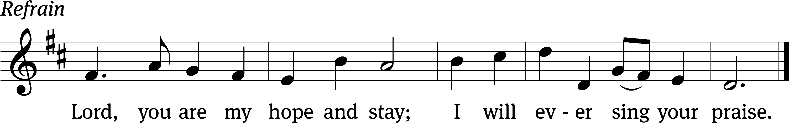


You, God, / are my God,
earnestly I / seek you;
I thirst for you,
my whole being / longs for you,
in a dry and parched land
where there is no / water.
I have seen you in the sanctu- / ary
and beheld your power and your / glory. Refrain

Because your love is bet- / ter than life,
my lips will glori- / fy you.
I will praise you as long / as I live,
and in your name I will lift / up my hands.
Because you / are my help,
I sing in the shadow / of your wings.
Glory be to the Father and / to the Son
and to the Holy / Spirit,
as it was in the be- / ginning,
is now, and will be forever. / Amen. Refrain
Text: Hal H. Hopson
Tune: Hal H. Hopson
Setting: Kermit G. Moldenhauer
Text and tune: © 2008 Birnamwood/MorningStar Music Publishers (refrain). Used by permission: OneLicense no. 716626
Setting: © 1993 Kermit G. Moldenhauer, admin. Northwestern Publishing House. Used by permission: OneLicense no. 716626
Gospel John 15:1–8
1“I am the true vine, and my Father is the gardener. 2He cuts off every branch in me that bears no fruit, while every branch that does bear fruit he prunes so that it will be even more fruitful. 3You are already clean because of the word I have spoken to you. 4Remain in me, as I also remain in you. No branch can bear fruit by itself; it must remain in the vine. Neither can you bear fruit unless you remain in me.
5“I am the vine; you are the branches. If you remain in me and I in you, you will bear much fruit; apart from me you can do nothing. 6If you do not remain in me, you are like a branch that is thrown away and withers; such branches are picked up, thrown into the fire and burned. 7If you remain in me and my words remain in you, ask whatever you wish, and it will be done for you. 8This is to my Father’s glory, that you bear much fruit, showing yourselves to be my disciples.

Children's Devotion Ages 3 through grade 5 are invited to come forward for a Bible lesson.

Children's Church During the service, parents may choose to take their children (ages 2-5) to Children’s Church. There they will hear a Bible story, and sing songs. They will return to the sanctuary during the offering.

709 Christ the Vine CW 709
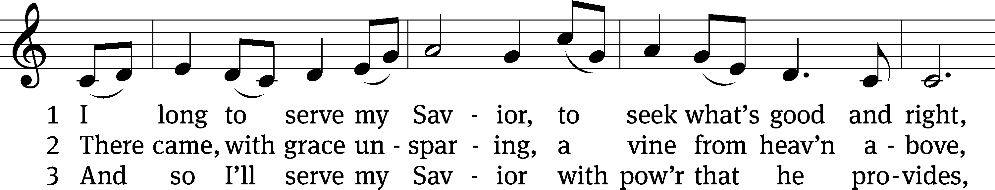
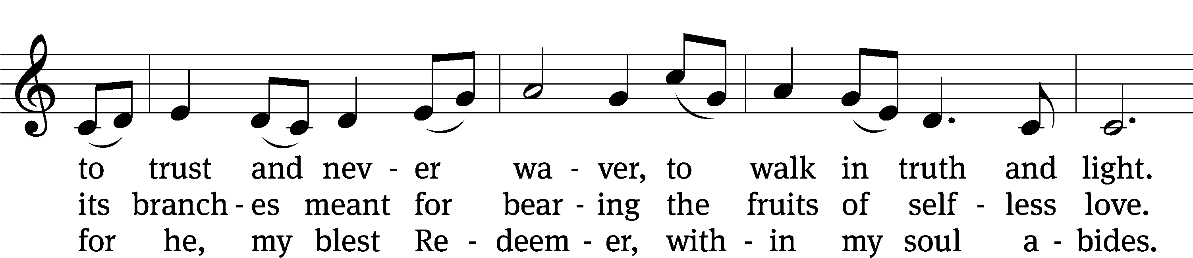
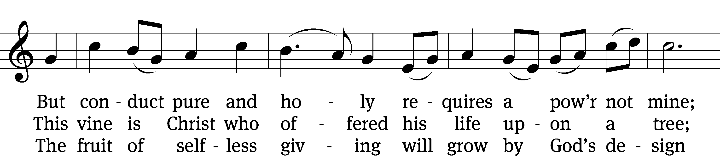
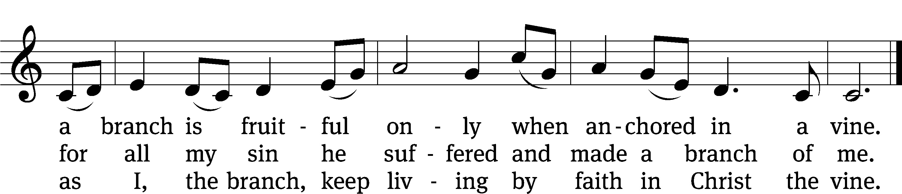
Text: Michael D. Schultz, b. 1963
Tune: Irish
Text: © 2021 Michael D. Schultz, admin. Northwestern Publishing House. Used by permission: OneLicense no. 716626
Tune: Public domain

Sermon Acts 4:32–37
32All the believers were one in heart and mind. No one claimed that any of their possessions was their own, but they shared everything they had. 33With great power the apostles continued to testify to the resurrection of the Lord Jesus. And God’s grace was so powerfully at work in them all 34that there were no needy persons among them. For from time to time those who owned land or houses sold them, brought the money from the sales 35and put it at the apostles’ feet, and it was distributed to anyone who had need.
36Joseph, a Levite from Cyprus, whom the apostles called Barnabas (which means “son of encouragement”), 37sold a field he owned and brought the money and put it at the apostles’ feet.

“Walk together with Jesus!”
Apostles’ Creed
I believe in God, the Father Almighty,
maker of heaven and earth.

I believe in Jesus Christ, his only Son, our Lord,
who was conceived by the Holy Spirit,
born of the Virgin Mary,
suffered under Pontius Pilate,
was crucified, died, and was buried.
He descended into hell.
The third day he rose again from the dead.
He ascended into heaven
and is seated at the right hand of God the Father Almighty.
From there he will come to judge the living and the dead.

I believe in the Holy Spirit,
the holy Christian Church,
the communion of saints,
the forgiveness of sins,
the resurrection of the body,
and the life everlasting. Amen.

Offering “We love because he first loved us.” 1Jn 4:19 God’s love in sending Jesus to live, to suffer, and to die for each of us motivates the members of Beautiful Savior to show their love and thanks by returning a portion of their income to the Lord. Through these free will offerings, this congregation and its ministries are maintained. If you would like to give securely online, scan this code or follow this link: bslclarksville.com
Prayer of the Church
Lord of life, fill our hearts with joy during this Easter season, for you have risen and conquered the grave. Imprint the message of victory on our hearts and implant it in our minds. Through the good news of your resurrection renew our hope and revive our faith. Lord, in your mercy,
Hear our prayer.

By baptizing us into your name, you have connected us to your death and rising. You have put our sin to death and have given us a new life. Enable us each day to think of ourselves as dead to sin and alive to you, so that we may walk in newness of life in all we do. Lord, in your mercy,
Hear our prayer.

In this fallen world, death and sorrow surround us. Touch the hearts of those who grieve the loss of a Christian they love. Direct their eyes to your empty tomb and ease their pain by reminding them that their loved ones will one day rise again. Lord, in your mercy,
Hear our prayer.

Lord, many people grieve without hope. Let the message of resurrection reach them and awaken faith in their hearts. Use us as your instruments to bring the word of life to their souls and the message of hope to their hearts. Lord, in your mercy,
Hear our prayer.

Stay by the side of all who are suffering. In your wise mercy, heal those who are sick, receiving treatment for illness, recovering from illness or surgery, or hurting in body or mind. Remind them that your victory over death is a fact, and comfort them with your promise to raise them and give them and all believers new, glorified bodies like yours. Lord, in your mercy,
Hear our prayer.

Hear us, Lord, as we pray in silence.

Silent prayer

Risen Savior, feed our faith with the message of your resurrection. Come to us in your Word and in the feast of your Sacrament to sustain and strengthen us until we feast with you in eternal glory.
Amen.

Lord’s Prayer
Our Father, who art in heaven,
hallowed be thy name,
thy kingdom come,
thy will be done
on earth as it is in heaven.
Give us this day our daily bread;
and forgive us our trespasses,
as we forgive those
who trespass against us;
and lead us not into temptation,
but deliver us from evil.
For thine is the kingdom
and the power and the glory
forever and ever. Amen.
595 Fruitful Trees, the Spirit’s Sowing CW 595
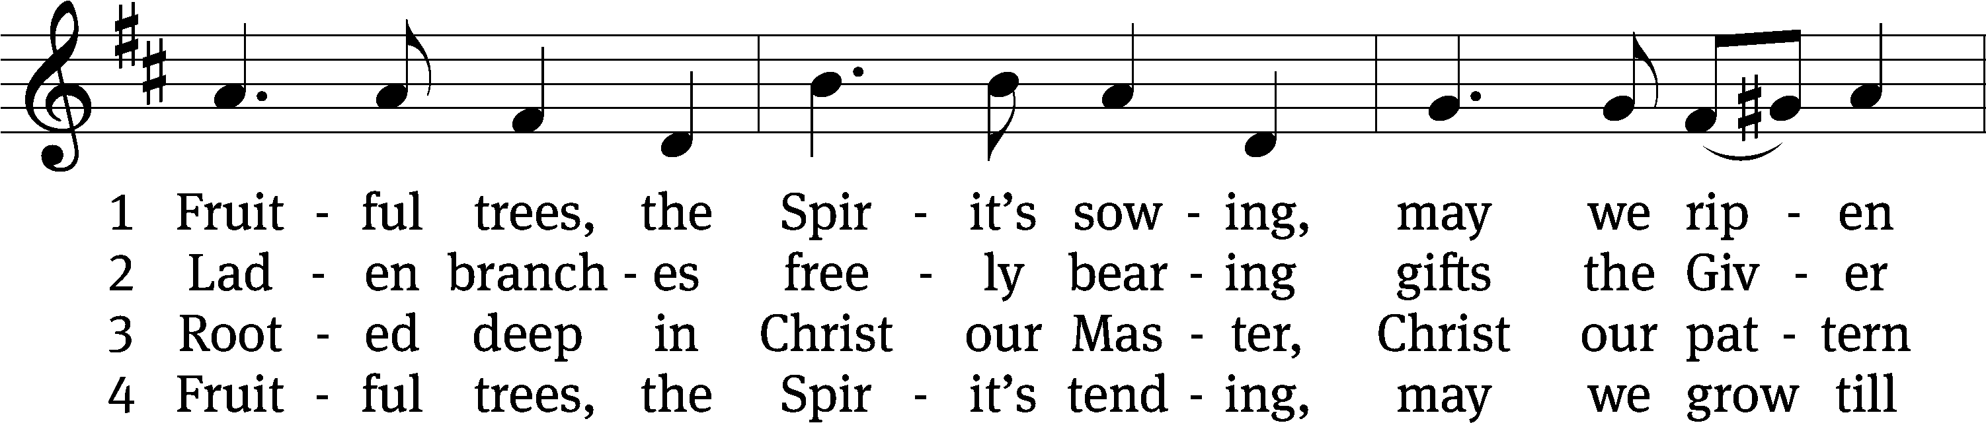
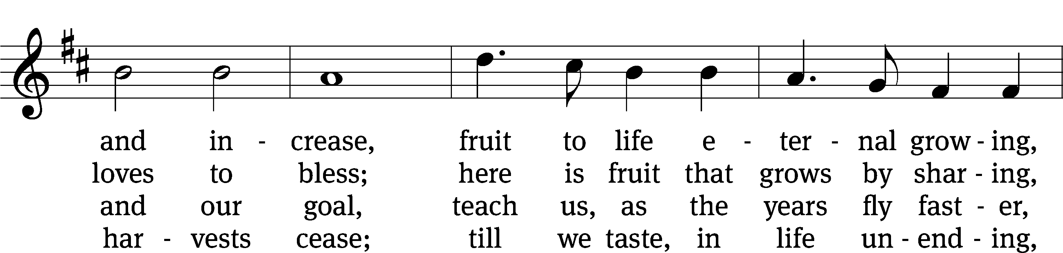
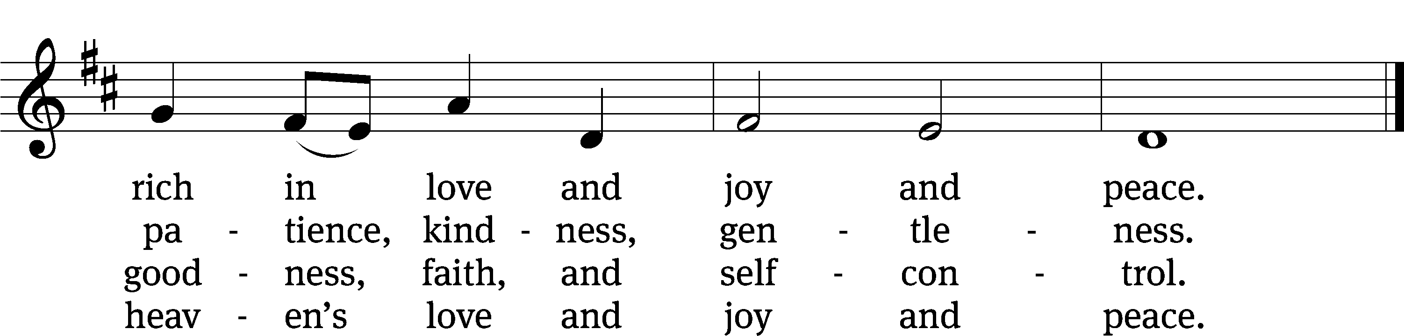
Text: Timothy Dudley-Smith, b. 1926
Tune: Ralph C. Schultz, b. 1932
Text: © 1984 Hope Publishing Co. Used by permission: OneLicense no. 716626
Tune: © 1980 Concordia Publishing House. Used by permission: OneLicense no. 716626
Closing Prayer
How can we thank you, Father, for allowing us to worship in your house today! We have heard the promises of your love in the gospel. We have praised you, confessed you, and prayed for your blessings. We have been strengthened by the witness and worship of others. Keep our faith strong as we live out the tasks of our life. Take away our doubts and fears, and give us courage to share the good news of your Son wherever we go and however we can. In Jesus’ name, we ask it.
Amen.
Blessing
The Lord bless you and keep you.
The Lord make his face shine on you and be gracious to you.
The Lord look on you with favor and T give you peace.
Amen.

518 Christ Be My Leader CW 518
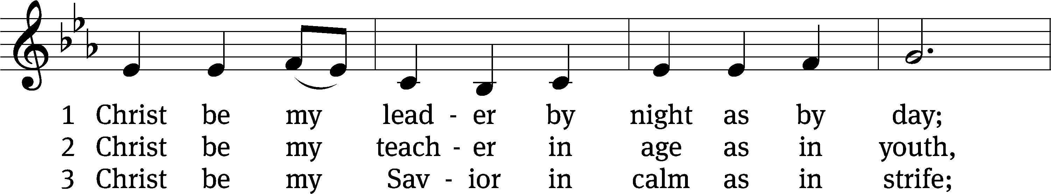
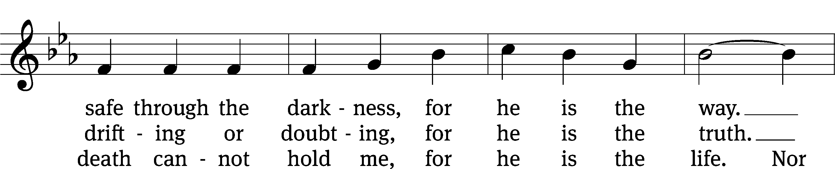
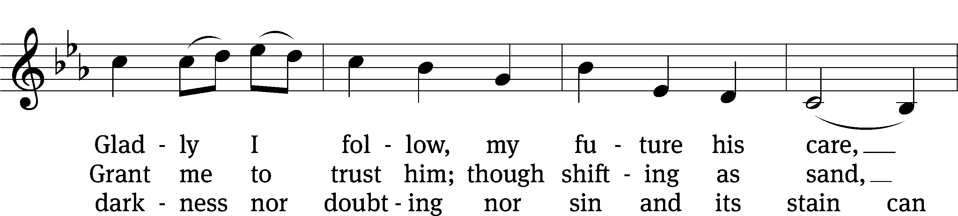
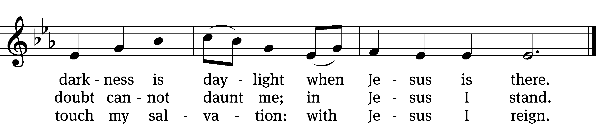
Text: Timothy Dudley-Smith, b. 1926
Tune: Irish
Text: © 1964, ren. 1992 Hope Publishing Co. Used by permission: OneLicense no. 716626
Tune: Public domain

Acknowledgments
Setting One from Christian Worship
Unless otherwise indicated, Scripture quotations are from The Holy Bible, New International Version®, NIV®. Copyright © 1973, 1978, 1984, 2011 by Biblica, Inc.TM Used by permission of Zondervan. All rights reserved worldwide.
Software distributed in partnership with Northwestern Publishing House.
Created by Christian Worship: Service Builder © 2024 Concordia Publishing House.

Next Week’s Worship
Our theme for worship: Resurrection Reality: Jesus’ Business Is Love: Therefore, So Is Ours. Our readings will be: Acts 9: 36-42, 1 John 4: 7-11, 19-21, and John 15: 9-17. We will sing the following hymns: 684 Father Welcomes, 461 He is Arisen! Glorious Word, 523 How Deep the Father’s Love for Us, 557 Dear Christians, One and All, Rejoice, and 697 May We Your Precepts, Lord, Fulfill.

THIS WEEK AT BEAUTIFUL SAVIOR
† Today 9:15am Sunday School
10:30am Worship
12pm BIC & Confirmation Class
† Tuesday 4pm Board of Education Meeting
† Wednesday 9am Mornings with Mommy
6pm Bible Study
† Sunday 9:15am Sunday School
10:30am Worship
Confirmation Sunday

Teaching Position Available
The preschool will have an opening for the Lead Teacher position in the 3-4 year old classroom. Please call the office at 931-905-1400 or speak with Miss Noon for more information.

Preschool Project
BSLP is looking for some large wooden units to be built for our outdoor classroom and playground. If you are interested, please call the office or speak with Miss Noon.

Lawn Maintenance
We are looking for volunteers to cut the grass throughout the summer. We have a zero-turn lawn mower, trimmer, and leaf blower. We even provide the gas! What we need are people willing to spend some time on a Friday or Saturday getting the property ready for church on Sunday. If you would like to help, please see the sign-up sheet in the entry-way. If you have questions, talk to Pastor.

Bible Study on the Move
Our mid-week Bible Study has moved back to Wednesday evenings! Currently we are studying the book of Acts and the beginnings of the Christian Church. Bible Study time is 6 pm. All are welcome!

Altar Flower Sign-up
If you would like to provide flowers for a Sunday Service, please see the sign up chart near the entry way table. It can be for a special occasion, or simply to beautify our altar on a Sunday morning. If you have questions, contact Eileen Cleveland at 239-410-6366 or email at thedoll48@gmail.com

Digging Deeper
If you would like to learn more about God’s Word and his love for us in Jesus, consider joining our next Bible Information Class. In this class, we cover the main themes and teachings of the Bible, apply it to our lives, and answer questions. Grow deeper and more certain in God’s love! Our next class begins in May. The BIC class also serves as our pre-membership class.

What’s next on Sundays?
Easter is not just a holiday. Easter is history. Jesus’ resurrection is the moment that defines reality for us all. If Christ remained dead, he is a fraud and failure. But Christ has indeed been raised. So, the reality: Jesus is exactly what he claimed to be—the Son of God, our Lord and Savior. If Christ remained dead, then the grave is the final, ugly, rotten end of us all. But Christ has indeed been raised. So, the reality is Jesus’ resurrection proves that “all will be made alive” (1 Corinthians 15:22). The reality of the resurrection does not just change our future, but the way we look at life now.

Sunday, May 5- Jesus’ Business Is Love; Therefore, So Is Ours
Sunday, May 9- Christ’s Ascension Means He Is Closer Than Ever
Sunday, May 12- We Will Overcome This Broken World
Sunday, May 19- Christ Has Not Left Us Alone

Outdoor Club
Who: Outdoor Club is a new group at Beautiful Savior to organize and host monthly outdoor activities. The goal of the club is to provide members with opportunities to fellowship outdoors. Various opportunities for hiking, camping, fishing, park events and much more will be scheduled for all members to sign-up and participate in the fun. If you want to know more about how to be involved with organizing/hosting or want to participate in the scheduled outing, please contact Hannah Lacey 775-515-2639.
What: Survival Skills for families (family not required individual sign-up is welcome). This is an event hosted by Montgomery County TN Parks and Recreation. Optional BYO lunch and hike at the park for those who would like to stick around after event is over. Sign-up for event is limited, please try and register as soon as possible. You can register yourself through the Montgomery County TN Parks and Recreation Facebook page, or let Hannah know you are interested in participating.
Event info from the park Facebook page:
This new 90 minute program is designed to empower families with the skills needed to survive wilderness emergency situations. Whether you are going on vacation to the woods, beach or a backyard, the skills will teach you to save yourself and show you how rescue teams operate. This is most beneficial when the whole family can attend. Children under 4 are welcome, however, the content and timeframe may not be sustainable, please use your best judgment. This program will take place inside the Nature Center using simulated situational tools and supplies.
Itinerary:
The psychology of survival Shelters
Fire Food
Water Signaling
First aid, everyone assembles their own emergency kit to take home!
Where: 2308 Rotary Park Drive Clarksville, TN
When: May 4th 10:30 to 12 *optional lunch at pavilion to follow.
Why: Fun!

Prayer List
Thank the Lord for the safe return of all the soldiers who recently came home and all soldiers and their families who are facing deployment. Please keep in your prayers this week all soldiers who are currently deployed. Please also remember: Roger Fox, son of Hilde Fox (cancer); Atenea, friend of Danika Osburn (broken arm); Cynthia Thorington, sister of Brenda Henschen (long-term Covid symptoms); Linda Kiecker, daughter of Selma Noon (pancreatic cancer); Theresa Robinson (recovery from eye surgery); Stacia Gupton, friend of Caryn Mclain, (serious illness); Nita Harris, friend of David & Allison Johnson (cancer/chemo); Teri Lee Dickinson & Family (bereavement); May Holman, mother of Trey Church (abdominal surgery); Christa Trusty (Health Issues); Curt Holz, brother of Pastor Holz (cancer); Bob Housh (Injured in fall); Renate Banks (illness); Marlys Donner, mother of Tim Donner (declining health); Josh Carter, friend of Adam Holz (recovery from car accident); Stacy Schroeder, daughter of Jeff & Eileen Cleveland (melanoma diagnosis); Aimee Gerkhardt, sister in law of Jessica Church (breast cancer); Brandon Vannoy, friend of Mac McCoo (seizures); Sheila Lynch, sister of Gayle Brooks (unable to walk); Drake Robideau, friend of Mary Daniel (strength & wellness); Mike LaFave (back problems); Linda Thomas, sister of Gayle Brooks, (physical rehab after injury); Gidget Tate (Health issues). If you would like to have a name or situation included or if you would like to give an update on a prayer request, please contact Pastor Holz or call the church office at 931-905-1400.

Serving in God’s House

Ushers: Art Ebbinger, Ray Mefford
Greeters: Loretta W, Ernie R
Kitchen: Hannah L, Mary D, Margareta S
Piano: Deb White
Fellowship: (T-Z)

Serving next week:

Ushers: Mike Rathge, Trey Church
Greeters: Jeff & Eileen Cleveland
Kitchen: Gael I, Loretta W, Mary D
Piano: Barb Noon
Fellowship: (A-G)

Our Mission
By grace, the mission of
Beautiful Savior Evangelical Lutheran Church is
to proclaim the Word of God so that we may praise his name,
grow together in the knowledge of our Savior,
and share with others his message of forgiveness and eternal life.

