Beautiful Savior Lutheran Church

June 18th, 2023 – Third Sunday after Pentecost

service theme: The Holy Ministry Demonstrates Compassion For God’s People

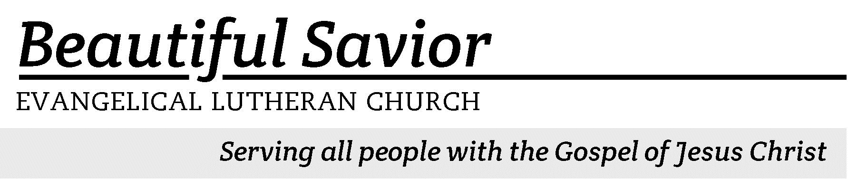


Welcome-- We are glad you could join us today! It is our hope that this service is a blessing to you. Please join us for worship again soon.

· Please save the last two rows of pews for parents with small children.

· Parents with little ones: If your child becomes restless during the service, that’s okay… We’re glad they’re here, and Jesus is pleased when they are brought to hear his Word: “Let the little children come to me.” If you need to be with your child in the Fellowship Hall, the service can be heard through a speaker.

· Five minutes before the worship service begins the usher will light the candles. This is our signal to quiet down and prepare our hearts for worship.

· Restrooms are conveniently located to the left as you exit the sanctuary.

· Please silence your cell phone before the start of the service.

Prayer for Worship
Almighty God, you have given us your only Son so that he may be for us both a sacrifice for sin and an example of living in faith. Give me grace and strength to follow Jesus wherever it may lead. Help me to strive every day in my life to walk in his footsteps. I ask this in Jesus’ name. Amen.

Beautiful Savior Lutheran Church
2526 Whitfield Road
Clarksville, TN 37040
931-905-1400
Website: www.bslclarksville.com
Kent Holz, Pastor
Bslc.clarksville@gmail.com
Barbara Noon, Preschool Director
beautifulsaviorpreschool@gmail.com
716 O Christ, Who Called the Twelve CW 716 sts. 1–3
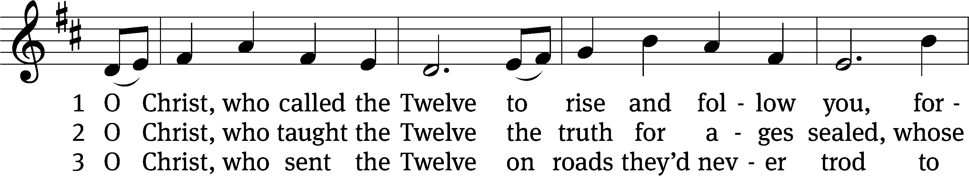
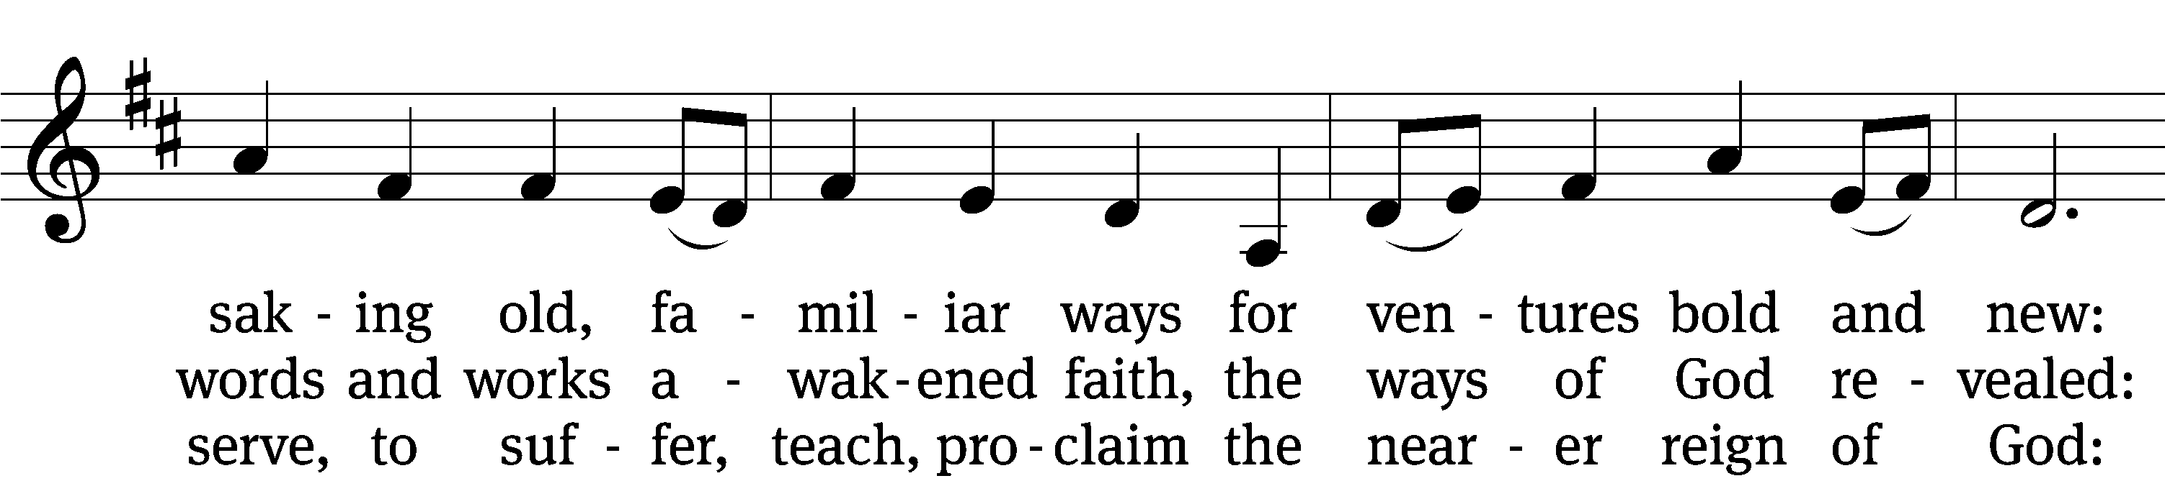
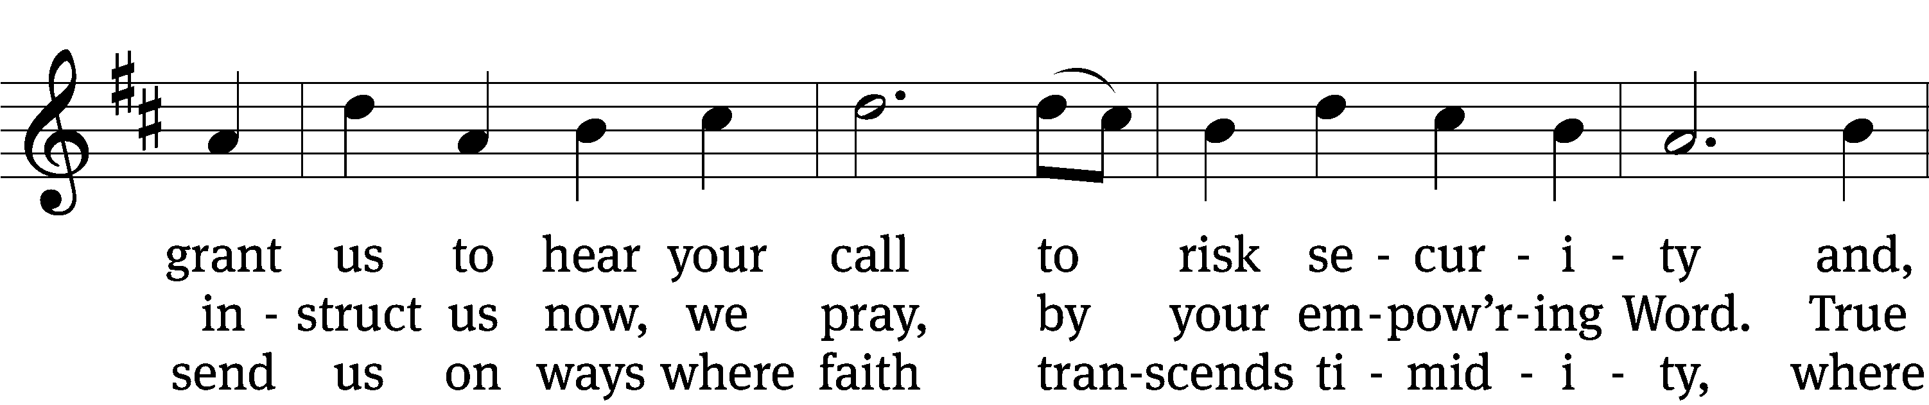
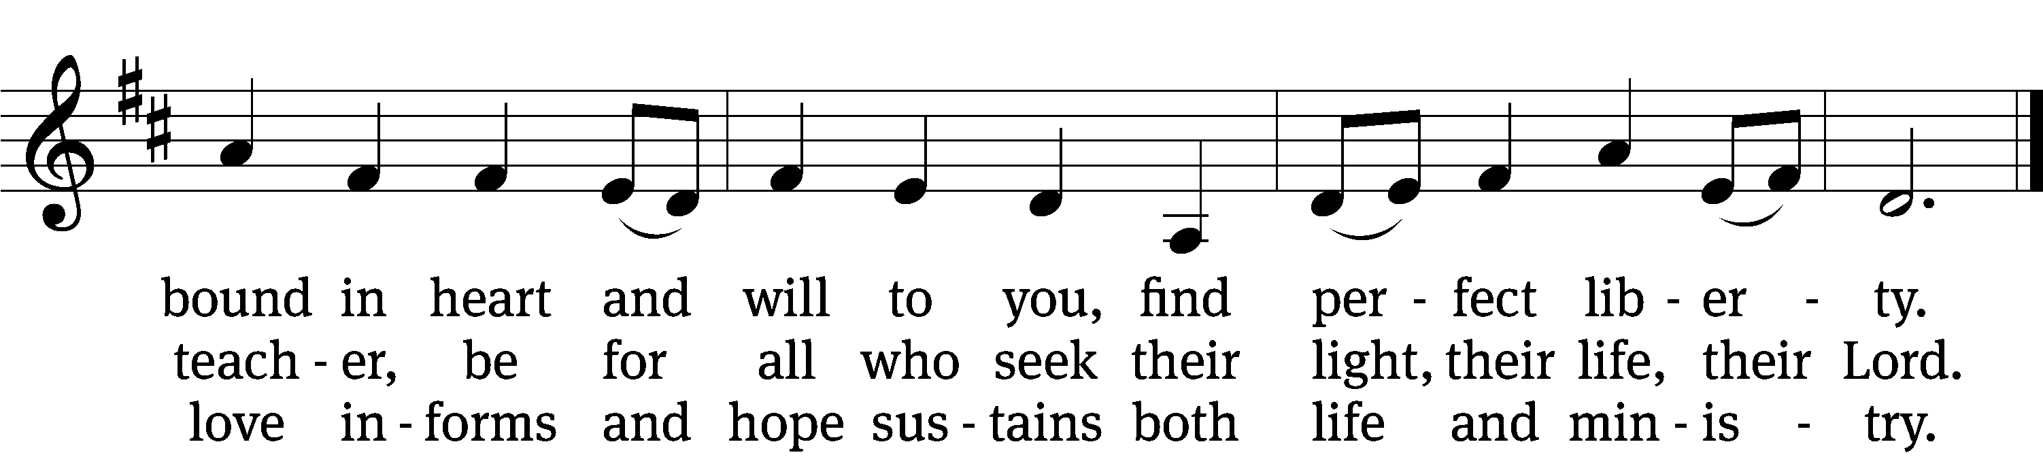
Text: Herman G. Stuempfle, Jr., 1923–2007
Tune: English; adapt. Franklin L. Sheppard, 1852–1930
Text: © 1993 GIA Publications, Inc. Used by permission: OneLicense no. 716626
Tune: Public domain

In the name of the Father and of the T Son and of the Holy Spirit.
Amen.

Confession
We have entered into God’s house and are standing on holy ground. However, our sins make us unworthy to stand here and they separate us from our God. So, let us ask God to have mercy on us and to forgive our sins.

Dear Father in heaven, I confess that I have been a sinner from birth and in countless ways I have sinned against you. By what I have thought, by what I have said, and by what I have done and failed to do, I have angered you and do not deserve to be standing here today. Instead, I deserve your punishment both now and forever. But according to your great mercy and love, hear my prayer and forgive me.

God has loved you and the whole world. He does not want anyone to be lost. So, he sent his Son to save sinners like you and me. Jesus lived a perfect life for you and he died to fully wash away your sins. Whoever believes in him has eternal life. Do you believe this?

Yes, I believe!

Sons and daughters of the heavenly Father, be of good cheer. Your sins are forgiven. You are justified by the blood of Jesus. You are at peace with God. Now let us worship him with joyful and attentive hearts.

Amen.

716 O Christ, Who Called the Twelve CW 716 st. 4
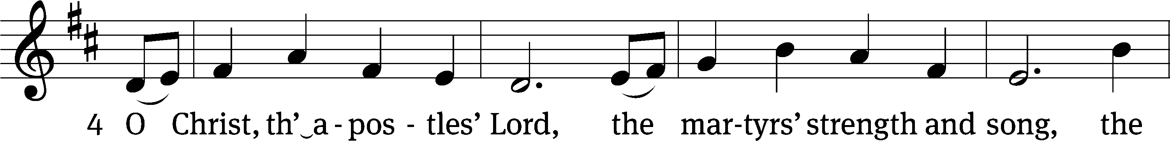
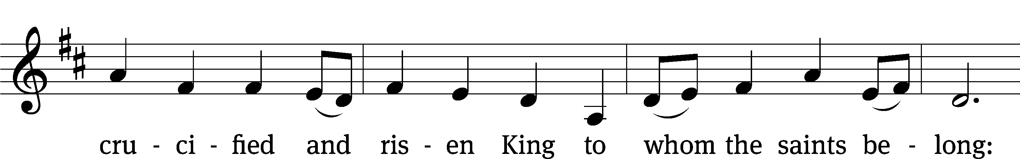
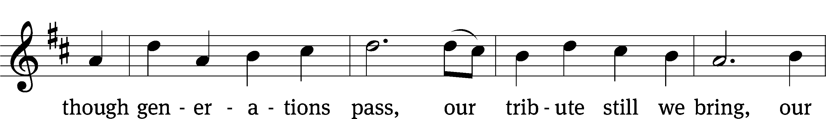
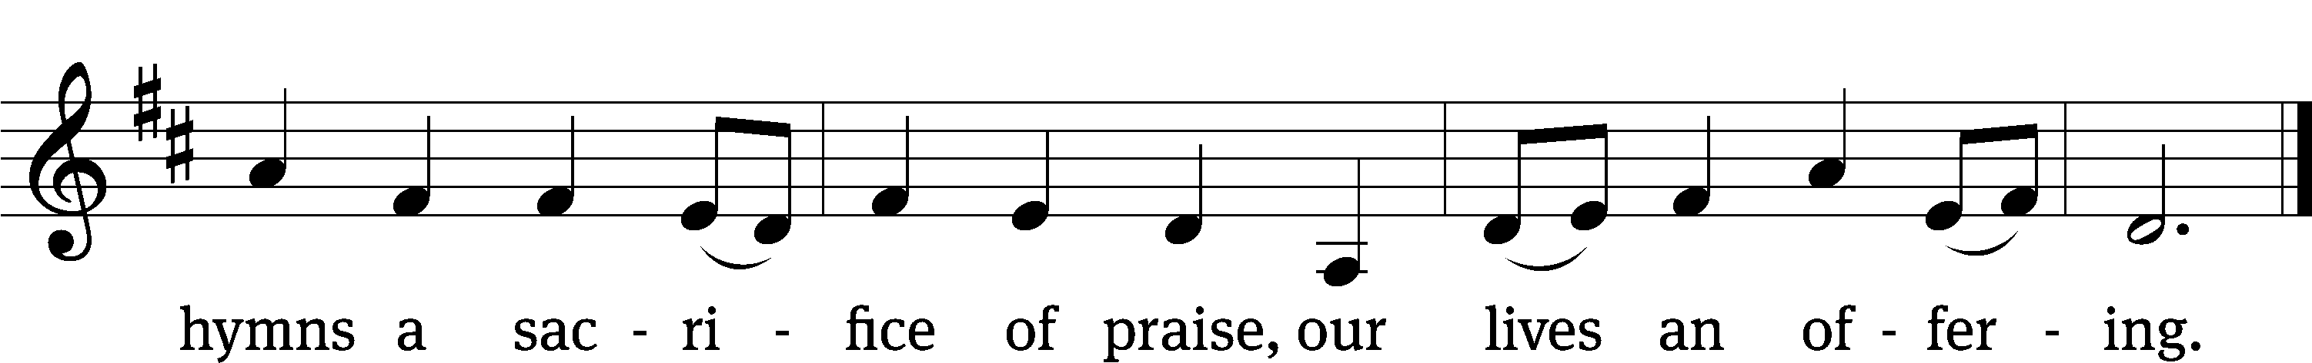
Text: Herman G. Stuempfle, Jr., 1923–2007
Tune: English; adapt. Franklin L. Sheppard, 1852–1930
Text: © 1993 GIA Publications, Inc. Used by permission: OneLicense no. 716626
Tune: Public domain
The Word

The Lord be with you.
And also with you.

Prayer of the Day
Let us pray.

Almighty, eternal God, in the Word of your apostles and prophets, you have proclaimed to us your saving will. Grant us faith to believe your promises that we may receive eternal salvation; through your Son, Jesus Christ our Lord, who lives and reigns with you and the Holy Spirit, one God, now and forever.
Amen.

First Reading Numbers 27:15–23
15Moses said to the Lord, 16“May the Lord, the God who gives breath to all living things, appoint someone over this community 17to go out and come in before them, one who will lead them out and bring them in, so the Lord’s people will not be like sheep without a shepherd.”
18So the Lord said to Moses, “Take Joshua son of Nun, a man in whom is the spirit of leadership, and lay your hand on him. 19Have him stand before Eleazar the priest and the entire assembly and commission him in their presence. 20Give him some of your authority so the whole Israelite community will obey him. 21He is to stand before Eleazar the priest, who will obtain decisions for him by inquiring of the Urim before the Lord. At his command he and the entire community of the Israelites will go out, and at his command they will come in.”
22Moses did as the Lord commanded him. He took Joshua and had him stand before Eleazar the priest and the whole assembly. 23Then he laid his hands on him and commissioned him, as the Lord instructed through Moses.

100A Enter His Gates with Thanksgiving Psalm 100A
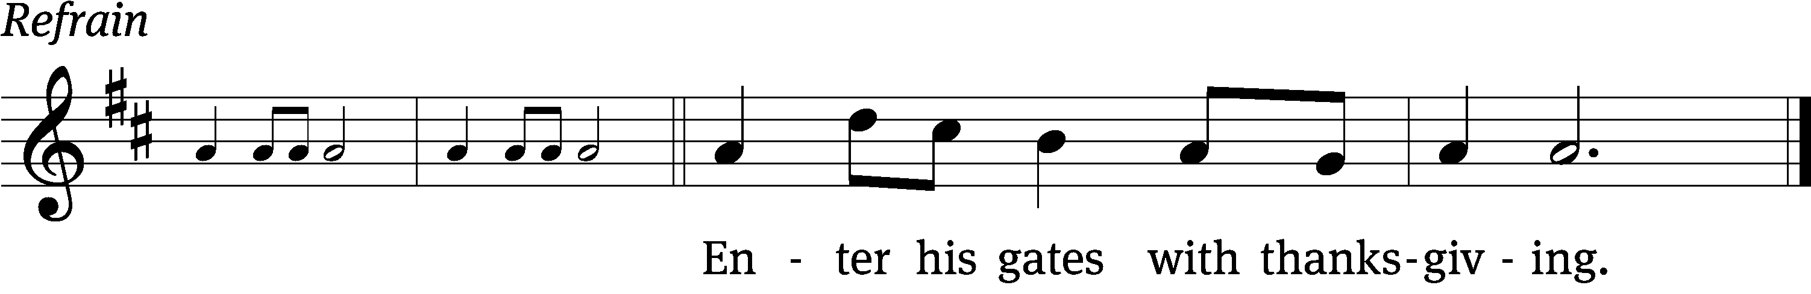
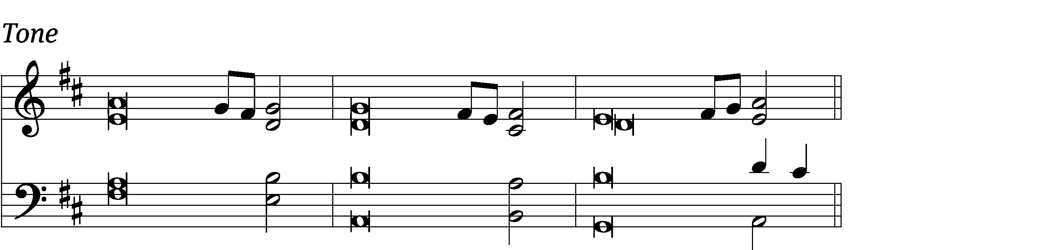

Shout for joy to the Lord, / all the earth.
Worship the Lord with / gladness;
come before him with / joyful songs.

Know that the / Lord is God.
It is he who made us, and / we are his;
we are his people, the sheep of his / pasture. Refrain

Enter his gates with thanks- / giving
and his / courts with praise;
give thanks to him and / praise his name.

For the / Lord is good
and his love endures for- / ever;
his faithfulness continues through all gener- / ations.

Glory be to the Father and to the Son and to the Holy / Spirit,
as it was in the be- / ginning,
is now, and will be forever. / Amen. Refrain
Tune: Bradley Ellingboe
Setting: ELW
Music: © 2008 Augsburg Fortress. Used by permission: OneLicense no. 716626

Second Reading 1 Corinthians 4:1–7
1This, then, is how you ought to regard us: as servants of Christ and as those entrusted with the mysteries God has revealed. 2Now it is required that those who have been given a trust must prove faithful. 3I care very little if I am judged by you or by any human court; indeed, I do not even judge myself. 4My conscience is clear, but that does not make me innocent. It is the Lord who judges me. 5Therefore judge nothing before the appointed time; wait until the Lord comes. He will bring to light what is hidden in darkness and will expose the motives of the heart. At that time each will receive their praise from God.
6Now, brothers and sisters, I have applied these things to myself and Apollos for your benefit, so that you may learn from us the meaning of the saying, “Do not go beyond what is written.” Then you will not be puffed up in being a follower of one of us over against the other. 7For who makes you different from anyone else? What do you have that you did not receive? And if you did receive it, why do you boast as though you did not?

Children's Devotion Ages 3 through grade 5 are invited to come forward for a Bible lesson.

Children's Church During the service, parents may choose to take their children (ages 2-5) to Children’s Church. There they will hear a Bible story, and sing songs. They will return to the sanctuary during the offering.

897 Lord Jesus, You Have Come CW 897 sts. 1–4
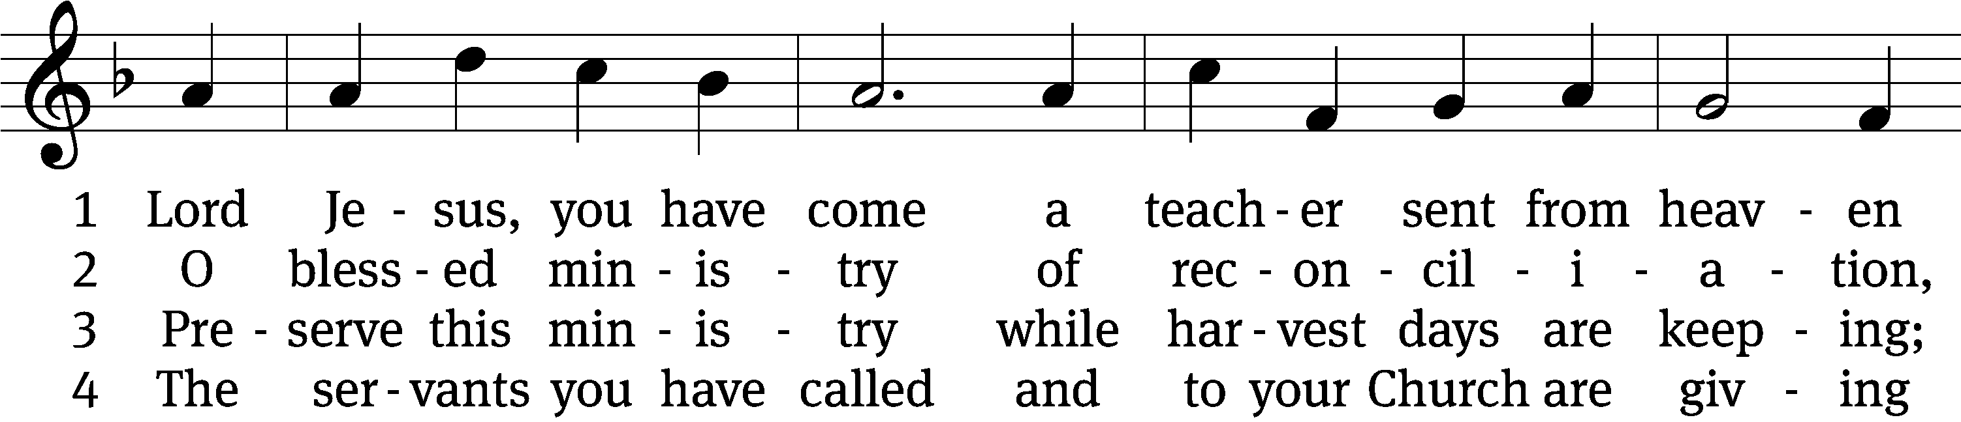
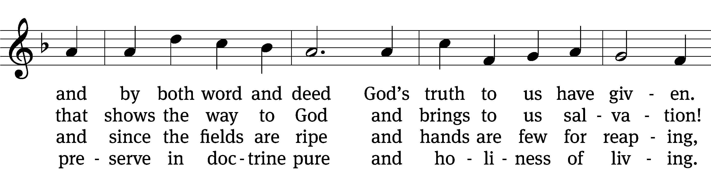
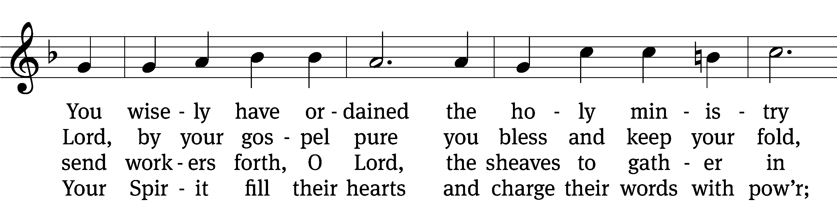
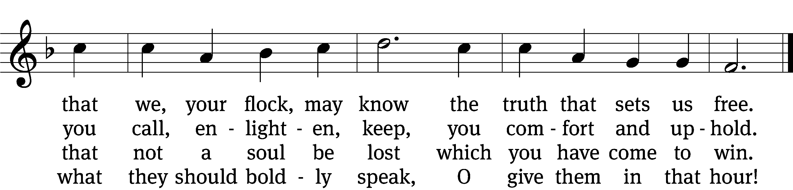
Text: tr. composite; Eberhard L. Fischer, 1695–1773, abr.
Tune: Neu-vermehrtes . . . Gesangbuch, 3rd ed., Meiningen, 1693
Text and tune: Public domain

Gospel Matthew 9:35—10:8
35Jesus went through all the towns and villages, teaching in their synagogues, proclaiming the good news of the kingdom and healing every disease and sickness. 36When he saw the crowds, he had compassion on them, because they were harassed and helpless, like sheep without a shepherd. 37Then he said to his disciples, “The harvest is plentiful but the workers are few. 38Ask the Lord of the harvest, therefore, to send out workers into his harvest field.”
1Jesus called his twelve disciples to him and gave them authority to drive out impure spirits and to heal every disease and sickness.
2These are the names of the twelve apostles: first, Simon (who is called Peter) and his brother Andrew; James son of Zebedee, and his brother John; 3Philip and Bartholomew; Thomas and Matthew the tax collector; James son of Alphaeus, and Thaddaeus; 4Simon the Zealot and Judas Iscariot, who betrayed him.
5These twelve Jesus sent out with the following instructions:
“Do not go among the Gentiles or enter any town of the Samaritans. 6Go rather to the lost sheep of Israel. 7As you go, proclaim this message: ‘The kingdom of heaven has come near.’ 8Heal the sick, raise the dead, cleanse those who have leprosy, drive out demons. Freely you have received; freely give.

“The compassionate heart of Jesus”
Apostles’ Creed
I believe in God, the Father Almighty,
maker of heaven and earth.

I believe in Jesus Christ, his only Son, our Lord,
who was conceived by the Holy Spirit,
born of the Virgin Mary,
suffered under Pontius Pilate,
was crucified, died, and was buried.
He descended into hell.
The third day he rose again from the dead.
He ascended into heaven
and is seated at the right hand of God the Father Almighty.
From there he will come to judge the living and the dead.

I believe in the Holy Spirit,
the holy Christian Church,
the communion of saints,
the forgiveness of sins,
the resurrection of the body,
and the life everlasting. Amen.


Offering “We love because he first loved us.” 1Jn 4:19 God’s love in sending Jesus to live, to suffer, and to die for each of us motivates the members of Beautiful Savior to show their love and thanks by returning a portion of their income to the Lord. Through these free will offerings, this congregation and its ministries are maintained.
Offerings are collected in the offering plate at the back of the sanctuary.
If you would like to give securely online, scan this code or follow this link: bslclarksville.com

Prayer of the Church
Loving God and Lord, you created the universe that surrounds us and the globe on which we live. You control all things through your Son, who sits at your right hand in glory.
Comfort us with the promise of your eternal presence.

Give your Word power as it works in our hearts and minds. Clear away our confusion, and demolish our doubts. Send your Spirit to strengthen both our confidence in your promises and our desire to live according to your will.
Take away our love of sinning, and restore us each day by your grace.

The signs of the times warn us that the end of time is near. Protect us from scoffers who sneer at your truth. Spare us and Christians around the world from all forms of hate and persecution.
Give us courage to carry the cross with patience and joy.

Instill in the hearts of our children a desire to follow you as they prepare for future days. Help them distinguish between what is passing and what is eternal, between instant thrills and lasting joy. Encourage more young people to prepare for service in the public ministry of the gospel.
Mold us and move us to be good examples for our youth.

Hold in your care, Lord, those who are experiencing physical or emotional pain and all who are afflicted by disease or facing death. Pour out your compassion on the grieving, and comfort the mourners who miss someone they loved.
Move us to pray for these brothers and sisters and to help when we can.

Hear us, Lord, as we pray in silence.

Silent prayer

Whether we pray together or alone, you have promised to hear and answer us. Give us patience to accept your blessings in whatever way you send them. In your love and wisdom, prepare us for the day when you will take us to be with you forever.
Hear us for Jesus’ sake. Amen.
Lord’s Prayer
Our Father, who art in heaven,
hallowed be thy name,
thy kingdom come,
thy will be done
on earth as it is in heaven.
Give us this day our daily bread;
and forgive us our trespasses,
as we forgive those
who trespass against us;
and lead us not into temptation,
but deliver us from evil.
For thine is the kingdom
and the power and the glory
forever and ever. Amen.

736 Lord, You Call Us as Your People CW 736
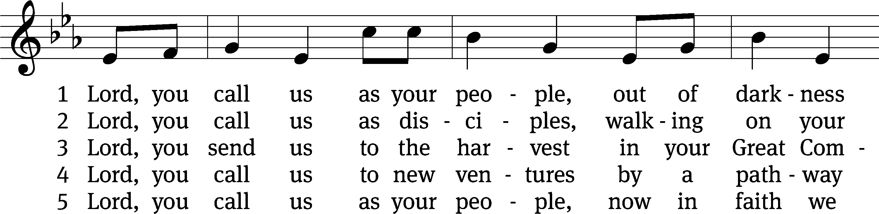
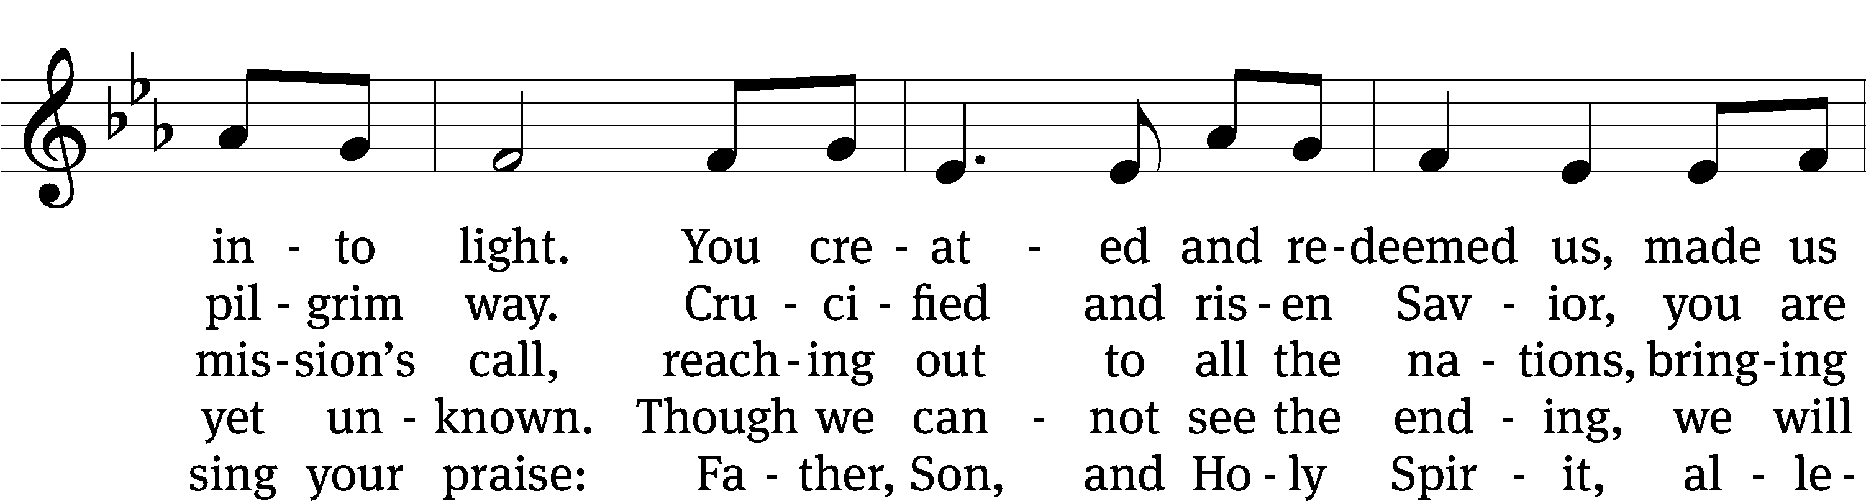
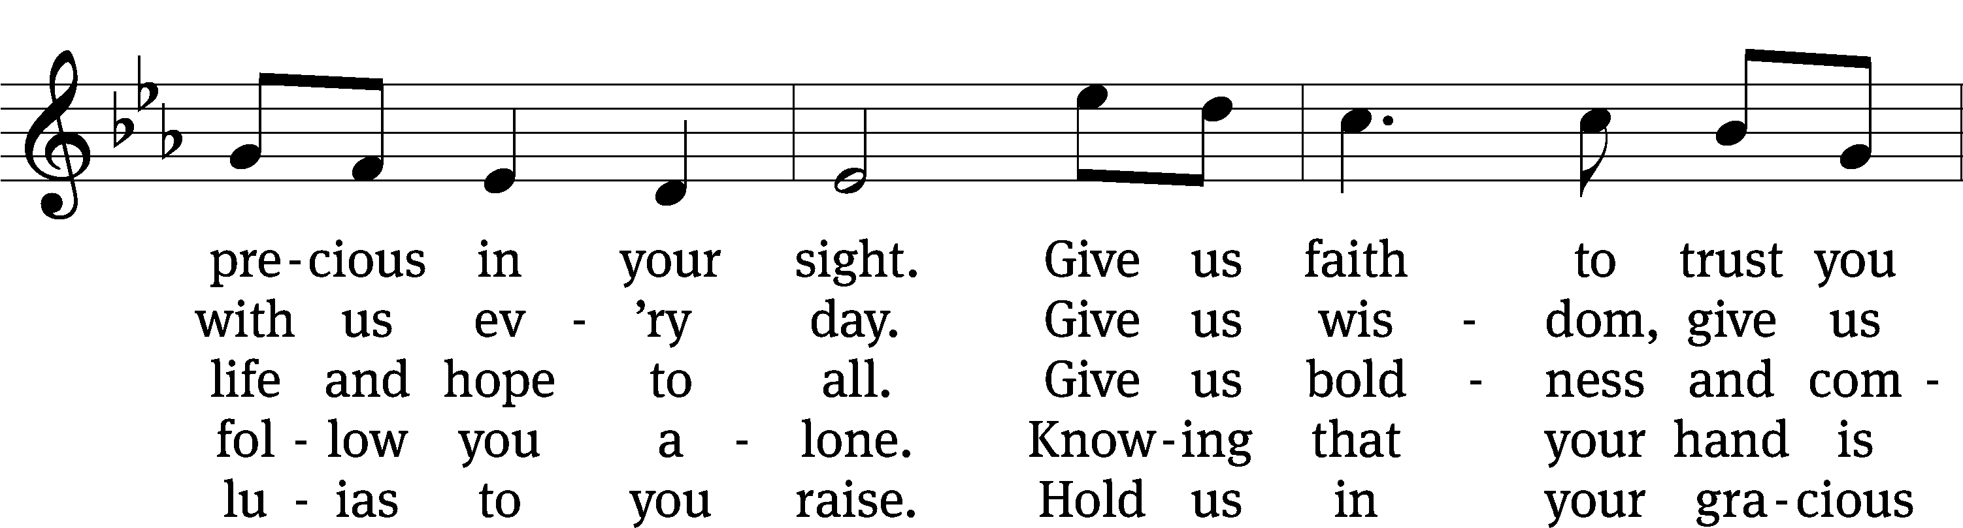
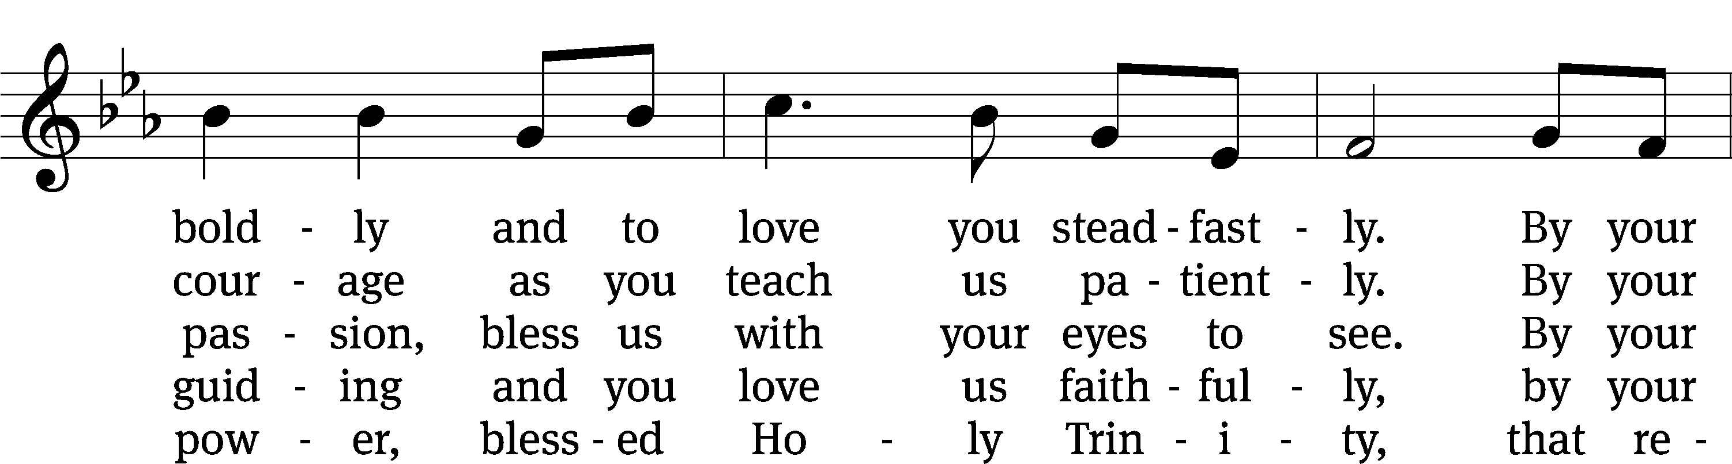
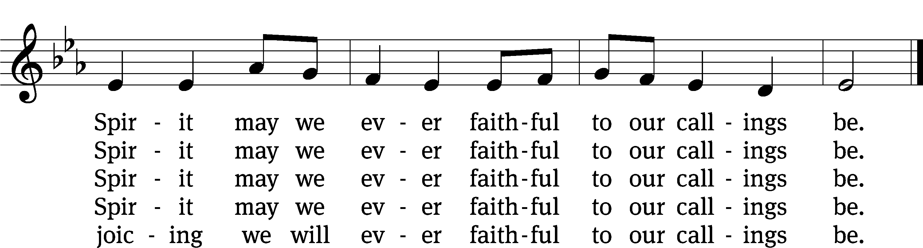
Tune: Marty Haugen, b. 1950
Text: © 2010 Stephen P. Mueller. Used by permission: OneLicense no. 716626
Tune: © 1987 GIA Publications, Inc. Used by permission: OneLicense no. 7166Closing Prayer
Closing Prayer
O God, because your abiding presence always goes with us, keep us aware of your daily mercies that we may live secure and content in your eternal love; through your Son, Jesus Christ our Lord, who lives and reigns with you and the Holy Spirit, one God, now and forever.
Amen.
Blessing
The Lord bless you and keep you.
The Lord make his face shine on you and be gracious to you.
The Lord look on you with favor and T give you peace.
Amen.

927 Lord, Dismiss Us with Your Blessing CW 927 sts. 1–2
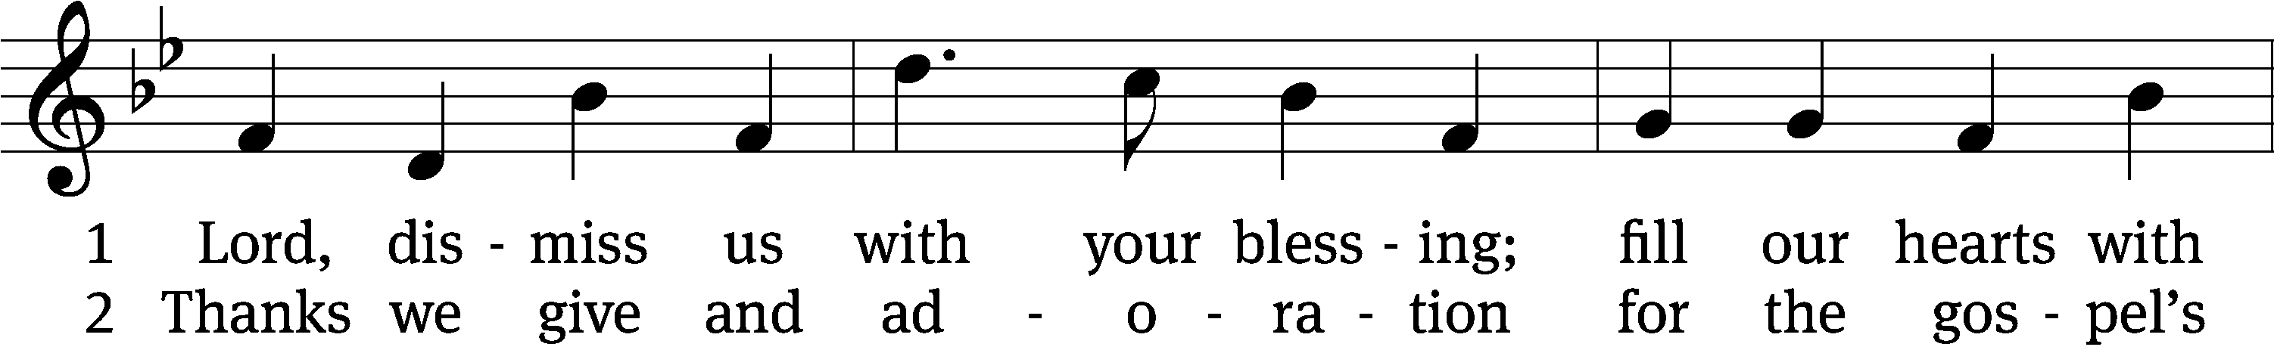
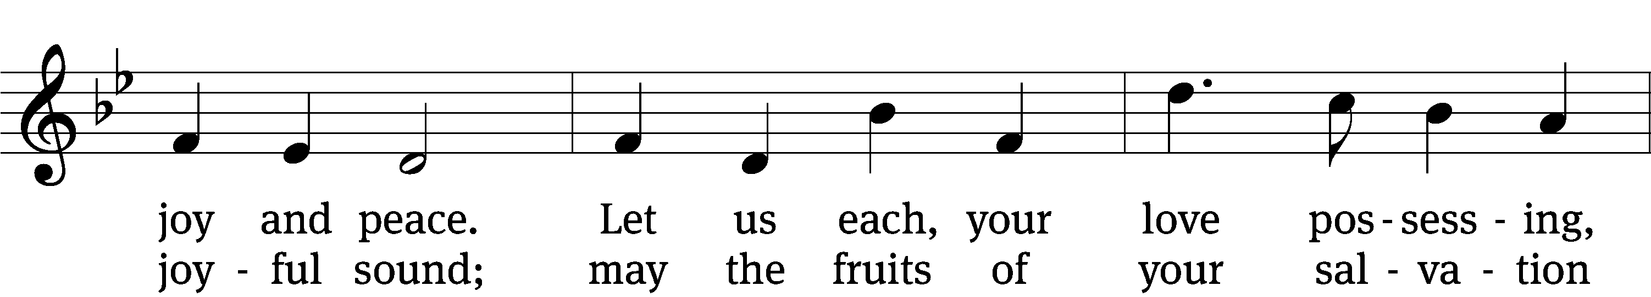
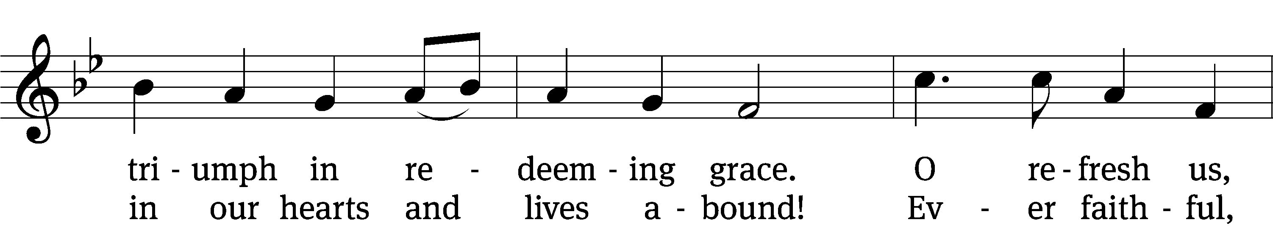
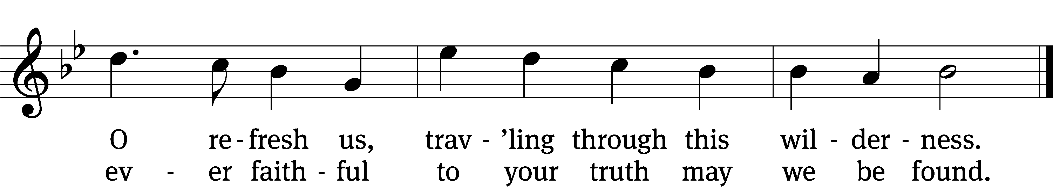
Text: attr. John Fawcett, 1740–1817, alt.
Tune: Henry T. Smart, 1813–1879
Text and tune: Public domain

Acknowledgments
Setting One from Christian Worship
Unless otherwise indicated, Scripture quotations are from The Holy Bible, New International Version®, NIV®. Copyright © 1973, 1978, 1984, 2011 by Biblica, Inc.TM Used by permission of Zondervan. All rights reserved worldwide.
Software distributed in partnership with Northwestern Publishing House.
Created by Christian Worship: Service Builder © 2023 Concordia Publishing House.

Next Week’s Worship
Our theme for worship: The Holy Ministry Preaches Christ Despite Persecution. Our readings will be: Jeremiah 20: 7-13, 2 Timothy 4: 1-8, Matthew 10: 5a, 21-33. We will sing the following hymns: 621 Praise, My Soul, the King of Heaven, 823 Jesus, Priceless Treasure, 813 He Will Hold Me Fast, 518 Christ Be My Leader.

THIS WEEK AT BEAUTIFUL SAVIOR
† Today 9:15am Sunday School
10:30am Worship
12 pm Bible Information Class
† Monday 5:30pm Nurture & Outreach
† Wednesday 11:30am Lunch Bunch
7pm Bible Study
† Sunday 9:15am Sunday School
10:30am Worship
12pm Bible Information Class

Summer Sunday School-Volunteers Needed!
We are in need of 4 volunteers to teach summer Sunday School next week, June 25th. All lessons will be provided. If interested, please use the sign-up sheet in the entryway. If you have any questions, please contact Jennifer Geer at 615-944-2062 or Pastor Holz.

Wednesday Evening Bible Study
This summer we are beginning a Bible Study called “Connecting Sinai To Calvary: A Guide To The Old Testament.” The book helps explain important and sometimes complex Old Testament concepts in simple terms. The author sheds light on the religion, culture, language, geography, and everyday life of the Israelites to help you better appreciate all of Scripture. Ultimately, the book demonstrates how God was intimately involved in the daily lives of his people, how he revealed his plan of salvation to them, and why Jesus is really the central figure of the Old Testament. To take part you will need to buy the book. Sign-up sheet is in the entry way.

Altar Flower Sign-up
If you would like to provide flowers for a Sunday Service, please see the sign-up chart near the entry way table. It can be for a special occasion, or simply to beautify our altar on a Sunday morning. If you have questions, contact Eileen Cleveland at 239-410-6366 or email at thedoll48@gmail.com

God’s Show and Tell: A Study on the Sacraments
Starting next week, June 25, we will begin a 6 week Sunday morning Bible Study on the Sacraments of Baptism and the Lord’s Supper. Bible Study begins at 9:30 on Sundays in the fellowship hall. Everything you need is provided.

Lawn Maintenance

We are looking for volunteers to cut the grass throughout the summer. We have a zero-turn lawn mower, trimmer, and leaf blower. We even provide the gas! What we need are people willing to spend some time on a Friday or Saturday getting the property ready for church on Sunday. If you would like to help, please see the sign-up sheet in the entry-way. If you have questions, talk to Pastor.

Lunch Bunch
Lunch Bunch will take place Wednesday, June 21st, at 11:30am. Lunch will be served here at church for our older and/or retired members and friends. If you would like to attend please sign up so the hosts can get an accurate headcount for the meal preparations. A free will offering will be taken to cover the cost of the meal. After the meal there will be a short devotion. This will be a great opportunity for fellowship and a chance to get to know other people. If you have questions, please talk with Doris Harvey or Pastor Holz.

Parent-Child Relationship Presentation
Rock of Ages Lutheran Church in Madison (Nashville) is offering a presentation called “Loving and Leading: Building a Strong Parent-Child Relationship.” The presentation will be given by Julie Straseske, a counselor from Christian Family Solutions. It will take place on Thursday, July 27, from 7pm-8pm. The presentation is free and child care will be provided if needed. Questions? Call Jordan Burmeister from Rock of Ages at 602-578-7127.

Summer Camps
Summer Camp themes and dates have been decided. Camps are open to all children ages 3 years old through 3rd grade. Registration is now open to current preschool and church families. Registration opens to the public on May 1st. Dates and themes are as follows: June 26-30 Fabulous Fables and Tales, July 10-14 Cooking with Kids, and July 17-21 Water, Water Everywhere. If you have any questions or would like more information, please call the office at 931-905-1400.

Prayer List

Thank the Lord for the safe return of all the soldiers who recently came home and all soldiers and their families who are facing deployment. Please keep in your prayers this week all soldiers who are currently deployed. Please also remember: Curt Holz, brother of Pastor Holz (cancer); Bob Housh (Injured in fall); Family of Marcia Carter, sister of Tim Donner (Marcia called home to heaven); Renate Banks (illness); Shan Bradford, daughter of Porter Matthew and friend of Margareta Smothers, (injured in car accident); Marlys Donner, mother of Tim Donner (declining health); Josh Carter, friend of Adam Holz (recovery from car accident); Stacy Schroeder, daughter of Jeff & Eileen Cleveland (melanoma diagnosis); Autumn Potter & family, friends of Jessica Boulter (death of sister); Aimee Gerkhardt, sister in law of Jessica Church (breast cancer); Steven Owens, father of Mark Owens, (cancer); Kathy Temple (cancer reoccurrence); Brandon Vannoy, friend of Mac McCoo (seizures); Sheila Lynch, sister of Gayle Brooks (unable to walk); Drake Robideau, friend of Mary Daniel (strength & wellness); Mike LaFave (back problems); Linda Thomas, sister of Gayle Brooks, (physical rehab after injury); Ruth Amorth, twin sister of Hilde Fox (seriously ill); Gary Davis, husband of Angela Davis (seizures); Gidget Tate (Health issues). If you would like to have a name or situation included or if you would like to give an update on a prayer request, please contact Pastor Holz or call the church office at 931-905-1400.

Serving in God’s House

Ushers: Daniel L, Josh G
Greeters: Art & Sandy E
Kitchen: Charmaine S , Mary D
Piano: Barb N
Fellowship: (N-S)

Serving next week:

Ushers: John H, Art E
Greeters: Loretta W, Ernie R
Kitchen: Margareta S, Hannah L, Mary D
Piano: Deb W
Fellowship: (T-Z)

Our Mission
By grace, the mission of
Beautiful Savior Evangelical Lutheran Church is
to proclaim the Word of God so that we may praise his name,
grow together in the knowledge of our Savior,
and share with others his message of forgiveness and eternal life.

