Beautiful Savior Lutheran Church

June 11th, 2023 – Second Sunday after Pentecost

service theme: the holy ministry is filled with sinners called by god
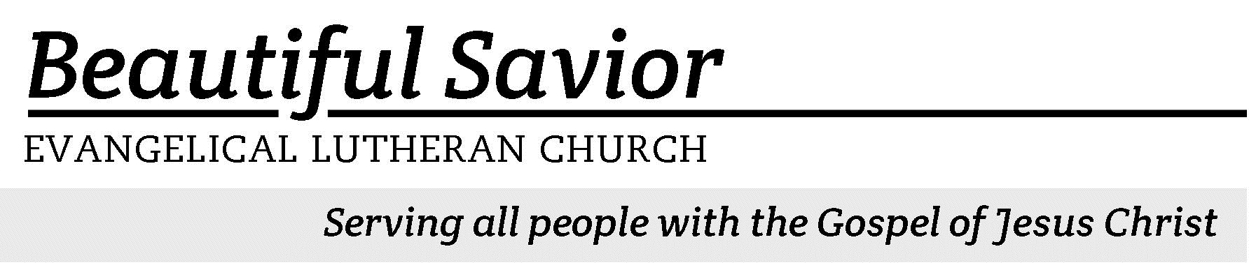


Welcome-- We are glad you could join us today! It is our hope that this service is a blessing to you. Please join us for worship again soon.

· Please save the last two rows of pews for parents with small children.

· Parents with little ones: If your child becomes restless during the service, that’s okay… We’re glad they’re here, and Jesus is pleased when they are brought to hear his Word: “Let the little children come to me.” If you need to be with your child in the Fellowship Hall, the service can be heard through a speaker.

· Five minutes before the worship service begins the usher will light the candles. This is our signal to quiet down and prepare our hearts for worship.

· Restrooms are conveniently located to the left as you exit the sanctuary.

· Please silence your cell phone before the start of the service.

Prayer for Worship
Lord Jesus, you are the Son of the Most High God and possess all power and glory. You have ascended to heaven and now rule over all things for the good of your church, your people. I pray that you would crush all evil in my life and send me your Holy Spirit that I may live and delight in the forgiveness that you have won for me. Bless my Worship today.
Amen.

Beautiful Savior Lutheran Church
2526 Whitfield Road
Clarksville, TN 37040
931-905-1400
Website: www.bslclarksville.com
Kent Holz, Pastor
Bslc.clarksville@gmail.com
Barbara Noon, Preschool Director
beautifulsaviorpreschool@gmail.com
738 The Son of God, Our Christ CW 738 sts. 1–3
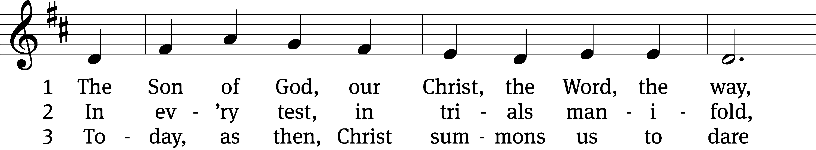
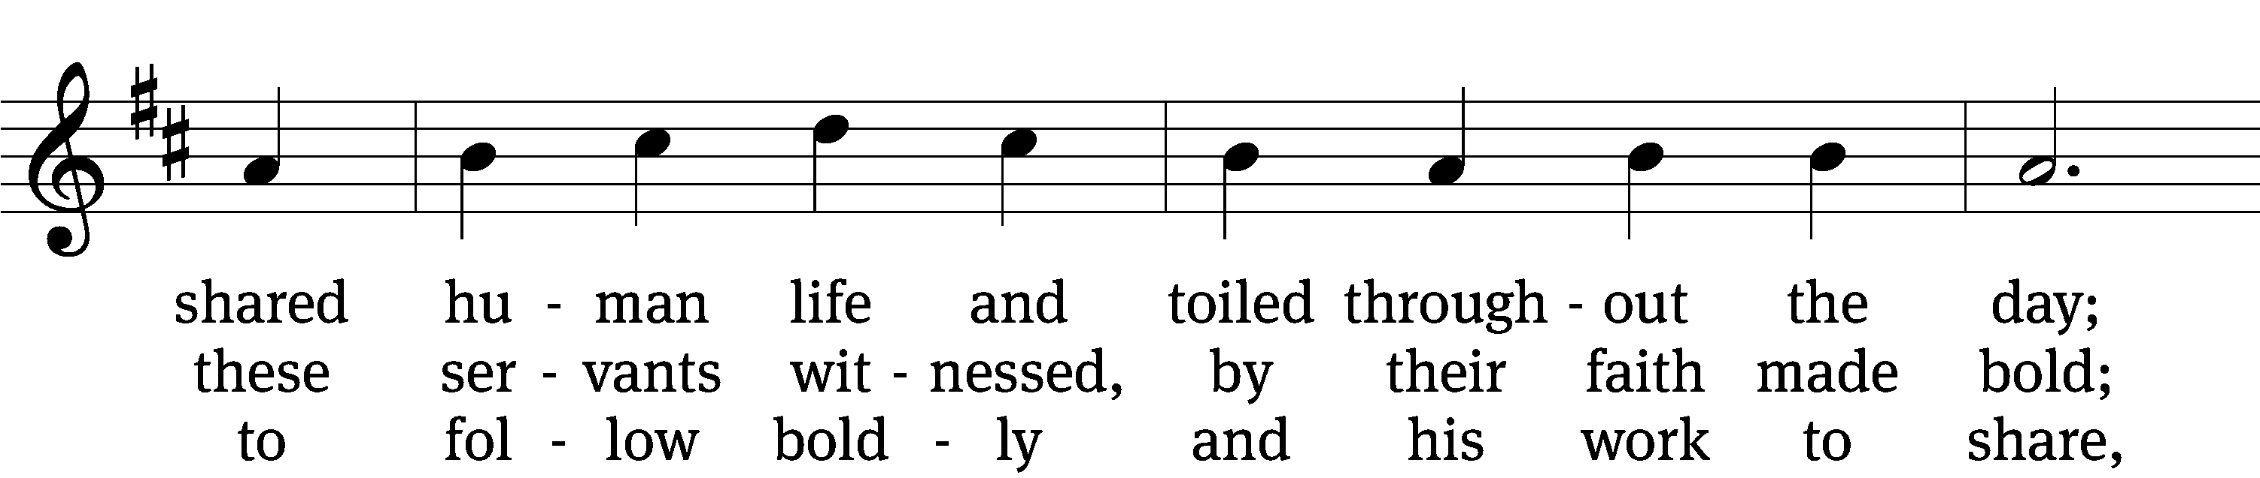
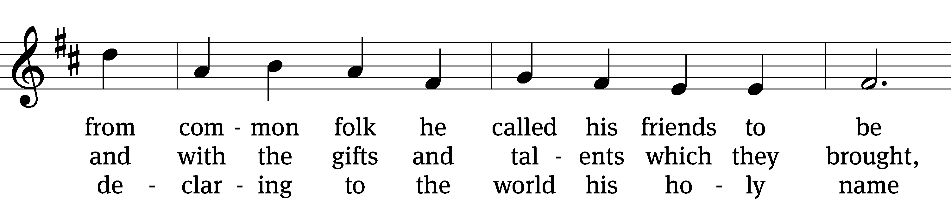
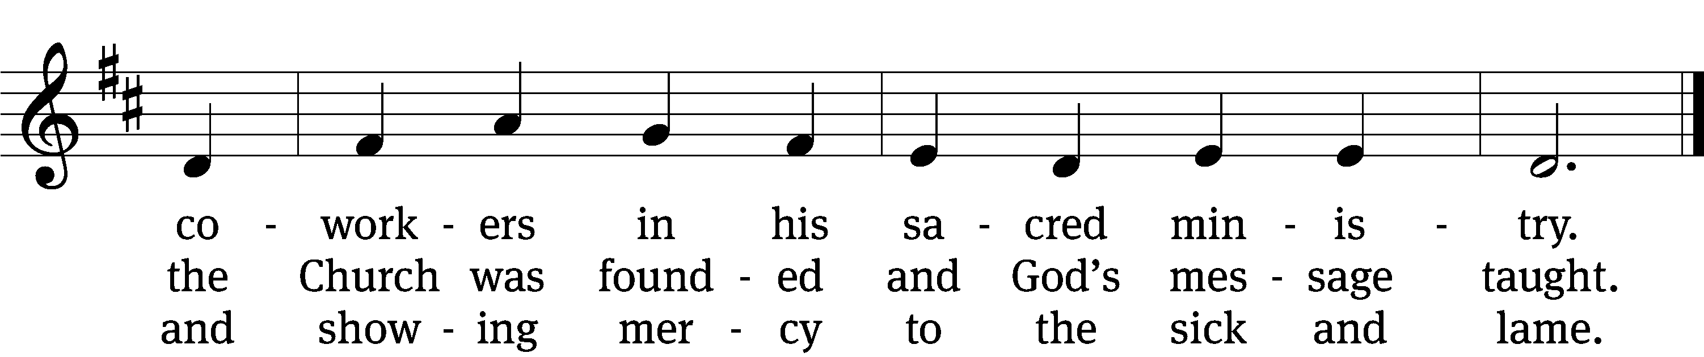
Text: Edward M. Blumenfeld, 1927–2013
Tune: Alfred M. Smith, 1879–1971
Text: © 1957, ren. 1985 The Hymn Society. Used by permission: OneLicense no. 716626
Tune: © 1990 Estate of Alfred M. Smith. Used by permission: OneLicense no. 716626

In the name of the Father and of the T Son and of the Holy Spirit.
Amen.
Confession
Since we are assembled to hear God's Word, and to call upon him in prayer, let
us consider how we have not been loving in our relationship with God and those around us; let us confess our sin before God, and call upon him for forgiveness and restoration. If you, O Lord, kept a record of sins,
O Lord, who could stand?

But with you there is forgiveness; therefore you are feared.
I confess to you, almighty God, that I have sinned against you in thought, word, and deed. I have not loved you above all things nor have I loved my neighbor as myself. I have been less than a friend. But I am truly sorry for my sins and sincerely repent of them. I pray for your forgiveness and mercy, which you have promised in Jesus Christ, who suffered and died for my sin as a loving friend and Savior.

For God so loved the world that he gave his one and only Son, that whoever believes in him will not perish, but have eternal life. You are forgiven for Jesus‘ sake. Through Jesus’ perfect life and death God has removed your guilt forever. You are his own dear child, may God give you strength to live according to his word.
In confidence of this, we say, “Amen!”
738 The Son of God, Our Christ CW 738 sts. 4–5
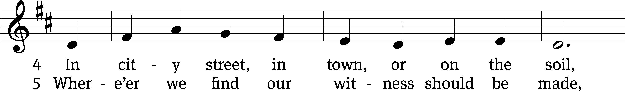
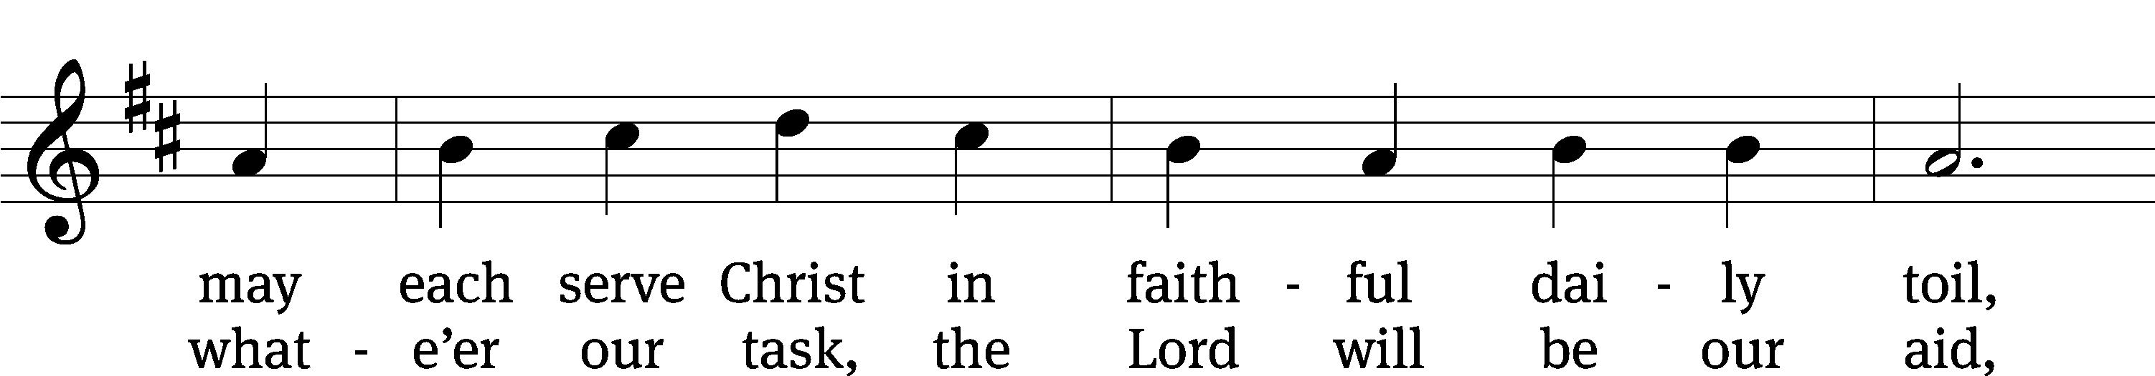
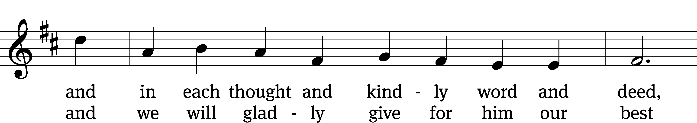
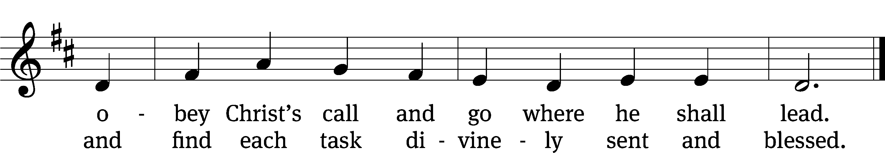
Text: Edward M. Blumenfeld, 1927–2013
Tune: Alfred M. Smith, 1879–1971
Text: © 1957, ren. 1985 The Hymn Society. Used by permission: OneLicense no. 716626
Tune: © 1990 Estate of Alfred M. Smith. Used by permission: OneLicense no. 716626

The Word

The Lord be with you.
And also with you.

Prayer of the Day
Let us pray.

Almighty and merciful God, you sent your Son, Jesus Christ, to seek and to save the lost. Graciously open our ears and our hearts to hear his call and follow him by faith that we may feast with him forever in his kingdom; through your Son, Jesus Christ our Lord, who lives and reigns with you and the Holy Spirit, one God, now and forever.
Amen.

First Reading Exodus 3:1–15
1Now Moses was tending the flock of Jethro his father-in-law, the priest of Midian, and he led the flock to the far side of the wilderness and came to Horeb, the mountain of God. 2There the angel of the Lord appeared to him in flames of fire from within a bush. Moses saw that though the bush was on fire it did not burn up. 3So Moses thought, “I will go over and see this strange sight—why the bush does not burn up.”
4When the Lord saw that he had gone over to look, God called to him from within the bush, “Moses! Moses!”
And Moses said, “Here I am.”
5“Do not come any closer,” God said. “Take off your sandals, for the place where you are standing is holy ground.” 6Then he said, “I am the God of your father, the God of Abraham, the God of Isaac and the God of Jacob.” At this, Moses hid his face, because he was afraid to look at God.
7The Lord said, “I have indeed seen the misery of my people in Egypt. I have heard them crying out because of their slave drivers, and I am concerned about their suffering. 8So I have come down to rescue them from the hand of the Egyptians and to bring them up out of that land into a good and spacious land, a land flowing with milk and honey—the home of the Canaanites, Hittites, Amorites, Perizzites, Hivites and Jebusites. 9And now the cry of the Israelites has reached me, and I have seen the way the Egyptians are oppressing them. 10So now, go. I am sending you to Pharaoh to bring my people the Israelites out of Egypt.”
11But Moses said to God, “Who am I that I should go to Pharaoh and bring the Israelites out of Egypt?”
12And God said, “I will be with you. And this will be the sign to you that it is I who have sent you: When you have brought the people out of Egypt, you will worship God on this mountain.”
13Moses said to God, “Suppose I go to the Israelites and say to them, ‘The God of your fathers has sent me to you,’ and they ask me, ‘What is his name?’ Then what shall I tell them?”
14God said to Moses, “I am who I am. This is what you are to say to the Israelites: ‘I am has sent me to you.’ ”
15God also said to Moses, “Say to the Israelites, ‘The Lord, the God of your fathers—the God of Abraham, the God of Isaac and the God of Jacob—has sent me to you.’
“This is my name forever,
the name you shall call me
from generation to generation.

119C Teach Me, O LORD Psalm 119C
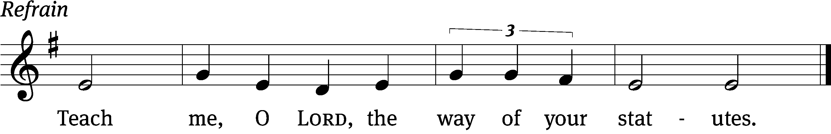


Do good to your / servant
according to your / word, Lord.
Teach me knowledge and good / judgment,
for I trust / your commands.
Before I was afflicted I / went astray,
but now I o- / bey your word. Refrain

You are good, and what you / do is good;
teach me / your decrees.
It was good for me to be af- / flicted
so that I might learn / your decrees.
The law from your mouth is more pre- / cious to me
than thousands of pieces of sil- / ver and gold.
Glory be to the Father and / to the Son
and to the Holy / Spirit,
as it was in the be- / ginning,
is now, and will be forever. / Amen. Refrain
Tune: Thomas Pavlechko
Setting: Thomas Pavlechko
Music: © 2004, 2012 Augsburg Fortress. Used by permission: OneLicense no. 716626

Second Reading 1 Timothy 1:12–17
12I thank Christ Jesus our Lord, who has given me strength, that he considered me trustworthy, appointing me to his service. 13Even though I was once a blasphemer and a persecutor and a violent man, I was shown mercy because I acted in ignorance and unbelief. 14The grace of our Lord was poured out on me abundantly, along with the faith and love that are in Christ Jesus.
15Here is a trustworthy saying that deserves full acceptance: Christ Jesus came into the world to save sinners—of whom I am the worst. 16But for that very reason I was shown mercy so that in me, the worst of sinners, Christ Jesus might display his immense patience as an example for those who would believe in him and receive eternal life. 17Now to the King eternal, immortal, invisible, the only God, be honor and glory for ever and ever. Amen.

Children's Devotion Ages 3 through grade 5 are invited to come forward for a Bible lesson.

Children's Church During the service, parents may choose to take their children (ages 2-5) to Children’s Church. There they will hear a Bible story, and sing songs. They will return to the sanctuary during the offering.

578 Chief of Sinners Though I Be CW 578 sts. 1–3, 5
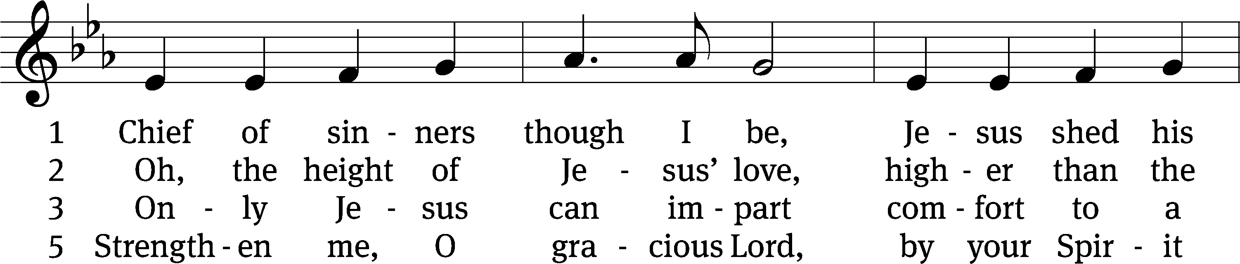
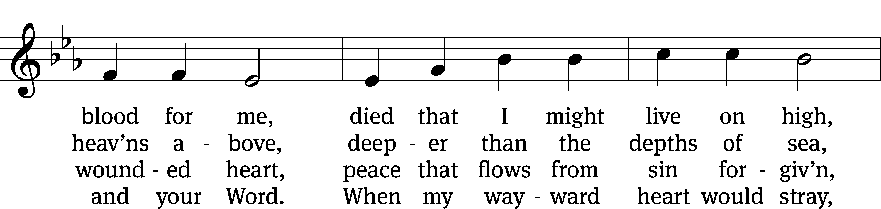
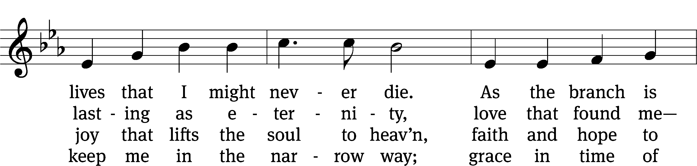
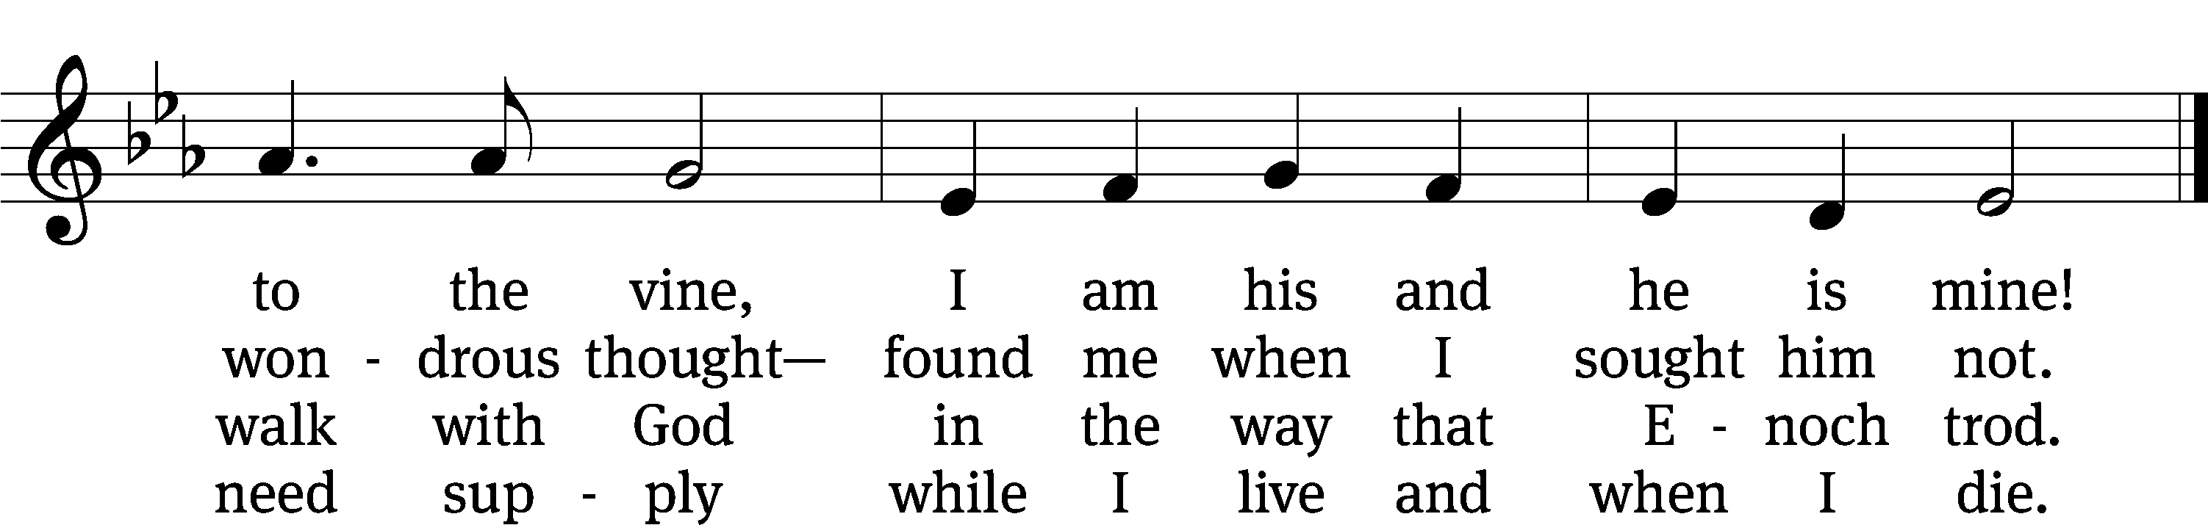
Text: William McComb, 1793–1873, alt.
Tune: Richard Redhead, 1820–1901
Text and tune: Public domain

Gospel Matthew 9:9–13
9As Jesus went on from there, he saw a man named Matthew sitting at the tax collector’s booth. “Follow me,” he told him, and Matthew got up and followed him.
10While Jesus was having dinner at Matthew’s house, many tax collectors and sinners came and ate with him and his disciples. 11When the Pharisees saw this, they asked his disciples, “Why does your teacher eat with tax collectors and sinners?”
12On hearing this, Jesus said, “It is not the healthy who need a doctor, but the sick. 13But go and learn what this means: ‘I desire mercy, not sacrifice.’ For I have not come to call the righteous, but sinners.”

“Take your place at Jesus’ table”
Apostles’ Creed
I believe in God, the Father Almighty,
maker of heaven and earth.

I believe in Jesus Christ, his only Son, our Lord,
who was conceived by the Holy Spirit,
born of the Virgin Mary,
suffered under Pontius Pilate,
was crucified, died, and was buried.
He descended into hell.
The third day he rose again from the dead.
He ascended into heaven
and is seated at the right hand of God the Father Almighty.
From there he will come to judge the living and the dead.

I believe in the Holy Spirit,
the holy Christian Church,
the communion of saints,
the forgiveness of sins,
the resurrection of the body,
and the life everlasting. Amen.

Offering “We love because he first loved us.” 1Jn 4:19 God’s love in sending Jesus to live, to suffer, and to die for each of us motivates the members of Beautiful Savior to show their love and thanks by returning a portion of their income to the Lord. Through these free will offerings, this congregation and its ministries are maintained.
Offerings are collected in the offering plate at the back of the sanctuary. If you would like to give securely online, scan this code or follow this link: bslclarksville.com



Prayer of the Church
Lord God, our maker and preserver, we praise and thank you for all that you give us day after day.
We are not worthy of all the mercies you show us.

You have given us your precious Word to nourish our souls and to protect us from the temptations of the devil, the world and our sinful nature.
We thank you for those who teach and preach your saving truth at this place and everywhere. Grant them a rich measure of patience wisdom and love.

Heavenly Father, we pray that you shield us from every kind of danger: sudden catastrophe, terrors of crime, and the pain of disease. Watch over those who travel by land, sea and air. Keep our loved ones from whatever perils may threaten them.
Heal those who are sick, cheer those who are sad, calm those who are distressed and comfort all who are old and infirm.

Bless our land, our people and those who hold offices of high trust. Keep our government and schools upright for the advancement of good citizenship and useful vocations that we may enjoy your gifts of peace, security and well being.
Grant your blessing to every nation on earth. Where there are wars, may there be peace. Where there is hatred, let it be healed. Where there is poverty, danger, or disaster, come with your almighty power to help and restore.

Special Prayers

Hear us, Lord, as we bring you our private petitions.

We bring these requests before you in the name of Jesus our Lord and ask you to hear us. Take all that we have--our bodies and minds, our time and skills, our ministries and offerings, and use them to your glory.
We give ourselves to you that we may serve you in whatever way is pleasing in your sight. Amen.

Lord’s Prayer
Our Father, who art in heaven,
hallowed be thy name,
thy kingdom come,
thy will be done
on earth as it is in heaven.
Give us this day our daily bread;
and forgive us our trespasses,
as we forgive those
who trespass against us;
and lead us not into temptation,
but deliver us from evil.
For thine is the kingdom
and the power and the glory
forever and ever. Amen.

575 By Grace I’m Saved CW 575 sts. 1–2, 5
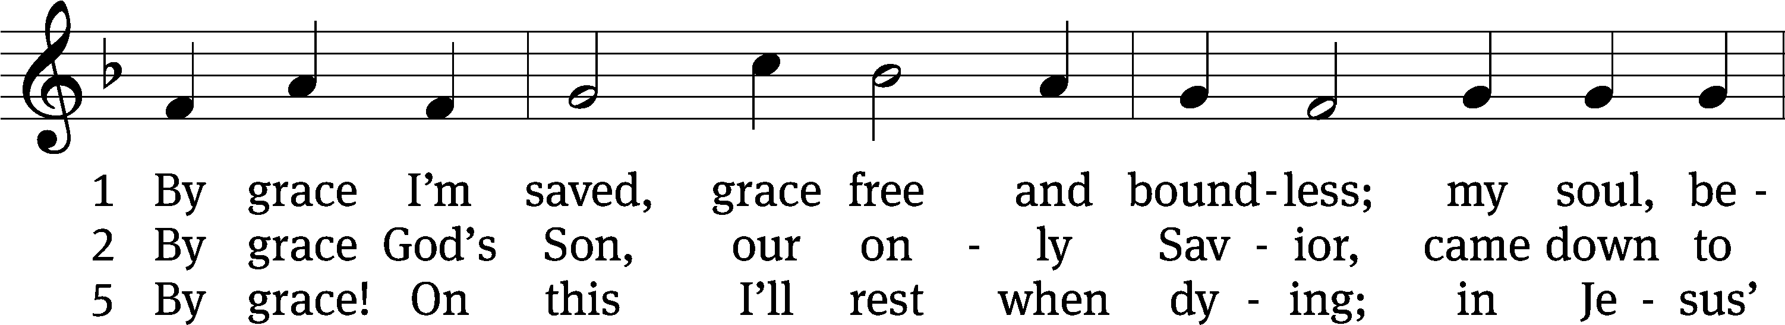
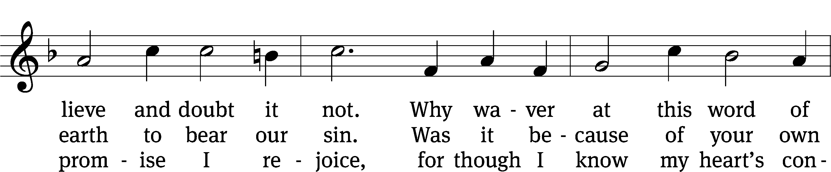
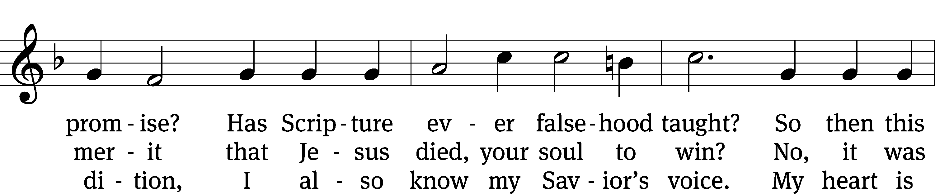
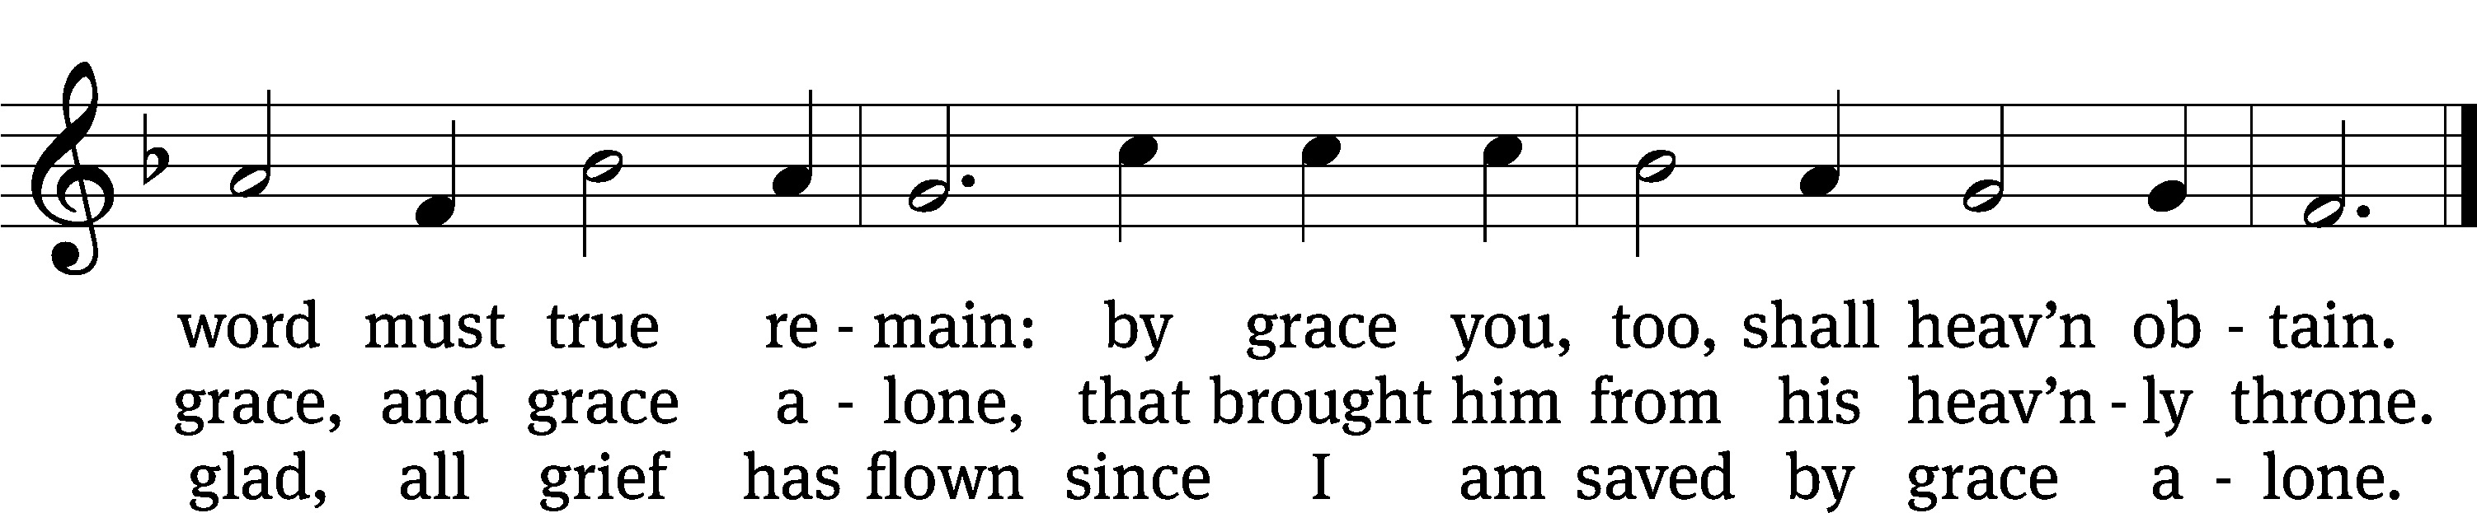
Text: tr. The Lutheran Hymnal, 1941, alt.; Christian L. Scheidt, 1709–1761, abr.
Tune: Cornelius H. Dretzel, 1697–1775
Text and tune: Public domain

Closing Prayer
How can I thank you, Father, for allowing me to worship in your house today! I have heard the promises of your love in the gospel. I have praised you, confessed you, and prayed for your blessings. I have been strengthened by the witness and worship of others. Keep my faith strong as I live out the tasks of my life, take away my doubts and fears, and give me courage to share the good news of your Son wherever I go and however I can.
Amen.

Blessing
The Lord bless you and keep you.
The Lord make his face shine on you and be gracious to you.
The Lord look on you with favor and T give you peace.
Amen.

896 Dear Lord, to Your True Servants Give CW 896
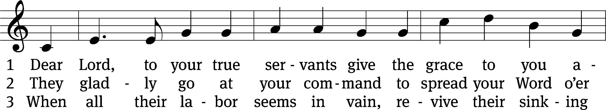
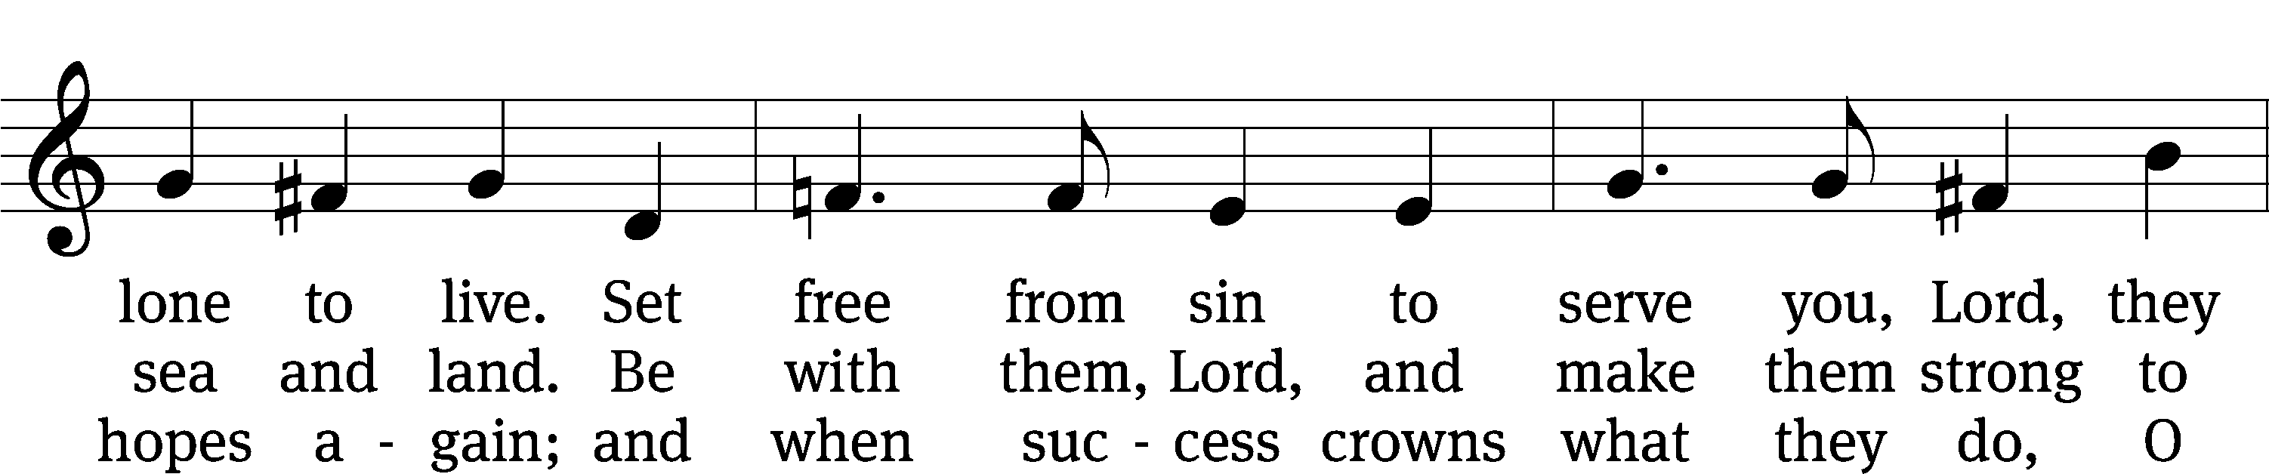
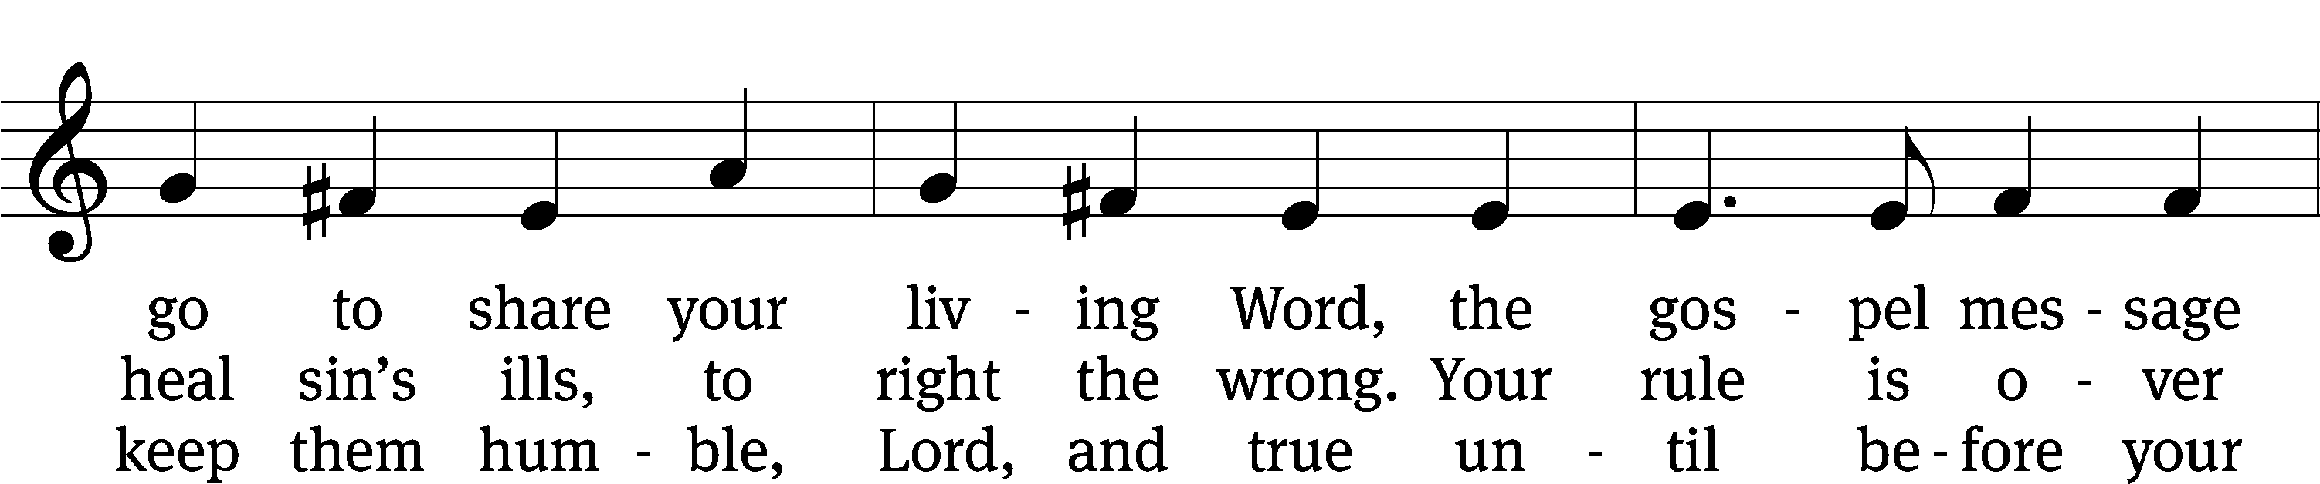
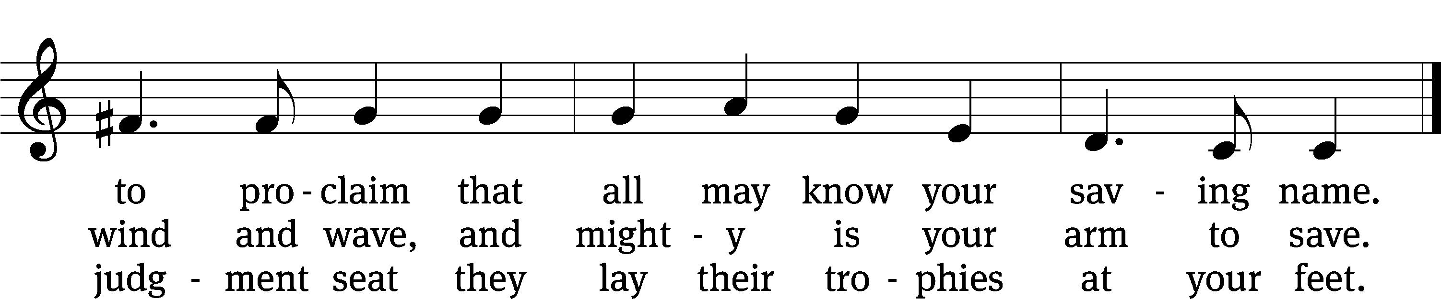
Text: W. Gustave Polack, 1890–1950, alt.
Tune: John B. Dykes, 1823–1876
Text: © 1941 Concordia Publishing House. Used by permission: OneLicense no. 716626
Tune: Public domain
Acknowledgments
Setting One from Christian Worship
Unless otherwise indicated, Scripture quotations are from The Holy Bible, New International Version®, NIV®. Copyright © 1973, 1978, 1984, 2011 by Biblica, Inc.TM Used by permission of Zondervan. All rights reserved worldwide.
Software distributed in partnership with Northwestern Publishing House.
Created by Christian Worship: Service Builder © 2023 Concordia Publishing House.

Next Week’s Worship
Our theme for worship: The Holy Ministry Demonstrates Compassion for God’s People. Our readings will be: Numbers 27: 15-23, 1 Corinthians 4: 1-7, and Matthew 9: 35-10:8. We will sing the following hymns: 716 O Christ, Who Called the Twelve, 897 Lord Jesus, You Have Come, 736 Lord, You Call Us as Your People, and 927 Lord, Dismiss Us with Your Blessing.

THIS WEEK AT BEAUTIFUL SAVIOR
† Today 9:15am Sunday School
10:30am Worship
12 pm Bible Information Class
† Monday 12 pm Board of Ed Meeting
† Wednesday 7pm No Bible Study this week
† Sunday 9:15am Sunday School
10:30am Worship
12pm Bible Information Class

Summer Sunday School-Volunteers Needed!
We are in need of 4 volunteers to teach summer Sunday School on June 4th, 11th, 18th, and 25th. All lessons will be provided. If interested, please use the sign-up sheet in the entryway. If you have any questions, please contact Jennifer Geer at 615-944-2062 or Pastor Holz.

Wednesday Evening Bible Study
This summer we are beginning a Bible Study called “Connecting Sinai To Calvary: A Guide To The Old Testament.” The book helps explain important and sometimes complex Old Testament concepts in simple terms. The author sheds light on the religion, culture, language, geography, and everyday life of the Israelites to help you better appreciate all of Scripture. Ultimately, the book demonstrates how God was intimately involved in the daily lives of his people, how he revealed his plan of salvation to them, and why Jesus is really the central figure of the Old Testament. To take part you will need to buy the book. Sign-up sheet is in the entry way.

Altar Flower Sign-up
If you would like to provide flowers for a Sunday Service, please see the sign-up chart near the entry way table. It can be for a special occasion, or simply to beautify our altar on a Sunday morning. If you have questions, contact Eileen Cleveland at 239-410-6366 or email at thedoll48@gmail.com

God’s Show and Tell: A Study on the Sacraments
Starting next week, June 18, we will begin a 6 week Sunday morning Bible Study on the Sacraments of Baptism and the Lord’s Supper. Bible Study begins at 9:30 on Sundays in the fellowship hall. Everything you need is provided.

Lawn Maintenance

We are looking for volunteers to cut the grass throughout the summer. We have a zero-turn lawn mower, trimmer, and leaf blower. We even provide the gas! What we need are people willing to spend some time on a Friday or Saturday getting the property ready for church on Sunday. If you would like to help, please see the sign-up sheet in the entry-way. If you have questions, talk to Pastor.
Pastor at Conference this week
Pastor Holz will be attending our District Called Worker Continuing Education Conference this week in Doral, FL. He will be out of the office Monday-Thursday but back in the office Friday.

Lunch Bunch
Lunch Bunch will take place Wednesday, June 21st, at 11:30am. Lunch will be served here at church for our older and/or retired members and friends. If you would like to attend please sign up so the hosts can get an accurate headcount for the meal preparations. A free will offering will be taken to cover the cost of the meal. After the meal there will be a short devotion. This will be a great opportunity for fellowship and a chance to get to know other people. If you have questions, please talk with Doris Harvey or Pastor Holz.

Parent-Child Relationship Presentation
Rock of Ages Lutheran Church in Madison (Nashville) is offering a presentation called “Loving and Leading: Building a Strong Parent-Child Relationship.” The presentation will be given by Julie Straseske, a counselor from Christian Family Solutions. It will take place on Thursday, July 27, from 7pm-8pm. The presentation is free and child care will be provided if needed. Questions? Call Jordan Burmeister from Rock of Ages at 602-578-7127.

Summer Camps
Summer Camp themes and dates have been decided. Camps are open to all children ages 3 years old through 3rd grade. Registration is now open to current preschool and church families. Registration opens to the public on May 1st. Dates and themes are as follows: June 26-30 Fabulous Fables and Tales, July 10-14 Cooking with Kids, and July 17-21 Water, Water Everywhere. If you have any questions or would like more information, please call the office at 931-905-1400.

Prayer List

Thank the Lord for the safe return of all the soldiers who recently came home and all soldiers and their families who are facing deployment. Please keep in your prayers this week all soldiers who are currently deployed. Please also remember: Curt Holz, brother of Pastor Holz (cancer); Bob Housh (Injured in fall); Family of Marcia Carter, sister of Tim Donner (Marcia called home to heaven); Sandy Holz, sister of Gael Irizarry (pneumonia); Renate Banks (illness); Shan Bradford, daughter of Porter Matthew and friend of Margareta Smothers, (injured in car accident); Marlys Donner, mother of Tim Donner (declining health); Josh Carter, friend of Adam Holz (recovery from car accident); Stacy Schroeder, daughter of Jeff & Eileen Cleveland (melanoma diagnosis); Autumn Potter & family, friends of Jessica Boulter (death of sister); Aimee Gerkhardt, sister in law of Jessica Church (breast cancer); Steven Owens, father of Mark Owens, (cancer); Kathy Temple (cancer reoccurrence); Brandon Vannoy, friend of Mac McCoo (seizures); Sheila Lynch, sister of Gayle Brooks (unable to walk); Drake Robideau, friend of Mary Daniel (strength & wellness); Mike LaFave (back problems); Linda Thomas, sister of Gayle Brooks, (physical rehab after injury); Ruth Amorth, twin sister of Hilde Fox (seriously ill); Gary Davis, husband of Angela Davis (seizures); Gidget Tate (Health issues). If you would like to have a name or situation included or if you would like to give an update on a prayer request, please contact Pastor Holz or call the church office at 931-905-1400.

Serving in God’s House

Ushers: David J, Ernie R
Greeters: Doris H, John H
Kitchen: Ingeborg H, Hannah L, Mary D
Piano: Barb Noon
Fellowship: (H-M)

Serving next week:

Ushers: Daniel L, Josh G
Greeters: Art & Sandy E
Kitchen: Charmaine S, Mary D
Piano: Barb N
Fellowship: (N-S)

