Beautiful Savior Lutheran Church

April 9th, 2023 – Resurrection of Our Lord

service theme: he lives to take me from death to life

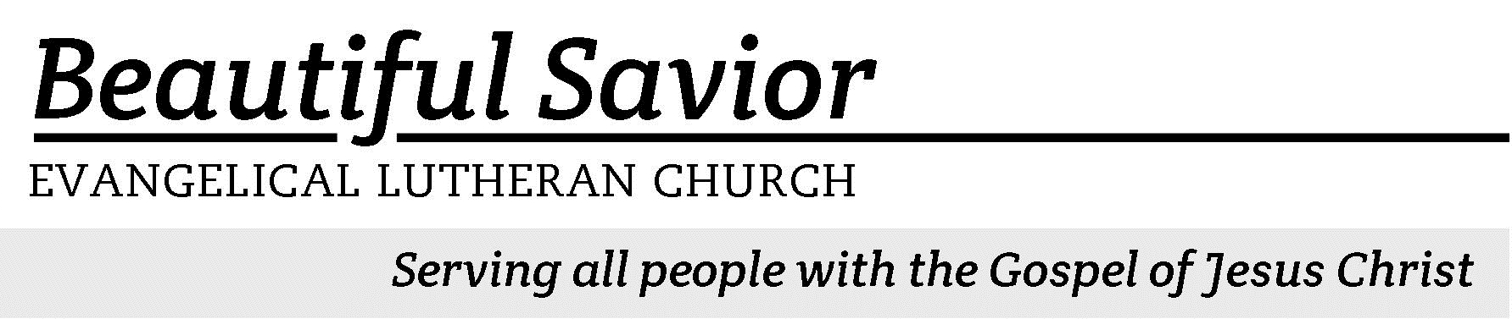


Welcome-- We are glad you could join us today! It is our hope that this service is a blessing to you. Please join us for worship again soon.

· Please save the last two rows of pews for parents with small children.

· Parents with little ones: If your child becomes restless during the service, that’s okay… We’re glad they’re here, and Jesus is pleased when they are brought to hear his Word: “Let the little children come to me.” If you need to be with your child in the Fellowship Hall, the service can be heard through a speaker.

· Five minutes before the worship service begins the usher will light the candles. This is our signal to quiet down and prepare our hearts for worship.

· Restrooms are conveniently located to the left as you exit the sanctuary.

· Please silence your cell phone before the start of the service.



Beautiful Savior Lutheran Church
2526 Whitfield Road
Clarksville, TN 37040
931-905-1400
Website: www.bslclarksville.com
Kent Holz, Pastor
Bslc.clarksville@gmail.com
Barbara Noon, Preschool Director
beautifulsaviorpreschool@gmail.com
Easter Greeting
Christ is risen!
He is risen indeed.

This is the day the Lord has made.
We will rejoice and be glad in it.

I will not die but live, and will proclaim what the Lord has done.
Christ has died. Christ is risen. Christ will come again.

I know that my Redeemer lives, and that in the end he will stand upon the earth.
Worthy is the Lamb, who was slain, to receive power and wealth and wisdom and strength and honor and glory and praise!

The Lamb at the center of the throne will be our shepherd; he will lead us to springs of living water.
And God will wipe away every tear from our eyes.

438 Jesus Christ Is Risen Today CW 438 sts. 1–3
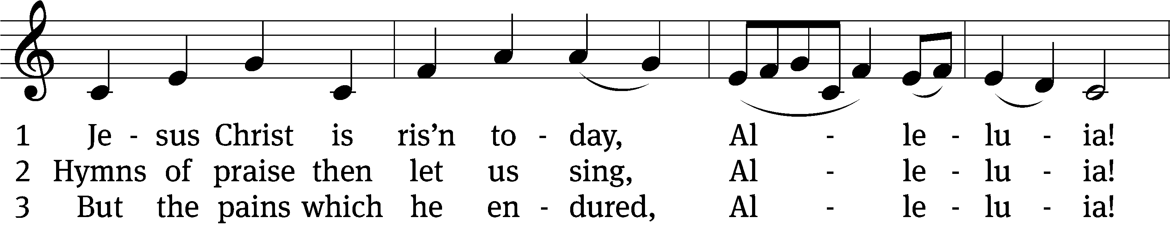
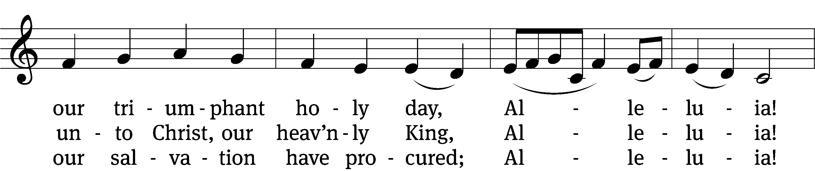
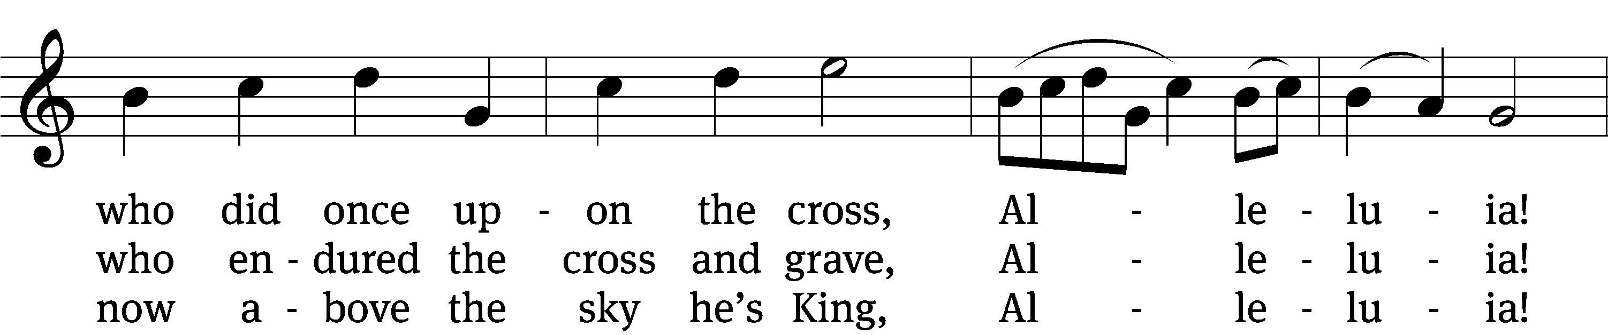
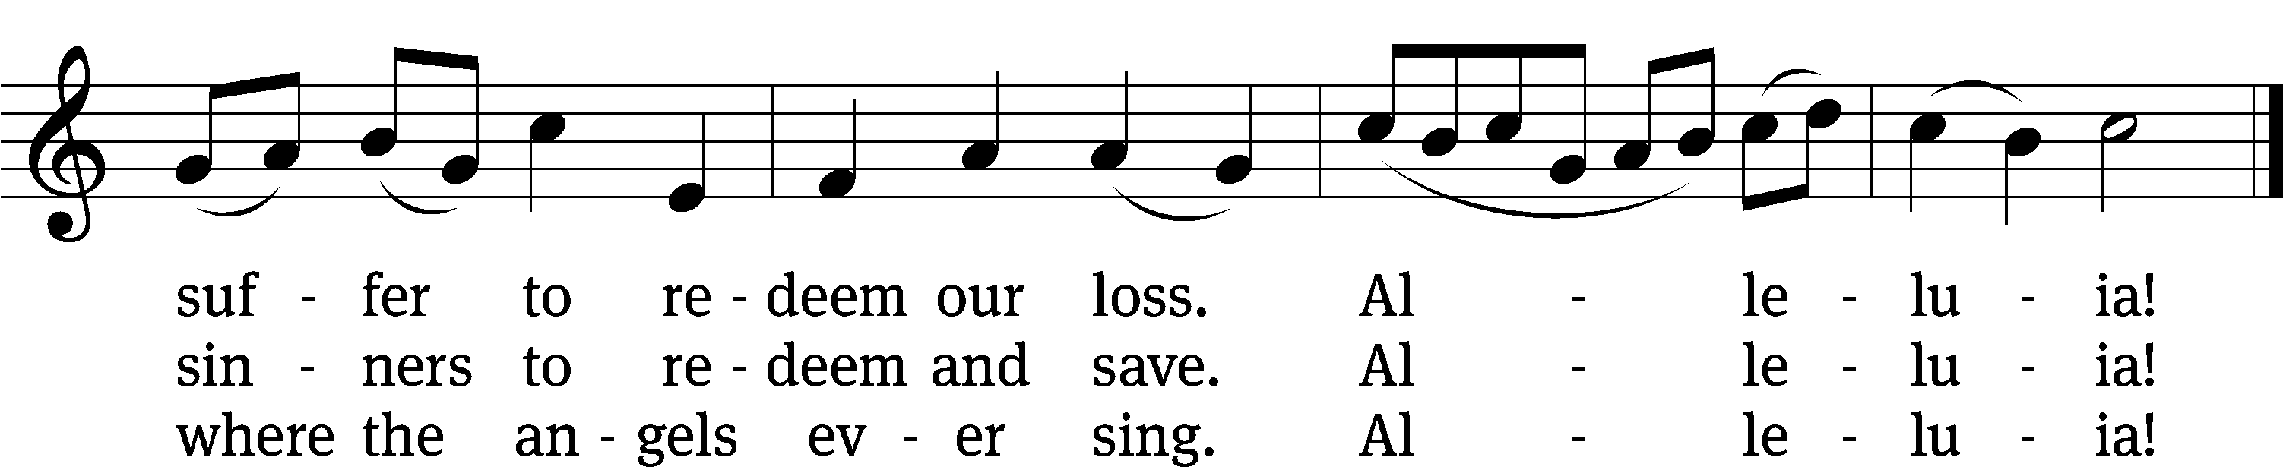
Text: tr. Lyra Davidica, 1708, alt.; Latin, 14th cent.
Tune: Lyra Davidica, London, 1708
Text and tune: Public domain
Easter Confession and Proclamation
Today we come to God in worship. God is the Eternal King, the Lord of holiness, the Creator of all. It is his will that we live in purity before him, in love with all people, and in line with his holy Word. But we realize that our words and actions do not live up to his perfect standard. For that reason, this morning we begin our worship in humble confession before God.

Lord God, forgive our wandering ways. For all of our sins— the open and obvious, and also the secret and unspoken, we ask for your forgiveness. So often we have ignored your Word and spurned your help. For these and all our sins we ask for your forgiveness.

God so loved the world that he gave his one and only Son— Jesus Christ. By the perfect life and innocent death of our Lord Jesus Christ, you are saved from the curse of sin and completely forgiven. By the resurrection of our Lord Jesus, death has no power over you!
Thank you, Lord, for your free and undeserved love. Give us joy in your victory, for it is ours as well!

438 Jesus Christ Is Risen Today CW 438 st. 4

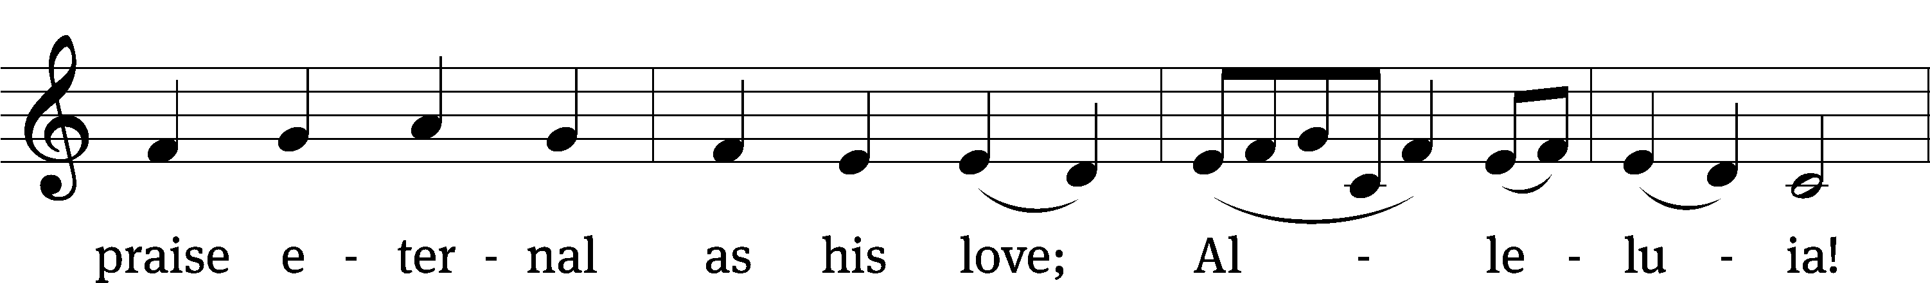
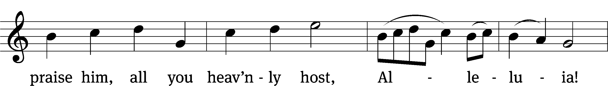

Text: Charles Wesley, 1707–1788
Tune: Lyra Davidica, London, 1708
Text and tune: Public domain
Prayer of the Day
Almighty God, by the glorious resurrection of your Son Jesus Christ, you conquered death and opened the gate to eternal life. Grant that we, who have been raised with him through baptism, may walk in newness of life and ever rejoice in the hope of sharing his glory; through Jesus Christ our Lord, to whom, with you and the Holy Spirit be dominion and praise now and forever.
Amen.

First Reading Jonah 2:2–9
2He said:
“In my distress I called to the Lord,
and he answered me.
From deep in the realm of the dead I called for help,
and you listened to my cry.
3You hurled me into the depths,
into the very heart of the seas,
and the currents swirled about me;
all your waves and breakers
swept over me.
4I said, ‘I have been banished
from your sight;
yet I will look again
toward your holy temple.’
5The engulfing waters threatened me,
the deep surrounded me;
seaweed was wrapped around my head.
6To the roots of the mountains I sank down;
the earth beneath barred me in forever.
But you, Lord my God,
brought my life up from the pit.
7“When my life was ebbing away,
I remembered you, Lord,
and my prayer rose to you,
to your holy temple.
8“Those who cling to worthless idols
turn away from God’s love for them.
9But I, with shouts of grateful praise,
will sacrifice to you.
What I have vowed I will make good.
I will say, ‘Salvation comes from the Lord.’ ”

461 He Is Arisen! Glorious Word CW 461
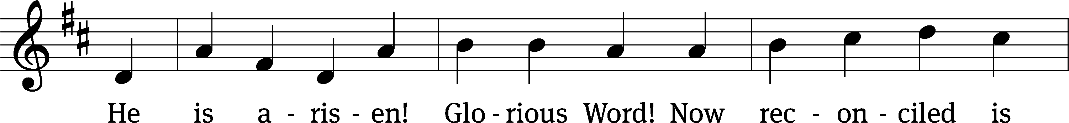
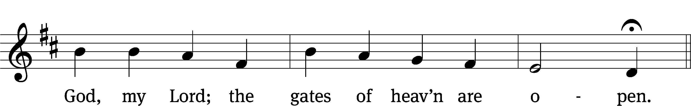
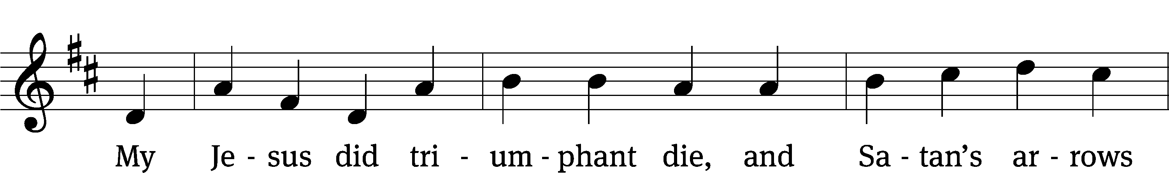
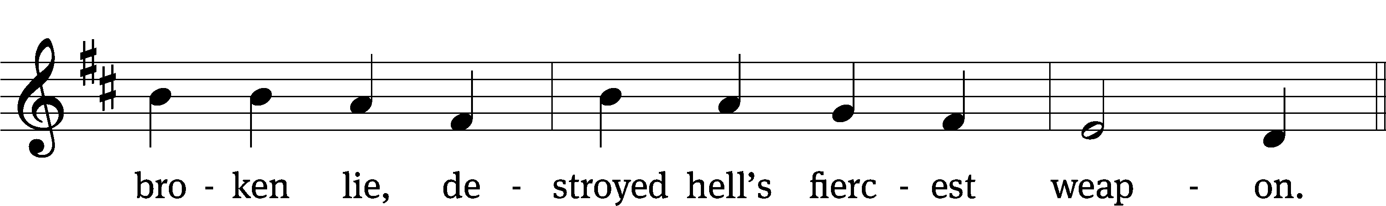

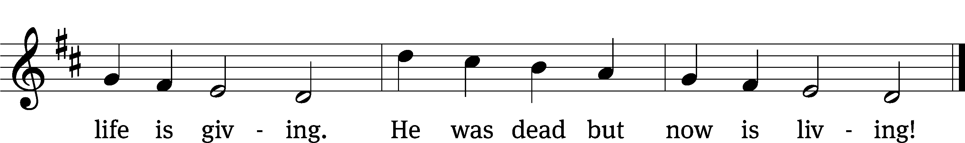
Text: tr. George A. T. Rygh, 1860–1942, alt.; Birgitte K. Boye, 1742–1824
Tune: Philipp Nicolai, 1556–1608
Text and tune: Public domain

Gospel Matthew 28:1–10
1After the Sabbath, at dawn on the first day of the week, Mary Magdalene and the other Mary went to look at the tomb.
2There was a violent earthquake, for an angel of the Lord came down from heaven and, going to the tomb, rolled back the stone and sat on it. 3His appearance was like lightning, and his clothes were white as snow. 4The guards were so afraid of him that they shook and became like dead men.
5The angel said to the women, “Do not be afraid, for I know that you are looking for Jesus, who was crucified. 6He is not here; he has risen, just as he said. Come and see the place where he lay. 7Then go quickly and tell his disciples: ‘He has risen from the dead and is going ahead of you into Galilee. There you will see him.’ Now I have told you.”
8So the women hurried away from the tomb, afraid yet filled with joy, and ran to tell his disciples. 9Suddenly Jesus met them. “Greetings,” he said. They came to him, clasped his feet and worshiped him. 10Then Jesus said to them, “Do not be afraid. Go and tell my brothers to go to Galilee; there they will see me.”

Children's Devotion Ages 3 through grade 5 are invited to come forward for a Bible lesson.

Children's Church During the service, parents may choose to take their children (ages 2-5) to Children’s Church. There they will hear a Bible story, and sing songs. They will return to the sanctuary during the offering

447 Christ Is Risen, He Is Risen Indeed (cong. Joins starting with v.4 refrain)
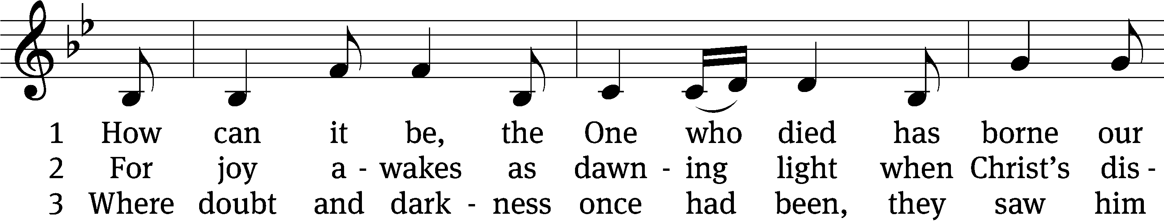
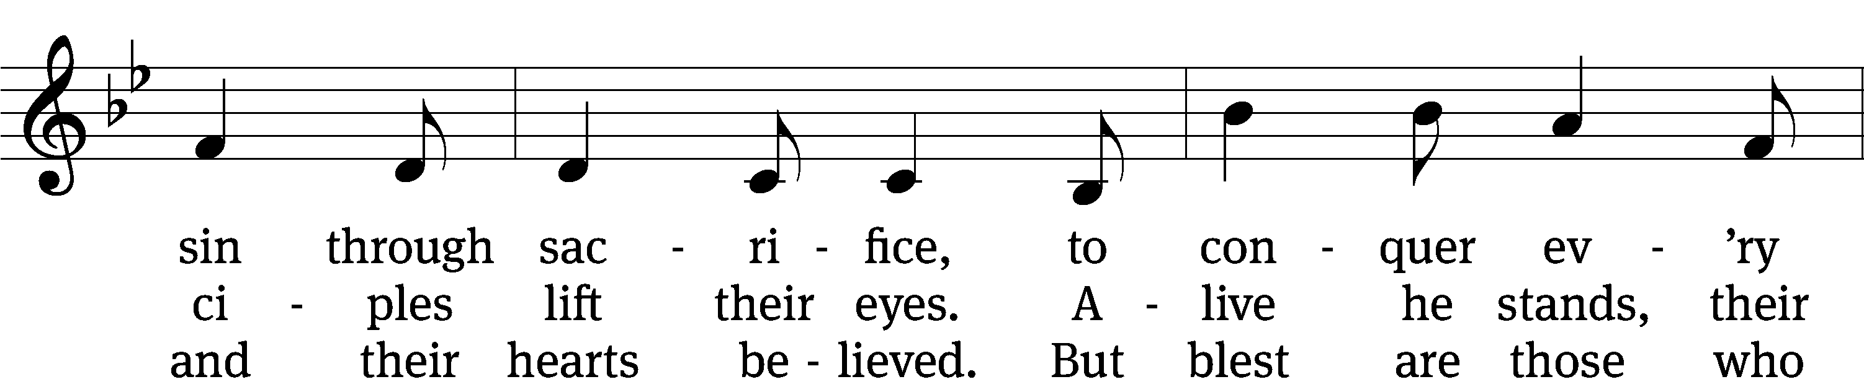
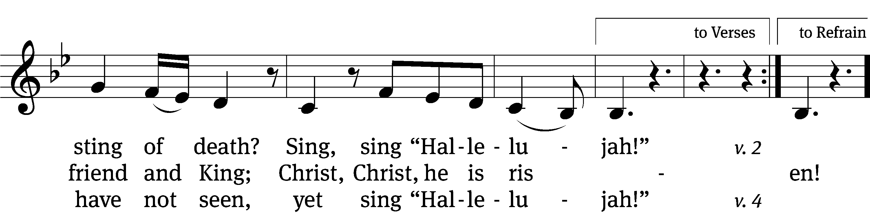
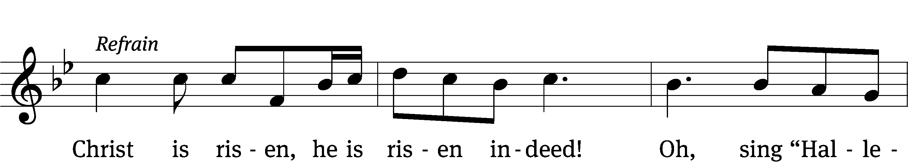
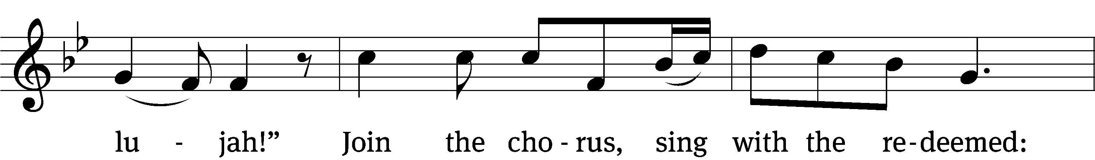
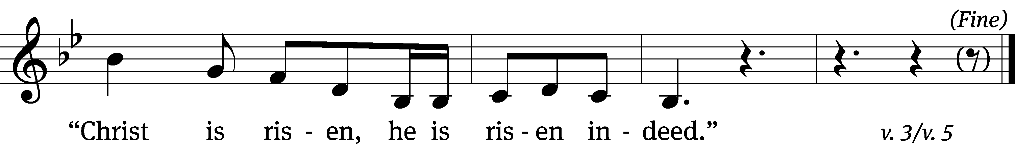

4 Once bound by fear, now bold in faith,
they preached the truth and pow’r of grace
and pouring out their lives they gained
life, life everlasting. (Refrain)

5 The pow’r that raised him from the grave
now works in us to pow’rf’lly save.
He frees our hearts to live his grace;
go, tell of his goodness. (Refrain)
Text: Ed Cash, b. 1971; Kristyn Getty, b. 1980; Keith Getty, b. 1974
Tune: Ed Cash, b. 1971; Kristyn Getty, b. 1980; Keith Getty, b. 1974
Text and tune: © 2012 Getty Music and Alletrop Music, admin. MusicServices.org and Capitol CMG Publishing. Used by permission: OneLicense no. 716626

Sermon 1 Corinthians 15:1–11
1Now, brothers and sisters, I want to remind you of the gospel I preached to you, which you received and on which you have taken your stand. 2By this gospel you are saved, if you hold firmly to the word I preached to you. Otherwise, you have believed in vain.
3For what I received I passed on to you as of first importance: that Christ died for our sins according to the Scriptures, 4that he was buried, that he was raised on the third day according to the Scriptures, 5and that he appeared to Cephas, and then to the Twelve. 6After that, he appeared to more than five hundred of the brothers and sisters at the same time, most of whom are still living, though some have fallen asleep. 7Then he appeared to James, then to all the apostles, 8and last of all he appeared to me also, as to one abnormally born.
9For I am the least of the apostles and do not even deserve to be called an apostle, because I persecuted the church of God. 10But by the grace of God I am what I am, and his grace to me was not without effect. No, I worked harder than all of them—yet not I, but the grace of God that was with me. 11Whether, then, it is I or they, this is what we preach, and this is what you believed.

“Easter Matters”
Apostles’ Creed
I believe in God, the Father Almighty,
maker of heaven and earth.

I believe in Jesus Christ, his only Son, our Lord,
who was conceived by the Holy Spirit,
born of the Virgin Mary,
suffered under Pontius Pilate,
was crucified, died, and was buried.
He descended into hell.
The third day he rose again from the dead.
He ascended into heaven
and is seated at the right hand of God the Father Almighty.
From there he will come to judge the living and the dead.

I believe in the Holy Spirit,
the holy Christian Church,
the communion of saints,
the forgiveness of sins,
the resurrection of the body,
and the life everlasting. Amen.


Offering “We love because he first loved us.” 1Jn 4:19 God’s love in sending Jesus to live, to suffer, and to die for each of us motivates the members of Beautiful Savior to show their love and thanks by returning a portion of their income to the Lord. Through these free will offerings, this congregation and its ministries are maintained.*If you would like to give your regular offering envelope, you can mail it to the church. If you would like to give securely online, scan this code or follow this link: bslclarksville.com
Prayer of the Day
Heavenly Father, God of grace, you have brought us into a new and living hope by the resurrection of Jesus from the dead.
Christ is risen!

We marvel at the love you showed by your willingness to sacrifice your Son to pay for our sins; we bow down in adoration at your mighty power, which raised him from the dead.
We praise you for sending the true Life and Light into the world.

Lord Jesus, God of grace, you have filled our hearts with resurrection joy by your victory over sin, death, and the grave.
You have conquered the darkness and given us comfort and hope.

Dear Savior, we who are weary and burdened come to you for rest, knowing that because of your perfect redemption there is now no condemnation for us.
You are risen indeed!

Take away our doubts and fears, and daily renew in us the joy of our salvation.
Alleluia!

Holy Spirit, God of grace, you have called us by the gospel and brought us to saving faith in our risen Lord.
We glorify you for opening our eyes to see the light of life.

Keep us with Jesus Christ in the one true faith.
He is risen!

As we journey through life, make us yearn for the day when you will give eternal life to us and all believers in Christ.
He is risen indeed!

Work through us as we proclaim the saving message of the crucified and risen Jesus near and far, so that many others may hear your call, obtain the salvation that is in Christ Jesus, and join us before the throne of our God and of the Lamb.
Alleluia! For our Lord God Almighty reigns. Alleluia! Amen.

Lord’s Prayer
Our Father, who art in heaven,
hallowed be thy name,
thy kingdom come,
thy will be done
on earth as it is in heaven.
Give us this day our daily bread;
and forgive us our trespasses,
as we forgive those
who trespass against us;
and lead us not into temptation,
but deliver us from evil.
For thine is the kingdom
and the power and the glory
forever and ever. Amen.
510 In Christ Alone CW 510
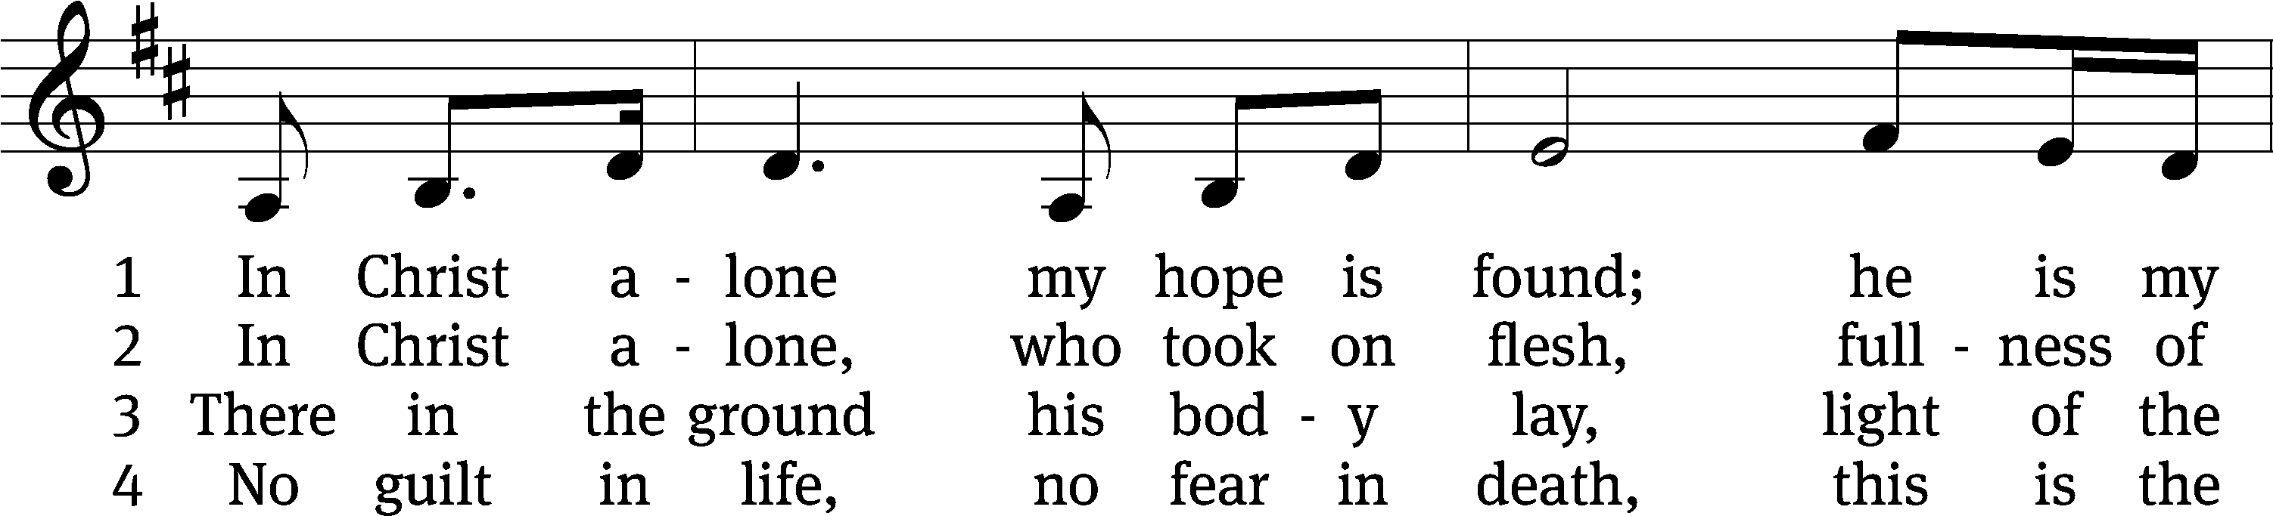
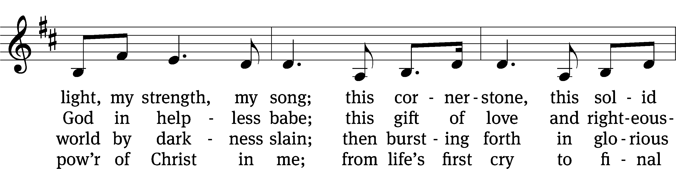
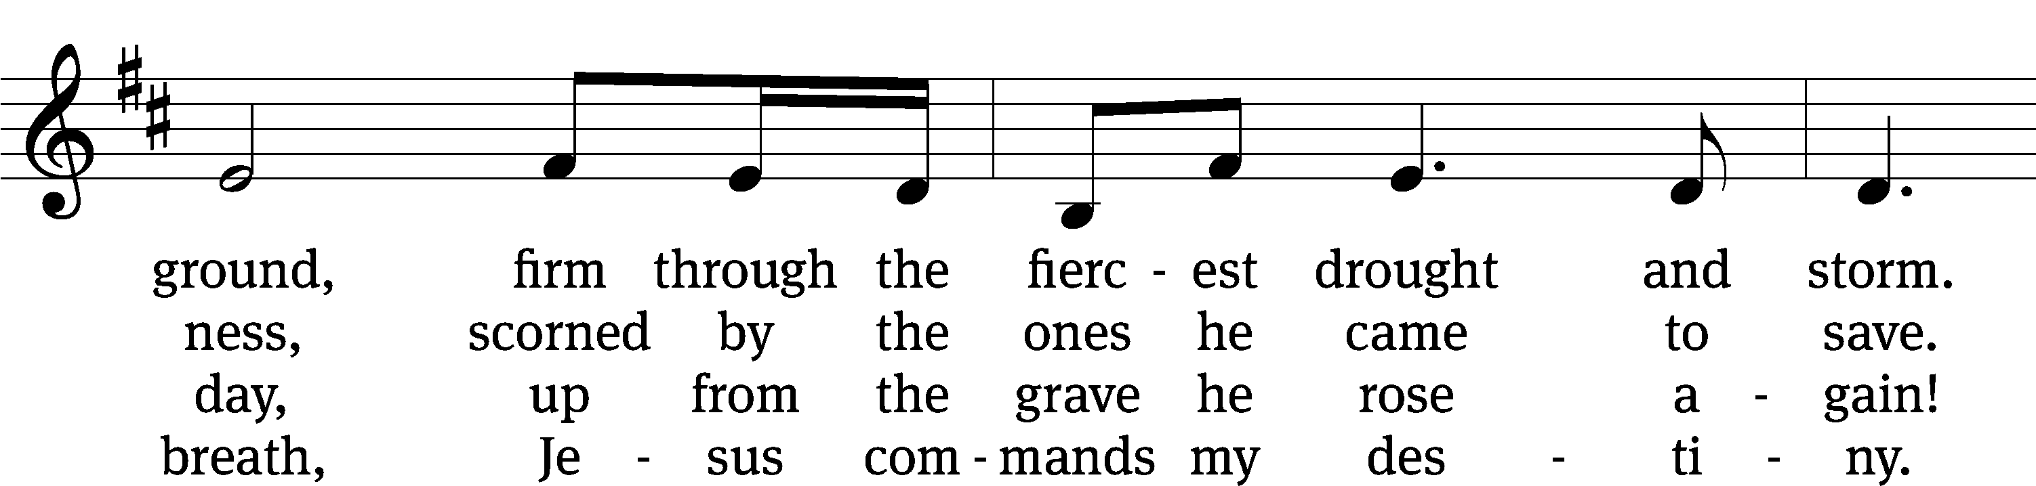
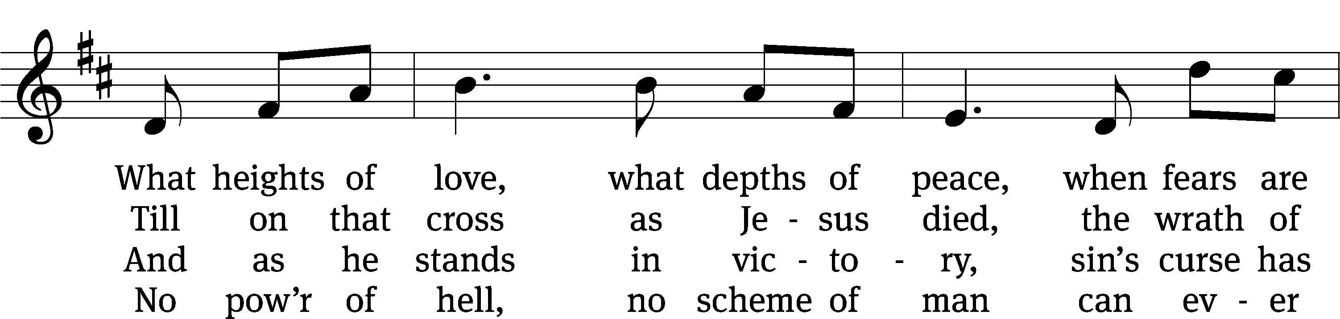
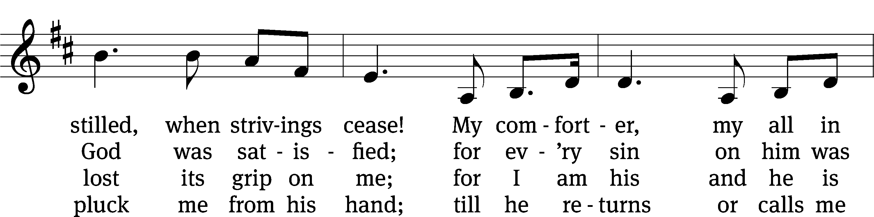
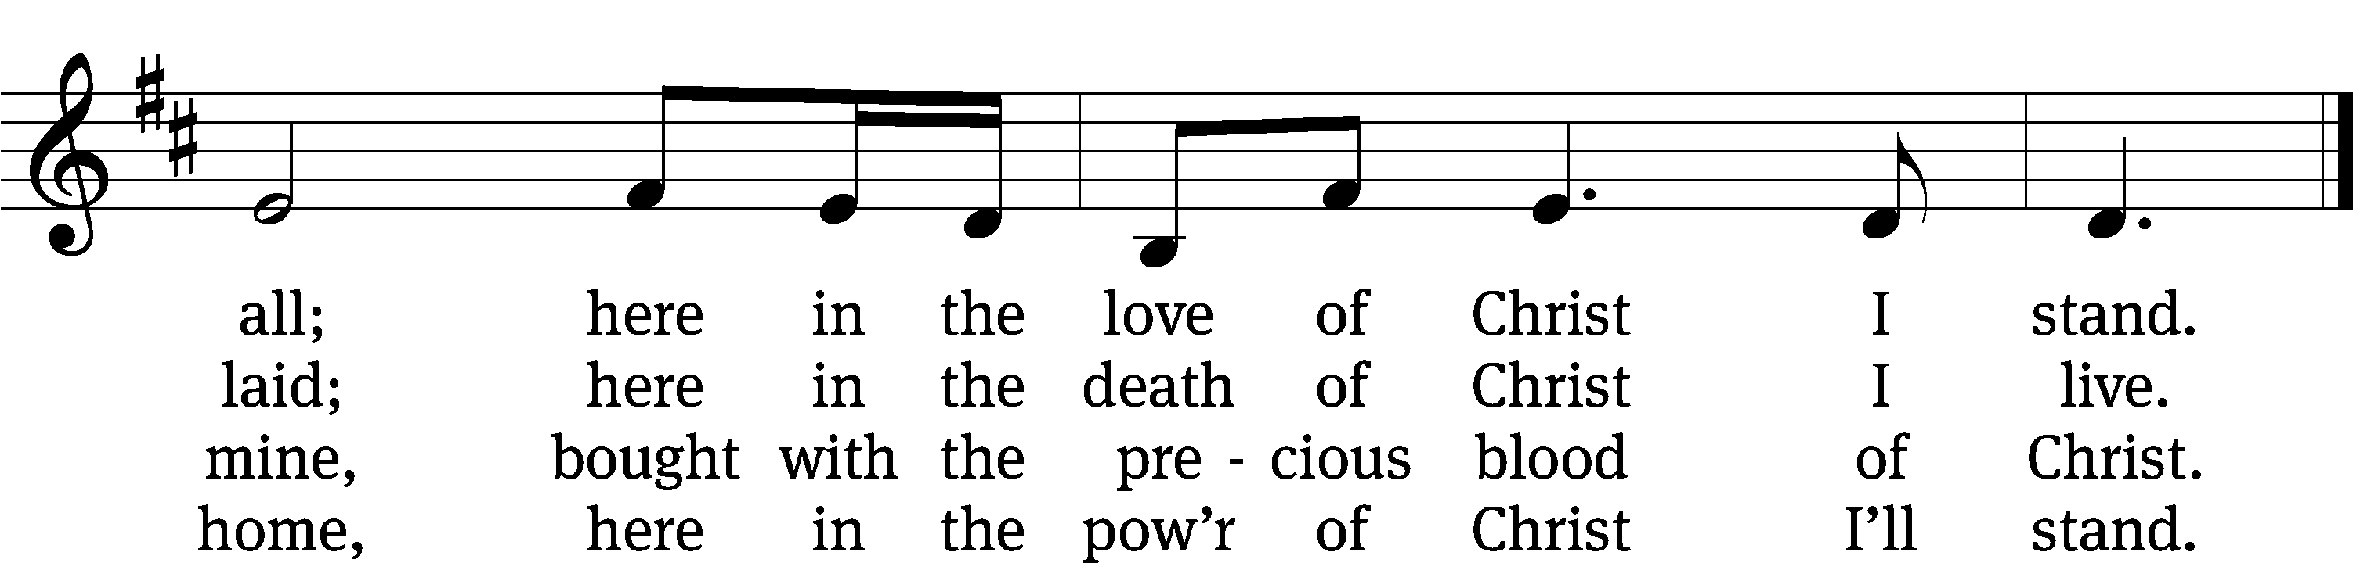
Text: Stuart Townend, b. 1963; Keith Getty, b. 1974
Tune: Stuart Townend, b. 1963; Keith Getty, b. 1974
Text and tune: © 2002 Thankyou Music, admin. CapitolCMGPublishing,com. Used by permission: OneLicense no. 716626

Closing Prayer
Precious Savior, you first came into the world in utter poverty and in deepest humility. Today you also came to us in your Word, in love, and in mercy. We know that you are going to come once again, in might and in majesty. Before that great day comes, implant your truth deeply in our hearts, so that all we attempt or achieve will serve to honor you, our Savior-King, who is worthy of all our praise.
Amen.

Easter Blessing
Through the resurrection of Jesus, God has become your Father and has made you his children. May you be filled with joy.
Amen.

Through the resurrection of Jesus, God has set you free from sin and death. May you live as people of hope.
Amen.

Brought into the resurrected Christ, you too, have been raised to a new life. May you live Spirit-filled lives.
Amen.
441 I Know That My Redeemer Lives (V.3 Men only, V.6 Women only)
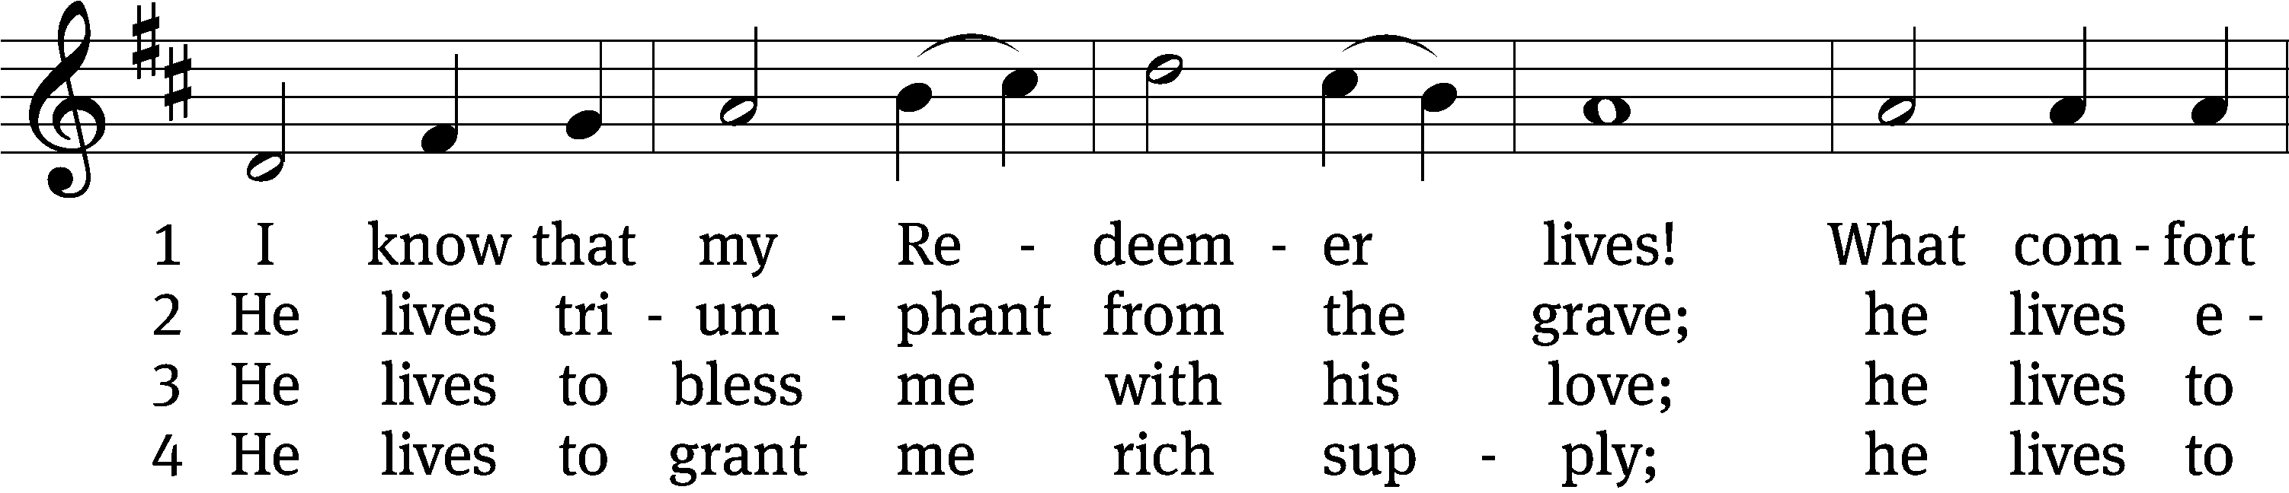
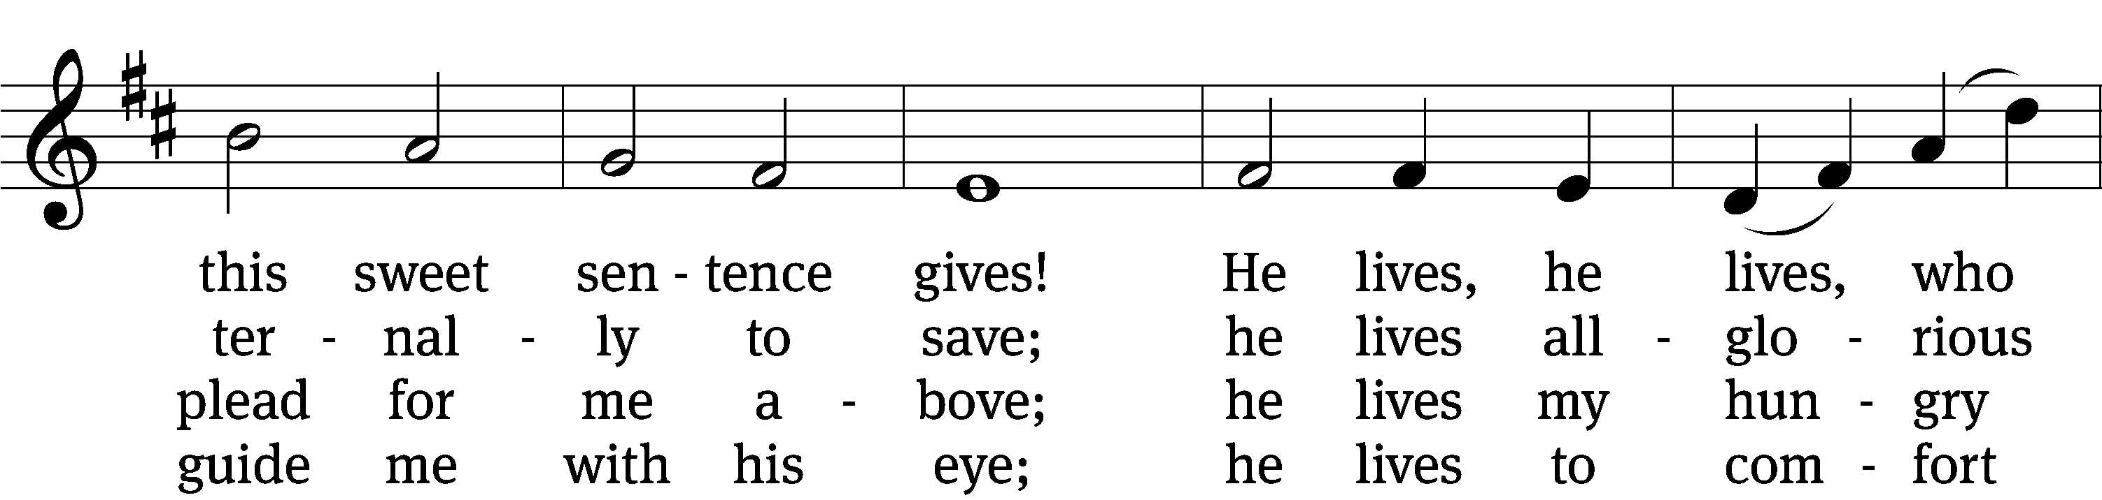
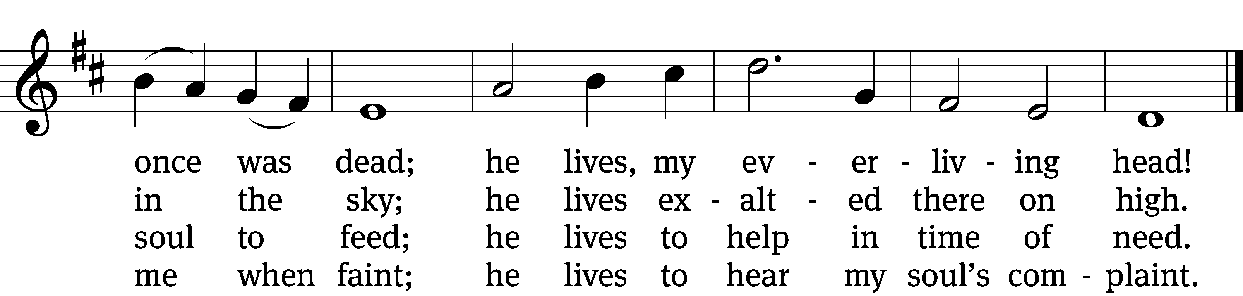

5 He lives to silence all my fears;
he lives to wipe away my tears;
he lives to calm my troubled heart;
he lives all blessings to impart.

6 He lives, my kind, wise, heav’nly friend;
he lives and loves me to the end;
he lives, and while he lives, I’ll sing;
he lives, my Prophet, Priest, and King.

7 He lives and grants me daily breath;
he lives, and I shall conquer death;
he lives my mansion to prepare;
he lives to bring me safely there.

8 He lives, all glory to his name!
He lives, my Jesus, still the same.
Oh, the sweet joy this sentence gives:
I know that my Redeemer lives!
Text: Samuel Medley, 1739–1799, abr.
Tune: attr. John C. Hatton, 1710–1793
Text and tune: Public domain
Acknowledgments
Setting One from Christian Worship
Unless otherwise indicated, Scripture quotations are from The Holy Bible, New International Version®, NIV®. Copyright © 1973, 1978, 1984, 2011 by Biblica, Inc.TM Used by permission of Zondervan. All rights reserved worldwide.
Software distributed in partnership with Northwestern Publishing House.
Created by Christian Worship: Service Builder © 2023 Concordia Publishing House.

Next Week’s Worship
Our theme for worship: “He Lives to Give Me Proof and Peace.” Our readings will be: Acts 2: 14a, 22-32, 1 Peter 1: 3-9, and John 20: 19-31.. We will sing the following hymns: 450 The Day of Resurrection, 445 He’s Risen, He’s Risen, 511 Crown Him with Many Crowns, and 800 How Firm a Foundation.

THIS WEEK AT BEAUTIFUL SAVIOR
† Today 8 am & 10:30am Worship
9:15 Easter Breakfast
Easter Egg Hunt following 2nd service
12 pm Confirmation Class
† Tuesday 5:30pm Steering Committee
† Wednesday 7pm Bible Study
† Sunday 9:30am Sunday School
10:30am Worship

The Next Step—Bible Information Class
Would you like the opportunity to grow deeper in what God’s Word has to say? On Tuesday, May 16, we will be starting our newest Bible Information Class. It is an overview of God’s Word and also serves as our pre-membership class. It will meet in the sanctuary following the Sunday service. Questions? Please speak with Pastor Holz.

Altar Flower Sign-up
If you would like to provide flowers for a Sunday Service, please see the sign up chart near the entry way table. It can be for a special occasion, or simply to beautify our altar on a Sunday morning. If you have questions, contact Eileen Cleveland at 239-410-6366 or email at thedoll48@gmail.com

25th Anniversary
In May of 2025, we will be celebrating the 25th anniversary of the founding of Beautiful Savior! While that seems like a long time off, we are already making plans to celebrate God's grace to us over the years and also will be unveiling a special thank offering which will raise funds to make improvements and renovations in our sanctuary area. Watch for more information to come in the following weeks.

Lunch Bunch
Lunch Bunch will take place Wednesday, April 19th, at 11:30am. Lunch will be served here at church for our older and/or retired members and friends. If you would like to attend please sign up so the hosts can get an accurate headcount for the meal preparations. A free will offering will be taken to cover the cost of the meal. After the meal there will be a short devotion. This will be a great opportunity for fellowship and a chance to get to know other people. If you have questions, please talk with Doris Harvey or Pastor Holz.

Ladies’ Day Out at Patti’s Settlement
The Ladies' Group is planning a day out at Patti's 1880's Settlement on Saturday, April 22 in Grand Rivers, Kentucky. Patti's is a destination for food, shopping, sightseeing, and more. Those attending will depart from the church parking lot on the 22nd at 10 am. If you would like to attend, please speak with Gael Irizzary. All ladies are welcome to attend, but there is a limit of 18 attendees.

Summer Camps
Summer Camp themes and dates have been decided. Camps are open to all children ages 3 years old through 3rd grade. Registration opens on May 1st. Dates and themes are as follows: June 26-30 Fabulous Fables and Tales, July 10-14 Cooking with Kids, and July 17-21 Water, Water Everywhere. If you have any questions or would like more information, please call the office at 931-905-140

New Sunday Bible Study
Next week we will begin a study called “Irreconcilable.” Maybe you’ve heard the phrase, “Don’t be such a Pharisee!” We know that being a Pharisee isn’t a good thing, but we may not know the reason. We will explore how that same mind-set is still prevalent in the world and in us! We will reflect on portions of God’s Word to help us combat the temptation of self-righteousness. We will meet in the fellowship hall at 9:30am on Sundays.

Next Week’s Worship
Join us next week as we continue our worship theme of: He Lives! We will focus on “Jesus lives to give me proof and peace.” Worship time is at 10:30am.

“He Lives” Worship Series
April 16- He Lives to give me proof and peace
April 23- He Lives to restore my hope
April 30- He Lives to be my Good Shepherd
May 7- He Lives to be the only way to Heaven
May 14- He Lives and calls me to live for Him
May 21- He Lives to give me eager expectation of glory

Prayer List

Thank the Lord for the safe return of all the soldiers who recently came home and all soldiers and their families who are facing deployment. Please keep in your prayers this week all soldiers who are currently deployed. Please also remember: Family of Marcia Carter, sister of Tim Donner (Marcia called home to heaven); Sandy Holz, sister of Gael Irizarry (pneumonia); Renate Banks (illness); Shan Bradford, daughter of Porter Matthew and friend of Margareta Smothers, (injured in car accident); Marlys Donner, mother of Tim Donner (declining health); Mark Lenz, father of Pamela Holz (recovery from tumor surgery); Caleb Westra, friend of the Holz family (Surgeries on his leg and foot after accident); Josh Carter, friend of Adam Holz (recovery from car accident); Stacy Schroeder, daughter of Jeff & Eileen Cleveland (melanoma diagnosis); Autumn Potter & family, friends of Jessica Boulter (death of sister); Aimee Gerkhardt, sister in law of Jessica Church (breast cancer); Steven Owens, father of Mark Owens, (cancer); Kathy Temple (cancer reoccurrence); Brandon Vannoy, friend of Mac McCoo (seizures); Sheila Lynch, sister of Gayle Brooks (unable to walk); Drake Robideau, friend of Mary Daniel (strength & wellness); Mike LaFave (back problems); Linda Thomas, sister of Gayle Brooks, (physical rehab after injury); Ruth Amorth, twin sister of Hilde Fox (seriously ill); Gary Davis, husband of Angela Davis (seizures); Gidget Tate (Health issues). If you would like to have a name or situation included or if you would like to give an update on a prayer request, please contact Pastor Holz or call the church office at 931-905-1400.

Serving in God’s House

Ushers: David J, Ernie R
Greeters: Doris M, Mac M
Kitchen: Ingeborg H, Hannah L, Mary D
Piano: Barb N
Fellowship: (H-M)

Serving next week:

Ushers: Daniel L, Josh G
Greeters: Art & Sandy E
Kitchen: Charmaine S, Mary D
Piano: Deb W
Fellowship: (N-S)

Our Mission
By grace, the mission of
Beautiful Savior Evangelical Lutheran Church is
to proclaim the Word of God so that we may praise his name,
grow together in the knowledge of our Savior,
and share with others his message of forgiveness and eternal life.

