Beautiful Savior Lutheran Church

April 2, 2023 – Passion Sunday

service theme: our greatest needs—a greater type of king

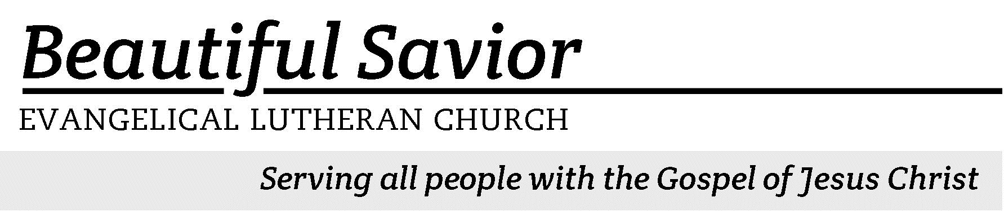


Welcome-- We are glad you could join us today! It is our hope that this service is a blessing to you. Please join us for worship again soon.

· Please save the last two rows of pews for parents with small children.

· Parents with little ones: If your child becomes restless during the service, that’s okay… We’re glad they’re here, and Jesus is pleased when they are brought to hear his Word: “Let the little children come to me.” If you need to be with your child in the Fellowship Hall, the service can be heard through a speaker.

· Five minutes before the worship service begins the usher will light the candles. This is our signal to quiet down and prepare our hearts for worship.

· Restrooms are conveniently located to the left as you exit the sanctuary.

· Please silence your cell phone before the start of the service.

Prayer for Worship
Lord Jesus, as you rode into Jerusalem to fulfill God’s promise for our salvation, so come into our lives to keep us on the way of salvation. You didn’t waver on your way to the cross; forgive us when we waver on our way. Because your will is one with the Father’s, so make our will one with yours. Amen.

Beautiful Savior Lutheran Church
2526 Whitfield Road
Clarksville, TN 37040
931-905-1400
Website: www.bslclarksville.com
Kent Holz, Pastor
Bslc.clarksville@gmail.com
Barbara Noon, Preschool Director
beautifulsaviorpreschool@gmail.com
.
Text: © 1949, 1953 The Stuart Hine Trust, admin. Hope Publishing Co. Used by permission: OneLicense no. 716626
Tune: © 1949, 1953 The Stuart Hine Trust, admin. CapitolCMGPublishing,com. Used by permission: OneLicense no. 716626



Procession with Palms

The pastor and worshipers collect palm branches and gather in the entryway for the start of the service.

The grace of our Lord + Jesus Christ and the love of God and the fellowship of the Holy Spirit be with you.
And also with you.

Dear friends in Christ: Today we come together to begin the solemn celebration of Holy Week. Christ entered in triumph into his own city to complete his work as our Messiah: to suffer, to die, and to rise again. Let us remember with devotion his entry that culminated at the empty tomb and follow him with a lively faith. United with him by Baptism, we share in his resurrection and new life.

Blessed is he who comes in the name of the Lord.
Hosanna in the highest!

Palm Sunday Gospel Matthew 21:1–11
1As they approached Jerusalem and came to Bethphage on the Mount of Olives, Jesus sent two disciples, 2saying to them, “Go to the village ahead of you, and at once you will find a donkey tied there, with her colt by her. Untie them and bring them to me. 3If anyone says anything to you, say that the Lord needs them, and he will send them right away.”
4This took place to fulfill what was spoken through the prophet:
5“Say to Daughter Zion,
‘See, your king comes to you,
gentle and riding on a donkey,
and on a colt, the foal of a donkey.’ ”
6The disciples went and did as Jesus had instructed them. 7They brought the donkey and the colt and placed their cloaks on them for Jesus to sit on. 8A very large crowd spread their cloaks on the road, while others cut branches from the trees and spread them on the road. 9The crowds that went ahead of him and those that followed shouted,
“Hosanna to the Son of David!”
“Blessed is he who comes in the name of the Lord!”
“Hosanna in the highest heaven!”
10When Jesus entered Jerusalem, the whole city was stirred and asked, “Who is this?”
11The crowds answered, “This is Jesus, the prophet from Nazareth in Galilee.”

Prayer
God our Father, we remember how Jesus entered Jerusalem and was welcomed as a king by those who shouted “Hosanna” and spread their clothing and palm branches in his path. Accept our praise, and listen to our prayers as we rejoice in our triumphant King, Jesus Christ, your Son, our Lord.
Amen.

Let us go forth in peace,
In the name of the Lord.

The assembly moves to the entrance of the sanctuary. As the processional hymn is introduced and sung, worshipers place their palm branches at the base of the cross and return to their seats.

412 All Glory, Laud, and Honor CW 412
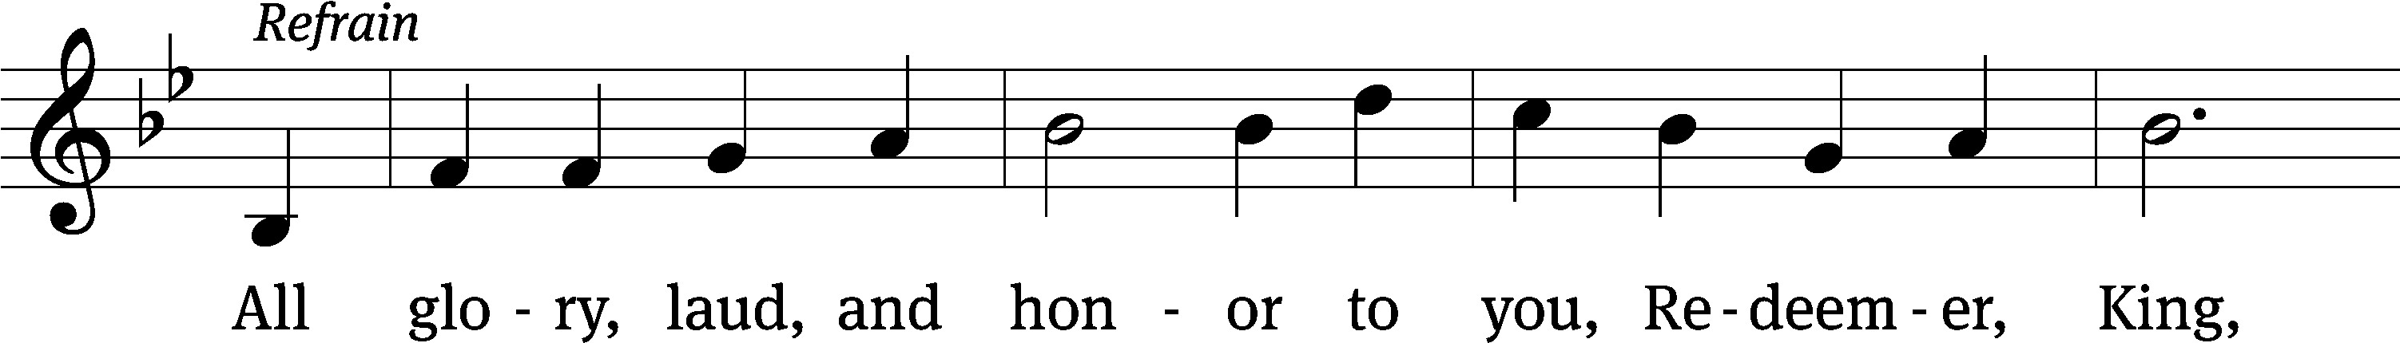
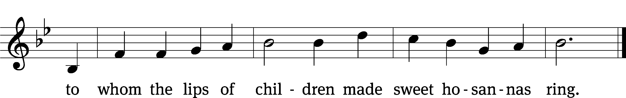
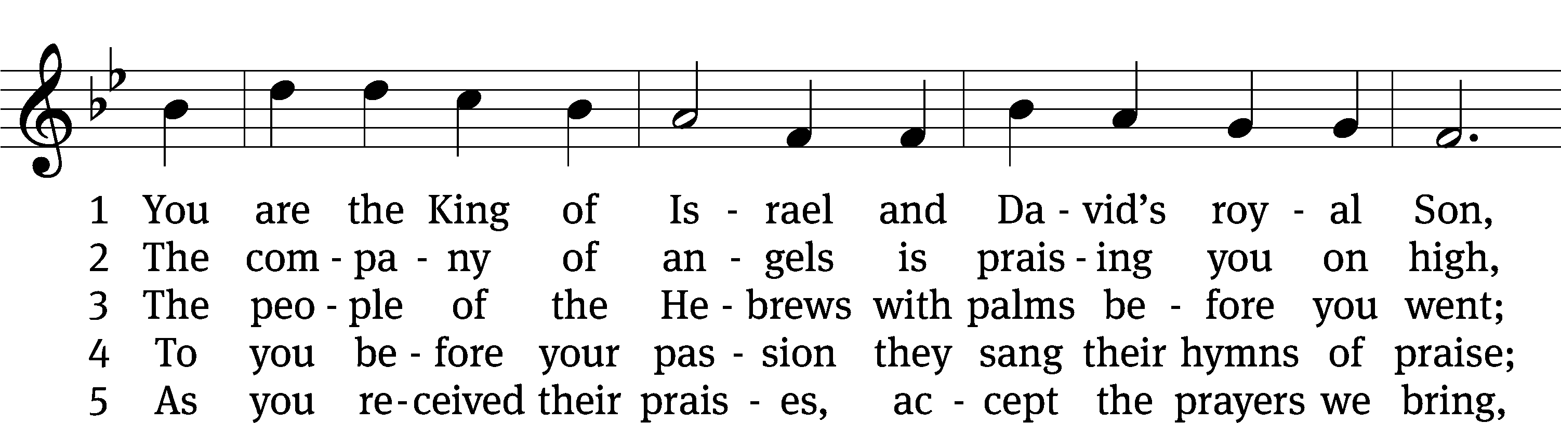
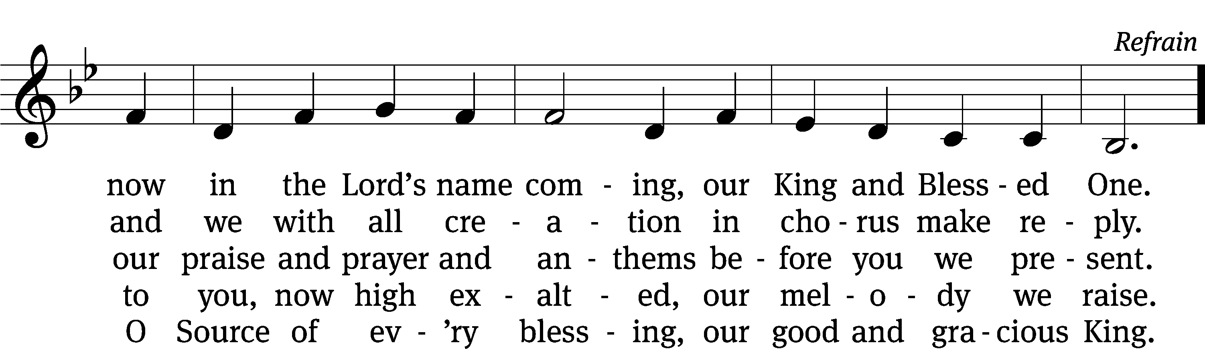
Text: tr. John Mason Neale, 1818–1866, alt.; Theodulph of Orleans, c. 762–821
Tune: Melchior Teschner, 1584–1635, alt.
Text and tune: Public domain

Blessed is he who comes in the name of the Lord.
Hosanna in the highest!

Prayer of the Day
Let us pray.

Almighty and everlasting God, you sent your Son, our Savior Jesus Christ, to take upon himself our flesh and suffer death upon the cross. Mercifully grant that we may follow the example of his great humility and patience and be made partakers of his resurrection; through your Son, Jesus Christ our Lord, who lives and reigns with you and the Holy Spirit, one God, now and forever.
Amen.
411 Ride On, Ride On in Majesty CW 411 sts. 1–2, 4–5
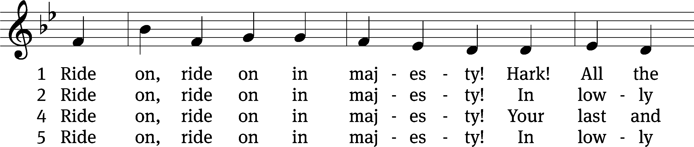
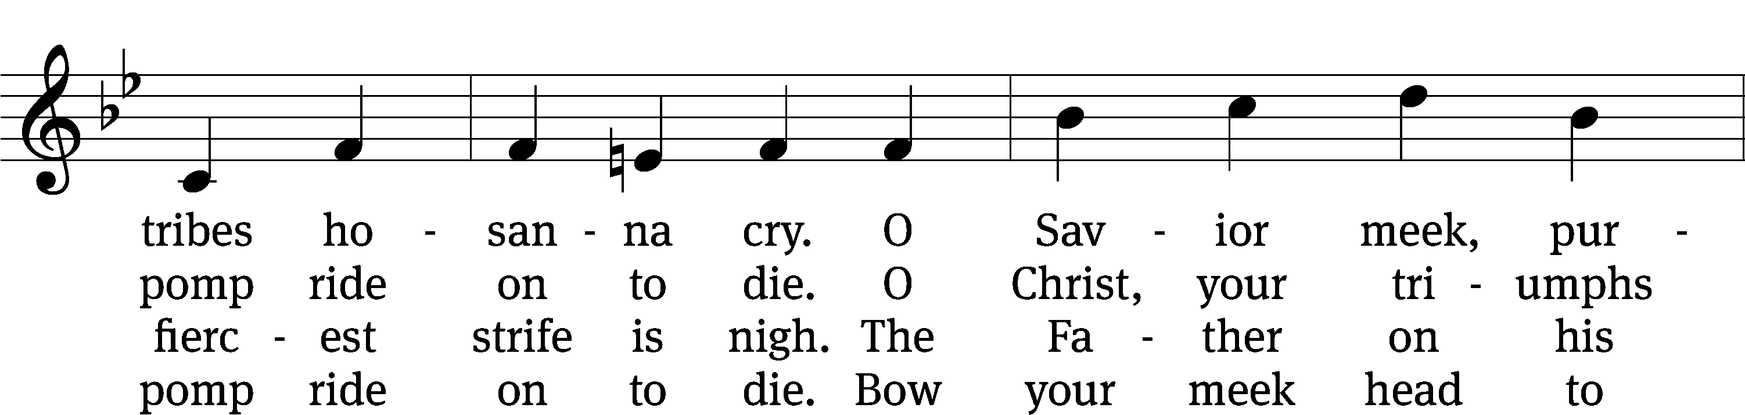
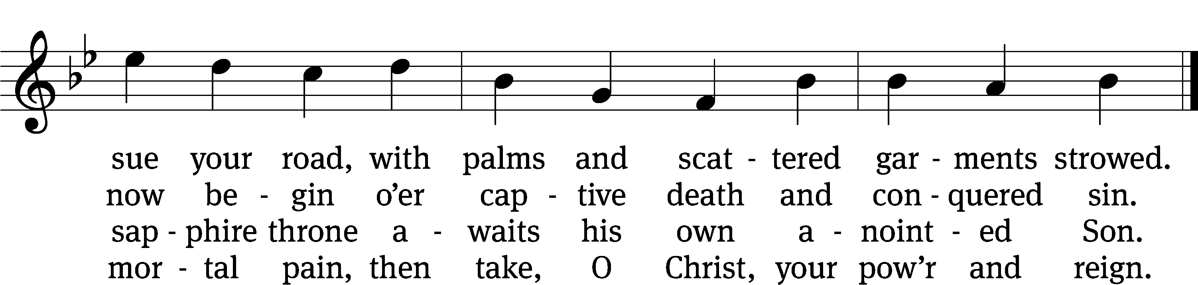
Text: Henry H. Milman, 1791–1868, alt.
Tune: Musicalisch Hand-Buch der Geistlichen Melodien, Hamburg, 1690, alt.
Text and tune: Public domain

Offering “We love because he first loved us.” 1Jn 4:19 God’s love in sending Jesus to live, to suffer, and to die for each of us motivates the members of Beautiful Savior to show their love and thanks by returning a portion of their income to the Lord. Through these free will offerings, this congregation and its ministries are maintained.*If you would like to give your regular offering envelope, you can mail it to the church. If you would like to give securely online, scan this code or follow this link: bslclarksville.com

The Sacrament

Preface
The Lord be with you.
And also with you.

Lift up your hearts.
We lift them up to the Lord.

Let us give thanks to the Lord our God.
It is right to give him thanks and praise.

It is truly good and right that we should at all times and in all places give you thanks, O Lord, holy Father, almighty and everlasting God, through Jesus Christ our Lord, who brought the gift of salvation to all people by his death on the tree of the cross so that the devil, who overcame us by a tree, would in turn by a tree be overcome. Therefore, with all the saints on earth and hosts of heaven, we praise your holy name and join their glorious song:

Holy, Holy, Holy CW 167
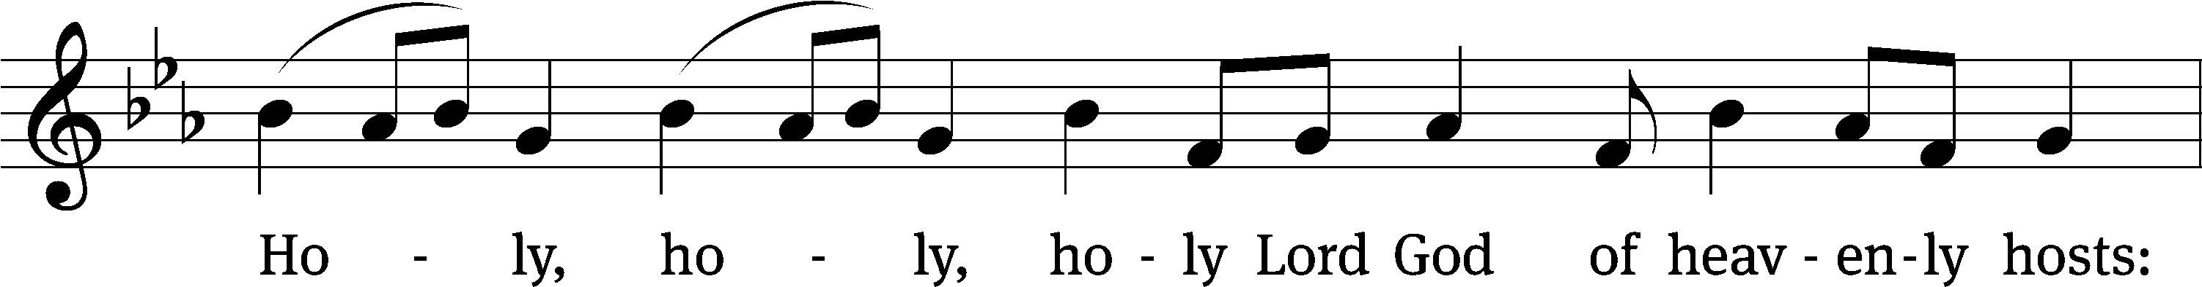
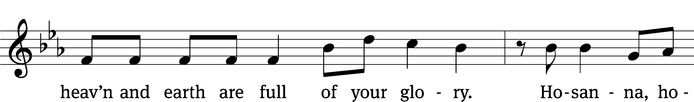
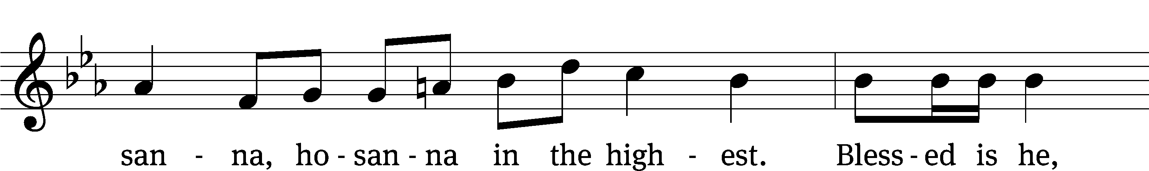
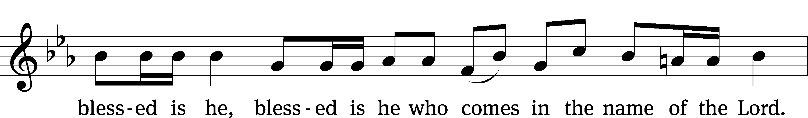
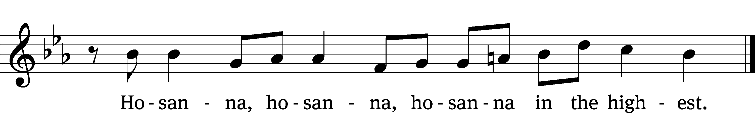

Words of Institution
Our Lord Jesus Christ, on the night he was betrayed, took bread; and when he had given thanks, he broke it and gave it to his disciples, saying, “Take and eat; this is my body, which is given for you. Do this in remembrance of me.”

Then he took the cup, gave thanks, and gave it to them, saying, “Drink from it, all of you; this is my blood of the new covenant, which is poured out for you for the forgiveness of sins. Do this, whenever you drink it, in remembrance of me.”

The peace of the Lord be with you always.
Amen.

O Christ, Lamb of God CW 169

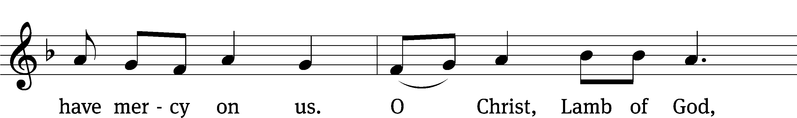
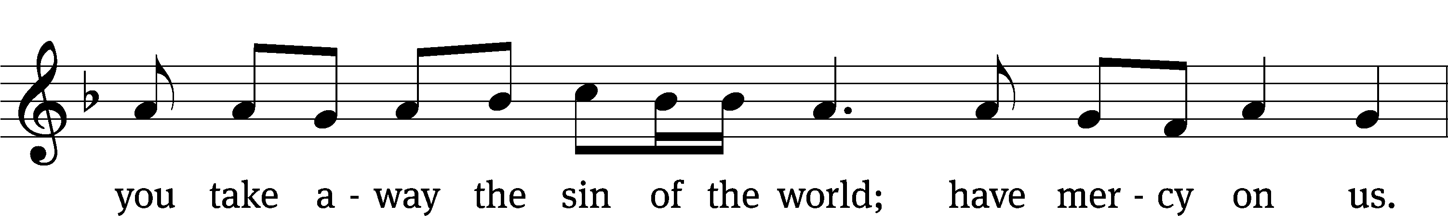

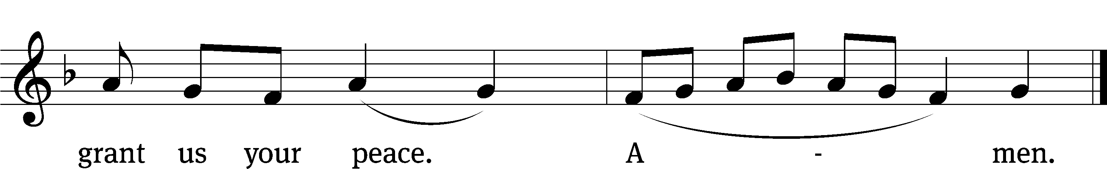

Distribution

The true body and blood of our Lord Jesus Christ strengthen and preserve you to life everlasting. Go T in peace.
Amen.

We give thanks, almighty God, that you have refreshed us with this saving gift. We pray that through it you will strengthen our faith in you and increase our love for one another. We ask this in the name of Jesus Christ our Lord, who lives and reigns with you and the Holy Spirit, one God, now and forever.
Amen.

The Passion of Our Lord and Savior Jesus Christ
According to Matthew’s Gospel
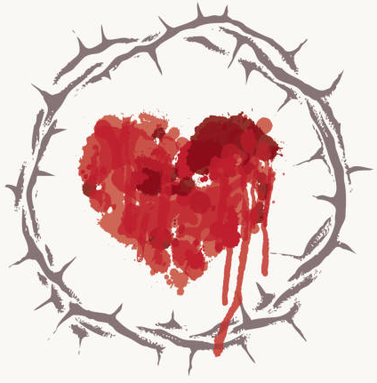

Each year as a church we focus on a certain Evangelist (gospel author) and his account of Christ’s life. Since the season of Advent, we have been regularly reading from the Gospel according to St. Matthew. We continue that today as we read Matthew’s record of our Savior’s passion.
Lord, sanctify us by the truth-your Word is truth.

420 Jesus, I Will Ponder Now CW 420 sts. 1, 5
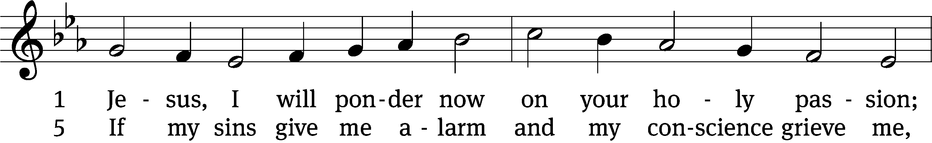
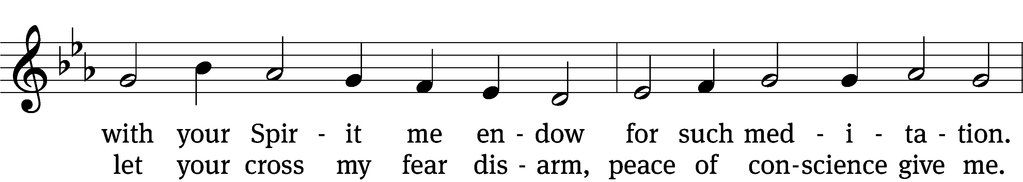
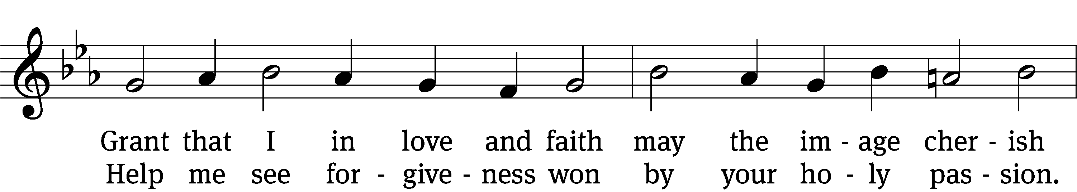
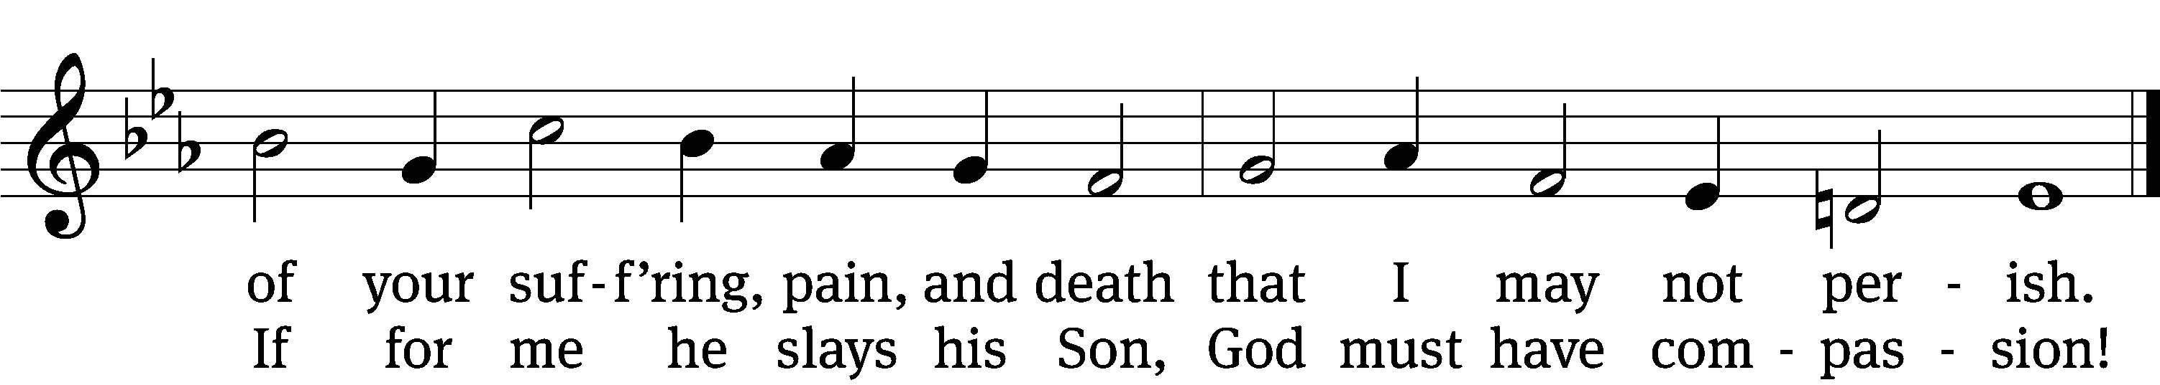
Text: tr. August Crull, 1845–1923, alt.; Sigmund von Birken, 1626–1681
Tune: Melchior Vulpius, c. 1570–1615
Text and tune: Public domain
Plot, Passover, and Lord’s Supper Matthew 26:1–35
1When Jesus had finished saying all these things, he said to his disciples, 2“As you know, the Passover is two days away—and the Son of Man will be handed over to be crucified.”
3Then the chief priests and the elders of the people assembled in the palace of the high priest, whose name was Caiaphas, 4and they schemed to arrest Jesus secretly and kill him. 5“But not during the festival,” they said, “or there may be a riot among the people.”
6While Jesus was in Bethany in the home of Simon the Leper, 7a woman came to him with an alabaster jar of very expensive perfume, which she poured on his head as he was reclining at the table.
8When the disciples saw this, they were indignant. “Why this waste?” they asked. 9“This perfume could have been sold at a high price and the money given to the poor.”
10Aware of this, Jesus said to them, “Why are you bothering this woman? She has done a beautiful thing to me. 11The poor you will always have with you, but you will not always have me. 12When she poured this perfume on my body, she did it to prepare me for burial. 13Truly I tell you, wherever this gospel is preached throughout the world, what she has done will also be told, in memory of her.”
14Then one of the Twelve—the one called Judas Iscariot—went to the chief priests 15and asked, “What are you willing to give me if I deliver him over to you?” So they counted out for him thirty pieces of silver. 16From then on Judas watched for an opportunity to hand him over.
17On the first day of the Festival of Unleavened Bread, the disciples came to Jesus and asked, “Where do you want us to make preparations for you to eat the Passover?”
18He replied, “Go into the city to a certain man and tell him, ‘The Teacher says: My appointed time is near. I am going to celebrate the Passover with my disciples at your house.’ ” 19So the disciples did as Jesus had directed them and prepared the Passover.
20When evening came, Jesus was reclining at the table with the Twelve. 21And while they were eating, he said, “Truly I tell you, one of you will betray me.”
22They were very sad and began to say to him one after the other, “Surely you don’t mean me, Lord?”
23Jesus replied, “The one who has dipped his hand into the bowl with me will betray me. 24The Son of Man will go just as it is written about him. But woe to that man who betrays the Son of Man! It would be better for him if he had not been born.”
25Then Judas, the one who would betray him, said, “Surely you don’t mean me, Rabbi?”
Jesus answered, “You have said so.”
26While they were eating, Jesus took bread, and when he had given thanks, he broke it and gave it to his disciples, saying, “Take and eat; this is my body.”
27Then he took a cup, and when he had given thanks, he gave it to them, saying, “Drink from it, all of you. 28This is my blood of the covenant, which is poured out for many for the forgiveness of sins. 29I tell you, I will not drink from this fruit of the vine from now on until that day when I drink it new with you in my Father’s kingdom.”
30When they had sung a hymn, they went out to the Mount of Olives.
31Then Jesus told them, “This very night you will all fall away on account of me, for it is written:
“ ‘I will strike the shepherd,
and the sheep of the flock will be scattered.’
32But after I have risen, I will go ahead of you into Galilee.”
33Peter replied, “Even if all fall away on account of you, I never will.”
34“Truly I tell you,” Jesus answered, “this very night, before the rooster crows, you will disown me three times.”
35But Peter declared, “Even if I have to die with you, I will never disown you.” And all the other disciples said the same.
432 O Dearest Jesus, What Law Have You Broken CW 432 sts. 1, 6
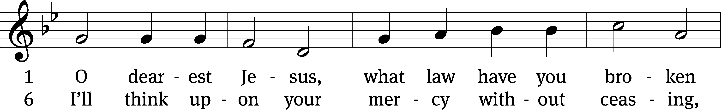
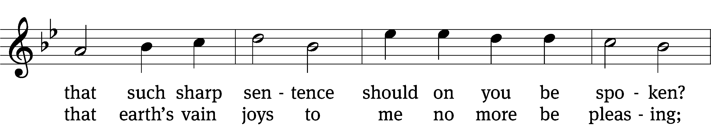
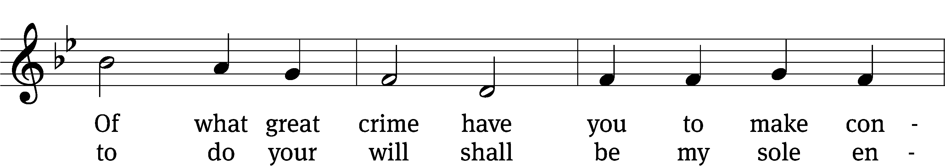
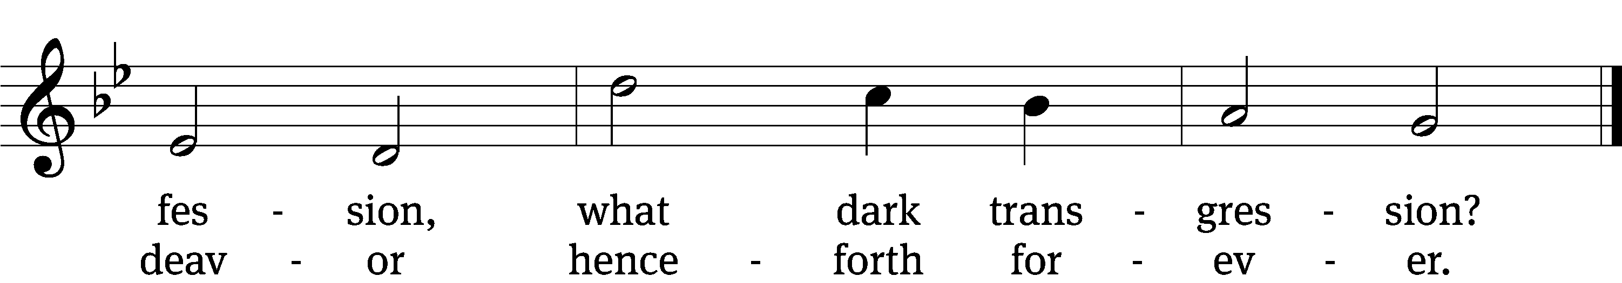
Text: tr. Catherine Winkworth, 1827–1878, alt.; Johann Heermann, 1585–1647
Tune: Johann Crüger, 1598–1662
Text and tune: Public domain

Gethsemane Matthew 26:36–56
36Then Jesus went with his disciples to a place called Gethsemane, and he said to them, “Sit here while I go over there and pray.” 37He took Peter and the two sons of Zebedee along with him, and he began to be sorrowful and troubled. 38Then he said to them, “My soul is overwhelmed with sorrow to the point of death. Stay here and keep watch with me.”
39Going a little farther, he fell with his face to the ground and prayed, “My Father, if it is possible, may this cup be taken from me. Yet not as I will, but as you will.”
40Then he returned to his disciples and found them sleeping. “Couldn’t you men keep watch with me for one hour?” he asked Peter. 41“Watch and pray so that you will not fall into temptation. The spirit is willing, but the flesh is weak.”
42He went away a second time and prayed, “My Father, if it is not possible for this cup to be taken away unless I drink it, may your will be done.”
43When he came back, he again found them sleeping, because their eyes were heavy. 44So he left them and went away once more and prayed the third time, saying the same thing.
45Then he returned to the disciples and said to them, “Are you still sleeping and resting? Look, the hour has come, and the Son of Man is delivered into the hands of sinners. 46Rise! Let us go! Here comes my betrayer!”
47While he was still speaking, Judas, one of the Twelve, arrived. With him was a large crowd armed with swords and clubs, sent from the chief priests and the elders of the people. 48Now the betrayer had arranged a signal with them: “The one I kiss is the man; arrest him.” 49Going at once to Jesus, Judas said, “Greetings, Rabbi!” and kissed him.
50Jesus replied, “Do what you came for, friend.”
Then the men stepped forward, seized Jesus and arrested him. 51With that, one of Jesus’ companions reached for his sword, drew it out and struck the servant of the high priest, cutting off his ear.
52“Put your sword back in its place,” Jesus said to him, “for all who draw the sword will die by the sword. 53Do you think I cannot call on my Father, and he will at once put at my disposal more than twelve legions of angels? 54But how then would the Scriptures be fulfilled that say it must happen in this way?”
55In that hour Jesus said to the crowd, “Am I leading a rebellion, that you have come out with swords and clubs to capture me? Every day I sat in the temple courts teaching, and you did not arrest me. 56But this has all taken place that the writings of the prophets might be fulfilled.” Then all the disciples deserted him and fled.

408 He Stood before the Court CW 408
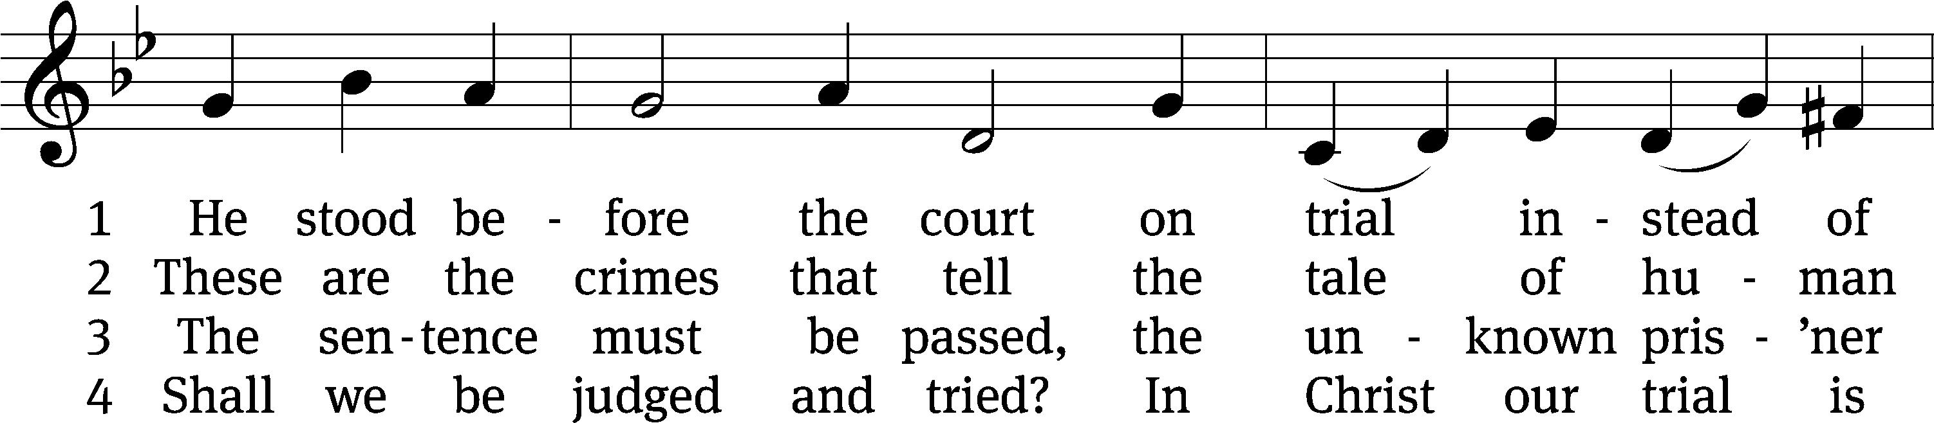
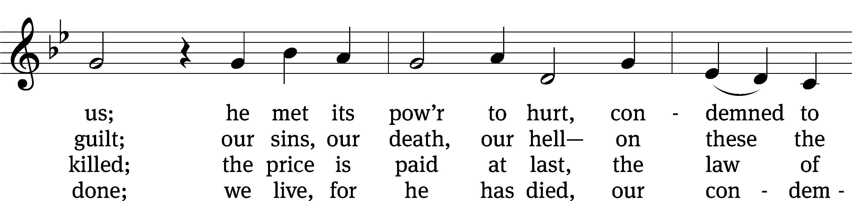
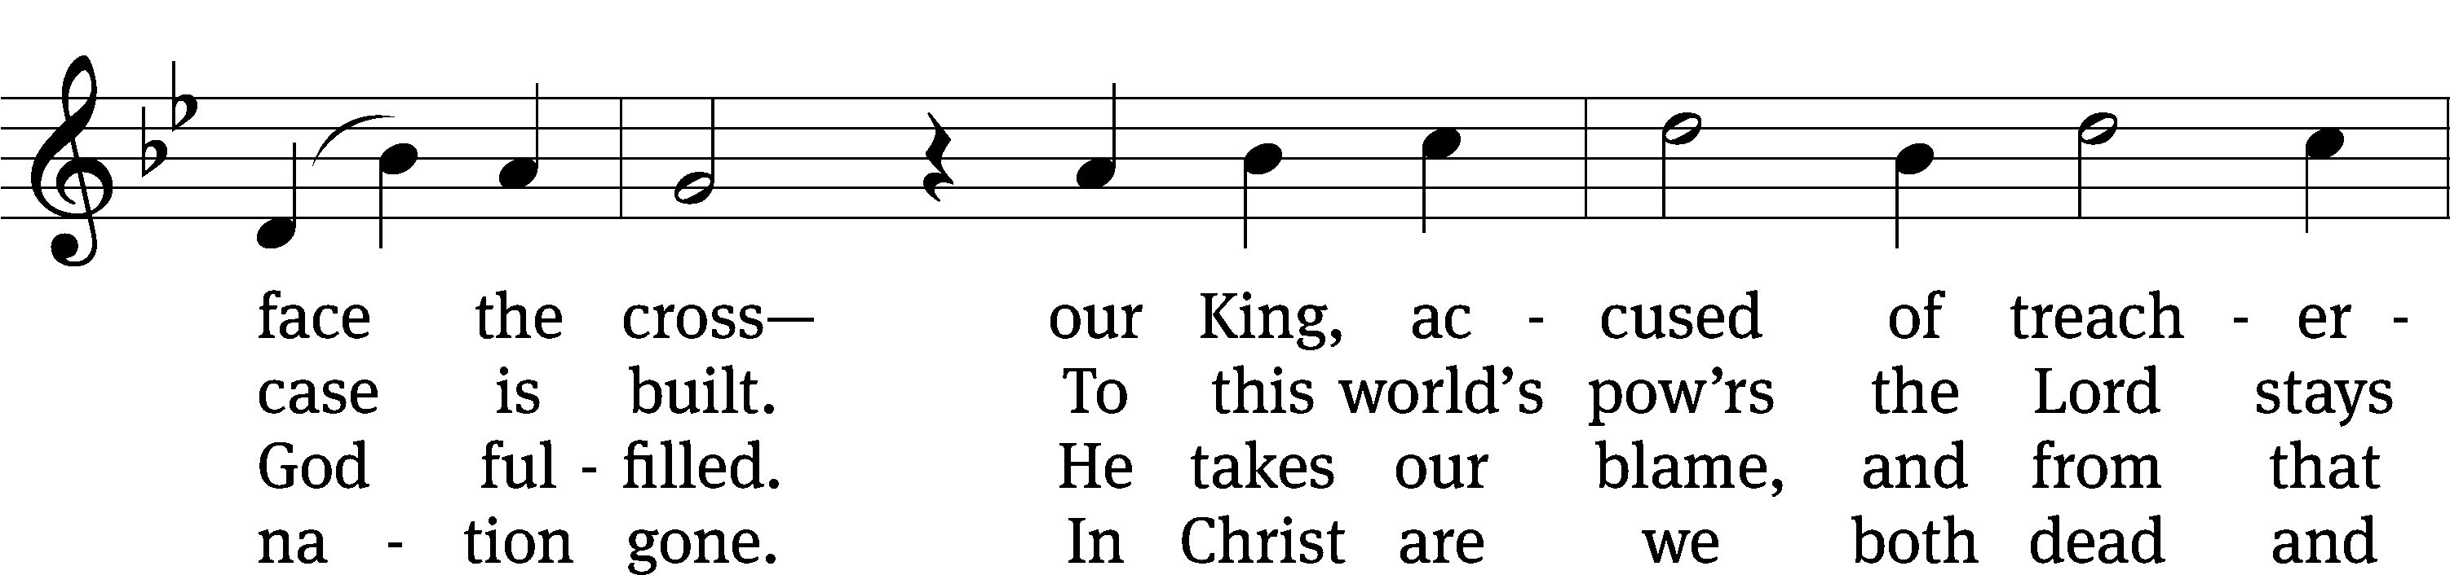
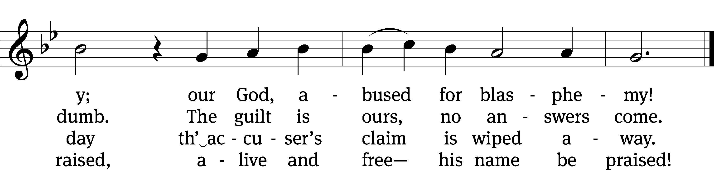
Text: Christopher M. Idle, b. 1938, alt.
Tune: Leland B. Sateren, 1913–2007
Text: © 1982 The Jubilate Group, admin. Hope Publishing Co. Used by permission: OneLicense no. 716626
Tune: © 1958 Service Book and Hymnal, admin. Augsburg Fortress. Used by permission: OneLicense no. 716626

Trial Before the High Priest Matthew 26:57–75
57Those who had arrested Jesus took him to Caiaphas the high priest, where the teachers of the law and the elders had assembled. 58But Peter followed him at a distance, right up to the courtyard of the high priest. He entered and sat down with the guards to see the outcome.
59The chief priests and the whole Sanhedrin were looking for false evidence against Jesus so that they could put him to death. 60But they did not find any, though many false witnesses came forward.
Finally two came forward 61and declared, “This fellow said, ‘I am able to destroy the temple of God and rebuild it in three days.’ ”
62Then the high priest stood up and said to Jesus, “Are you not going to answer? What is this testimony that these men are bringing against you?” 63But Jesus remained silent.
The high priest said to him, “I charge you under oath by the living God: Tell us if you are the Messiah, the Son of God.”
64“You have said so,” Jesus replied. “But I say to all of you: From now on you will see the Son of Man sitting at the right hand of the Mighty One and coming on the clouds of heaven.”
65Then the high priest tore his clothes and said, “He has spoken blasphemy! Why do we need any more witnesses? Look, now you have heard the blasphemy. 66What do you think?”
“He is worthy of death,” they answered.
67Then they spit in his face and struck him with their fists. Others slapped him 68and said, “Prophesy to us, Messiah. Who hit you?”
69Now Peter was sitting out in the courtyard, and a servant girl came to him. “You also were with Jesus of Galilee,” she said.
70But he denied it before them all. “I don’t know what you’re talking about,” he said.
71Then he went out to the gateway, where another servant girl saw him and said to the people there, “This fellow was with Jesus of Nazareth.”
72He denied it again, with an oath: “I don’t know the man!”
73After a little while, those standing there went up to Peter and said, “Surely you are one of them; your accent gives you away.”
74Then he began to call down curses, and he swore to them, “I don’t know the man!”
Immediately a rooster crowed. 75Then Peter remembered the word Jesus had spoken: “Before the rooster crows, you will disown me three times.” And he went outside and wept bitterly.

430 Stricken, Smitten, and Afflicted CW 430 sts. 1, 4
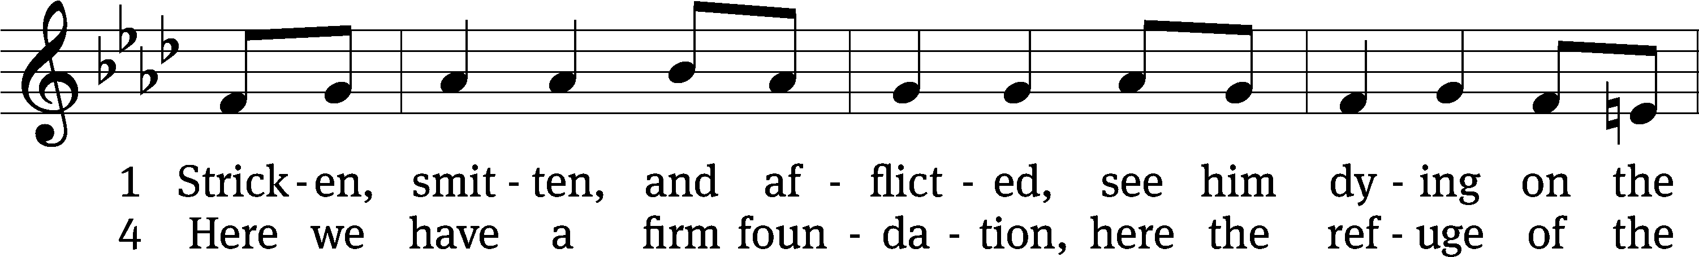
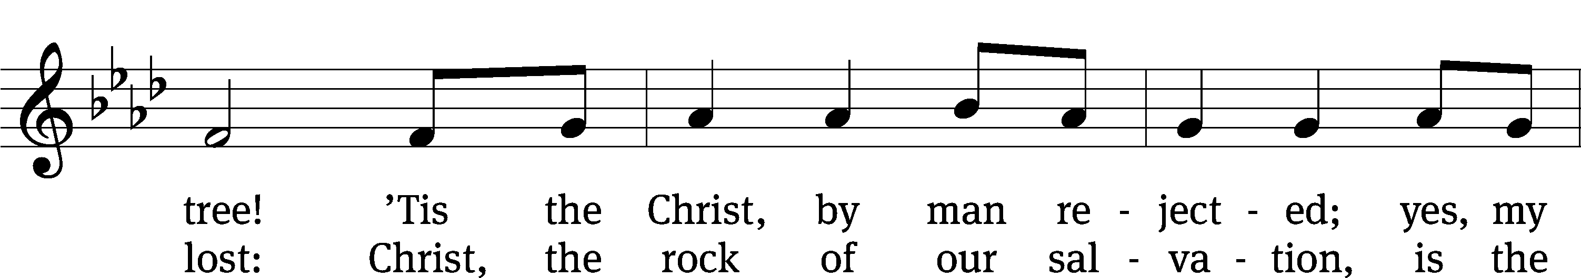
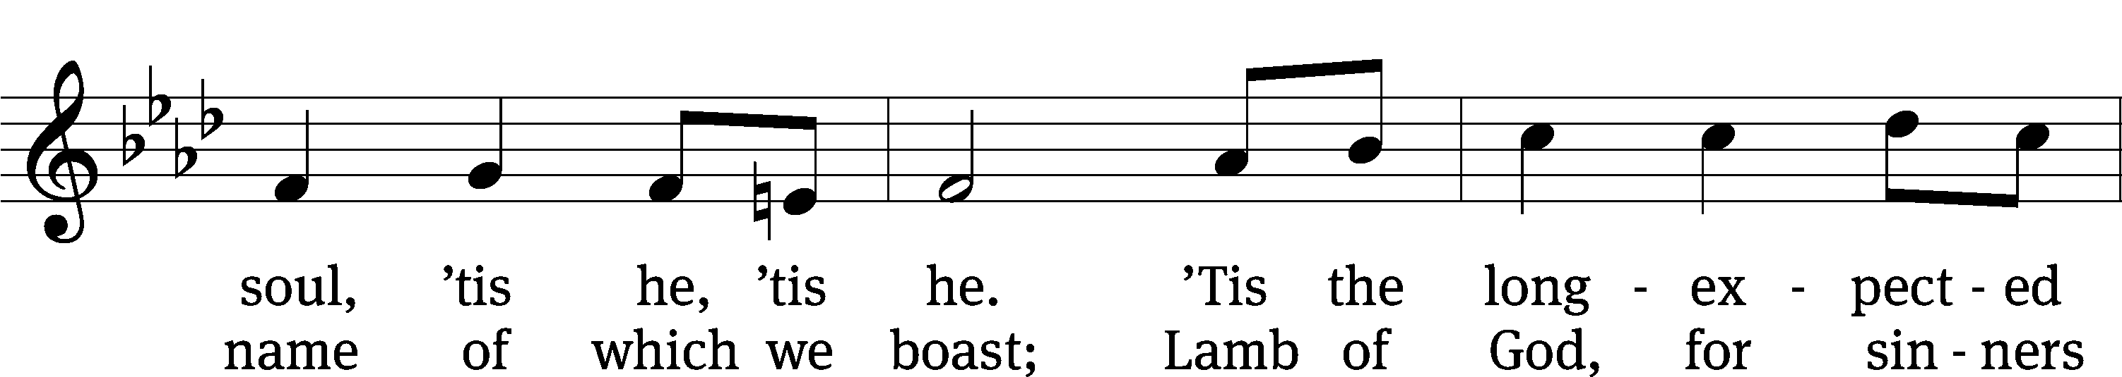
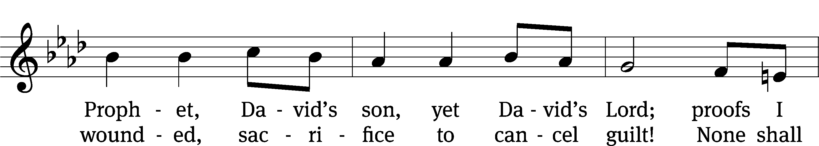
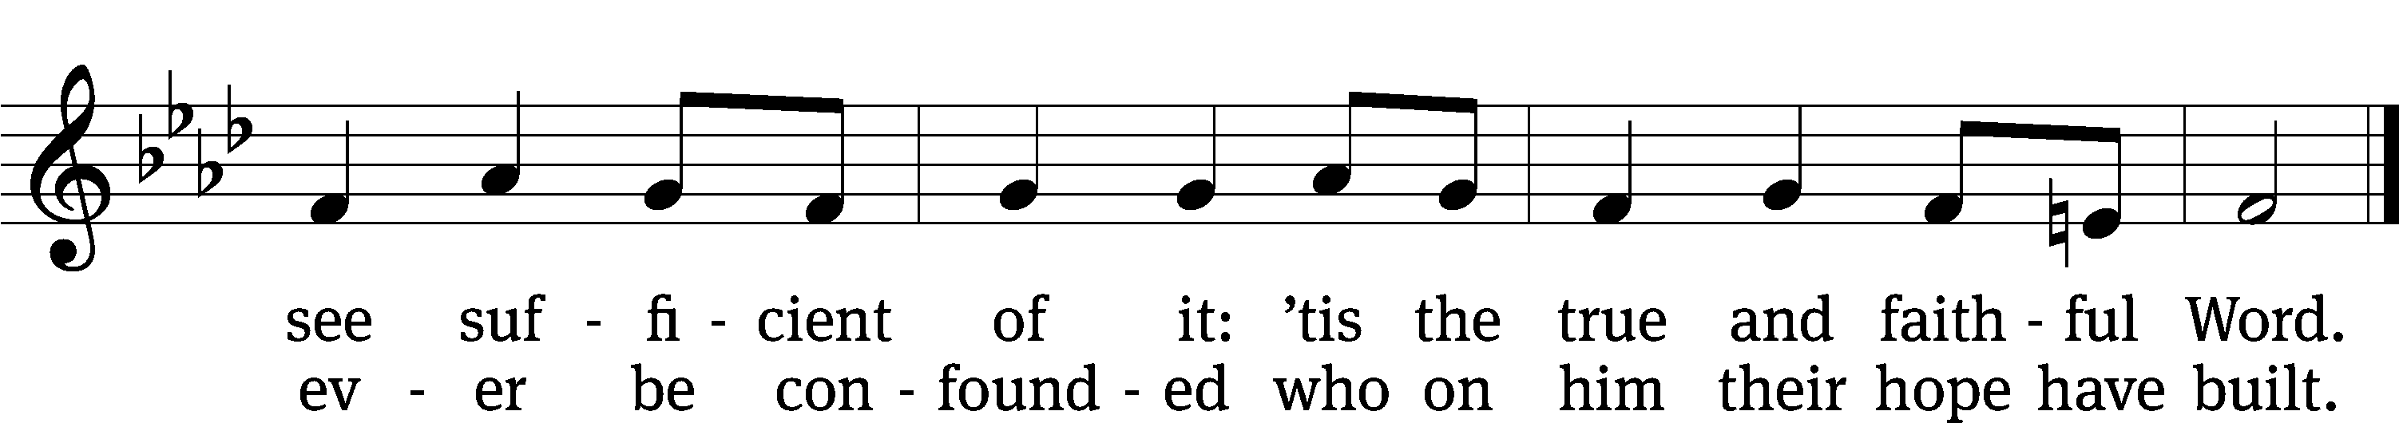
Text: Thomas Kelly, 1769–1855, alt.
Tune: Geistliche Volkslieder, Paderborn, 1850
Text and tune: Public domain

Trial before Pilate Matthew 27:1–26
1Early in the morning, all the chief priests and the elders of the people made their plans how to have Jesus executed. 2So they bound him, led him away and handed him over to Pilate the governor.
3When Judas, who had betrayed him, saw that Jesus was condemned, he was seized with remorse and returned the thirty pieces of silver to the chief priests and the elders. 4“I have sinned,” he said, “for I have betrayed innocent blood.”
“What is that to us?” they replied. “That’s your responsibility.”
5So Judas threw the money into the temple and left. Then he went away and hanged himself.
6The chief priests picked up the coins and said, “It is against the law to put this into the treasury, since it is blood money.” 7So they decided to use the money to buy the potter’s field as a burial place for foreigners. 8That is why it has been called the Field of Blood to this day. 9Then what was spoken by Jeremiah the prophet was fulfilled: “They took the thirty pieces of silver, the price set on him by the people of Israel, 10and they used them to buy the potter’s field, as the Lord commanded me.”
11Meanwhile Jesus stood before the governor, and the governor asked him, “Are you the king of the Jews?”
“You have said so,” Jesus replied.
12When he was accused by the chief priests and the elders, he gave no answer. 13Then Pilate asked him, “Don’t you hear the testimony they are bringing against you?” 14But Jesus made no reply, not even to a single charge—to the great amazement of the governor.
15Now it was the governor’s custom at the festival to release a prisoner chosen by the crowd. 16At that time they had a well-known prisoner whose name was Jesus Barabbas. 17So when the crowd had gathered, Pilate asked them, “Which one do you want me to release to you: Jesus Barabbas, or Jesus who is called the Messiah?” 18For he knew it was out of self-interest that they had handed Jesus over to him.
19While Pilate was sitting on the judge’s seat, his wife sent him this message: “Don’t have anything to do with that innocent man, for I have suffered a great deal today in a dream because of him.”
20But the chief priests and the elders persuaded the crowd to ask for Barabbas and to have Jesus executed.
21“Which of the two do you want me to release to you?” asked the governor.
“Barabbas,” they answered.
22“What shall I do, then, with Jesus who is called the Messiah?” Pilate asked.
They all answered, “Crucify him!”
23“Why? What crime has he committed?” asked Pilate.
But they shouted all the louder, “Crucify him!”
24When Pilate saw that he was getting nowhere, but that instead an uproar was starting, he took water and washed his hands in front of the crowd. “I am innocent of this man’s blood,” he said. “It is your responsibility!”
25All the people answered, “His blood is on us and on our children!”
26Then he released Barabbas to them. But he had Jesus flogged, and handed him over to be crucified.
428 O Sacred Head, Now Wounded CW 428 sts. 1, 3
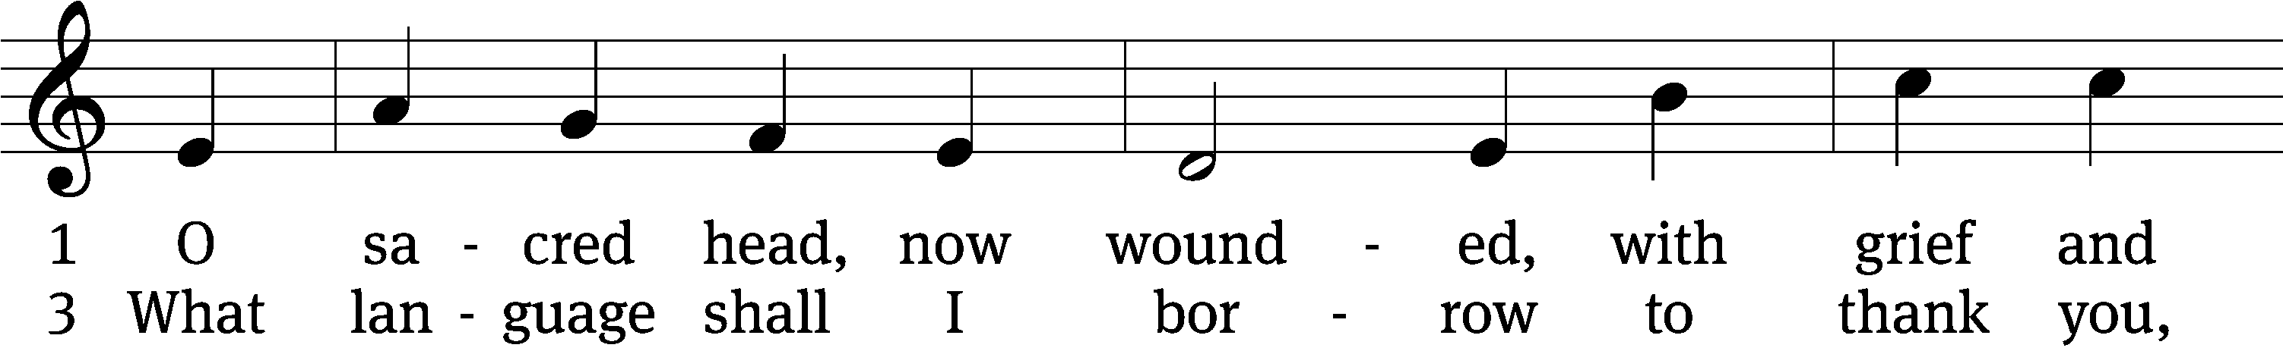
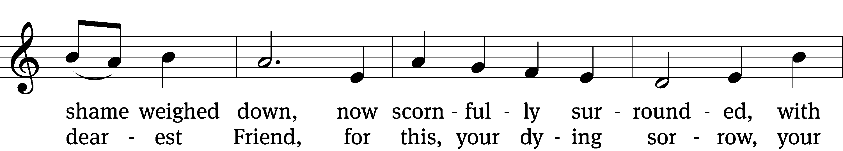
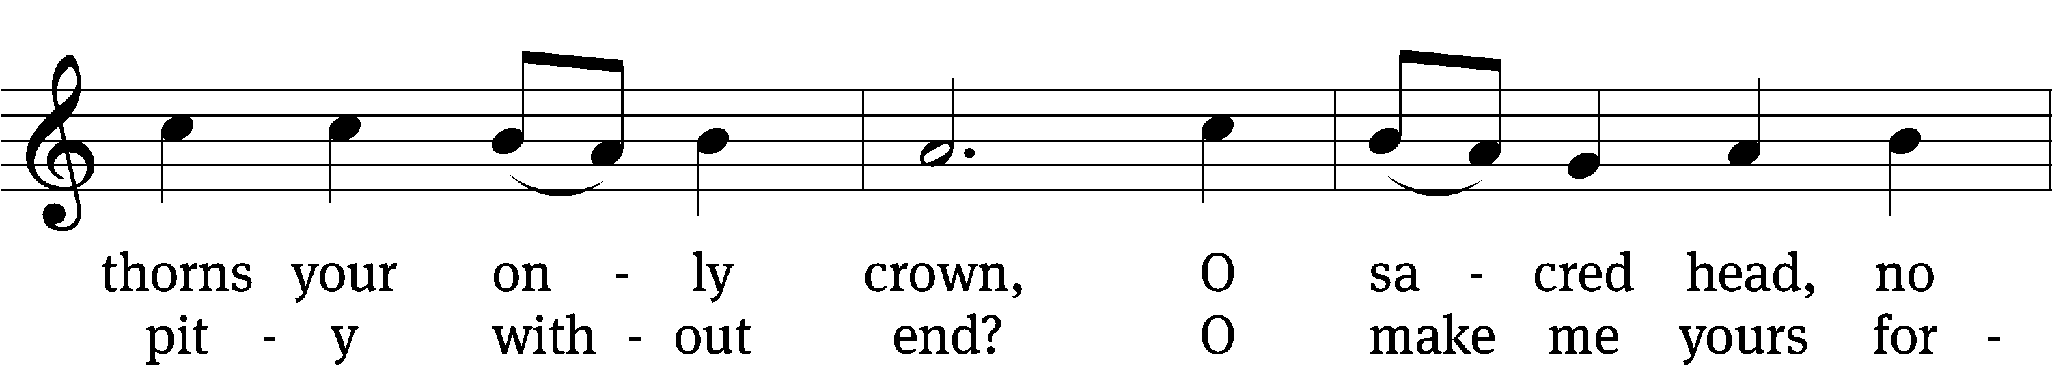
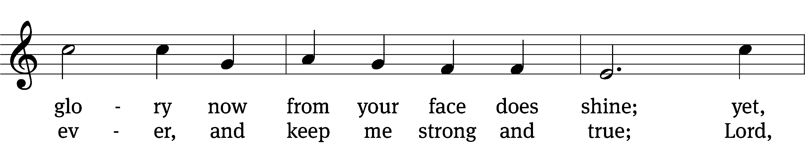
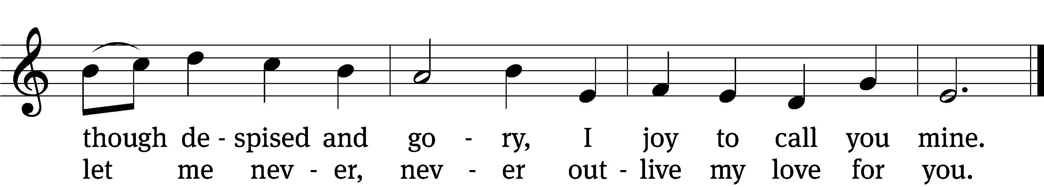
Text: tr. The Lutheran Hymnal, 1941, alt.; German version, Paul Gerhardt, 1607–1676; attr. Bernard of Clairvaux, 1091–1153, abr.
Tune: Hans Leo Hassler, 1546–1612
Text: © 1941 Concordia Publishing House. Used by permission: OneLicense no. 716626
Tune: Public domain

Death and Burial Matthew 27:27–66
27Then the governor’s soldiers took Jesus into the Praetorium and gathered the whole company of soldiers around him. 28They stripped him and put a scarlet robe on him, 29and then twisted together a crown of thorns and set it on his head. They put a staff in his right hand. Then they knelt in front of him and mocked him. “Hail, king of the Jews!” they said. 30They spit on him, and took the staff and struck him on the head again and again. 31After they had mocked him, they took off the robe and put his own clothes on him. Then they led him away to crucify him.
32As they were going out, they met a man from Cyrene, named Simon, and they forced him to carry the cross. 33They came to a place called Golgotha (which means “the place of the skull”). 34There they offered Jesus wine to drink, mixed with gall; but after tasting it, he refused to drink it. 35When they had crucified him, they divided up his clothes by casting lots. 36And sitting down, they kept watch over him there. 37Above his head they placed the written charge against him: this is jesus, the king of the jews.
38Two rebels were crucified with him, one on his right and one on his left. 39Those who passed by hurled insults at him, shaking their heads 40and saying, “You who are going to destroy the temple and build it in three days, save yourself! Come down from the cross, if you are the Son of God!” 41In the same way the chief priests, the teachers of the law and the elders mocked him. 42“He saved others,” they said, “but he can’t save himself! He’s the king of Israel! Let him come down now from the cross, and we will believe in him. 43He trusts in God. Let God rescue him now if he wants him, for he said, ‘I am the Son of God.’ ” 44In the same way the rebels who were crucified with him also heaped insults on him.
45From noon until three in the afternoon darkness came over all the land. 46About three in the afternoon Jesus cried out in a loud voice, “Eli, Eli,lemasabachthani?” (which means “My God, my God, why have you forsaken me?”).
47When some of those standing there heard this, they said, “He’s calling Elijah.”
48Immediately one of them ran and got a sponge. He filled it with wine vinegar, put it on a staff, and offered it to Jesus to drink. 49The rest said, “Now leave him alone. Let’s see if Elijah comes to save him.”
50And when Jesus had cried out again in a loud voice, he gave up his spirit.
51At that moment the curtain of the temple was torn in two from top to bottom. The earth shook, the rocks split 52and the tombs broke open. The bodies of many holy people who had died were raised to life. 53They came out of the tombs after Jesus’ resurrection and went into the holy city and appeared to many people.
54When the centurion and those with him who were guarding Jesus saw the earthquake and all that had happened, they were terrified, and exclaimed, “Surely he was the Son of God!”
55Many women were there, watching from a distance. They had followed Jesus from Galilee to care for his needs. 56Among them were Mary Magdalene, Mary the mother of James and Joseph, and the mother of Zebedee’s sons.
57As evening approached, there came a rich man from Arimathea, named Joseph, who had himself become a disciple of Jesus. 58Going to Pilate, he asked for Jesus’ body, and Pilate ordered that it be given to him. 59Joseph took the body, wrapped it in a clean linen cloth, 60and placed it in his own new tomb that he had cut out of the rock. He rolled a big stone in front of the entrance to the tomb and went away. 61Mary Magdalene and the other Mary were sitting there opposite the tomb.
62The next day, the one after Preparation Day, the chief priests and the Pharisees went to Pilate. 63“Sir,” they said, “we remember that while he was still alive that deceiver said, ‘After three days I will rise again.’ 64So give the order for the tomb to be made secure until the third day. Otherwise, his disciples may come and steal the body and tell the people that he has been raised from the dead. This last deception will be worse than the first.”
65“Take a guard,” Pilate answered. “Go, make the tomb as secure as you know how.” 66So they went and made the tomb secure by putting a seal on the stone and posting the guard.

428 O Sacred Head, Now Wounded CW 428 st. 4
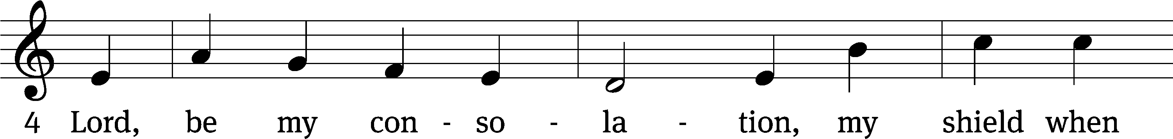
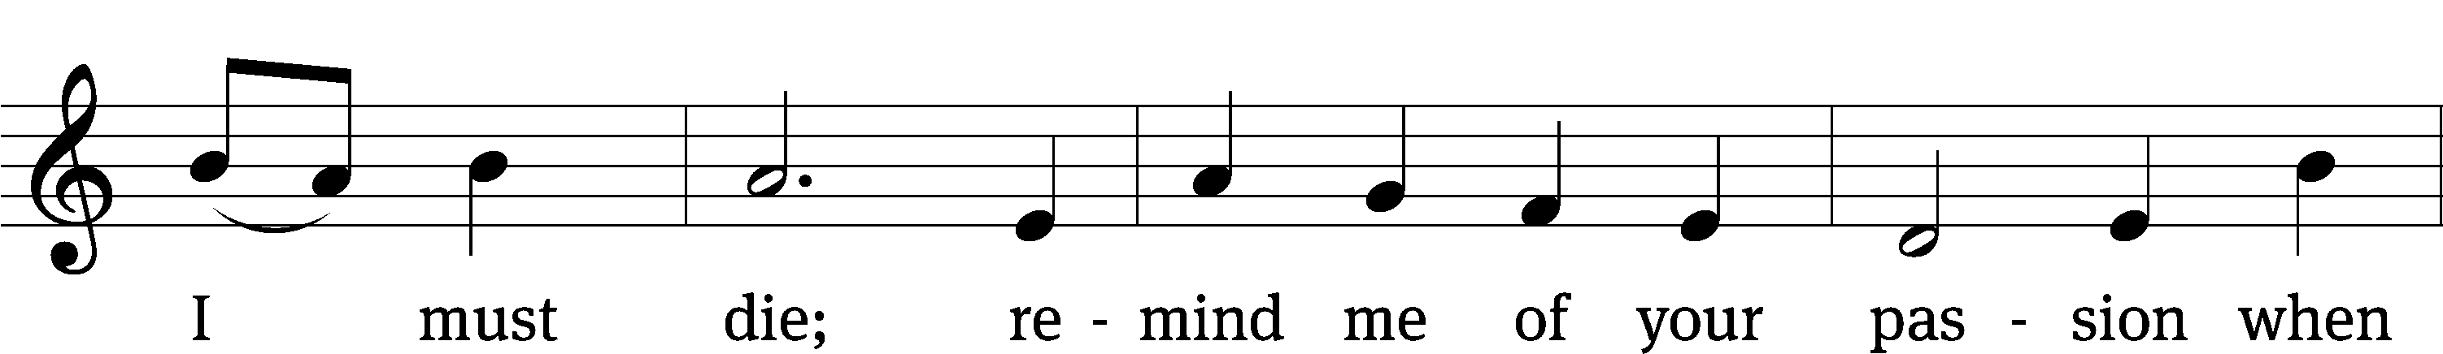
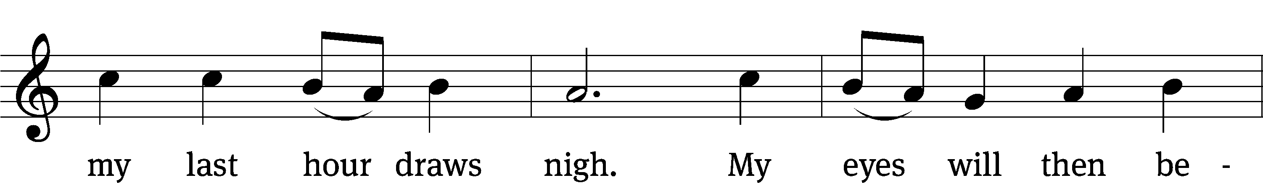
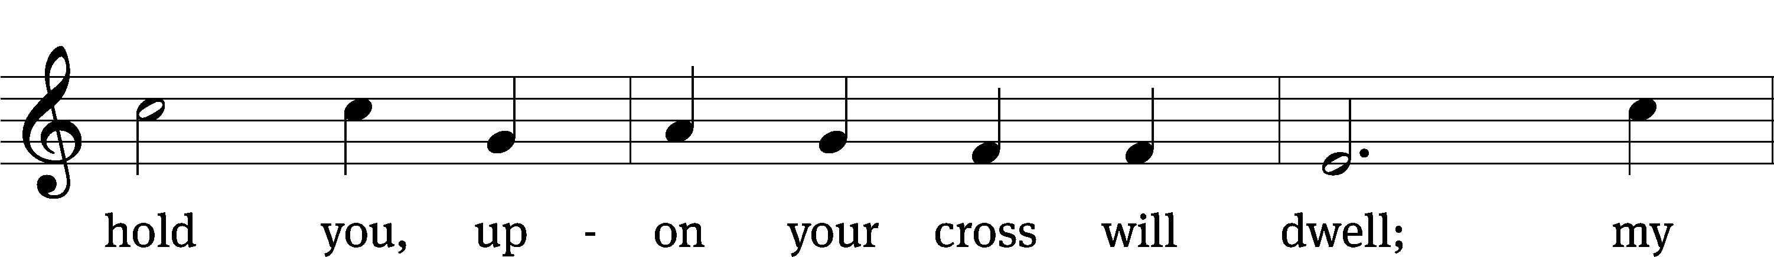
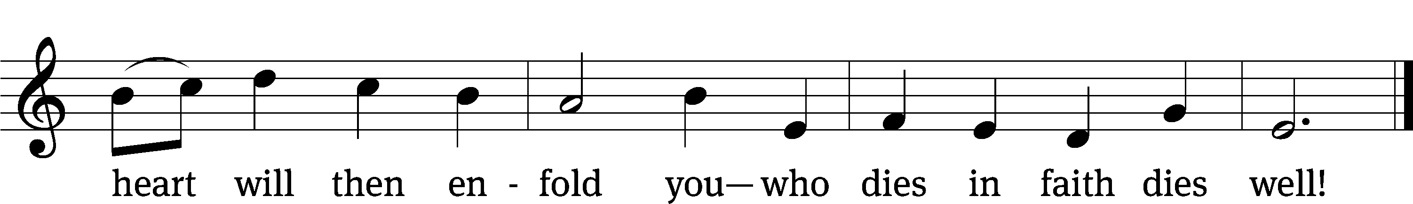
Text: tr. The Lutheran Hymnal, 1941, alt.; German version, Paul Gerhardt, 1607–1676; attr. Bernard of Clairvaux, 1091–1153, abr.
Tune: Hans Leo Hassler, 1546–1612
Text: © 1941 Concordia Publishing House. Used by permission: OneLicense no. 716626
Tune: Public domain

Prayer
Almighty and everlasting God, You sent Your Son, our Savior Jesus Christ, to take upon Himself our flesh and to suffer death upon the cross. Mercifully grant that we may follow the example of his great humility and patience and be made partakers of his resurrection; through the same Jesus Christ, our Lord, who lives and reigns with You and the Holy Spirit, one God, now and forever.
Amen.

Blessing
The Lord bless you and keep you.
The Lord make his face shine on you and be gracious to you.
The Lord look on you with favor and T give you peace.
Amen.

423 The Power of the Cross CW 423 sts. 1, Ref , 2–4, Final Refrain
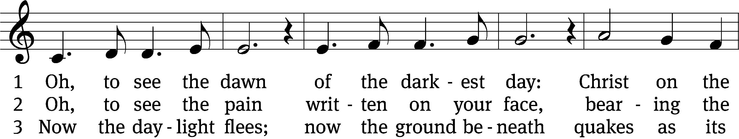
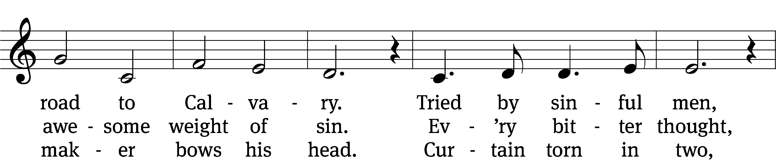
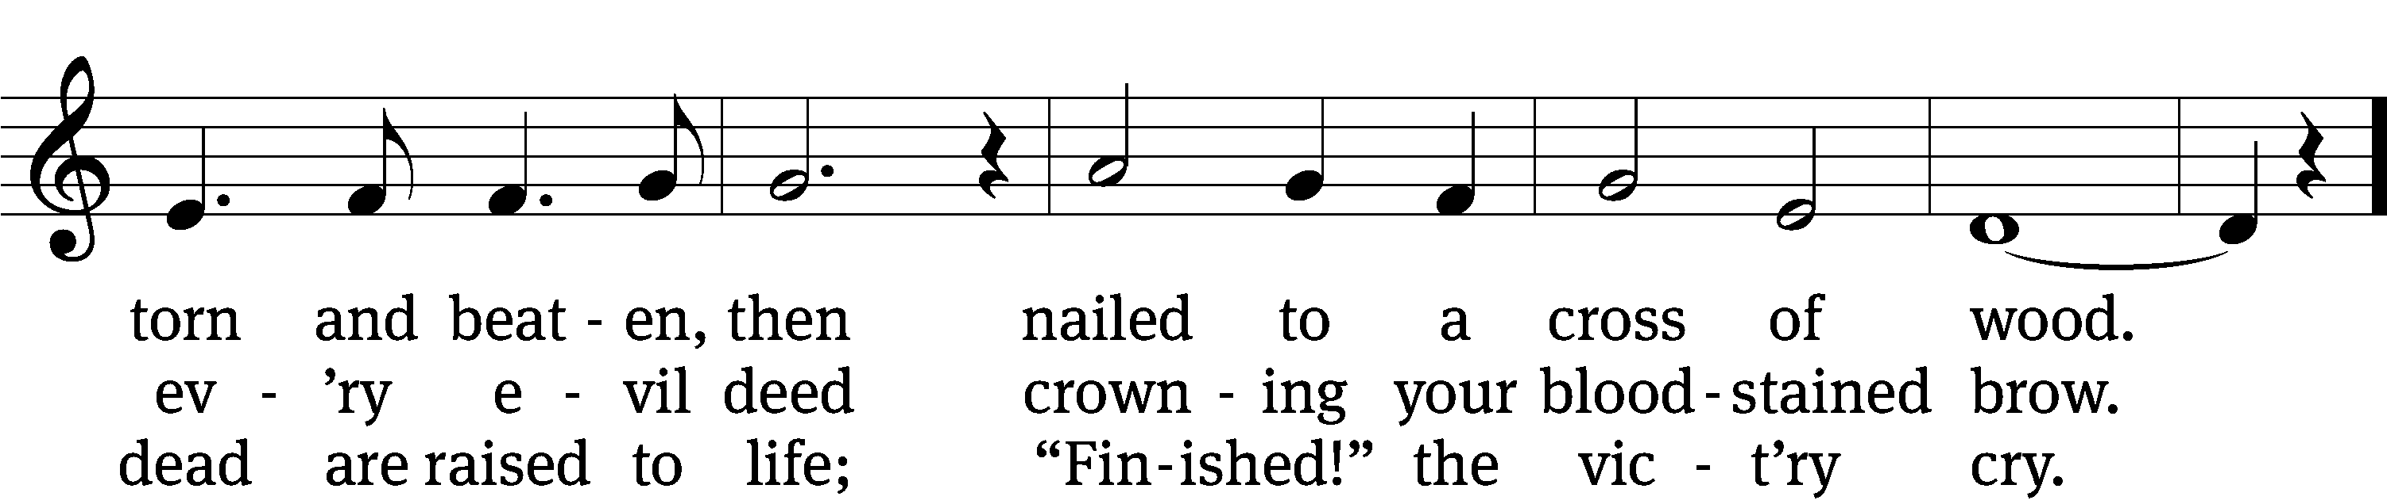
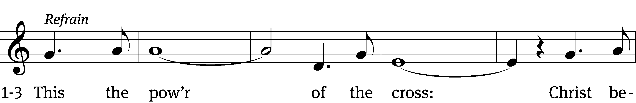
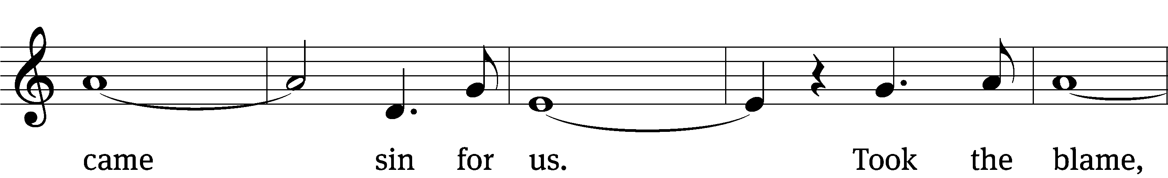
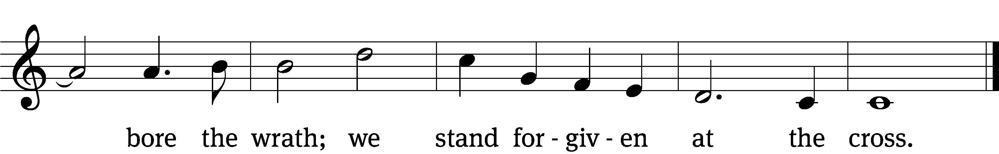

4 Oh, to see my name
written in the wounds,
for through your suff’ring I am free.
Death is crushed to death;
life is mine to live,
won through your selfless love!
(Final Refrain)

Final Refrain
This the pow’r of the cross:
Son of God—slain for us.
What a love, what a cost!
We stand forgiven at the cross.
Text: Stuart Townend, b. 1963; Keith Getty, b. 1974
Tune: Stuart Townend, b. 1963; Keith Getty, b. 1974
Text and tune: © 2005 Thankyou Music, admin. CapitolCMGPublishing,com. Used by permission: OneLicense no. 716626

Acknowledgments
Setting One from Christian Worship
Unless otherwise indicated, Scripture quotations are from The Holy Bible, New International Version®, NIV®. Copyright © 1973, 1978, 1984, 2011 by Biblica, Inc.TM Used by permission of Zondervan. All rights reserved worldwide.
Software distributed in partnership with Northwestern Publishing House.
Created by Christian Worship: Service Builder © 2023 Concordia Publishing House.

Next Week’s Worship
Our theme for worship: “He Lives to Take Me From Death to Life.” Our readings will be: Jonah 2: 2-9, 1 Corinthians 15: 1-11, and Matthew 28: 1-10. We will sing the following hymns: 438 Jesus Christ Is Risen Today, 510 In Christ Alone, 447 Christ Is Risen, He is Risen Indeed, and 441 I Know That My Redeemer Lives.

THIS WEEK AT BEAUTIFUL SAVIOR
† Today 10:30am Worship
12 pm Confirmation Class
† Tuesday N0 7pm Bible Study
† Thursday 7pm Worship with Communion
† Friday 7pm Tenebrae Service
† Sunday 9:15 Easter Breakfast
9:30am Sunday School
8am & 10:30am Worship
Easter Egg Hunt following 2nd Service

Easter postcards
There are Easter invite postcards available today. Think about your FRAN network (Friends, Relatives, Associates, and Neighbors) who you can give an invite card to for Easter. All the information you need is on the card. Grab a few and share them!

Altar Flower Sign-up
If you would like to provide flowers for a Sunday Service, please see the sign up chart near the entry way table. It can be for a special occasion, or simply to beautify our altar on a Sunday morning. If you have questions, contact Eileen Cleveland at 239-410-6366 or email at thedoll48@gmail.com

25th Anniversary
In May of 2025, we will be celebrating the 25th anniversary of the founding of Beautiful Savior! While that seems like a long time off, we are already making plans to celebrate God's grace to us over the years and also will be unveiling a special thankoffering which will raise funds to make improvements and renovations in our sanctuary area. Watch for more information to come in the following weeks.
The Next Step—Bible Information Class
Would you like the opportunity to grow deeper in what God’s Word has to say? On Sunday, May 15, we will be starting our newest Bible Information Class. It is an overview of God’s Word and also serves as our pre-membership class. It will meet in the sanctuary following the Sunday service. Questions? Please speak with Pastor Holz.

Easter egg candy
We are in need of non-chocolate, individually wrapped candies for our Easter egg hunt here at church on Easter Sunday. You can drop off the candy at church on Sunday or anytime during the week.

Easter breakfast
There will be an Easter breakfast at 9:15 am on Easter Sunday. Eggs, sausage and breakfast staples will be provided, but we are in need of fruit, pastries and other breakfast items for Easter breakfast. If you would like to bring something to share, please see the sign-up sheet on the entryway table.

Lunch Bunch
Lunch Bunch will take place Wednesday, April 19th, at 11:30am. Lunch will be served here at church for our older and/or retired members and friends. If you would like to attend please sign up so the hosts can get an accurate headcount for the meal preparations. A free will offering will be taken to cover the cost of the meal. After the meal there will be a short devotion. This will be a great opportunity for fellowship and a chance to get to know other people. If you have questions, please talk with Doris Harvey or Pastor Holz.

Ladies’ Day Out at Patti’s Settlement
The Ladies' Group is planning a day out at Patti's 1880's Settlement on Saturday, April 22 in Grand Rivers, Kentucky. Patti's is a destination for food, shopping, sightseeing, and more. Those attending will depart from the church parking lot on the 22nd at 10 am. If you would like to attend, please speak with Gael Irizzary. All ladies are welcome to attend, but there is a limit of 18 attendees.

Summer Camps
Summer Camp themes and dates have been decided. Camps are open to all children ages 3 years old through 3rd grade. Registration opens on May 1st. Dates and themes are as follows: June 26-30 Fabulous Fables and Tales, July 10-14 Cooking with Kids, and July 17-21 Water, Water Everywhere. If you have any questions or would like more information, please call the office at 931-905-1400.

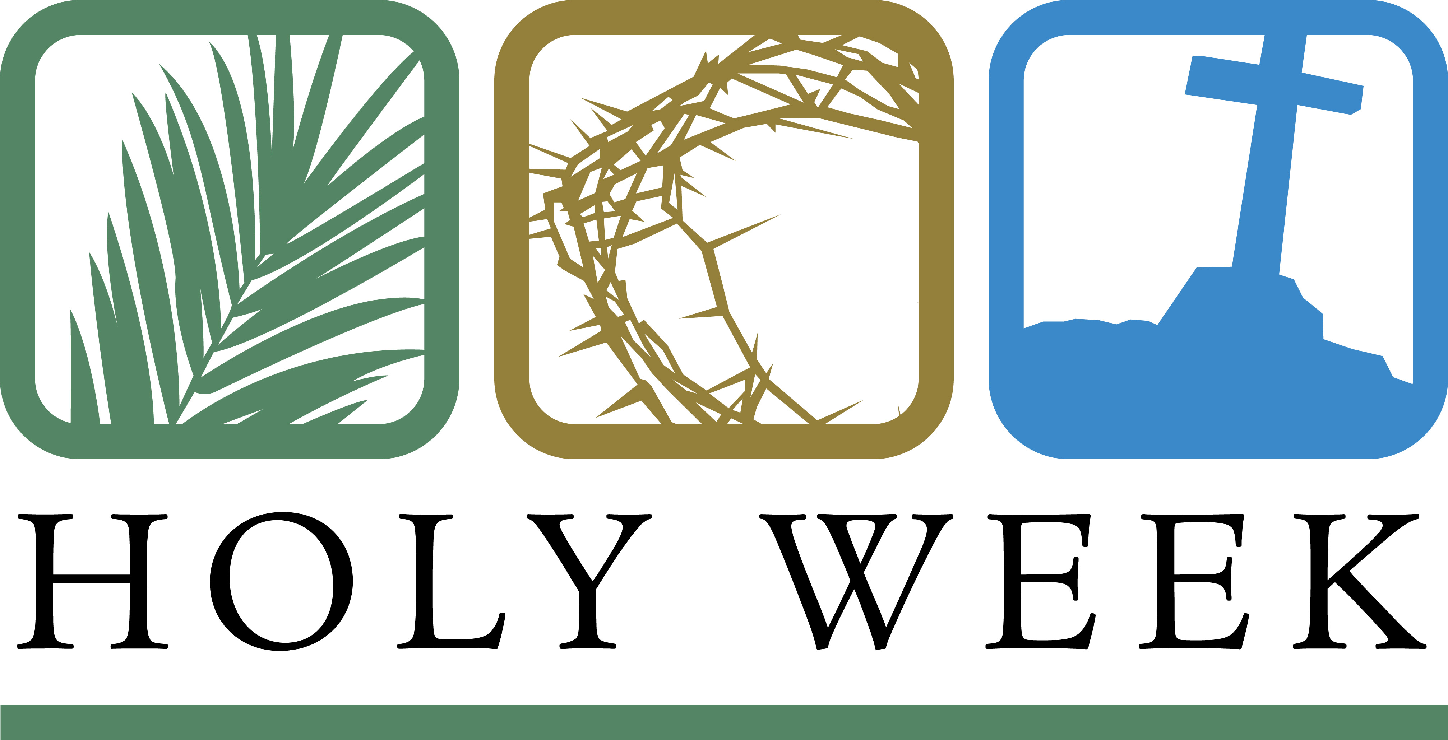

Maundy Thursday, April 6, 7pm
This is a special communion service that commemorates both the “new command” that Jesus gave to his disciples to “love one another”, and also the gift of his body and blood to us in the Lord’s Supper. This service ends with the Stripping of the Altar. All items are removed from the front of the church to remember how Jesus was abandoned by his disciples.

Good Friday Tenebrae April 7, 7pm
This service is a service of darkness in which we remember the final “seven words” of Jesus on the cross and his final loving actions in winning our salvation. The church is progressively darkened and candles extinguished to recount Jesus’ crucifixion and death. But one light remains to remind us of the new life (Easter) that is to come.

Easter Sunday Worship April 9, 8 & 10:30am We look into the empty tomb and rejoice that Jesus is risen!

Prayer List

Thank the Lord for the safe return of all the soldiers who recently came home and all soldiers and their families who are facing deployment. Please keep in your prayers this week all soldiers who are currently deployed. Please also remember: Family of Marcia Carter, sister of Tim Donner (Marcia called home to heaven); Sandy Holz, sister of Gael Irizarry (pneumonia); Renate Banks (illness); Shan Bradford, daughter of Porter Matthew and friend of Margareta Smothers, (injured in car accident); Marlys Donner, mother of Tim Donner (declining health); Mark Lenz, father of Pamela Holz (recovery from tumor surgery); Caleb Westra, friend of the Holz family (Surgeries on his leg and foot after accident); Josh Carter, friend of Adam Holz (recovery from car accident); Stacy Schroeder, daughter of Jeff & Eileen Cleveland (melanoma diagnosis); Autumn Potter & family, friends of Jessica Boulter (death of sister); Aimee Gerkhardt, sister in law of Jessica Church (breast cancer); Steven Owens, father of Mark Owens, (cancer); Kathy Temple (cancer reoccurrence); Brandon Vannoy, friend of Mac McCoo (seizures); Sheila Lynch, sister of Gayle Brooks (unable to walk); Drake Robideau, friend of Mary Daniel (strength & wellness); Mike LaFave (back problems); Linda Thomas, sister of Gayle Brooks, (physical rehab after injury); Ruth Amorth, twin sister of Hilde Fox (seriously ill); Gary Davis, husband of Angela Davis (seizures); Gidget Tate (Health issues). If you would like to have a name or situation included or if you would like to give an update on a prayer request, please contact Pastor Holz or call the church office at 931-905-1400.

Serving in God’s House

Ushers: Mike R, Trey Church
Greeters: Loretta Wilder, Ernie Rautter
Kitchen: Margareta S, Hannah L, Mary D
Piano: Deb White
Fellowship: (A-G)

Serving next week:

Ushers: David J, Ernie R
Greeters: Doris M, Mac M
Kitchen: Ingeborg H, Hannah L, Mary D
Piano: Barb N
Fellowship: (H-M)

Our Mission
By grace, the mission of
Beautiful Savior Evangelical Lutheran Church is
to proclaim the Word of God so that we may praise his name,
grow together in the knowledge of our Savior,
and share with others his message of forgiveness and eternal life.

