Beautiful Savior Lutheran Church

March 5th, 2023 – Second Sunday in Lent

service theme: our greatest needs—a gift for the world

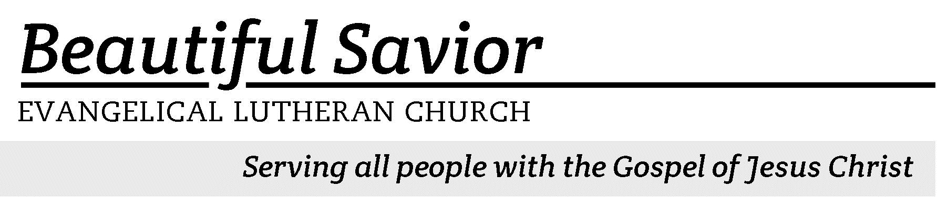


Welcome-- We are glad you could join us today! It is our hope that this service is a blessing to you. Please join us for worship again soon.

· Please save the last two rows of pews for parents with small children.

· Parents with little ones: If your child becomes restless during the service, that’s okay… We’re glad they’re here, and Jesus is pleased when they are brought to hear his Word: “Let the little children come to me.” If you need to be with your child in the Fellowship Hall, the service can be heard through a speaker.

· Five minutes before the worship service begins the usher will light the candles. This is our signal to quiet down and prepare our hearts for worship.

· Restrooms are conveniently located to the left as you exit the sanctuary.

· Please silence your cell phone before the start of the service.

Prayer for Worship
Lord God, often in my life I feel that I am crushed. Whether it is the weight of my sin or the burdens of life, the weight is heavy. Renew me and lighten the burden with the forgiveness that I have in Jesus, my Lord and Savior. Thank you for providing for me the answer to my greatest need.
Amen.

Beautiful Savior Lutheran Church
2526 Whitfield Road
Clarksville, TN 37040
931-905-1400
Website: www.bslclarksville.com
Kent Holz, Pastor
Bslc.clarksville@gmail.com
Barbara Noon, Preschool Director
beautifulsaviorpreschool@gmail.com
612 How Great Thou Art CW 612 sts. 1, Ref, 2–3
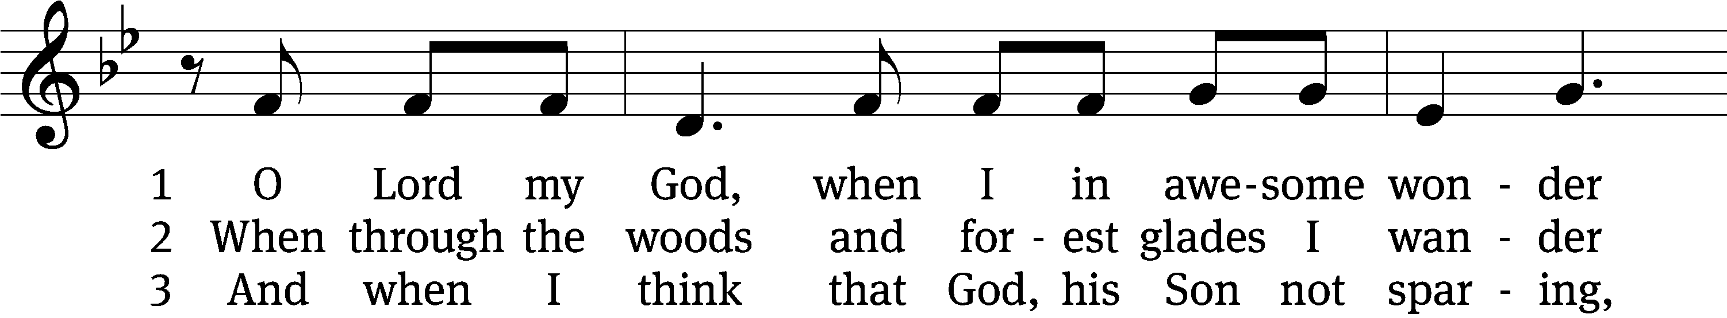
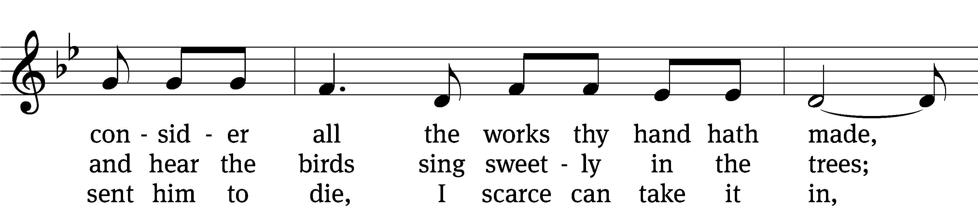
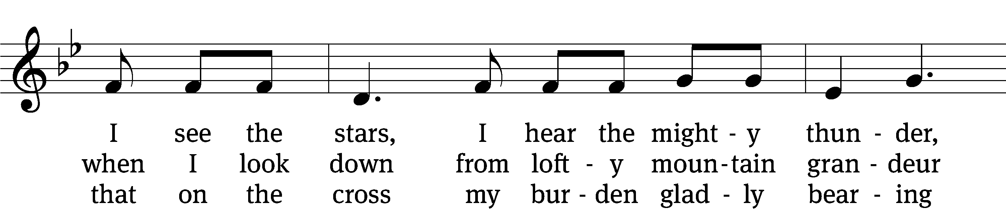
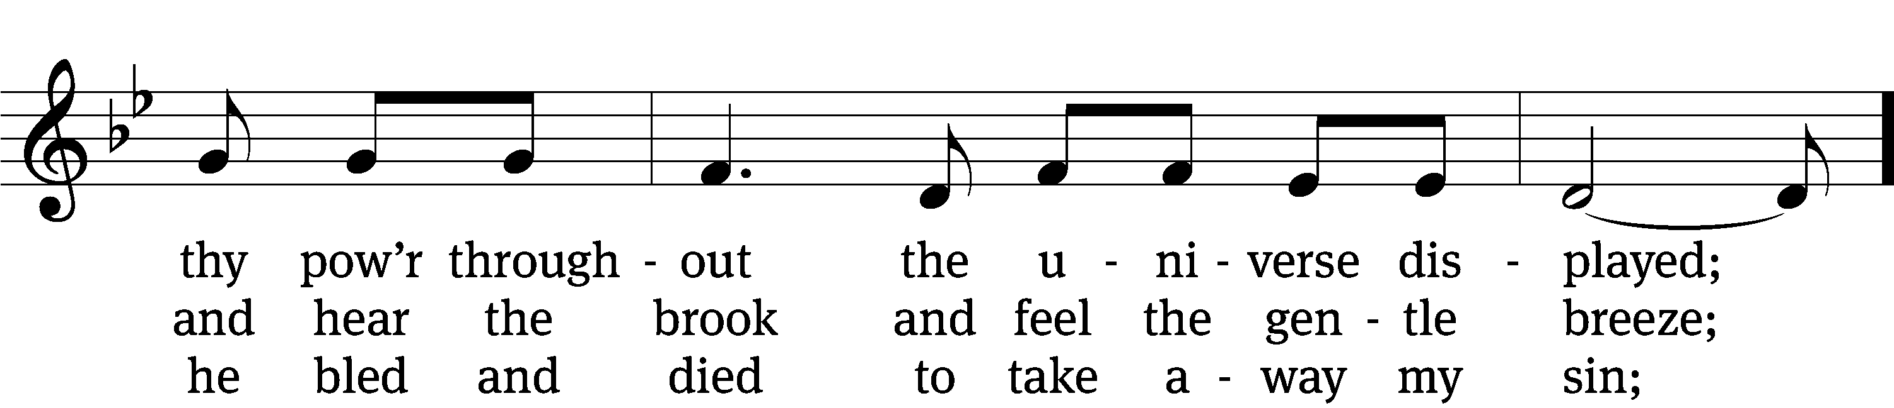
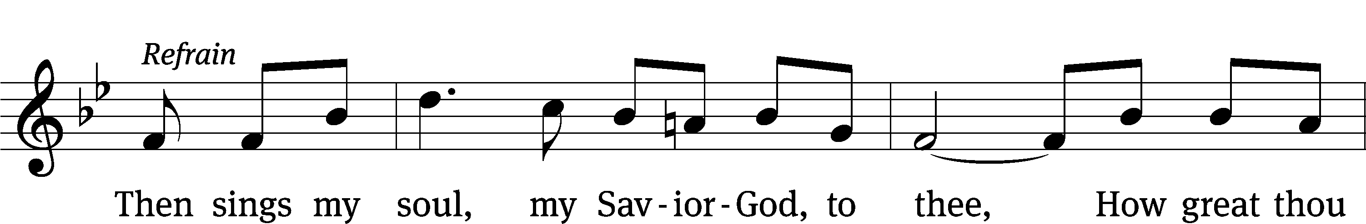
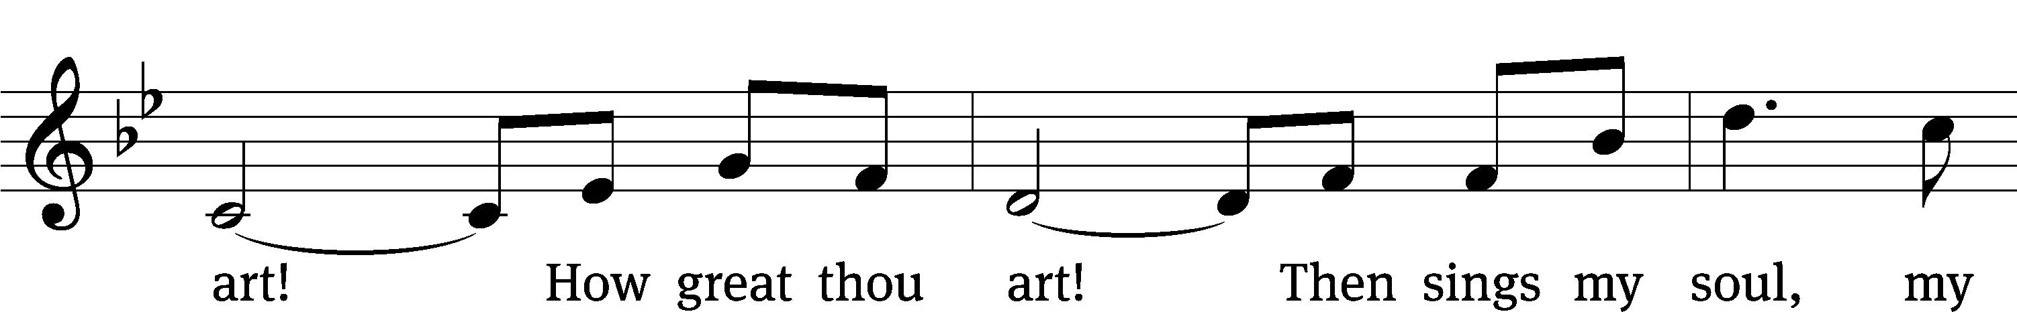
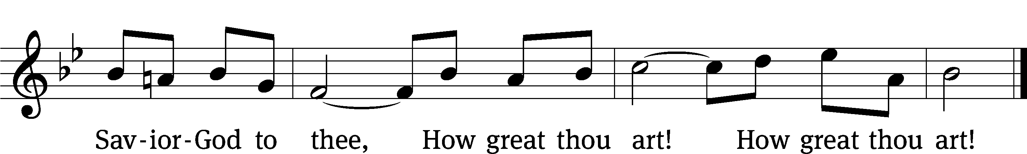
Text: Stuart W. K. Hine, 1899–1989
Tune: Swedish; setting: Stuart W. K. Hine, 1899–1989, alt.
Text: © 1949, 1953 The Stuart Hine Trust, admin. Hope Publishing Co. Used by permission: OneLicense no. 716626
Tune: © 1949, 1953 The Stuart Hine Trust, admin. CapitolCMGPublishing,com. Used by permission: OneLicense no. 716626

In the name of the Father and of the T Son and of the Holy Spirit.
Amen.
Confession
If we claim to be without sin, we deceive ourselves and the truth is not in us.
If we confess our sins, God is faithful and just
and will forgive us our sins
and purify us from all unrighteousness.

Let us confess our sins to the Lord.
Holy God, gracious Father,
I am sinful by nature
and have sinned against you in my thoughts, words, and actions.
I have not loved you with my whole heart;
I have not loved others as I should.
I deserve your punishment both now and forever.
But Jesus, my Savior, paid for my sins
with his innocent suffering and death.
Trusting in him, I pray: God, have mercy on me, a sinner.

Our gracious Father in heaven has been merciful to us. He sent his only Son, Jesus Christ, who gave his life as the atoning sacrifice for the sins of the whole world. Therefore, as a called servant of Christ and by his authority, I forgive you all your sins in the name of the Father and of the T Son and of the Holy Spirit.
Amen.

612 How Great Thou Art CW 612 st. 4

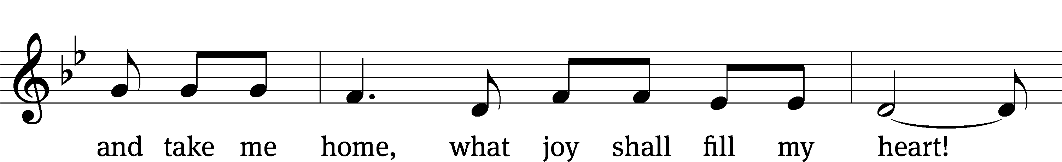
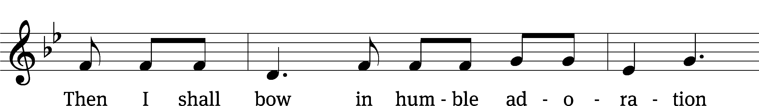
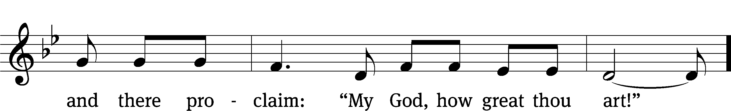
Text: Stuart W. K. Hine, 1899–1989
Tune: Swedish; setting: Stuart W. K. Hine, 1899–1989, alt.
Text: © 1949, 1953 The Stuart Hine Trust, admin. Hope Publishing Co. Used by permission: OneLicense no. 716626
Tune: © 1949, 1953 The Stuart Hine Trust, admin. CapitolCMGPublishing,com. Used by permission: OneLicense no. 716626

Lord, Have Mercy
In peace let us pray to the Lord.
Lord, have mercy.

For the peace from above and for our salvation, let us pray to the Lord.
Lord, have mercy.

For the peace of the whole world, for the well-being of the Church of God, and for the unity of all, let us pray to the Lord.
Lord, have mercy.

For this holy house and for all who offer here their worship and praise, let us pray to the Lord.
Lord, have mercy.

Help, save, comfort, and defend us, gracious Lord.
Amen.
The Word

The Lord be with you.
And also with you.

Prayer of the Day
Let us pray.

Almighty God, you see that we have no power to defend ourselves. Guard and keep us both outwardly and inwardly from all adversities that may happen to the body and all evil thoughts that may assault and hurt the soul; through your Son, Jesus Christ our Lord, who lives and reigns with you and the Holy Spirit, one God, now and forever.
Amen.

First Reading Romans 4:1–5,13–17
1What then shall we say that Abraham, our forefather according to the flesh, discovered in this matter? 2If, in fact, Abraham was justified by works, he had something to boast about—but not before God. 3What does Scripture say? “Abraham believed God, and it was credited to him as righteousness.”
4Now to the one who works, wages are not credited as a gift but as an obligation. 5However, to the one who does not work but trusts God who justifies the ungodly, their faith is credited as righteousness.
13It was not through the law that Abraham and his offspring received the promise that he would be heir of the world, but through the righteousness that comes by faith. 14For if those who depend on the law are heirs, faith means nothing and the promise is worthless, 15because the law brings wrath. And where there is no law there is no transgression.
16Therefore, the promise comes by faith, so that it may be by grace and may be guaranteed to all Abraham’s offspring—not only to those who are of the law but also to those who have the faith of Abraham. He is the father of us all. 17As it is written: “I have made you a father of many nations.” He is our father in the sight of God, in whom he believed—the God who gives life to the dead and calls into being things that were not.

121A I Lift Up My Eyes to the Mountains Psalm 121A
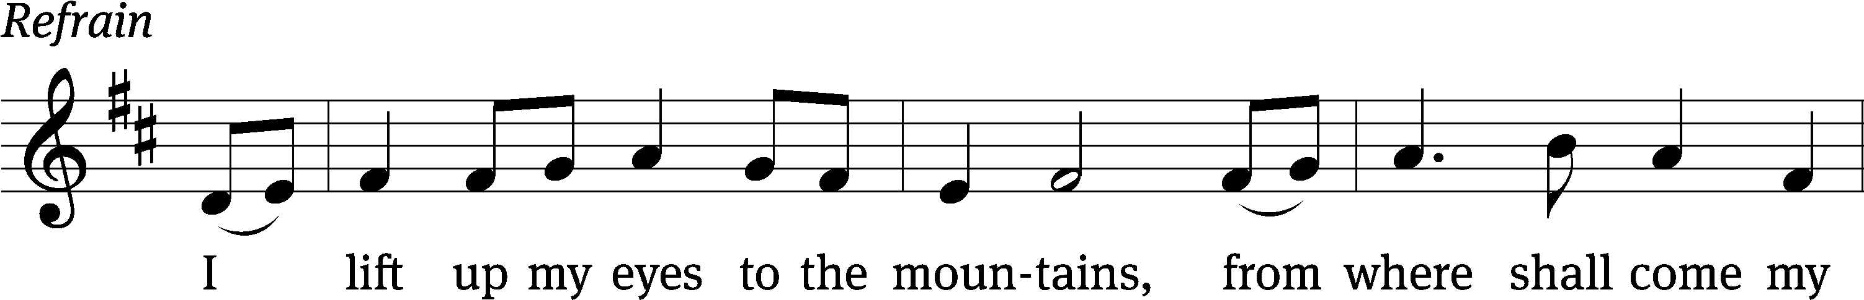
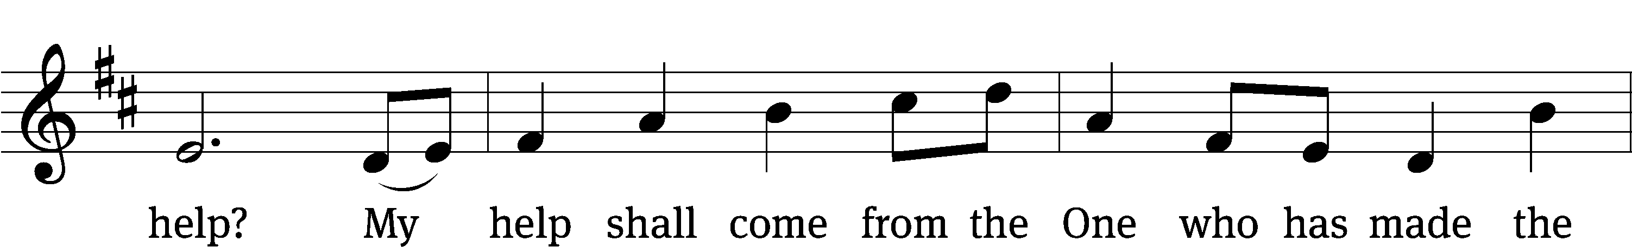
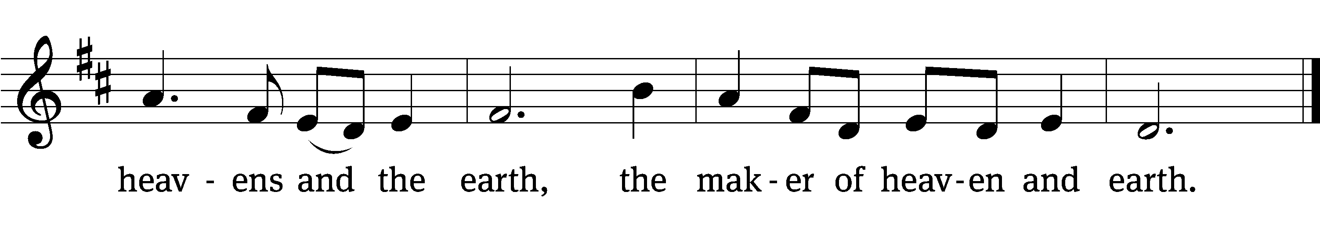


I lift up my eyes to the / mountains—
where does my help / come from?
My help comes / from the Lord,
the maker of / heaven and earth.
He will not let your / foot slip—
he who watches over you will not / slumber;
indeed, he who watches over / Israel
will neither / slumber nor sleep. Refrain

The Lord watches / over you—
the Lord is your shade / at your right hand.
The Lord will keep you / from all harm—
he will watch / over your life;
the Lord will watch over your coming and / going
both now and for- / evermore.
Glory be to the Father and / to the Son
and to the Holy / Spirit,
as it was in the be- / ginning,
is now, and will be forever. / Amen. Refrain
Tune: Marty Haugen
Tune: © 2000 GIA Publications, Inc. Used by permission: OneLicense no. 716626
Setting: © 2021 Northwestern Publishing House. Used by permission: OneLicense no. 716626

Gospel John 3:1–17
1Now there was a Pharisee, a man named Nicodemus who was a member of the Jewish ruling council. 2He came to Jesus at night and said, “Rabbi, we know that you are a teacher who has come from God. For no one could perform the signs you are doing if God were not with him.”
3Jesus replied, “Very truly I tell you, no one can see the kingdom of God unless they are born again.”
4“How can someone be born when they are old?” Nicodemus asked. “Surely they cannot enter a second time into their mother’s womb to be born!”
5Jesus answered, “Very truly I tell you, no one can enter the kingdom of God unless they are born of water and the Spirit. 6Flesh gives birth to flesh, but the Spirit gives birth to spirit. 7You should not be surprised at my saying, ‘You must be born again.’ 8The wind blows wherever it pleases. You hear its sound, but you cannot tell where it comes from or where it is going. So it is with everyone born of the Spirit.”
9“How can this be?” Nicodemus asked.
10“You are Israel’s teacher,” said Jesus, “and do you not understand these things? 11Very truly I tell you, we speak of what we know, and we testify to what we have seen, but still you people do not accept our testimony. 12I have spoken to you of earthly things and you do not believe; how then will you believe if I speak of heavenly things? 13No one has ever gone into heaven except the one who came from heaven—the Son of Man. 14Just as Moses lifted up the snake in the wilderness, so the Son of Man must be lifted up, 15that everyone who believes may have eternal life in him.”
16For God so loved the world that he gave his one and only Son, that whoever believes in him shall not perish but have eternal life. 17For God did not send his Son into the world to condemn the world, but to save the world through him.

Children's Devotion Ages 3 through grade 5 are invited to come forward for a Bible lesson.

Children's Church During the service, parents may choose to take their children (ages 2-5) to Children’s Church. There they will hear a Bible story, and sing songs. They will return to the sanctuary during the offering

523 How Deep the Father’s Love for Us CW 523
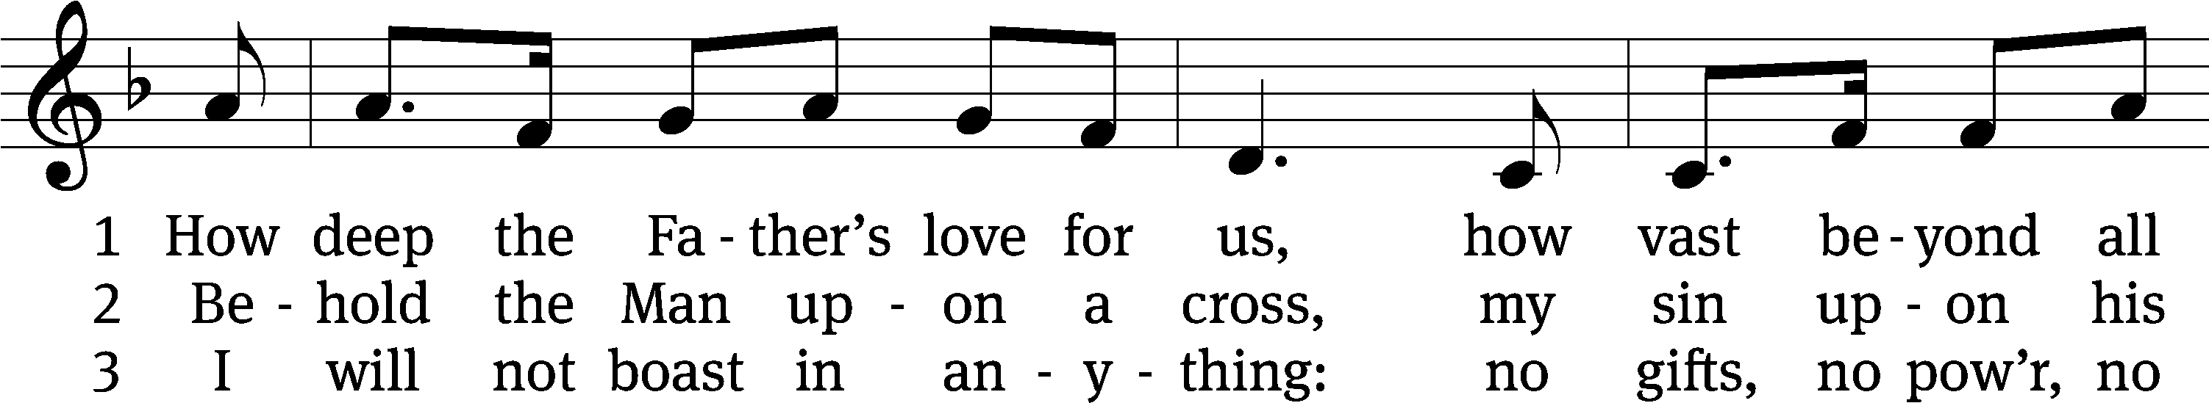
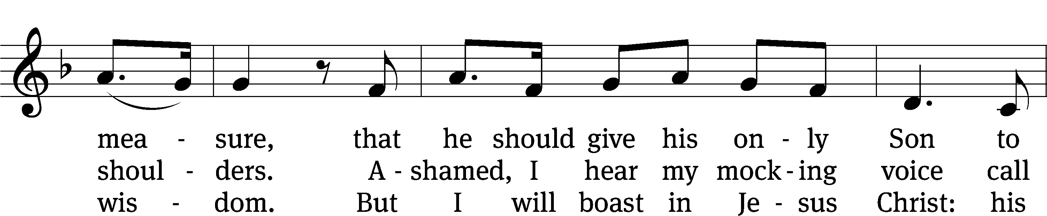
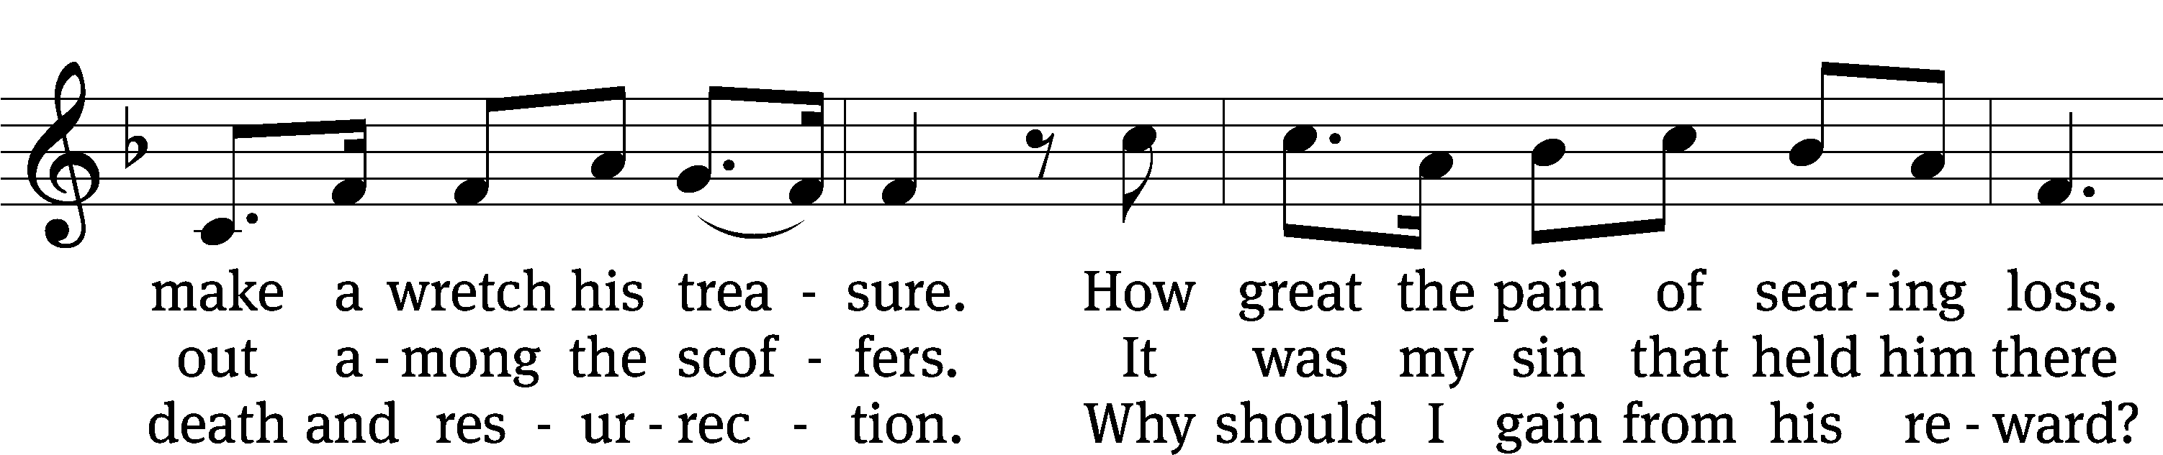
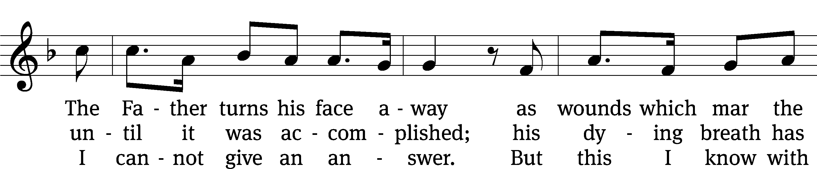
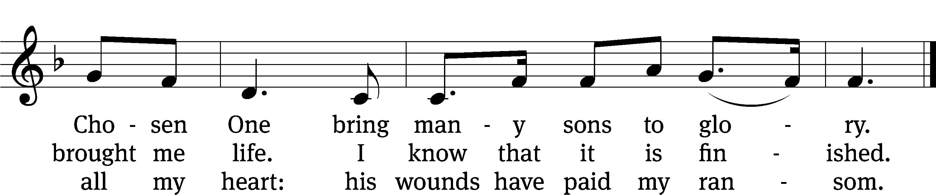
Text: Stuart Townend, b. 1963
Tune: Stuart Townend, b. 1963
Text and tune: © 1995 Thankyou Music, admin. CapitolCMGPublishing,com. Used by permission: One License no. A-716626

Sermon Genesis 12:1–8
1The Lord had said to Abram, “Go from your country, your people and your father’s household to the land I will show you.
2“I will make you into a great nation,
and I will bless you;
I will make your name great,
and you will be a blessing.
3I will bless those who bless you,
and whoever curses you I will curse;
and all peoples on earth
will be blessed through you.”
4So Abram went, as the Lord had told him; and Lot went with him. Abram was seventy-five years old when he set out from Harran. 5He took his wife Sarai, his nephew Lot, all the possessions they had accumulated and the people they had acquired in Harran, and they set out for the land of Canaan, and they arrived there.
6Abram traveled through the land as far as the site of the great tree of Moreh at Shechem. At that time the Canaanites were in the land. 7The Lord appeared to Abram and said, “To your offspring I will give this land.” So he built an altar there to the Lord, who had appeared to him.
8From there he went on toward the hills east of Bethel and pitched his tent, with Bethel on the west and Ai on the east. There he built an altar to the Lord and called on the name of the Lord.

“God says: “Trust me.”
Nicene Creed
We believe in one God, the Father, the Almighty,
maker of heaven and earth,
of all that is,
seen and unseen.

We believe in one Lord, Jesus Christ, the only Son of God,
eternally begotten of the Father,
God from God, Light from Light, true God from true God,
begotten, not made,
of one being with the Father.
Through him all things were made.
For us and for our salvation, he came down from heaven,
was incarnate of the Holy Spirit and the Virgin Mary,
and became truly human.
For our sake he was crucified under Pontius Pilate.
He suffered death and was buried.
On the third day he rose again in accordance with the Scriptures.
He ascended into heaven
and is seated at the right hand of the Father.
He will come again in glory to judge the living and the dead,
and his kingdom will have no end.

We believe in the Holy Spirit,
the Lord, the giver of life,
who proceeds from the Father and the Son,
who in unity with the Father and the Son
is worshiped and glorified,
who has spoken through the prophets.
We believe in one holy Christian and apostolic Church.
We acknowledge one baptism for the forgiveness of sins.
We look for the resurrection of the dead
and the life of the world to come. Amen.


Offering “We love because he first loved us.” 1Jn 4:19 God’s love in sending Jesus to live, to suffer, and to die for each of us motivates the members of Beautiful Savior to show their love and thanks by returning a portion of their income to the Lord. Through these free will offerings, this congregation and its ministries are maintained.
*If you would like to give your regular offering envelope, you can mail it to the church. If you would like to give securely online, scan this code or follow this link: bslclarksville.com

The Sacrament
Preface
The Lord be with you.
And also with you.

Lift up your hearts.
We lift them up to the Lord.

Let us give thanks to the Lord our God.
It is right to give him thanks and praise.

It is truly good and right that we should at all times and in all places give you thanks, O Lord, holy Father, almighty and everlasting God, through Jesus Christ our Lord, who brought the gift of salvation to all people by his death on the tree of the cross so that the devil, who overcame us by a tree, would in turn by a tree be overcome. Therefore, with all the saints on earth and hosts of heaven, we praise your holy name and join their glorious song:

Holy, Holy, Holy CW 167
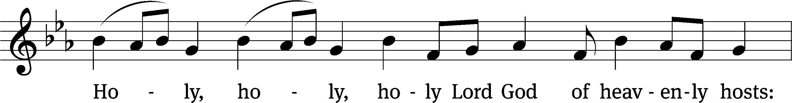
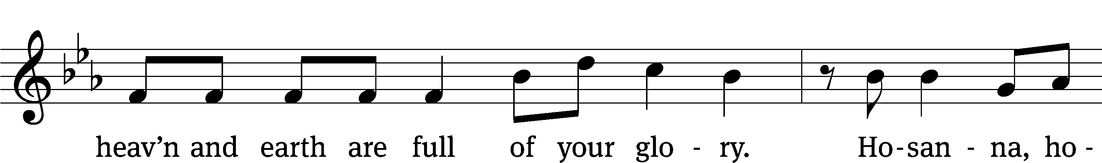
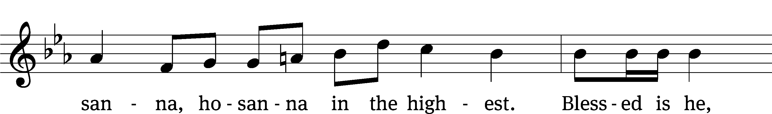
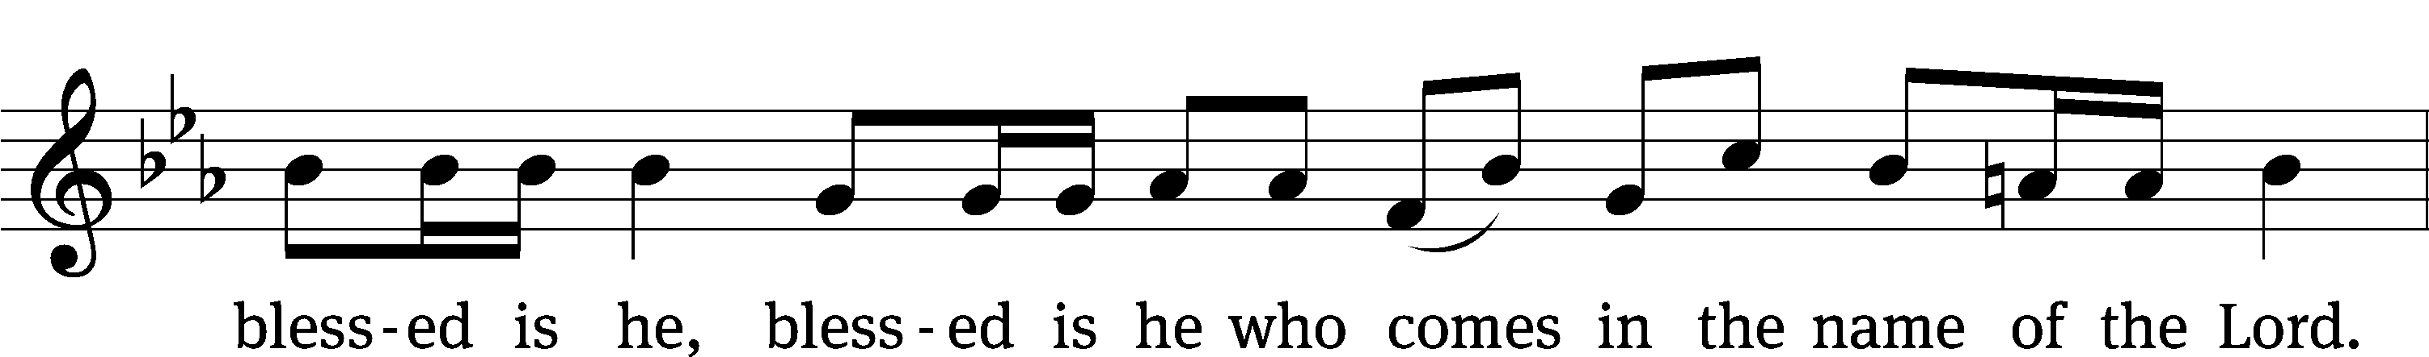
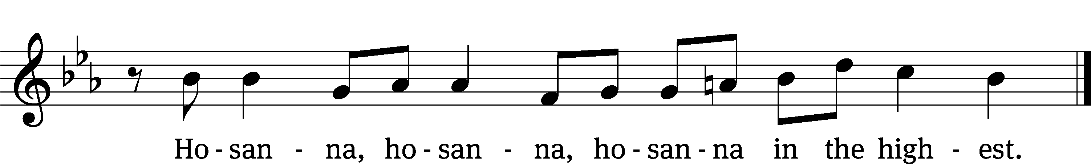

Words of Institution
Our Lord Jesus Christ, on the night he was betrayed, took bread; and when he had given thanks, he broke it and gave it to his disciples, saying, “Take and eat; this is my T body, which is given for you. Do this in remembrance of me.”

Then he took the cup, gave thanks, and gave it to them, saying, “Drink from it, all of you; this is my T blood of the new covenant, which is poured out for you for the forgiveness of sins. Do this, whenever you drink it, in remembrance of me.”

The peace of the Lord be with you always.
Amen.

O Christ, Lamb of God CW 169

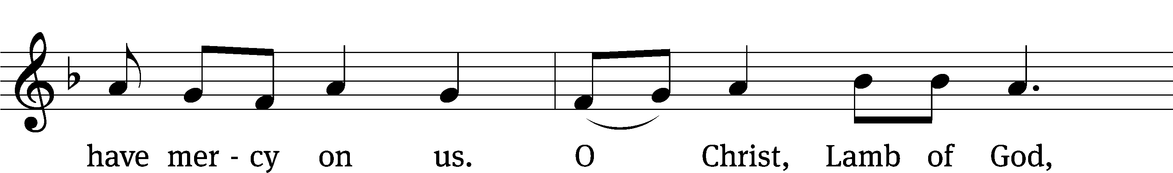
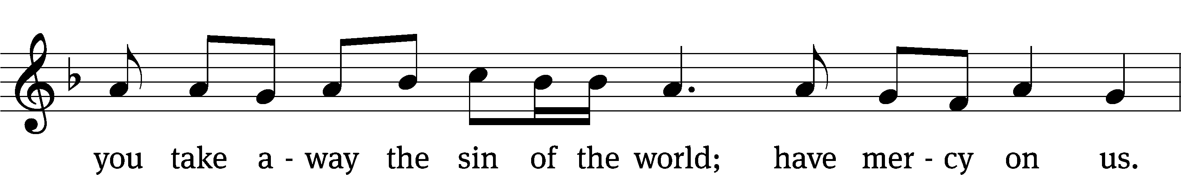



Distribution (When we come to the Lord’s Supper, we receive the body and blood of our Lord Jesus Christ for the personal assurance of forgiveness. But the Lord’s Supper is also a confessional act, by which we confess a oneness of faith. We therefore ask only those who are confirmed members of Beautiful Savior Lutheran Church or of sister Wisconsin Synod Lutheran churches to approach the altar. If anyone has a question about our communion practice or would like to become a communicant member of Beautiful Savior, please speak with the pastor after the service.)
570 God Loved the World So That He Gave CW 570
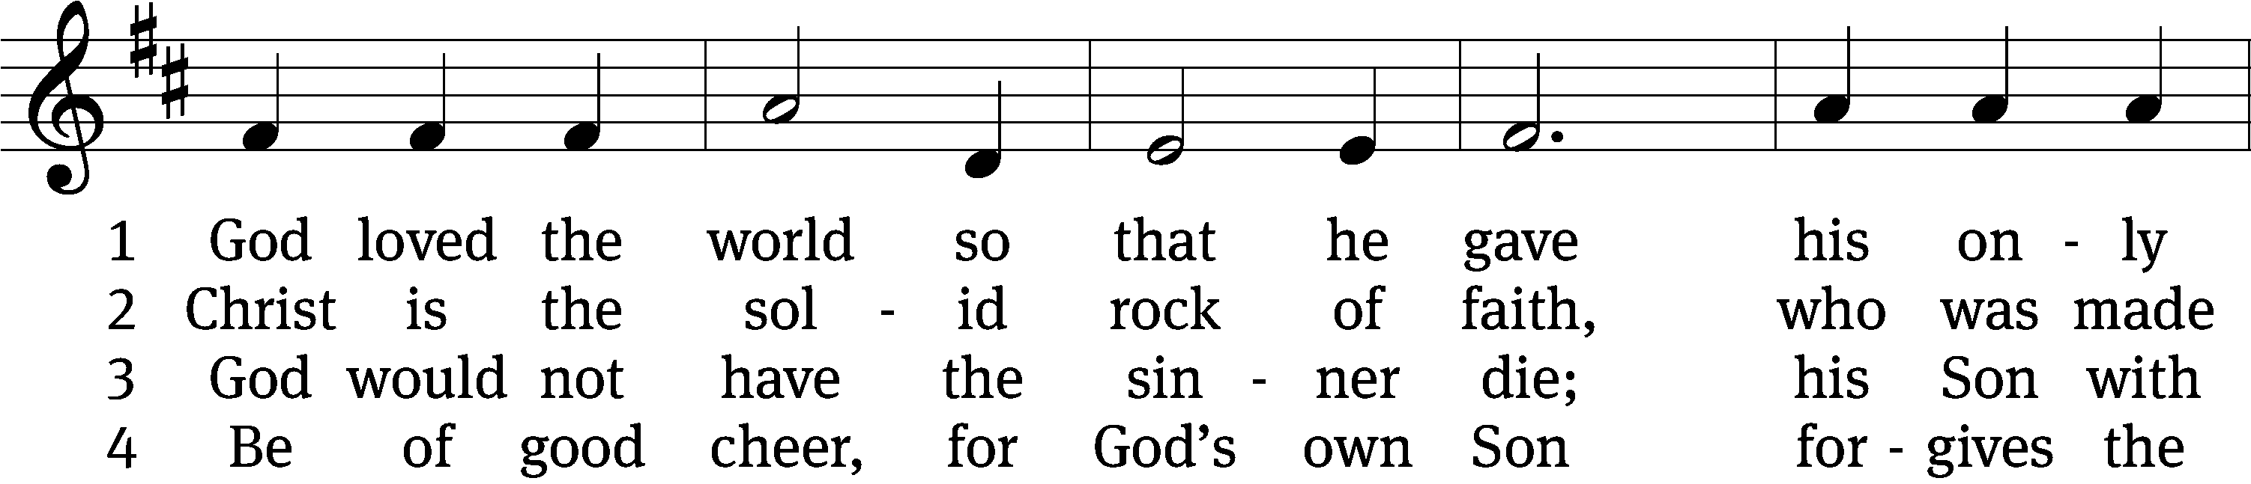
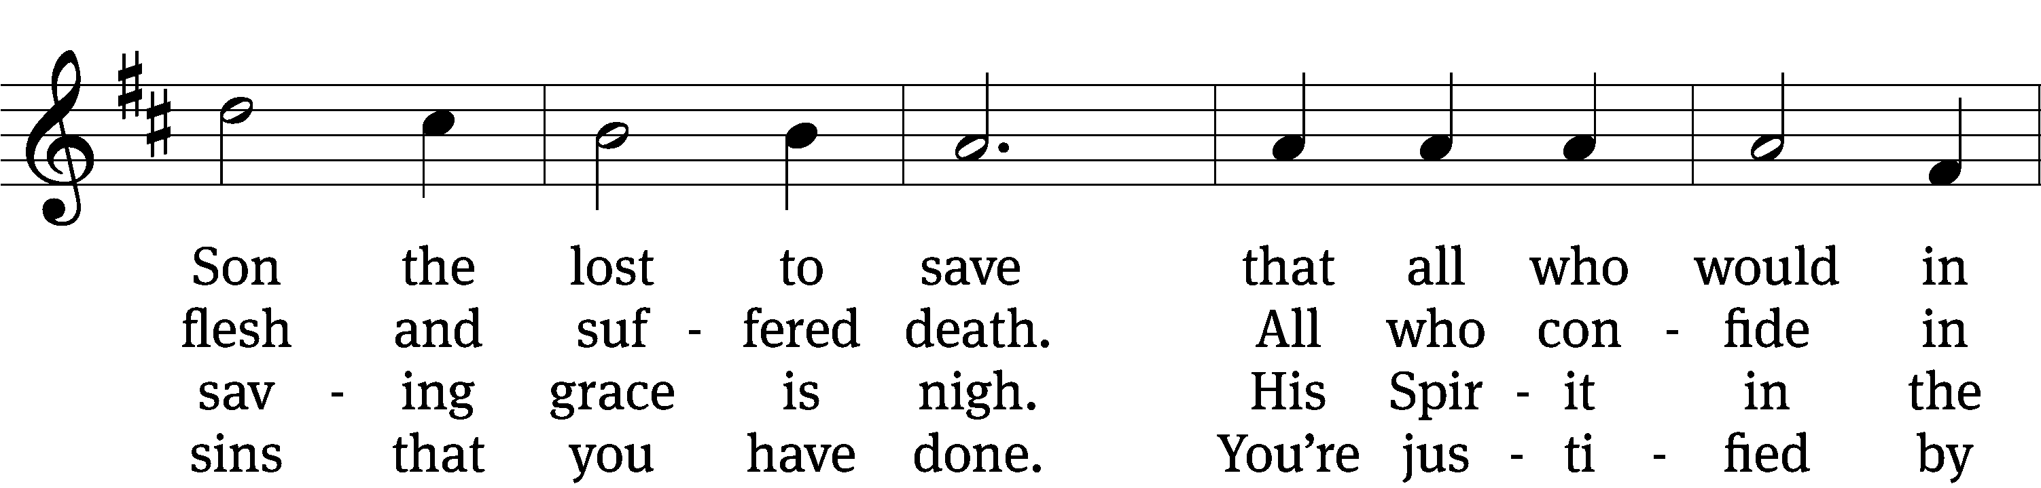
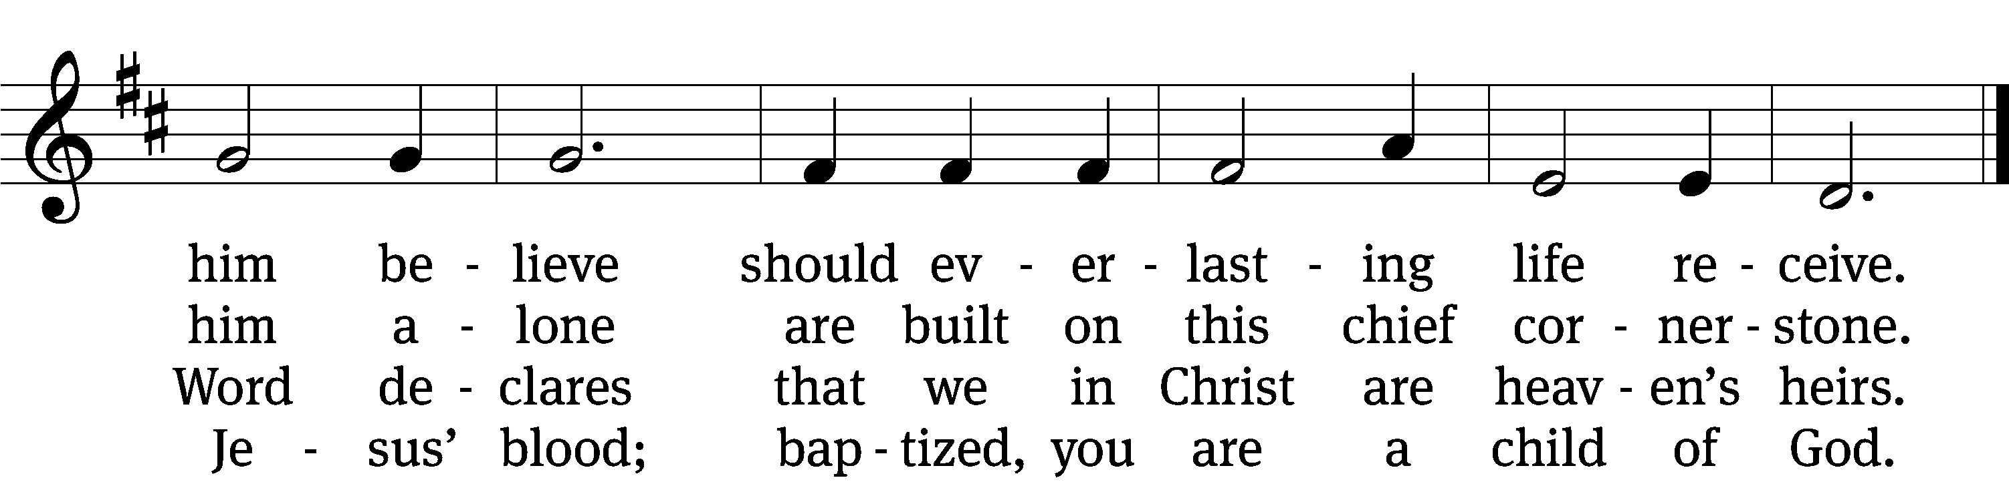

5 If you are sick, if death is near,
this truth your troubled heart can cheer:
Christ Jesus saves my soul from death;
this is the anchor of my faith!

6 Glory to God the Father, Son,
and Holy Spirit, Three in One!
To you, O blessèd Trinity,
be praise now and eternally!
Text: tr. August Crull, 1845–1923, alt.; Heiliges Lippen- und Hertzens- Opffer, Stettin, c. 1778
Tune: George J. Elvey, 1816–1893
Text and tune: Public domain

Communion Blessing

The true body and blood of our Lord Jesus Christ strengthen and preserve you to life everlasting. Go T in peace.
Amen.
Prayer
Give thanks to the Lord, for he is good;
his mercy endures forever.

Whenever we eat this bread and drink this cup,
we proclaim the Lord’s death until he comes.

We give thanks, almighty God, that you have refreshed us with this saving gift. We pray that through it you will strengthen our faith in you and increase our love for one another. We ask this in the name of Jesus Christ our Lord, who lives and reigns with you and the Holy Spirit, one God, now and forever.
Amen.
Blessing
The Lord bless you and keep you.
The Lord make his face shine on you and be gracious to you.
The Lord look on you with favor and T give you peace.
Amen.

627 To God Be the Glory CW 627
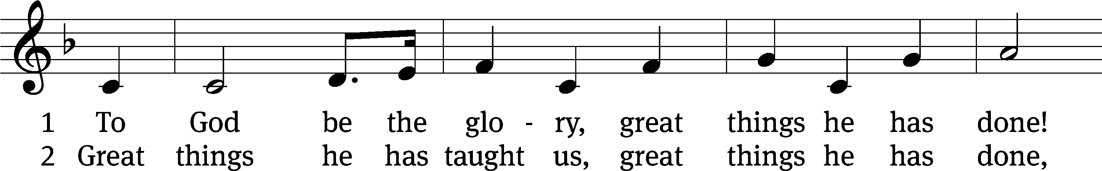
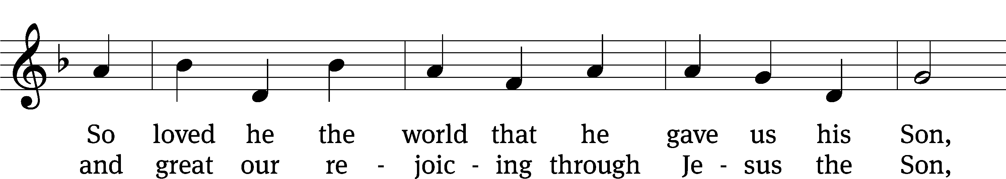
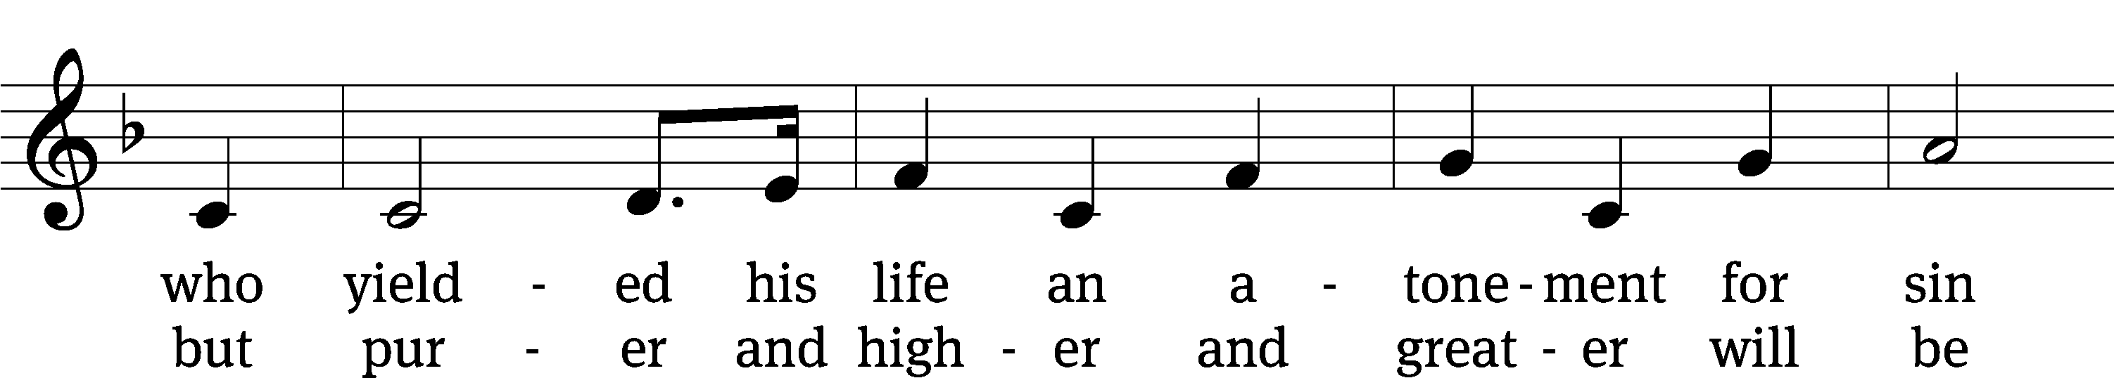
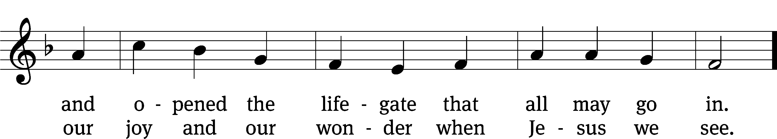
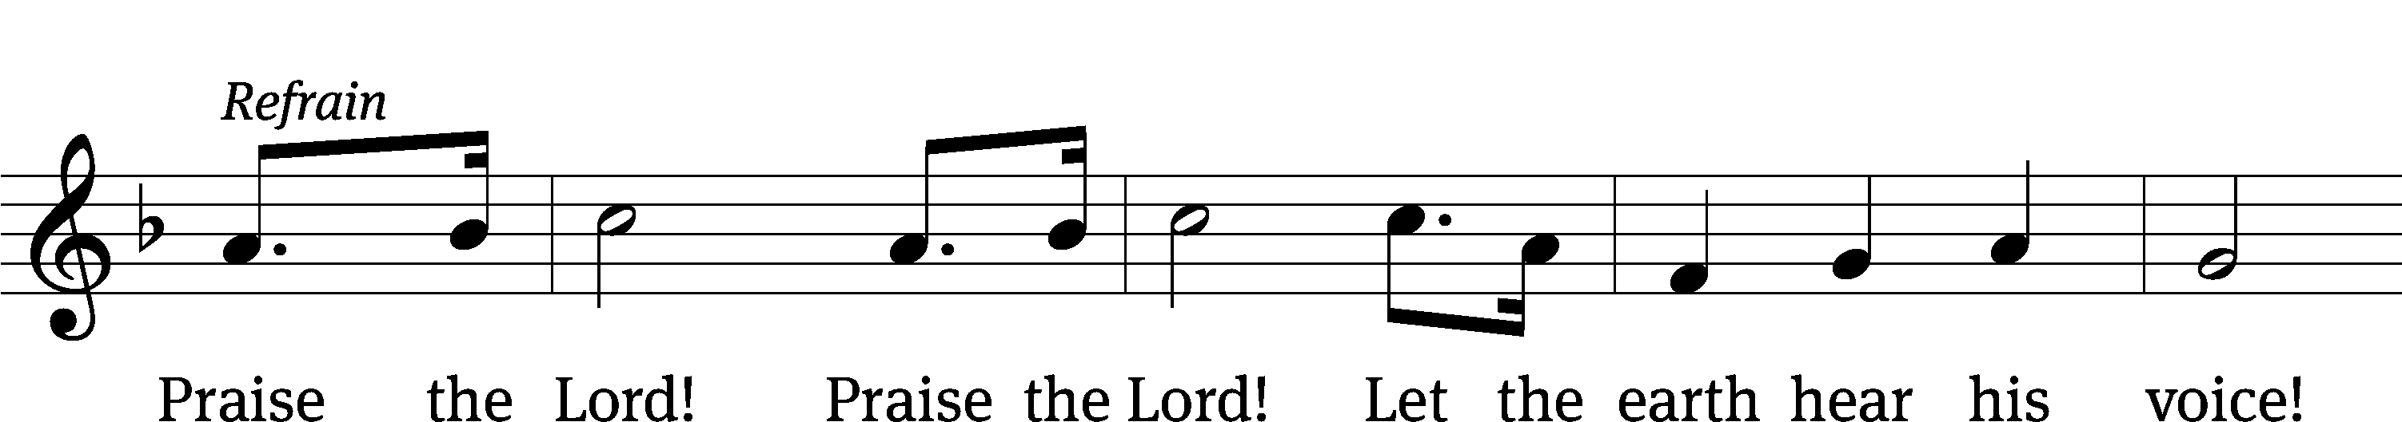
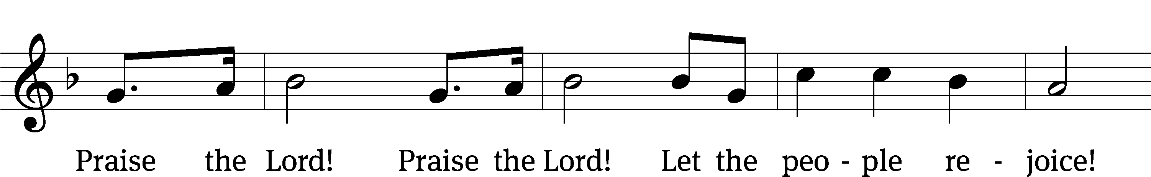
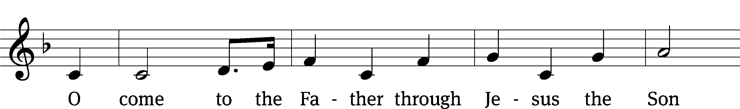
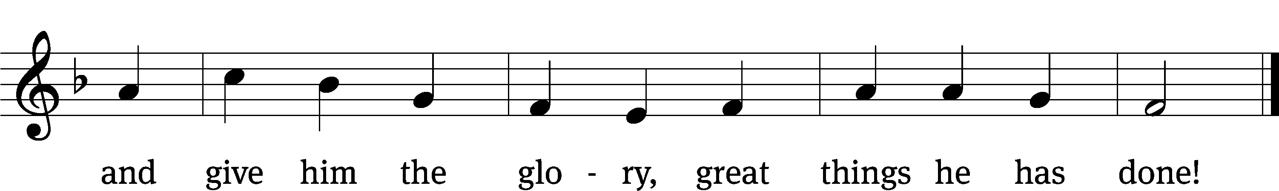
Text: Fanny J. Crosby, 1820–1915, abr., alt.
Tune: William H. Doane, 1832–1915
Text and tune: Public domain

Acknowledgments
Setting One from Christian Worship
Unless otherwise indicated, Scripture quotations are from The Holy Bible, New International Version®, NIV®. Copyright © 1973, 1978, 1984, 2011 by Biblica, Inc.TM Used by permission of Zondervan. All rights reserved worldwide.
Software distributed in partnership with Northwestern Publishing House.
Created by Christian Worship: Service Builder © 2023 Concordia Publishing House.

Next Week’s Worship
Our theme for worship: “Our Greatest Needs—Water for the Thirsty.” Our readings will be: Exodus 17: 1-7, Romans 5: 1-8, John 4: 5-26. We will sing the following hymns: 526 What Wondrous Love Is This, 703 I heard the Voice of Jesus Say, 533 Jesus, Love of My Soul, and 517 Praise the One Who Breaks the Darkness.

THIS WEEK AT BEAUTIFUL SAVIOR
† Today 10:30am Worship
12 pm Bible Information Class
12 pm Confirmation Class
† Tuesday 530pm Steering Committee
7 pm Bible Study
† Wednesday 6pm Soup Supper
7pm Mid-week Lent Worship
† Sunday 9:30am Sunday School
10:30am Worship
12 pm Confirmation Class
12 pm Bible Information Class

Camp South
Attention all Youth entering grades 4-9! Get ready for the most fun you'll have this summer at Camp South! With incredible activities like tough mudder, zip line, inflatables, and massive group competitions, you're sure to have a blast! The camp also features next-level worship and the opportunity to make more new friends than you can count. The camp is located just outside of Atlanta at 720 FFA FHA Camp Rd. Covington, GA 30014 and will be held from July 24-28, 2023. The estimated cost of the camp is $315 per attendee and payment and travel will be coordinated through your local church. Please note that each church must provide one like-gendered chaperone for every 5 like-gendered youth. Registration is now open! https://southatlanticyouth.com/camp-south

Spring Clean-Up Day
Come and help keep our property looking beautiful! We are scheduling a spring clean-up day on Saturday, March 25, starting at 9 AM. Please bring along your own gloves and tools as we will be removing several dead shrubs, trimming bushes and trees, and weeding, and spreading new mulch on the front and side mulch beds of the buildings. We need many hands to accomplish the work that we are planning.

25th Anniversary
In May of 2025, we will be celebrating the 25th anniversary of the founding of Beautiful Savior! While that seems like a long time off, we are already making plans to celebrate God's grace to us over the years and also will be unveiling a special thank offering which will raise funds to make improvements and renovations in our sanctuary area. Watch for more information to come in the following weeks.

Offering Envelopes
If you have not picked up your offering envelope for 2023, please take yours from the entryway table. Many choose to give their thanks offerings online but if you would like an offering envelope and do not have one, please let Pastor know and he will get you one.

Tuesday Bible Study
Who is Jesus? In our new Tuesday evening Bible Study, we will listen to Jesus tell us who he is by examining his eight “I am” statements in the New Testament. We will meet in the Fellowship Hall starting on Tuesday, February 21st at 7pm and Jesus will tell us who he is—from the “Bread of Life” to the “Vine” and many other beautiful statements of Jesus about himself.

Giving Statements
If you have not picked up your giving statement for 2022, please check your mailbox for your giving record. If you do not have a giving statement and would like a record of your thanks offerings for 2022, please see Dan Walker in the church office.

Altar Flower Sign-up
If you would like to provide flowers for a Sunday Service, please see the sign up chart near the entry way table. It can be for a special occasion, or simply to beautify our altar on a Sunday morning. If you have questions, contact Eileen Cleveland at 239-410-6366 or email at thedoll48@gmail.com

Preschool Early Registration
Early registration for the 2023-2023 school year is now open to the congregation and current preschool families. The registration fee will be reduced to $75 through March 31st. Registration will open to the community beginning March 1st. Please call the office at 931-905-1400 to set up a time to register.
Sundays in Lent
Lent is the season of the Church Year where we wrestle with our greatest needs. Lent also demonstrates that in Christ, all our greatest needs are met. Here is what the Spirit makes clear this season. If you lack Christ, you have nothing. If you have Christ, you have everything you truly need! Our worship in Lent will follow this pattern:

Sunday, March 12: Water for the Thirsty
Sunday, March 19: Sight for the Blind
Sunday, March 26: Life for the Dead
Sunday, April 2: A Greater Type of King

Mid-week Lent: His Final Steps
Starting Ash Wednesday, February 22, we will begin a series of six mid-week Lent services that will prepare our hearts for the sacrifice of our Savior on Good Friday and his joyful resurrection on Easter Sunday. Prior to the service, there will be a simple “soup supper” at 6pm. Services will begin at 7pm. If you would like to sponsor one of the Wednesday meals, please sign up on the entry way table.

March 8: His Final Steps Led to a Tomb
March 15: His Final Steps Led to Some Greeks
March 22: His Final Steps Led to a Fig Tree
March 29: His Final Steps Led to a Dinner Celebration



Prayer List

Thank the Lord for the safe return of all the soldiers who recently came home and all soldiers and their families who are facing deployment. Please keep in your prayers this week all soldiers who are currently deployed. Please also remember: Sandy Holz, sister of Gael Irizarry (pneumonia); Renate Banks (illness);Patrick Smalley, brother in law to Jeff Cleveland (in hospice care); Shan Bradford, daughter of Porter Matthew and friend of Margareta Smothers, (injured in car accident); Marlys Donner, mother of Tim Donner (declining health); Mark Lenz, father of Pamela Holz (recovery from tumor surgery); Caleb Westra, friend of the Holz family (Surgeries on his leg and foot after accident); Josh Carter, friend of Adam Holz (recovery from car accident); Stacy Schroeder, daughter of Jeff & Eileen Cleveland (melanoma diagnosis); Autumn Potter & family, friends of Jessica Boulter (death of sister); Aimee Gerkhardt, sister in law of Jessica Church (breast cancer); Steven Owens, father of Mark Owens, (cancer); Kathy Temple (cancer reoccurrence); Eric Smith, friend of Tim Donner (kidney surgery & complications); Brandon Vannoy, friend of Mac McCoo (seizures); Sheila Lynch, sister of Gayle Brooks (unable to walk); Drake Robideau, friend of Mary Daniel (strength & wellness); Mike LaFave (back problems); Linda Thomas, sister of Gayle Brooks, (physical rehab after injury); Ruth Amorth, twin sister of Hilde Fox (seriously ill); Gary Davis, husband of Angela Davis (seizures); Gidget Tate (Health issues). If you would like to have a name or situation included or if you would like to give an update on a prayer request, please contact Pastor Holz or call the church office at 931-905-1400.

Serving in God’s House

Ushers: Mike R, Trey C
Greeters: Jeff & Eileen Cleveland
Kitchen: Gael Irizarry, Loretta W, Mary Daniel
Piano: Deb White
Fellowship: (A-G)

Serving next week:

Ushers: David J, Ernie R
Greeters: Doris M, Mac M
Kitchen: Charmaine S, Mary D
Piano: Barb N
Fellowship: (H-M)

