Beautiful Savior Lutheran Church

January 8, 2023 – Baptism of Our Lord

Service Theme: Jesus Appears as the anointed one

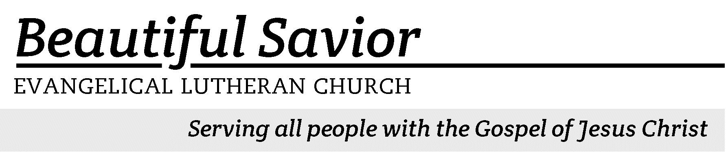


Welcome-- We are glad you could join us today! It is our hope that this service is a blessing to you. Please join us for worship again soon.

· Please save the last two rows of pews for parents with small children.

· Parents with little ones: If your child becomes restless during the service, that’s okay… We’re glad they’re here, and Jesus is pleased when they are brought to hear his Word: “Let the little children come to me.” If you need to be with your child in the Fellowship Hall, the service can be heard through a speaker.

· Five minutes before the worship service begins the usher will light the candles. This is our signal to quiet down and prepare our hearts for worship.

· Restrooms are conveniently located to the left as you exit the sanctuary.

· Please silence your cell phone before the start of the service.

Prayer for Worship
Lord God, thank you for giving me an eternal inheritance in heaven through baptism. You have clothed me in the righteousness of Christ through the washing of water with God’s Word. Forgive me for taking my baptism for granted and let me find joy in the renewal and rebirth you have given me.
Amen.

Beautiful Savior Lutheran Church
2526 Whitfield Road
Clarksville, TN 37040
931-905-1400
Website: www.bslclarksville.com
Kent Holz, Pastor
Bslc.clarksville@gmail.com
Barbara Noon, Preschool Director
beautifulsaviorpreschool@gmail.com
375 Arise and Shine in Splendor CW 375 sts. 1–3
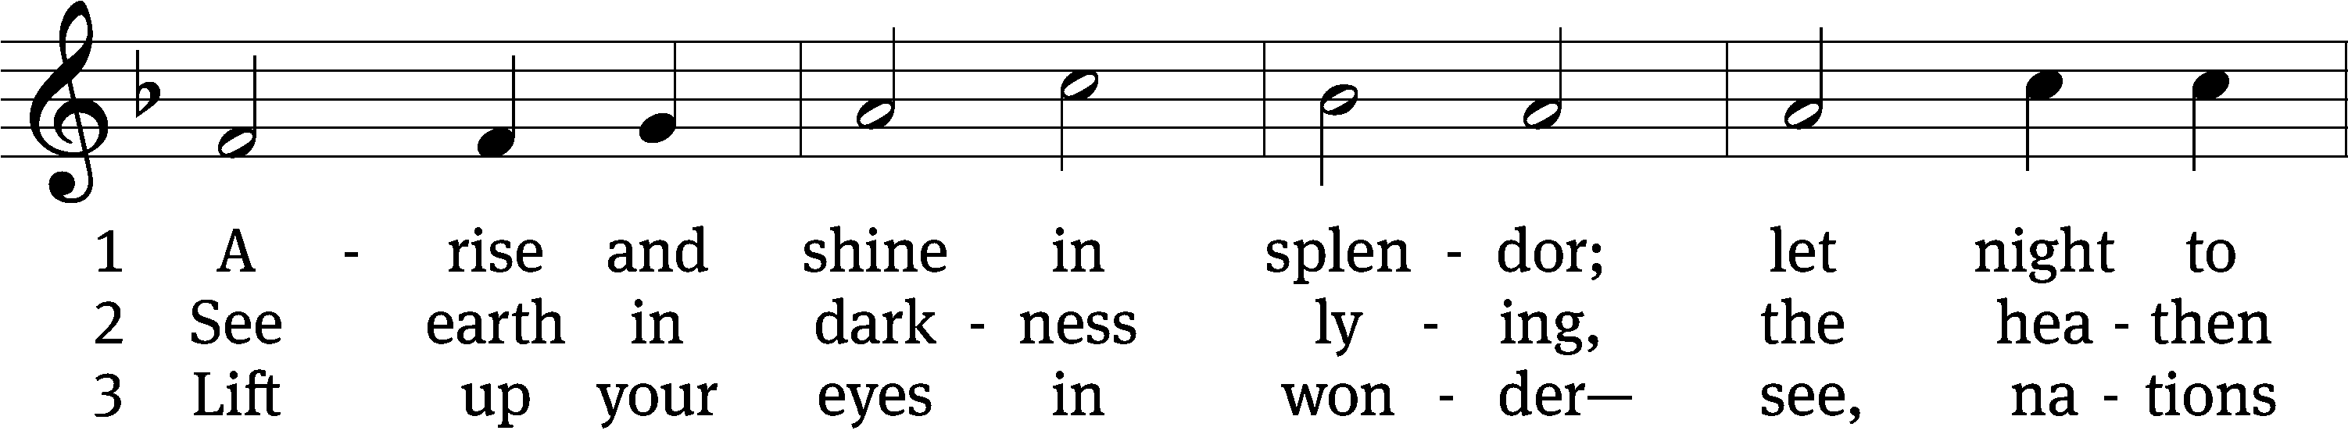
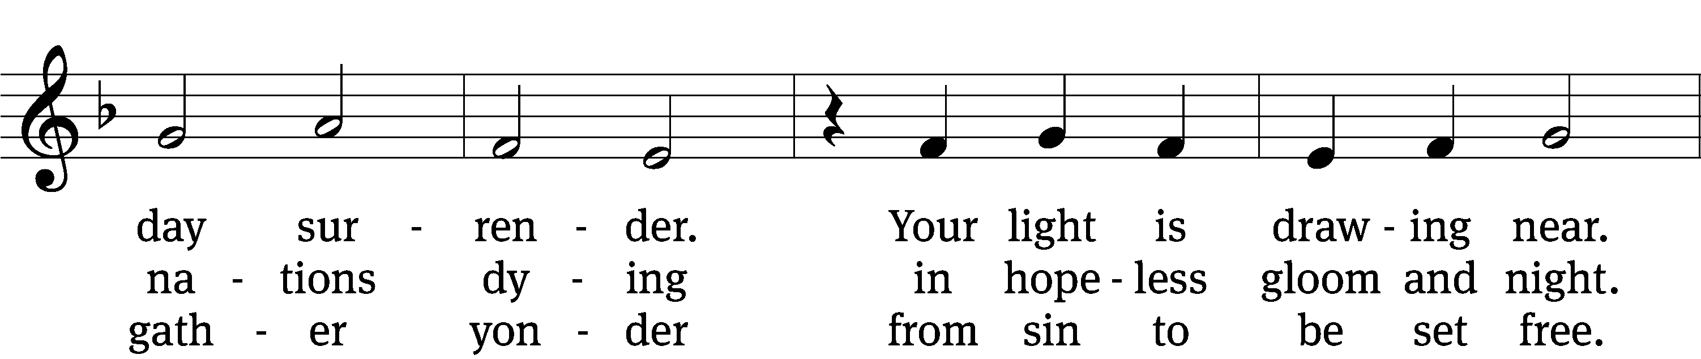
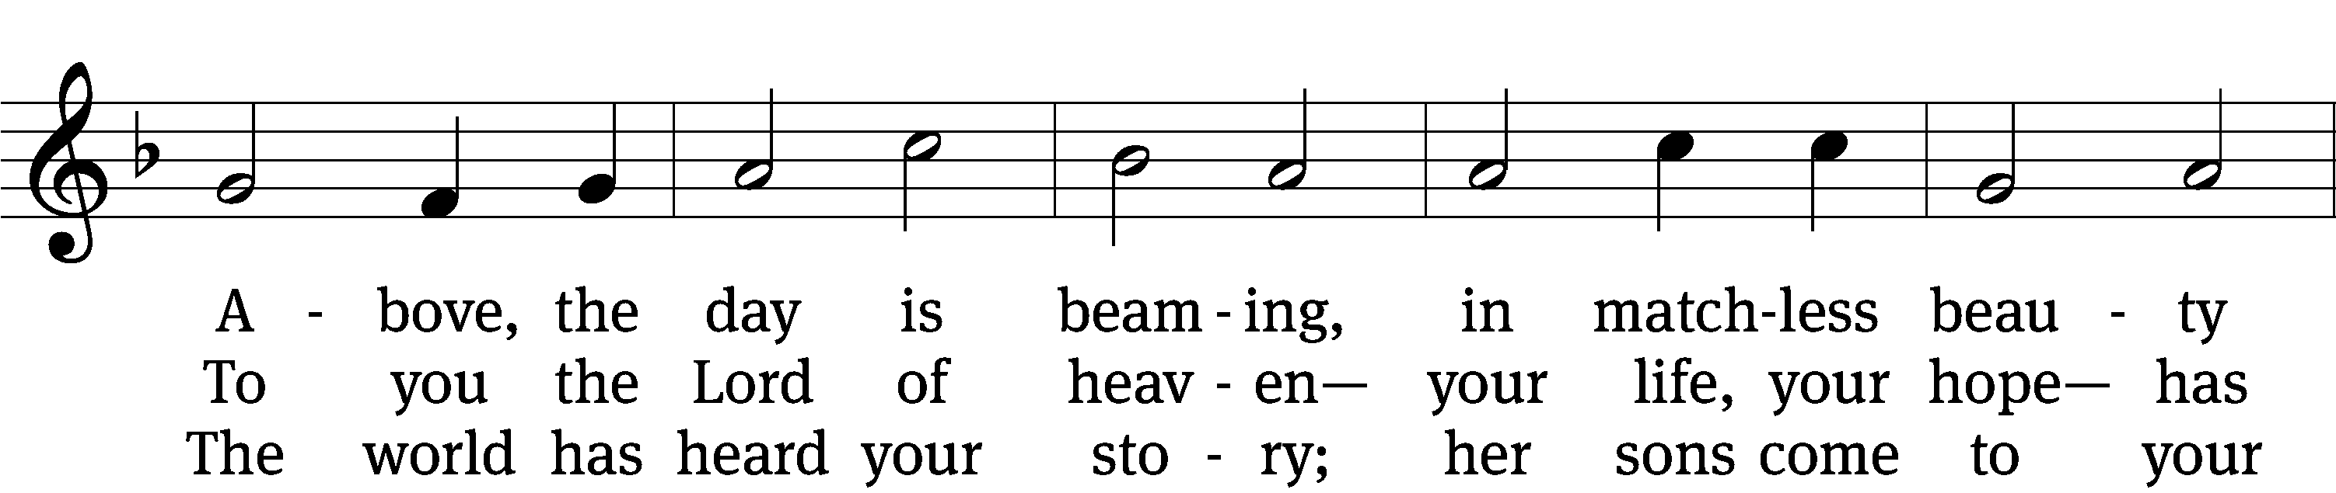
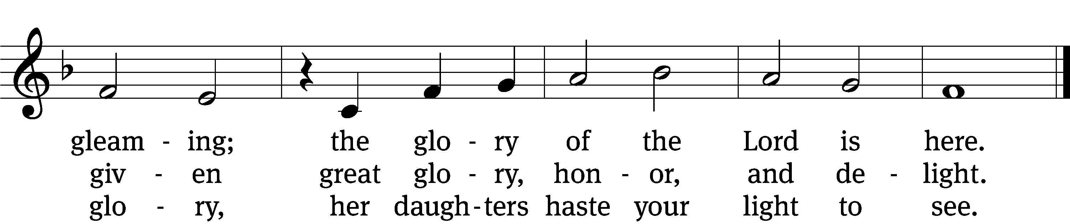
Text: tr. Gerhard Gieschen, 1899–1987, alt.; Martin Opitz, 1597–1639, abr.
Tune: The Lutheran Hymnal, 1941, alt.; Heinrich Isaac, c. 1450–1517
Text: © 1941 Concordia Publishing House. Used by permission: OneLicense no. 716626
Tune: Public domain

In the name of the Father and of the T Son and of the Holy Spirit.
Amen.
Confession CW 154
I tell you the truth, no one can enter the kingdom of God unless he is born of water and the Spirit.
Flesh gives birth to flesh, but the Spirit gives birth to spirit.

Surely we were sinful at birth, sinful from the time our mothers conceived us.
But we were washed, we were sanctified, we were justified in the name of the Lord Jesus Christ and by the Spirit of our God.

As baptized children of God, we confess our sins.
Holy and merciful Father, I confess that I am by nature sinful and that I have disobeyed you in my thoughts, words, and actions. I have done what is evil and failed to do what is good. For this I deserve your punishment both now and in eternity. But I am truly sorry for my sins, and trusting in my Savior Jesus Christ, I pray: Lord, have mercy on me, a sinner.

Christ loved the church and gave himself up for her to make her holy, cleansing her by the washing with water through the word, and to present her to himself as a radiant church, without stain or wrinkle or any other blemish, but holy and blameless. Therefore, as a called servant of Christ and by his authority, I forgive you all your sins in the name of the Father and of the Son and of the Holy Spirit.
Amen.

375 Arise and Shine in Splendor CW 375 st. 4
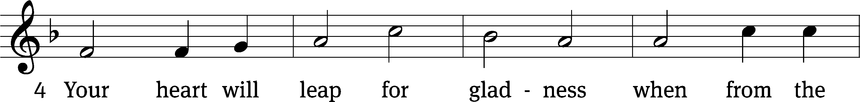
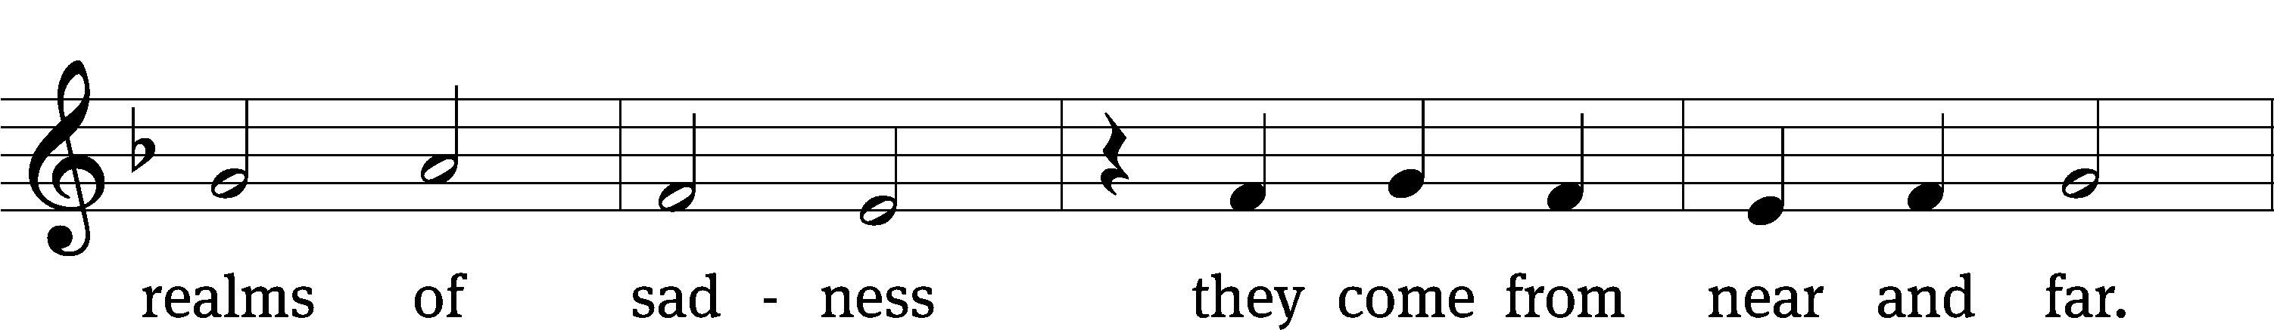
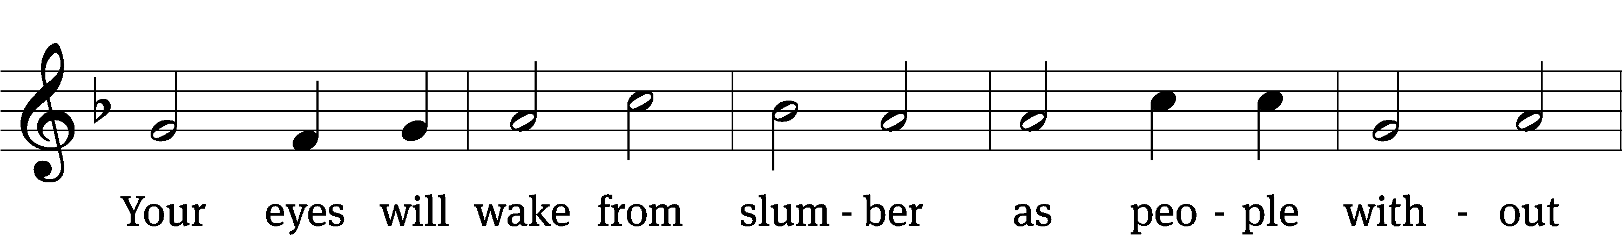
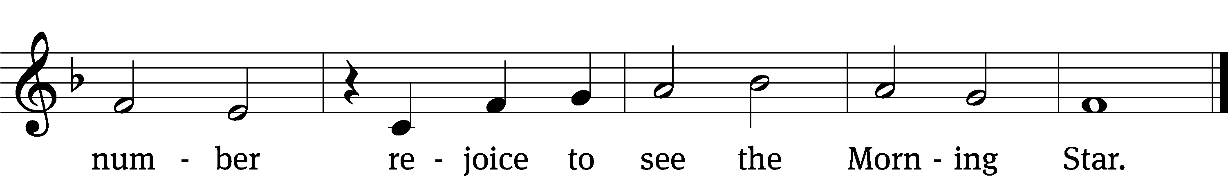
Text: tr. Gerhard Gieschen, 1899–1987, alt.; Martin Opitz, 1597–1639, abr.
Tune: The Lutheran Hymnal, 1941, alt.; Heinrich Isaac, c. 1450–1517
Text: © 1941 Concordia Publishing House. Used by permission: OneLicense no. 716626
Tune: Public domain

The Word

The Lord be with you.
And also with you.
Prayer of the Day
Let us pray.

Father in heaven, at the baptism of Jesus in the River Jordan, you proclaimed him your beloved Son and anointed him with the Holy Spirit. Keep us who are baptized into Christ faithful in our calling as your children, and make us heirs with him of everlasting life; through your Son, Jesus Christ our Lord, who lives and reigns with you and the Holy Spirit, one God, now and forever.
Amen.
First Reading Isaiah 42:1–7
1“Here is my servant, whom I uphold,
my chosen one in whom I delight;
I will put my Spirit on him,
and he will bring justice to the nations.
2He will not shout or cry out,
or raise his voice in the streets.
3A bruised reed he will not break,
and a smoldering wick he will not snuff out.
In faithfulness he will bring forth justice;
4he will not falter or be discouraged
till he establishes justice on earth.
In his teaching the islands will put their hope.”
5This is what God the Lord says—
the Creator of the heavens, who stretches them out,
who spreads out the earth with all that springs from it,
who gives breath to its people,
and life to those who walk on it:
6“I, the Lord, have called you in righteousness;
I will take hold of your hand.
I will keep you and will make you
to be a covenant for the people
and a light for the Gentiles,
7to open eyes that are blind,
to free captives from prison
and to release from the dungeon those who sit in darkness.

2A You Are My Son Psalm 2A
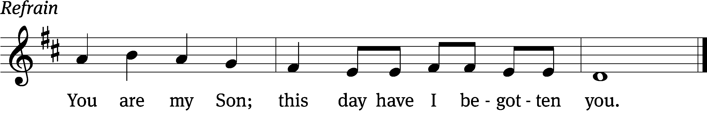


Why do the / nations rage?
Why do the peoples / plot in vain?
The kings of the earth take their stand and the rulers assemble a- / gainst the Lord
and against his A- / nointed One. Refrain

He who sits in / heaven laughs;
the Lord / scoffs at them.
Then he addresses them in his anger and frightens them with his fury, / saying,
“I have set my King on Zion, my / holy hill.” Refrain

I will declare the / Lord’s decree:
He said to me, “You are my Son; today I have be- / gotten you.”
Glory be to the Father and / to the Son
and to the / Holy Spirit,
as it was in the be- / ginning,
is now, and will be forever. / Amen. Refrain
Text: translation
Tune: Thomas Pavlechko
Text: © 2021 Northwestern Publishing House (verse text tr.). Used by permission: OneLicense no. 716626
Music: © 2004, 2012 Thomas Pavlechko, admin. Augsburg Fortress. Used by permission: OneLicense no. 716626

Second Reading Acts 10:34–38
34Then Peter began to speak: “I now realize how true it is that God does not show favoritism 35but accepts from every nation the one who fears him and does what is right. 36You know the message God sent to the people of Israel, announcing the good news of peace through Jesus Christ, who is Lord of all. 37You know what has happened throughout the province of Judea, beginning in Galilee after the baptism that John preached— 38how God anointed Jesus of Nazareth with the Holy Spirit and power, and how he went around doing good and healing all who were under the power of the devil, because God was with him.

Children's Devotion Ages 3 through grade 5 are invited to come forward for a Bible lesson.

Children's Church During the service, parents may choose to take their children (ages 2-5) to Children’s Church. There they will hear a Bible story, and sing songs. They will return to the sanctuary during the offering.

377 To Jordan’s River Came Our Lord CW 377
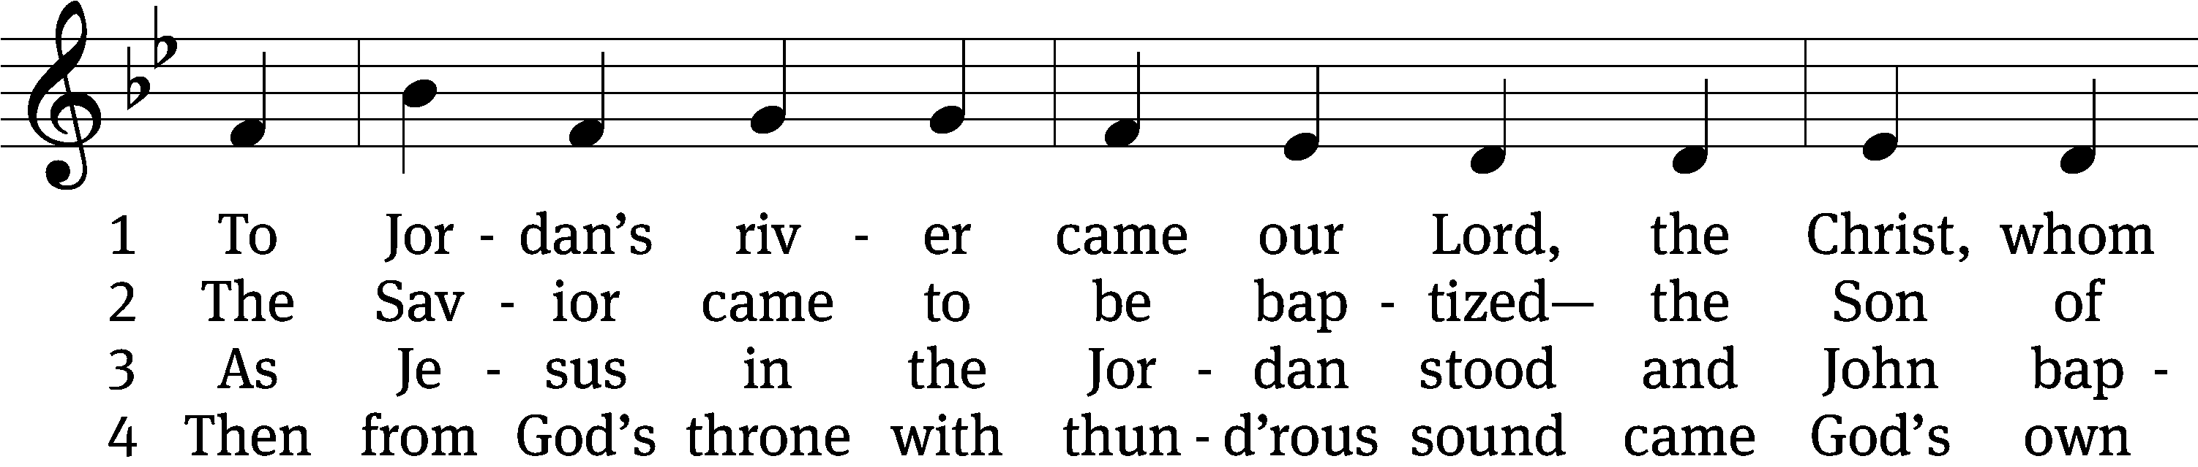
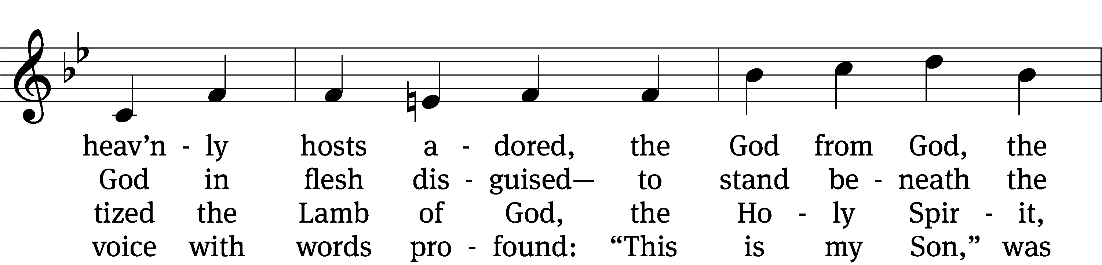
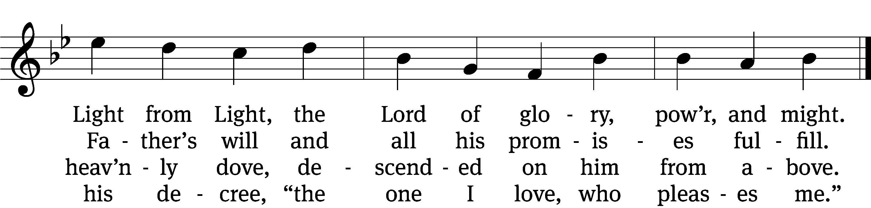

5 The Father’s word, the Spirit’s flight
anointed Christ in glorious sight
as God’s own choice, from Adam’s fall
to save the world and free us all.

6 Now rise, faint hearts: be resolute!
This man is Christ, our substitute!
He was baptized in Jordan’s stream,
proclaimed Redeemer, Lord supreme.
Text: James P. Tiefel, b. 1949
Tune: Musicalisch Hand-Buch der Geistlichen Melodien, Hamburg, 1690, alt.
Text: © 1993 James P. Tiefel, admin. Northwestern Publishing House. Used by permission: OneLicense no. 716626
Tune: Public domain

Gospel Matthew 3:13–17
13Then Jesus came from Galilee to the Jordan to be baptized by John. 14But John tried to deter him, saying, “I need to be baptized by you, and do you come to me?”
15Jesus replied, “Let it be so now; it is proper for us to do this to fulfill all righteousness.” Then John consented.
16As soon as Jesus was baptized, he went up out of the water. At that moment heaven was opened, and he saw the Spirit of God descending like a dove and alighting on him. 17And a voice from heaven said, “This is my Son, whom I love; with him I am well pleased.”

“Jesus’ work begins”

Apostles’ Creed
I believe in God, the Father Almighty,
maker of heaven and earth.

I believe in Jesus Christ, his only Son, our Lord,
who was conceived by the Holy Spirit,
born of the Virgin Mary,
suffered under Pontius Pilate,
was crucified, died, and was buried.
He descended into hell.
The third day he rose again from the dead.
He ascended into heaven
and is seated at the right hand of God the Father Almighty.
From there he will come to judge the living and the dead.

I believe in the Holy Spirit,
the holy Christian Church,
the communion of saints,
the forgiveness of sins,
the resurrection of the body,
and the life everlasting. Amen.

Offering “We love because he first loved us.” 1Jn 4:19 God’s love in sending Jesus to live, to suffer, and to die for each of us motivates the members of Beautiful Savior to show their love and thanks by returning a portion of their income to the Lord. Through these free will offerings, this congregation and its ministries are maintained.
*If you would like to give your regular offering envelope, you can mail it to the church. If you would like to give securely online, scan this code or follow this link: bslclarksville.com

Prayer of the Church
Almighty God and Father, we thank you for all your mercies, especially for the gift of your Son, through whom you have revealed your gracious will. We praise you for the Holy Spirit and his working through the means of grace.
Plant your Word in our hearts, and cause it to produce fruit in our lives.

Strengthen and defend your Church, that by your Word and sacraments faith may grow and love toward all may increase.
Support all who spread the light of your truth throughout the world.

Keep our children in the grace of their baptisms. Enable their parents to train them in lives of faith.
Raise up Christians to serve you in the ministry of the Word and in all godly walks of life.

Preserve our nation in justice and honor. Guide and bless all who make, administer, and judge our laws.
Give them wisdom that they may promote justice and hinder evil.

Let your blessing rest on planting and harvest, commerce and industry, medicine and science, the arts and culture. Protect all who travel, and care for those whose work is difficult or dangerous.
Be with all who devote themselves to any useful task.

Comfort all who are in sorrow or need, sickness or adversity. Remember those who suffer persecution for the faith. Have mercy on those for whom death draws near.
Grant them your love, and take them into your tender care.

Hear us, Lord, as we pray in silence.

We remember with thanksgiving those who have loved and served you, who now rest from their labors. Console those who are mourning or living with sadness.
Keep us in the true faith, and bring us at last to the joys of heaven.

Grant us these things, Father, for the sake of Jesus, who died and rose again.
Amen.

Lord’s Prayer
Our Father, who art in heaven,
hallowed be thy name,
thy kingdom come,
thy will be done
on earth as it is in heaven.
Give us this day our daily bread;
and forgive us our trespasses,
as we forgive those
who trespass against us;
and lead us not into temptation,
but deliver us from evil.
For thine is the kingdom
and the power and the glory
forever and ever. Amen.

374 The Star Proclaims the King Is Here CW 374
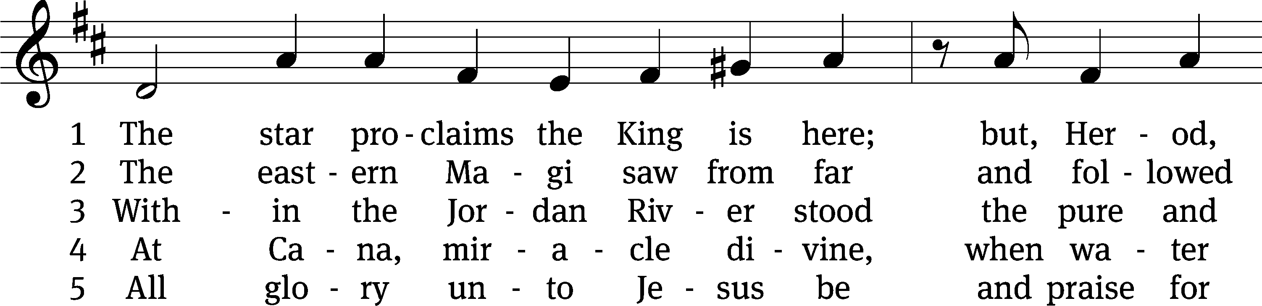
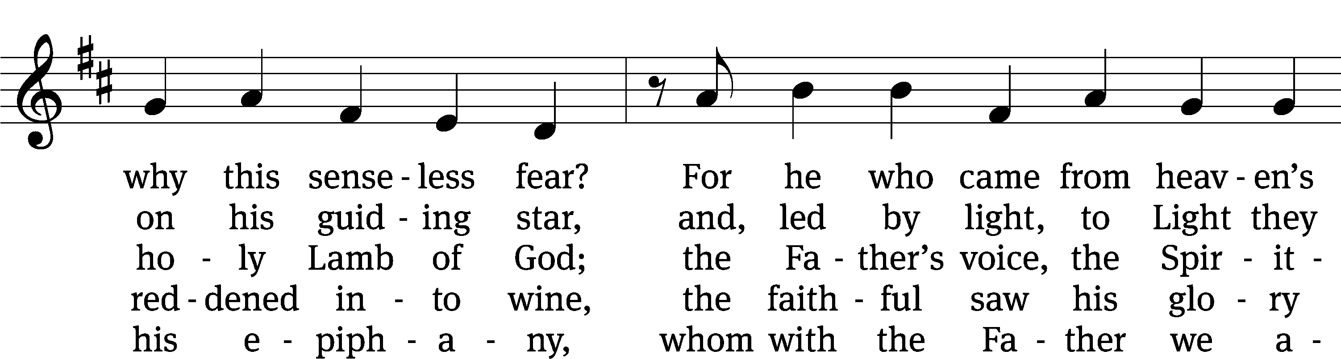
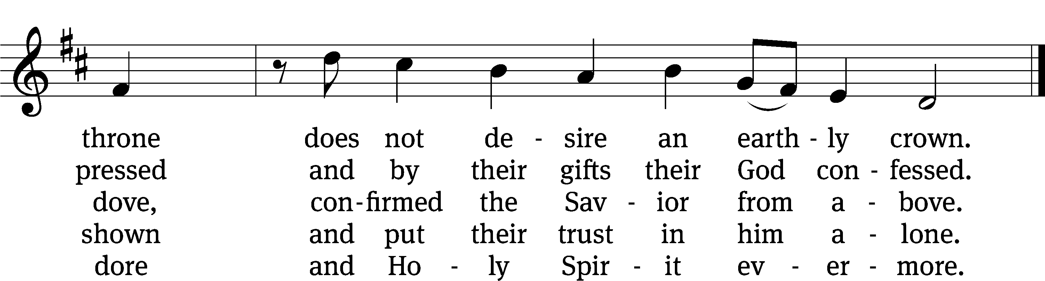
Text: tr. John Mason Neale, 1818–1866, alt.; Coelius Sedulius, 5th cent., abr.
Tune: Geistliche Lieder auffs new gebessert, Wittenberg, 1535, ed. Joseph Klug
Text and tune: Public domain

Closing Prayer
God, our heavenly Father, you have fashioned us to praise and to serve you. Help us to live our lives so that in all things we fulfill your plan and purpose for us. We know that it is easy to place our own interests and desires ahead of your will, so keep us focused on doing what is pleasing to you. Reach into our hearts through your Word today, so that from week to week we may more joyfully and more consistently devote our time and energies to those things which will be of value for eternity. Send your Holy Spirit to work on and in our hearts that our joy of salvation might also spill into our daily lives. Hear our prayer through Jesus, who has brought about our eternal salvation.
Amen.
Blessing
The Lord bless you and keep you.
The Lord make his face shine on you and be gracious to you.
The Lord look on you with favor and T give you peace.
Amen.

950 Lord, Bid Your Servant Go in Peace CW 950
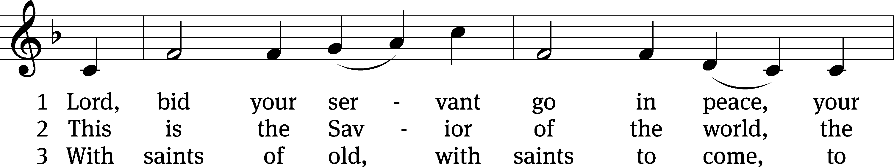
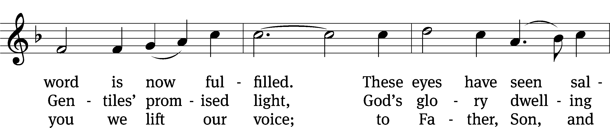
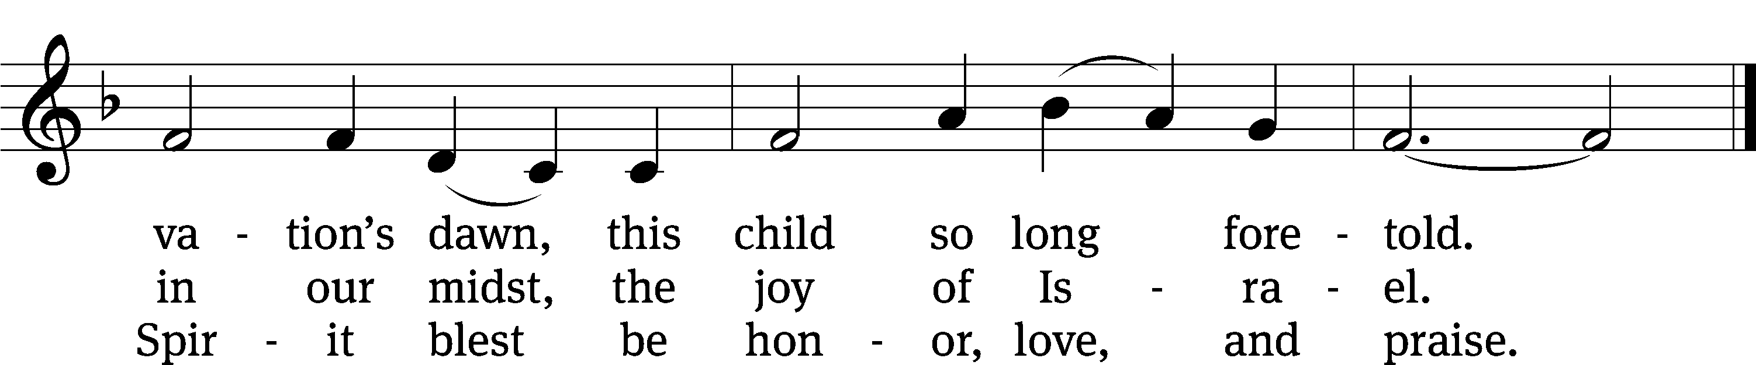
Text: James Quinn, SJ, 1919–2010
Tune: American
Text: © 1969, 1989 James Quinn, SJ, admin. OCP Publications. Used by permission: OneLicense no. 716626
Tune: Public domain

Acknowledgments
Setting One from Christian Worship
Unless otherwise indicated, Scripture quotations are from The Holy Bible, New International Version®, NIV®. Copyright © 1973, 1978, 1984, 2011 by Biblica, Inc.TM Used by permission of Zondervan. All rights reserved worldwide.
Software distributed in partnership with Northwestern Publishing House.
Created by Christian Worship: Service Builder © 2023 Concordia Publishing House.

No Lunch Bunch This Month
Due to the pipe break in the fellowship hall, there will be no monthly lunch bunch for the month of January.

Next Week’s Worship
Our theme for worship: “Jesus Appears as the Lamb of God.” Our readings will be: Isaiah 49: 1-6, Colossians 2: 6-15, and John 1: 29-41. We will sing the following hymns: 380, Jesus Shall Reign Where’er the Sun, 525 The Lamb, 530 Praise Be to Christ, 929 May the Peace of God.

THIS WEEK AT BEAUTIFUL SAVIOR
† Today 10:30am Worship
12 pm Bible Information Class
† Tuesday 4 pm Board of Education Meeting
† Sunday 9:30am Sunday School
10:30am Worship
12 pm Confirmation Class
12 pm Bible Information Class

Welcoming Guests and Creating a Sense of Belonging
On two Sundays, January 22 and Sunday, January 29, we are needing your help! We will be brainstorming ways that we as a congregation can make guests feel like part of our Beautiful Savior family. Everyone is needed for the best input! We will meet in the fellowship hall at 9:30 am on those two Sundays. And it comes with an assignment: Ask yourself this question: “If I were a first-time guest to Beautiful Savior, what did I notice?”

One by One Bible Study starts Today!
One by One is a Bible study based on Pastor David Rosenau’s keynote presentation at the WELS National Conference on Lutheran Leadership in January of 2020. Using powerful personal stories and drawing from his wealth of experience both as a detective and a parish pastor, Pastor Rosenau helps Christians understand why it is so important to see every soul as a treasure and why we want to be willing to spend the time and effort necessary to share the gospel with each one. This video-based Bible Study will meet in the fellowship hall at 9:30.
Jesus Appears—Worship Series

The Gospels tell only a little about Jesus’ life as an infant. Then, St. Luke briefly discusses the desire of the boy Jesus to be in the temple. Then, Scripture falls silent, telling us nothing about almost two decades of Jesus’ life. For most of Jesus' adult life, he lived quietly in Galilee, practicing the carpentry he had learned from his adoptive father, Joseph. Jesus had no followers. Jesus was not famous. But at the exact time God the Father had appointed, Jesus left that obscurity behind. The word epiphany means “appearance.” In the Season of Epiphany, we watch Jesus begin his public ministry. Jesus makes his first appearances. And in those appearances, it quickly becomes clear that this is more than a random carpenter’s son. As Jesus appears, we see exactly who he is and what he came to do. Our worship for three weeks will follow this pattern:

Jesus Appears as the Anointed One— Sunday, January 8
Jesus Appears as the Lamb of God— Sunday, January 15
Jesus Appears as the Light in the Darkness— Sunday, January 22

Prayer List
Thank the Lord for the safe return of all the soldiers who recently came home and all soldiers and their families who are facing deployment. Please keep in your prayers this week all soldiers who are currently deployed. Please also remember: Marlys Donner, mother of Tim Donner (declining health); Mark Lenz, father of Pamela Holz (recovery from tumor surgery); Caleb Westra, friend of the Holz family (Surgeries on his leg and foot after accident); Pat Bray, father of Allison Johnson (skin cancer and surgery); Josh Carter, friend of Adam Holz (recovery from car accident); Stacy Schroeder, daughter of Jeff & Eileen Cleveland (melanoma diagnosis); Autumn Potter & family, friends of Jessica Boulter (death of sister); Aimee Gerkhardt, sister in law of Jessica Church (breast cancer); Roger Chism, friend of Hilde Fox (diverticulitis); Steven Owens, father of Mark Owens, (cancer); Kathy Temple (cancer reoccurrence); Eric Smith, friend of Tim Donner (kidney surgery & complications); Brandon Vannoy, friend of Mac McCoo (seizures); Sheila Lynch, sister of Gayle Brooks (unable to walk); Drake Robideau, friend of Mary Daniel (strength & wellness); Mike LaFave (back problems); Linda Thomas, sister of Gayle Brooks, (physical rehab after injury); Ruth Amorth, twin sister of Hilde Fox (seriously ill); Gary Davis, husband of Angela Davis (seizures); and Gidget Tate (Health issues). If you would like to have a name or situation included or if you would like to give an update on a prayer request, please contact Pastor Holz or call the church office at 931-905-1400.

Serving in God’s House

Ushers: David Johnson, Ernie Rautter
Greeters: Doris Harvey, Mac McCoo
Kitchen: Ingeborg Haught, Mary Daniel
Piano: Barb Noon
Fellowship: H-M

Serving next week:

Ushers: Daniel L, Josh G
Greeters: Art & Sandy E
Kitchen: Charmaine S, Mary D
Piano: Deb White
Fellowship: N-S

