Beautiful Savior Lutheran Church



January 29th, 2023 – Fourth Sunday after Epiphany

Service Theme: The Savior’s Sermon: Trust in God’s Strength

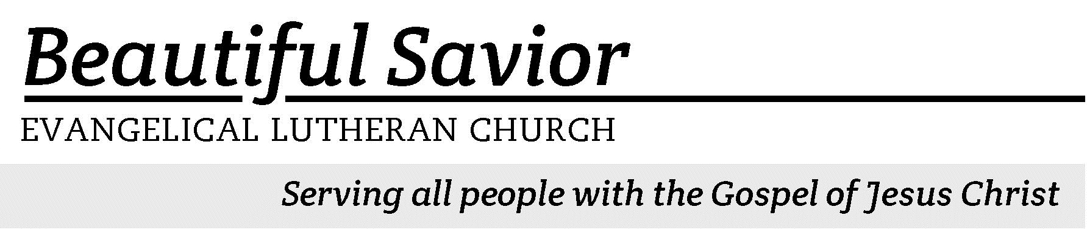


Welcome-- We are glad you could join us today! It is our hope that this service is a blessing to you. Please join us for worship again soon.

· Please save the last two rows of pews for parents with small children.

· Parents with little ones: If your child becomes restless during the service, that’s okay… We’re glad they’re here, and Jesus is pleased when they are brought to hear his Word: “Let the little children come to me.” If you need to be with your child in the Fellowship Hall, the service can be heard through a speaker.

· Five minutes before the worship service begins the usher will light the candles. This is our signal to quiet down and prepare our hearts for worship.

· Restrooms are conveniently located to the left as you exit the sanctuary.

· Please silence your cell phone before the start of the service.

Prayer for Worship
O God of hope, I turn aside from an unquiet world, seeking rest for my spirit and light for my thoughts. I bring my wounds to be healed, my sins to be forgiven, and my hopes to be renewed. Draw me to yourself and take me out of the loneliness of my own self. Fill me with your light and the fullness of your peace.
Amen.

Beautiful Savior Lutheran Church
2526 Whitfield Road
Clarksville, TN 37040
931-905-1400
Website: www.bslclarksville.com
Kent Holz, Pastor
Bslc.clarksville@gmail.com
Barbara Noon, Preschool Director
beautifulsaviorpreschool@gmail.com

562 Jesus Paid It All CW 562 sts. 1, Ref, 2–3
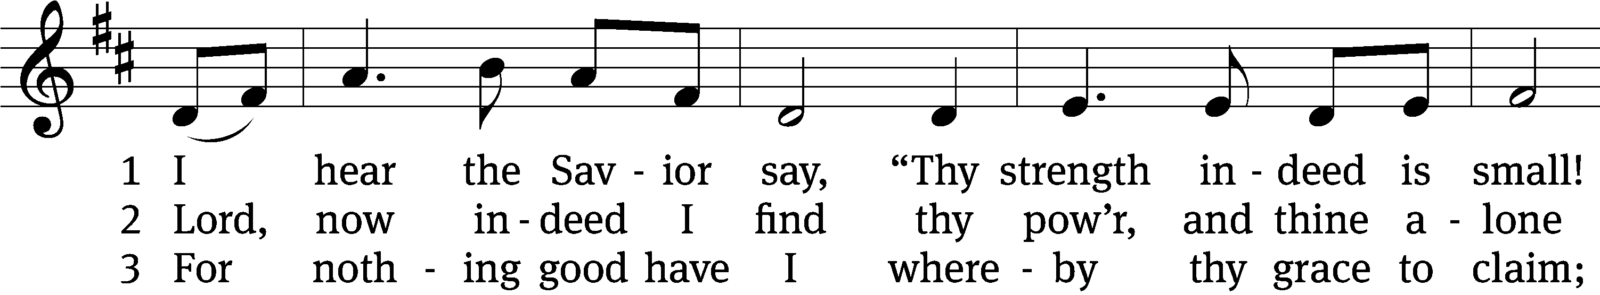
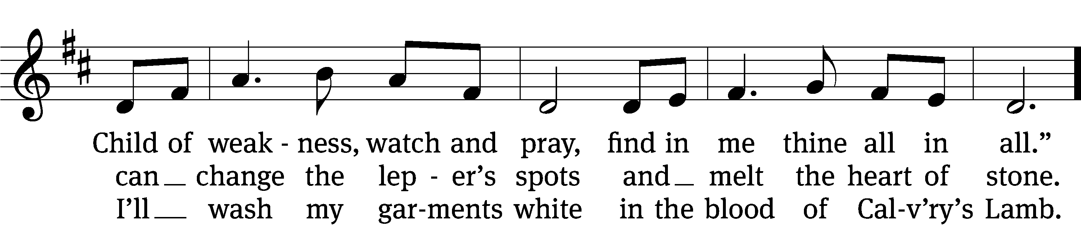
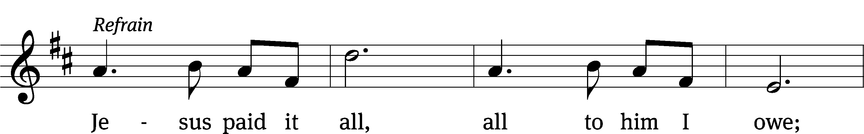
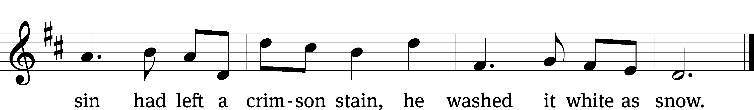
Text: Elvina M. Hall, 1820–1889
Tune: John T. Grape, 1835–1915
Text and tune: Public domain

In the name of the Father and of the T Son and of the Holy Spirit.
Amen.
Confession
We have entered into God’s house and are standing on holy ground. However, our sins make us unworthy to stand here and they separate us from our God. So, let us ask God to have mercy on us and to forgive our sins.
Dear Father in heaven, I confess that I have been a sinner from birth and in countless ways I have sinned against you. By what I have thought, by what I have said, and by what I have done and failed to do, I have angered you and do not deserve to be standing here today. Instead, I deserve your punishment both now and forever. But according to your great mercy and love, hear my prayer and forgive me.

God has loved you and the whole world. He does not want anyone to be lost. So, he sent his Son to save sinners like you and me. Jesus lived a perfect life for you and he died to fully wash away your sins. Whoever believes in him has eternal life. Do you believe this?
Yes, I believe!

Sons and daughters of the heavenly Father, be of good cheer. Your sins are forgiven. You are justified by the blood of Jesus. You are at peace with God. Now let us worship him with joyful and attentive hearts.
Amen.

562 Jesus Paid It All CW 562 st. 4
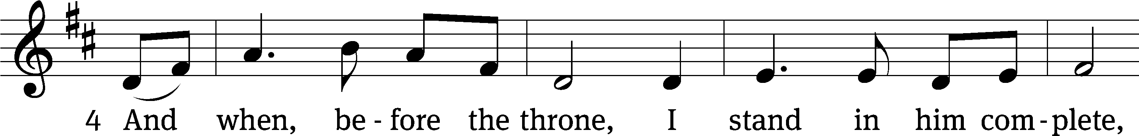
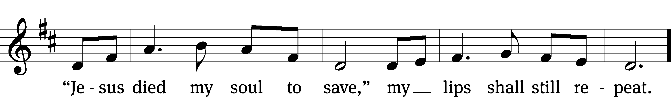

The Word

The Lord be with you.
And also with you.

Prayer of the Day
Let us pray.

Almighty and everlasting God, look with mercy on our weaknesses, and in all our dangers and needs stretch out the right hand of your majesty to help and defend us; through your Son, Jesus Christ our Lord, who lives and reigns with you and the Holy Spirit, one God, now and forever.
Amen.
First Reading Zephaniah 2:3; 3:11–13
3Seek the Lord, all you humble of the land,
you who do what he commands.
Seek righteousness, seek humility;
perhaps you will be sheltered
on the day of the Lord’s anger.
11On that day you, Jerusalem, will not be put to shame
for all the wrongs you have done to me,
because I will remove from you
your arrogant boasters.
Never again will you be haughty
on my holy hill.
12But I will leave within you
the meek and humble.
The remnant of Israel
will trust in the name of the Lord.
13They will do no wrong;
they will tell no lies.
A deceitful tongue
will not be found in their mouths.
They will eat and lie down
and no one will make them afraid.”

1A Blessed Are They Psalm 1A
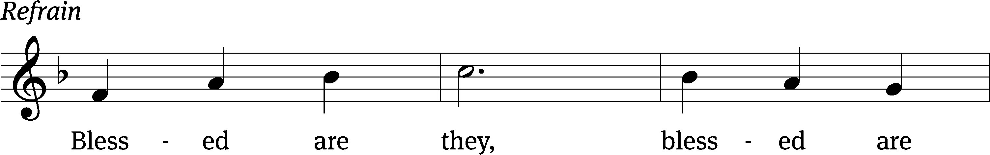



Blessed is the one who / does not walk
in step with the / wicked
or stand in the way that / sinners take
or sit in the company of / mockers,
but whose delight is in the law / of the Lord,
and who meditates on his law / day and night.
That person is like a tree planted by streams of / water,
which yields its fruit in / season
and whose leaf does not / wither—
whatever they do / prospers. Refrain

Not so the / wicked!
They are like chaff that the wind / blows away.
Therefore the wicked will not stand in the / judgment,
nor sinners in the assembly of the / righteous. Refrain

For the Lord watches over the way of the / righteous,
but the way of the wicked leads to de- / struction.
Glory be to the Father and / to the Son
and to the Holy / Spirit,
as it was in the be- / ginning,
is now, and will be forever. / Amen. Refrain
Text: Lectionary for Mass (refrain)
Tune: Michel Guimont
Setting: Michel Guimont
Text: © 1969, 1981, 1997 ICEL (refrain). Used by permission: OneLicense no. 716626
Music: © 1998 GIA Publications, Inc. Used by permission: OneLicense no. 716626

Second Reading 1 Corinthians 1:26–31
26Brothers and sisters, think of what you were when you were called. Not many of you were wise by human standards; not many were influential; not many were of noble birth. 27But God chose the foolish things of the world to shame the wise; God chose the weak things of the world to shame the strong. 28God chose the lowly things of this world and the despised things—and the things that are not—to nullify the things that are, 29so that no one may boast before him. 30It is because of him that you are in Christ Jesus, who has become for us wisdom from God—that is, our righteousness, holiness and redemption. 31Therefore, as it is written: “Let the one who boasts boast in the Lord.”

Children's Devotion Ages 3 through grade 5 are invited to come forward for a Bible lesson.

Children's Church During the service, parents may choose to take their children (ages 2-5) to Children’s Church. There they will hear a Bible story, and sing songs. They will return to the sanctuary during the offering

572 Not What My Hands Have Done CW 572
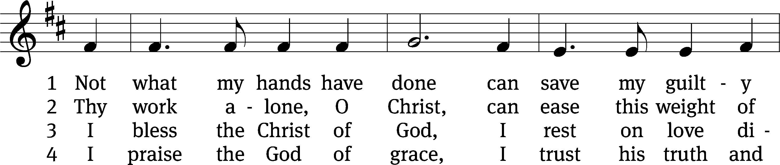
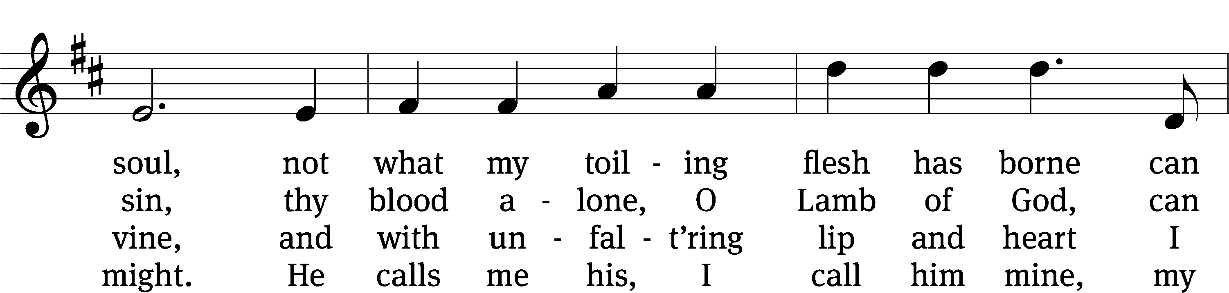
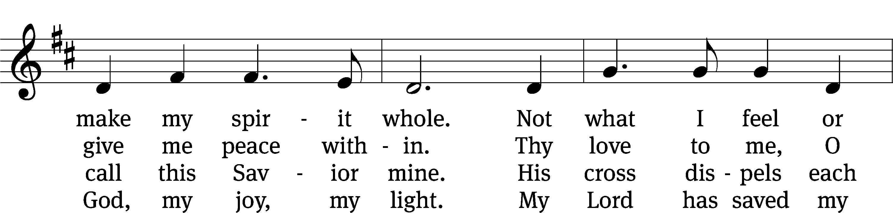
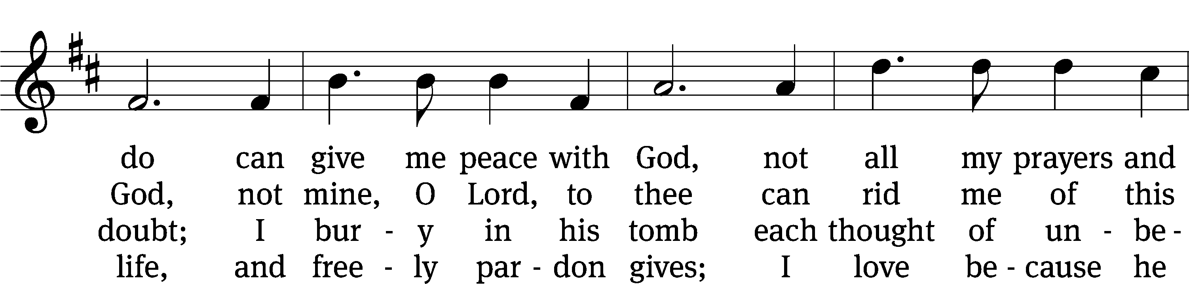
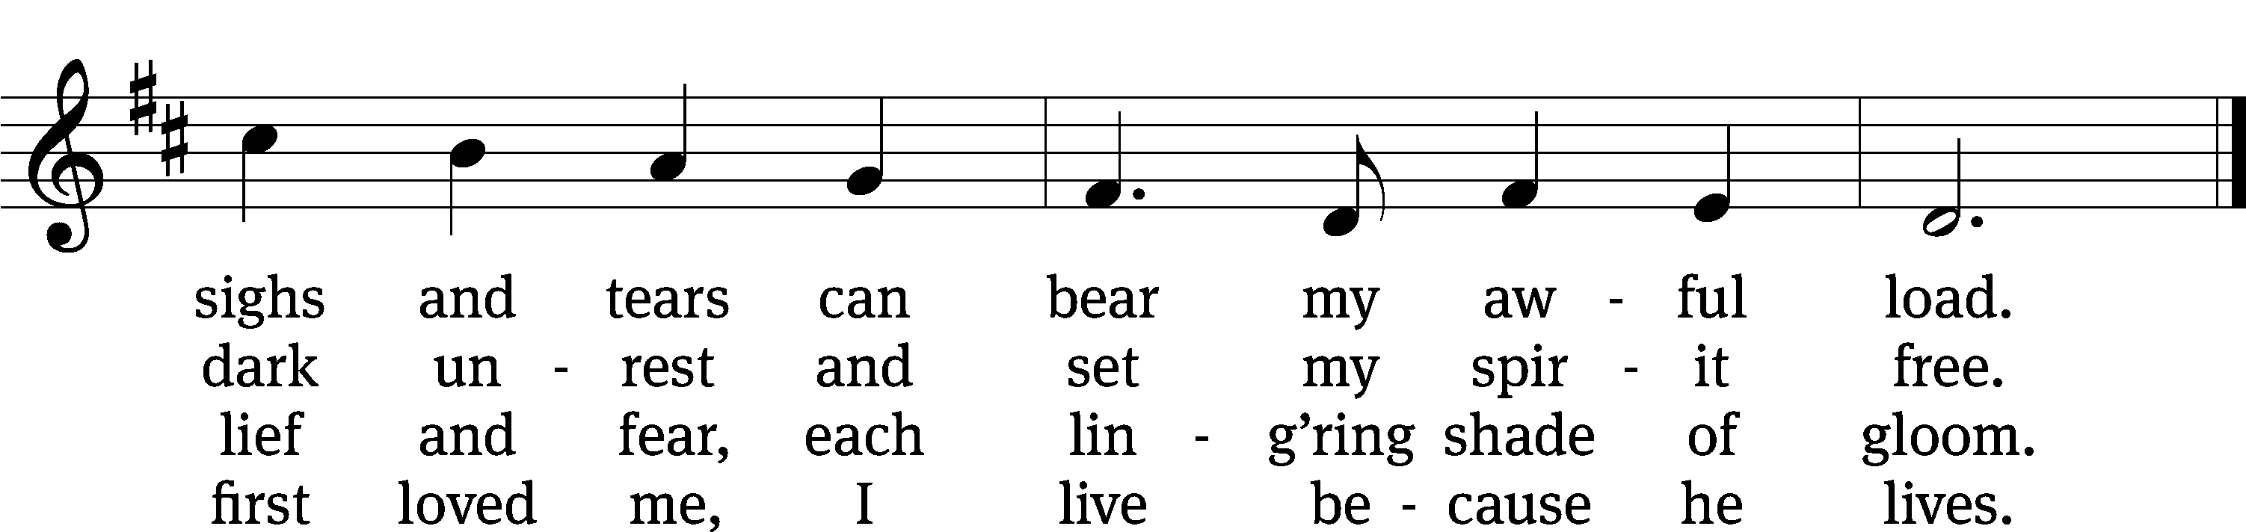
Text: Horatius Bonar, 1808–1889, abr.
Tune: George W. Martin, 1828–1881, alt.
Text and tune: Public domain

Gospel Matthew 5:1–12
1Now when Jesus saw the crowds, he went up on a mountainside and sat down. His disciples came to him, 2and he began to teach them.
He said:
3“Blessed are the poor in spirit,
for theirs is the kingdom of heaven.
4Blessed are those who mourn,
for they will be comforted.
5Blessed are the meek,
for they will inherit the earth.
6Blessed are those who hunger and thirst for righteousness,
for they will be filled.
7Blessed are the merciful,
for they will be shown mercy.
8Blessed are the pure in heart,
for they will see God.
9Blessed are the peacemakers,
for they will be called children of God.
10Blessed are those who are persecuted because of righteousness,
for theirs is the kingdom of heaven.
11“Blessed are you when people insult you, persecute you and falsely say all kinds of evil against you because of me. 12Rejoice and be glad, because great is your reward in heaven, for in the same way they persecuted the prophets who were before you.

“You are blessed!”

Apostles’ Creed
I believe in God, the Father Almighty,
maker of heaven and earth.

I believe in Jesus Christ, his only Son, our Lord,
who was conceived by the Holy Spirit,
born of the Virgin Mary,
suffered under Pontius Pilate,
was crucified, died, and was buried.
He descended into hell.
The third day he rose again from the dead.
He ascended into heaven
and is seated at the right hand of God the Father Almighty.
From there he will come to judge the living and the dead.

I believe in the Holy Spirit,
the holy Christian Church,
the communion of saints,
the forgiveness of sins,
the resurrection of the body,
and the life everlasting. Amen.


Offering “We love because he first loved us.” 1Jn 4:19 God’s love in sending Jesus to live, to suffer, and to die for each of us motivates the members of Beautiful Savior to show their love and thanks by returning a portion of their income to the Lord. Through these free will offerings, this congregation and its ministries are maintained.
*If you would like to give your regular offering envelope, you can mail it to the church. If you would like to give securely online, scan this code or follow this link: bslclarksville.com

Prayer of the Church
Lord Jesus Christ, Son of God and Mary’s Son, in the fullness of time you came into our world to save us from sin and death.
You ushered in the day of grace so long foretold.

Beloved Son of the Father, revered by the Magi, baptized by John, you came preaching and teaching, healing and comforting, forgiving and encouraging:
You brought the light of life to those walking in darkness, and the joy of salvation to those doomed to death.

Prince of peace, shine like a beacon for us and the people of our world. Let the good news of salvation be heard in the remotest corners of the earth. Open our own lips to speak your name to those around us who still live without faith or hope:
Arouse us and our missionaries to flood the world with the light of your gospel.

Lord of the Church, let your peace rule our hearts that we may use our gifts to serve you and each other in willing gratitude and joy. Watch over our loved ones near and far, that they may remember your love and rejoice in your salvation. Strengthen the faith of the sick and the disheartened. Give hope to those in despair and comfort those who mourn.
Be gracious to all and lead us to reflect your love in everything we say and do.

Hear us, Lord, as we pray in silence.

Finally, bring us and all your believers to the heavenly home where we will stand in the full light of your glory and with all your saints and angels sing the everlasting song of triumph.
Amen.

Lord’s Prayer
Our Father, who art in heaven,
hallowed be thy name,
thy kingdom come,
thy will be done
on earth as it is in heaven.
Give us this day our daily bread;
and forgive us our trespasses,
as we forgive those
who trespass against us;
and lead us not into temptation,
but deliver us from evil.
For thine is the kingdom
and the power and the glory
forever and ever. Amen.

813 He Will Hold Me Fast CW 813
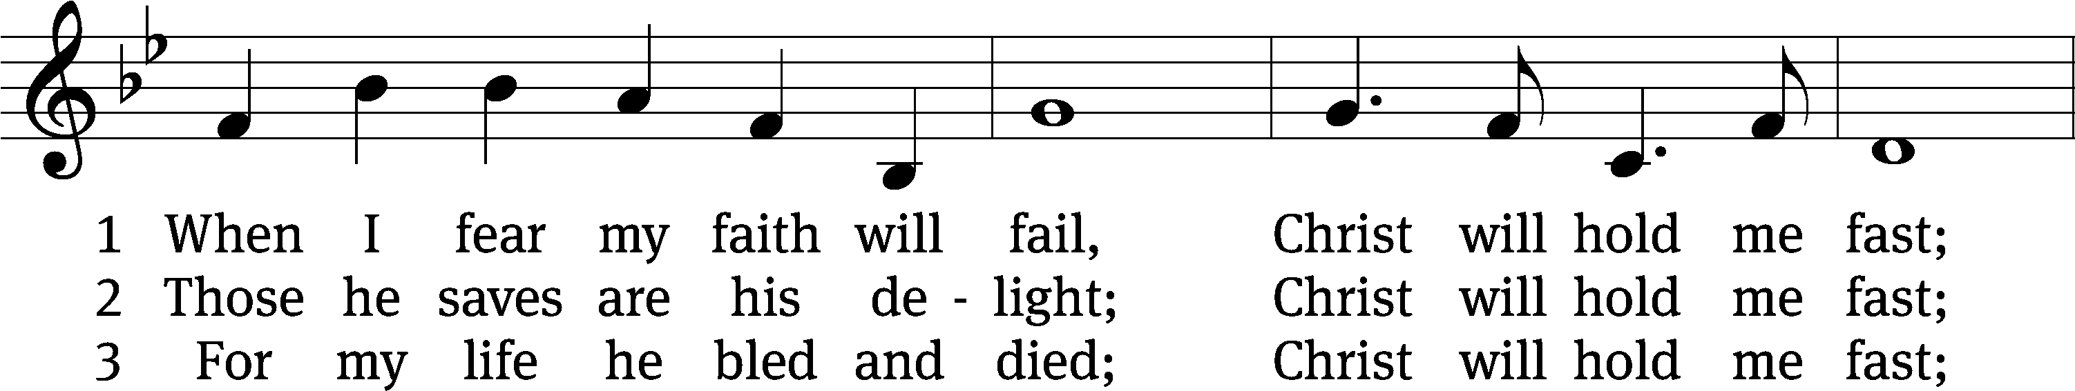
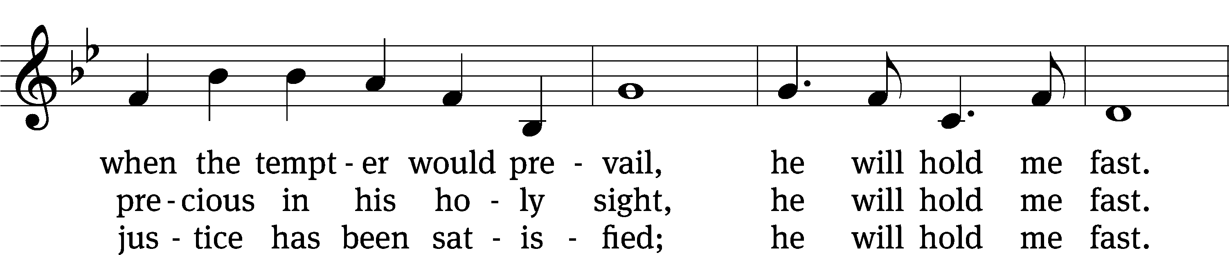
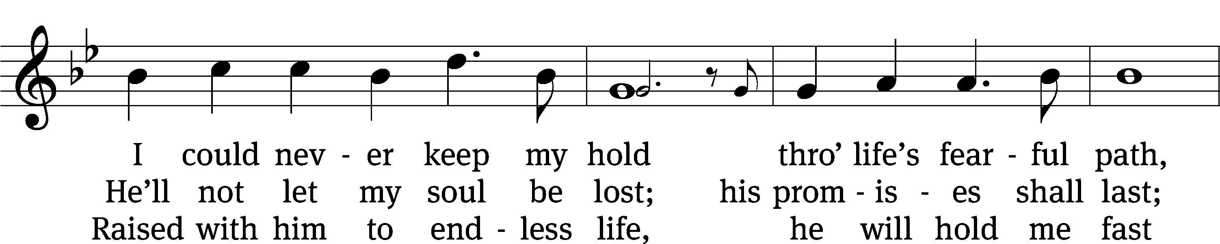
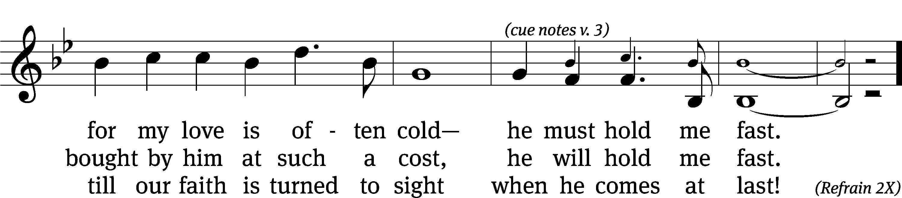
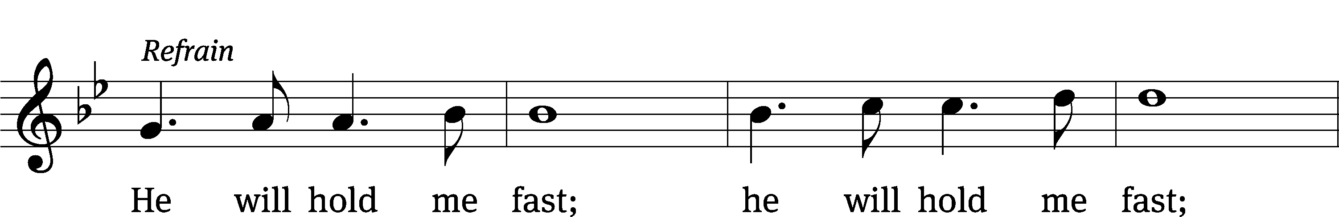
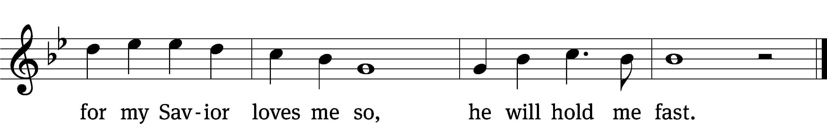
Text (sts. 1–2): Matt Merker, b. 1984, alt.; (sts. 1, Ref, 2): Ada Habershon, 1861–1918; (st. 3): Matt Merker, b. 1984
Tune: Matt Merker, b. 1984
Text (sts. 1–2): Public domain
Text (sts. Ref, 3) and tune: © 2013 Getty Music Publishing and Matt Merker, admin. MusicServices.org. Used by permission: OneLicense no. 716626

Closing Prayer
God, our heavenly Father, you have fashioned us to praise and to serve you. Help us to live our lives so that in all things we fulfill your plan and purpose for us. We know that it is easy to place our own interests and desires ahead of your will, so keep us focused on doing what is pleasing to you. Reach into our hearts through your Word today, so that from week to week we may more joyfully and more consistently devote our time and energies to those things which will be of value for eternity. Send your Holy Spirit to work on and in our hearts that our joy of salvation might also spill into our daily lives. Hear our prayer through Jesus, who has brought about our eternal salvation.
Amen.

Blessing
The Lord bless you and keep you.
The Lord make his face shine on you and be gracious to you.
The Lord look on you with favor and T give you peace.
Amen.

923 Guide Me, O Thou Great Jehovah CW 923
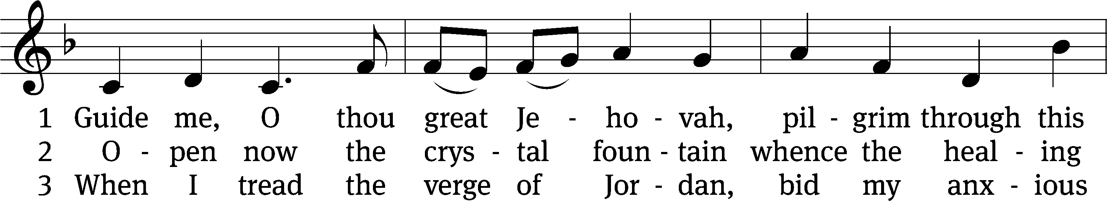
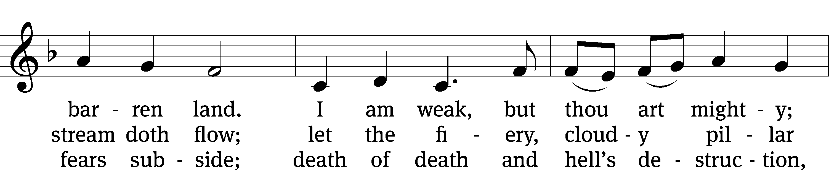
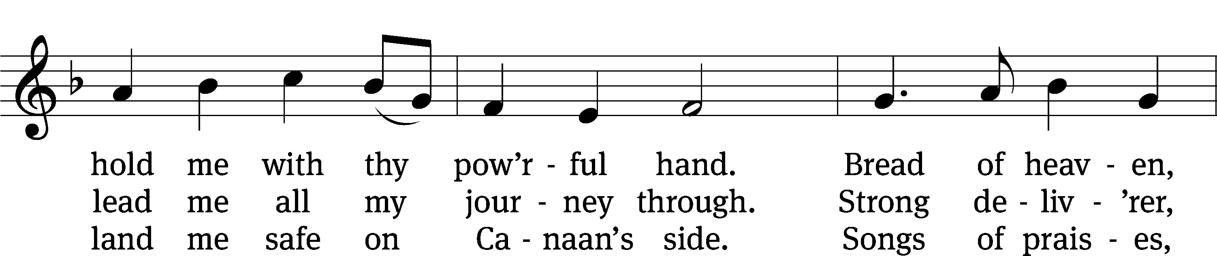
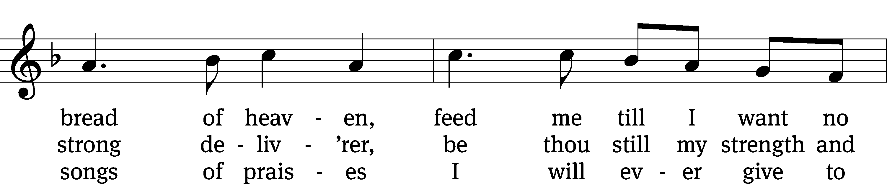
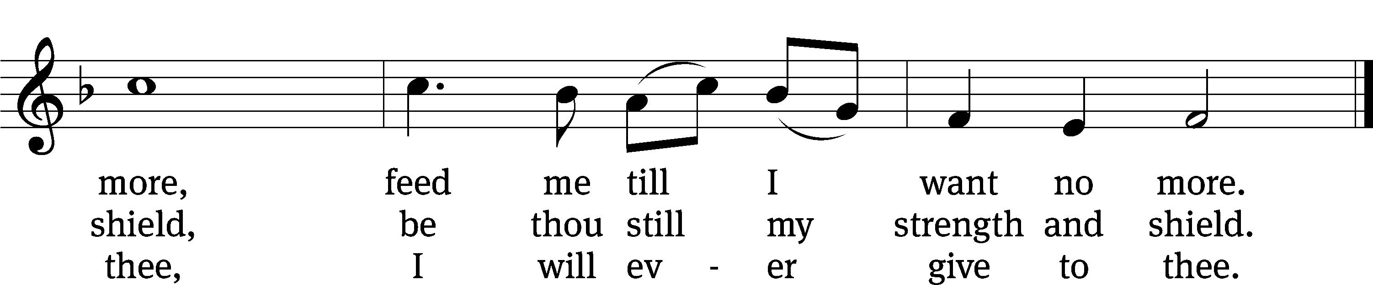
Text: William Williams, 1717–1791, abr.; (st. 1): tr. Peter Williams, 1722–1796, alt.; (sts. 2–3): tr. William Williams, 1717–1791
Tune: John Hughes, 1873–1932
Text and tune: Public domain

Acknowledgments
Setting One from Christian Worship
Unless otherwise indicated, Scripture quotations are from The Holy Bible, New International Version®, NIV®. Copyright © 1973, 1978, 1984, 2011 by Biblica, Inc.TM Used by permission of Zondervan. All rights reserved worldwide.
Software distributed in partnership with Northwestern Publishing House.
Created by Christian Worship: Service Builder © 2023 Concordia Publishing House.

No Lunch Bunch This Month
Due to the pipe break in the fellowship hall, there will be no monthly lunch bunch for the month of January.

Calls Received
Our preschool director and teacher Miss Noon has received a call to serve as teacher and Early Childhood Ministry Director at Reformation Lutheran Church in San Diego, CA. Pastor Holz has received a call to serve as Pastor at Fount of Life Lutheran Church in Colorado Springs, CO. Please keep both Miss Noon and Pastor Holz in your prayers as they deliberate their calls here at Beautiful Savior and their new calls. They welcome your thoughts and input.

Offering Envelopes
If you have not picked up your offering envelope for 2023, please take yours from the entryway table. Many choose to give their thanks offerings online but if you would like an offering envelope and do not have one, please let Pastor know and he will get you one.

Next Week’s Worship
Our theme for worship: “The Savior’s Sermon: You Are…So Be.” Our readings will be: Exodus 19: 1-8a, 1 Peter 2: 9-12, Matthew 5: 13-20. We will sing the following hymns: 376 Rise Up and Shine, 706 Come Unto Me, Ye Weary, 668 Jesus Comes Today with Healing, 736 Lord, You Call Us as Your People.

THIS WEEK AT BEAUTIFUL SAVIOR
† Today 10:30am Worship
12 pm Bible Information Class
† Friday-Sunday Gatlinburg Teen Ski Trip
† Sunday 9:30am Sunday School
10:30am Worship
12 pm Confirmation Class
12 pm Bible Information Class

Welcoming Guests and Creating a Sense of Belonging
On two Sundays, January 22 and Sunday, January 29, we are needing your help! We will be brainstorming ways that we as a congregation can make guests feel like part of our Beautiful Savior family. Everyone is needed for the best input! We will meet in the fellowship hall at 9:30 am on those two Sundays. And it comes with an assignment: Ask yourself this question: “If I were a first-time guest to Beautiful Savior, what did I notice?

One by One Bible Study starts on February 5th!
One by One is a Bible study based on Pastor David Rosenau’s keynote presentation at the WELS National Conference on Lutheran Leadership in January of 2020. Using powerful personal stories and drawing from his wealth of experience both as a detective and a parish pastor, Pastor Rosenau helps Christians understand why it is so important to see every soul as a treasure and why we want to be willing to spend the time and effort necessary to share the gospel with each one. This video-based Bible Study will meet in the fellowship hall at 9:30.

Funeral
God called home the soul of our member Gerrie (Gerda) Sample home to heaven this past week at the age of 91. Gerrie had been in care facilities for the last 9 years. Her funeral was this past Thursday. God comfort her family with the hope of the resurrection.
Tuesday Bible Study
Who is Jesus? In our new Tuesday evening Bible Study, we will listen to Jesus tell us who he is by examining his eight “I am” statements in the New Testament. We will meet in the Fellowship Hall starting on Tuesday, February 14th at 7pm and Jesus will tell us who he is—from the “Bread of Life” to the “Vine” and many other beautiful statements of Jesus about himself.

Giving Statements
If you have not picked up your giving statement for 2022, please check your mailbox for your giving record. If you do not have a giving statement and would like a record of your thanks offerings for 2022, please see Dan Walker in the church office.
February Calendars and Meditation Books
Help yourself to a copy of the February Church Calendar and the newest Meditations daily devotional book. Both are available on the entry way table.

The Savior’s Sermon—Worship Series

The Greek word epiphany means “appearance.” In the first half of this church season called Epiphany, we saw Jesus appear on the scene, beginning his ministry. He calls his disciples. It is not long before large crowds start following Jesus around Galilee. So, in the second half of this season Jesus is going to teach us what it means to be one of his followers. Jesus does this through the most famous sermon of all time. It is not delivered while standing in a pulpit but while sitting on a hill. Elevated above the crowd, Jesus’ voice would carry through the air. His followers hung on his every word as the Christ talked about living an authentic Christian life. It is called the Sermon on the Mount. Our worship the next few weeks will follow this pattern:

Trust in God’s Strength --- Sunday, January 29
You Are . . . So Be ---Sunday, February 5
Live a Holy Life---Sunday, February 12
Love Your Enemies---Sunday, February 19

Prayer List

Thank the Lord for the safe return of all the soldiers who recently came home and all soldiers and their families who are facing deployment. Please keep in your prayers this week all soldiers who are currently deployed. Please also remember: Patrick Smalley, brother in law to Jeff Cleveland, (in hospice care); Shan Bradford, daughter of Porter Matthew and friend of Margareta Smothers, (injured in car accident); Marlys Donner, mother of Tim Donner (declining health); Mark Lenz, father of Pamela Holz (recovery from tumor surgery); Caleb Westra, friend of the Holz family (Surgeries on his leg and foot after accident); Pat Bray, father of Allison Johnson (skin cancer and surgery); Josh Carter, friend of Adam Holz (recovery from car accident); Stacy Schroeder, daughter of Jeff & Eileen Cleveland (melanoma diagnosis); Autumn Potter & family, friends of Jessica Boulter (death of sister); Aimee Gerkhardt, sister in law of Jessica Church (breast cancer); Roger Chism, friend of Hilde Fox (diverticulitis); Steven Owens, father of Mark Owens, (cancer); Kathy Temple (cancer reoccurrence); Eric Smith, friend of Tim Donner (kidney surgery & complications); Brandon Vannoy, friend of Mac McCoo (seizures); Sheila Lynch, sister of Gayle Brooks (unable to walk); Drake Robideau, friend of Mary Daniel (strength & wellness); Mike LaFave (back problems); Linda Thomas, sister of Gayle Brooks, (physical rehab after injury); Ruth Amorth, twin sister of Hilde Fox (seriously ill); Gary Davis, husband of Angela Davis (seizures); Gidget Tate (Health issues). If you would like to have a name or situation included or if you would like to give an update on a prayer request, please contact Pastor Holz or call the church office at 931-905-1400.

Serving in God’s House

Ushers: Mac McCoo, Art Ebbinger
Greeters: Mac McCoo, Doris H
Kitchen: Mary Daniel
Piano: Deb White
Fellowship: All

Serving next week:

Ushers: Mike R, Trey C
Greeters: Jeff & Eileen C
Kitchen: Gail I, Loretta W, Mary D
Piano: Barb Noon
Fellowship: (A-G)

