Beautiful Savior Lutheran Church

December 18, 2022 – Fourth Sunday in Advent

Service Theme: Come, lord Jesus—as immanuel!

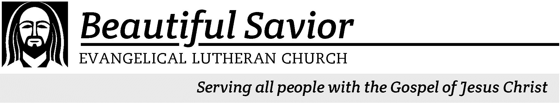


Welcome-- We are glad you could join us today! It is our hope that this service is a blessing to you. Please join us for worship again soon.

· Please save the last two rows of pews for parents with small children.

· Parents with little ones: If your child becomes restless during the service, that’s okay… We’re glad they’re here, and Jesus is pleased when they are brought to hear his Word: “Let the little children come to me.” If you need to be with your child in the Fellowship Hall, the service can be heard through a speaker.

· Five minutes before the worship service begins the usher will light the candles. This is our signal to quiet down and prepare our hearts for worship.

· Restrooms are conveniently located to the left as you exit the sanctuary.

· Please silence your cell phone before the start of the service.

Prayer for Worship
Heavenly Father, prepare my heart for the arrival of your Son and my Savior. Help me to clear out everything that prevents me and distracts me from the birth of my Savior. Use your Word to give me peace and hope so that I am ready not only for the arrival of the Babe of Bethlehem, but also for the King of Kings when he comes in glory. Amen.

Kent Holz, Pastor
Beautiful Savior Lutheran Church
2526 Whitfield Road
Clarksville, TN 37040
931-905-1400
Website: www.bslclarksville.com
Bslc.clarksville@gmail.com
Barbara Noon, Preschool Director
beautifulsaviorpreschool@gmail.com
327 O Come, O Come, Emmanuel CW 327 sts. 1, Ref, 2–3
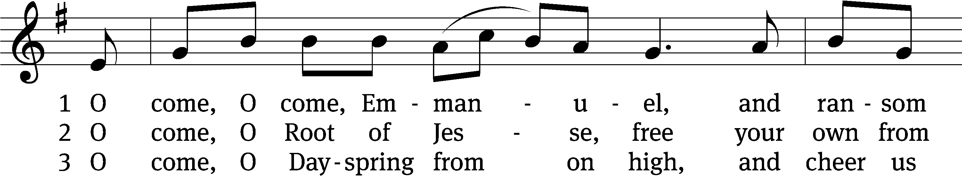
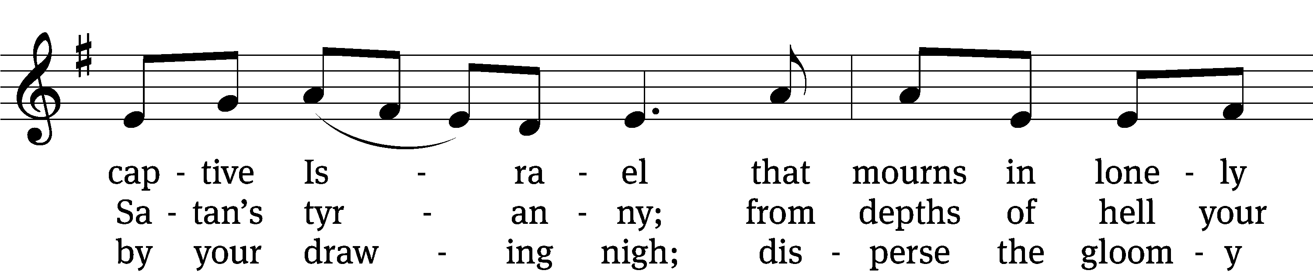
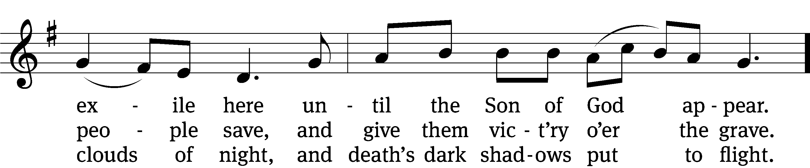
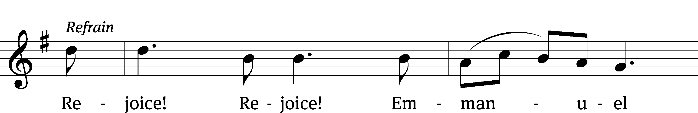
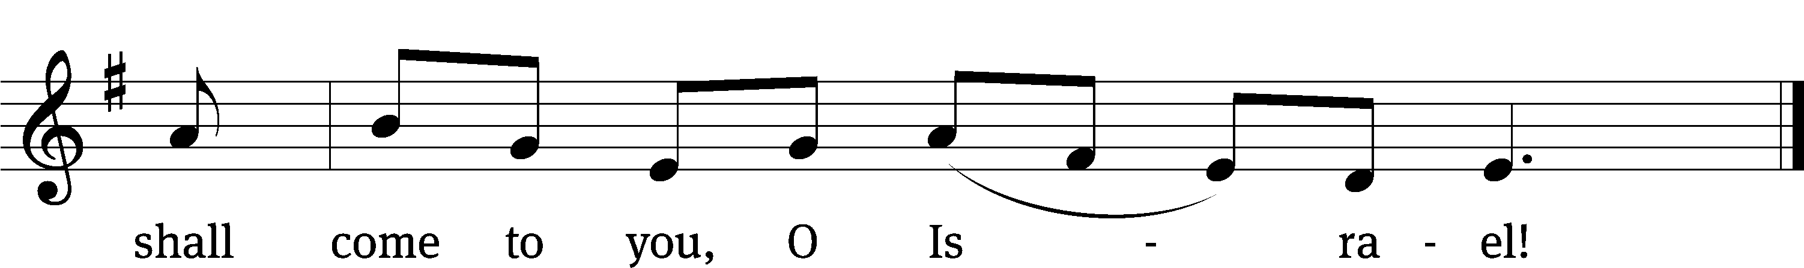
Text: Latin, c. 12th cent., Psalteriolum Cantionum Catholicarum, Köln, 1710; tr. John Mason Neale, 1818–1866, alt.
Tune: French, 15th cent., alt
Text and tune: Public domain

In the name of the Father and of the T Son and of the Holy Spirit.
Amen.

Confession
The season of Advent is a time to prepare our hearts for the coming of Jesus.
We look forward to the coming of our Savior in the flesh as a babe in Bethlehem.

We anticipate his return in judgment as our King.
We welcome him in his daily coming to us in Word and Sacrament.

We prepare our hearts to receive our Savior by repenting of our many sins.
Heavenly Father, I have not always carried out my responsibilities…
as a husband, wife or single person,
as a parent or child,
as employer or employee,
as a teacher or student.

I have not always loved God with all my heart.
I have not always gladly heard his Word, and patiently endured
affliction.
At times I have been dishonest, proud, and unforgiving.
At times I have been selfish, lazy, envious, and quarrelsome.
I do not always speak in a way that builds others up, but instead tears them down.
I do not always treat my body as a gift from God; I do not always use it to his glory.
I have failed to do what is right and good in God’s sight.

God has said through his apostle, “When we confess our sins, God is faithful and just and will forgive us our sins and purify us from all unrighteousness.” (1John 1:9) By the grace of God the Father, he provided Jesus as the sinless one for you. He offered Jesus as the Lamb of God, whose blood washes all sin from you. God has pardoned your sins for Jesus’ sake.
Amen.
327 O Come, O Come, Emmanuel CW 327 st. 4
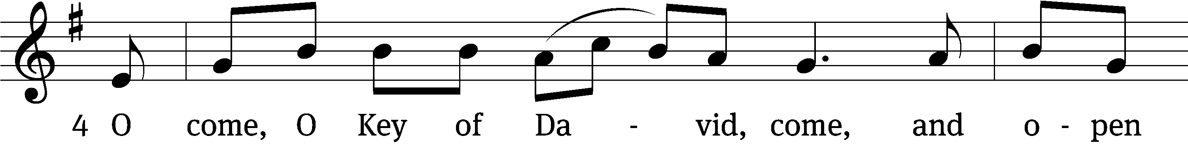
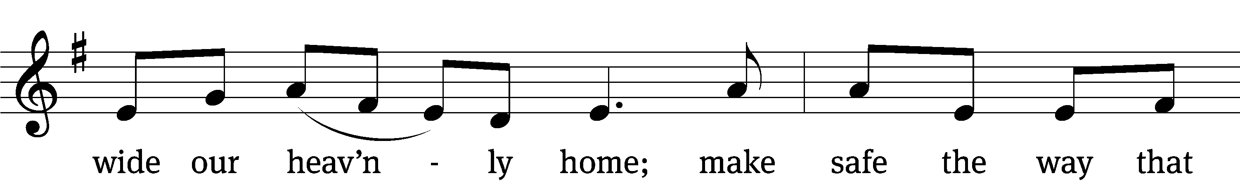
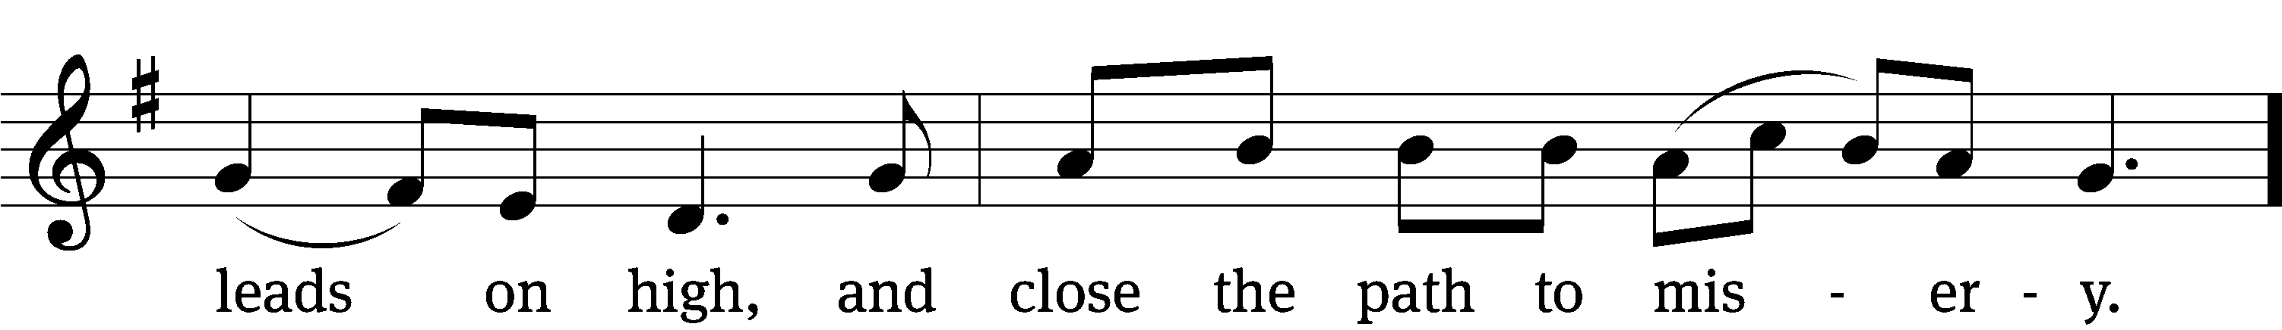
Text: Latin, c. 12th cent., Psalteriolum Cantionum Catholicarum, Köln, 1710; tr. John Mason Neale, 1818–1866, alt.
Tune: French, 15th cent., alt
Text and tune: Public domain

The Word

The Lord be with you.
And also with you.

Prayer of the Day
Let us pray.

Stir up your power, O Lord, and come. Take away the burden of our sins, and make us ready for the celebration of your birth, that we may receive you in joy and serve you always; for you live and reign with the Father and the Holy Spirit, one God, now and forever.
Amen.
First Reading Isaiah 7:10–14
10Again the Lord spoke to Ahaz, 11“Ask the Lord your God for a sign, whether in the deepest depths or in the highest heights.”
12But Ahaz said, “I will not ask; I will not put the Lord to the test.”
13Then Isaiah said, “Hear now, you house of David! Is it not enough to try the patience of humans? Will you try the patience of my God also? 14Therefore the Lord himself will give you a sign: The virgin will conceive and give birth to a son, and will call him Immanuel.

89A Forever I Will Sing Psalm 89A
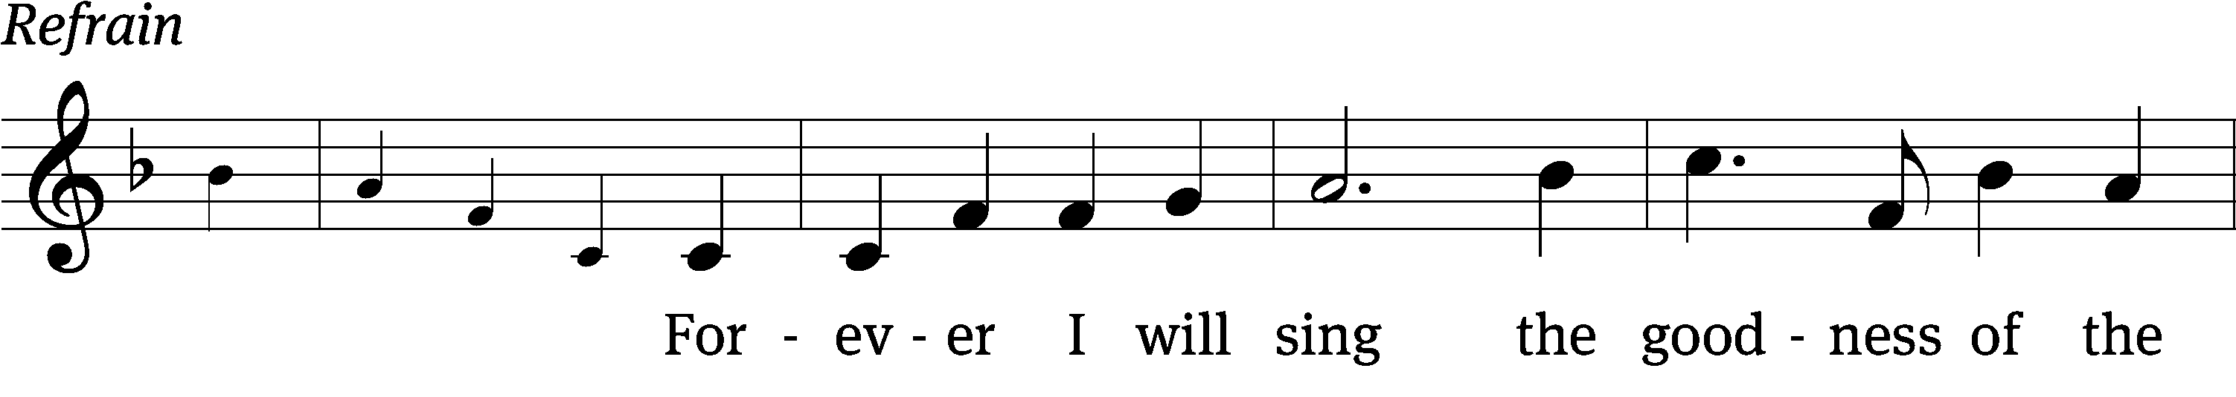
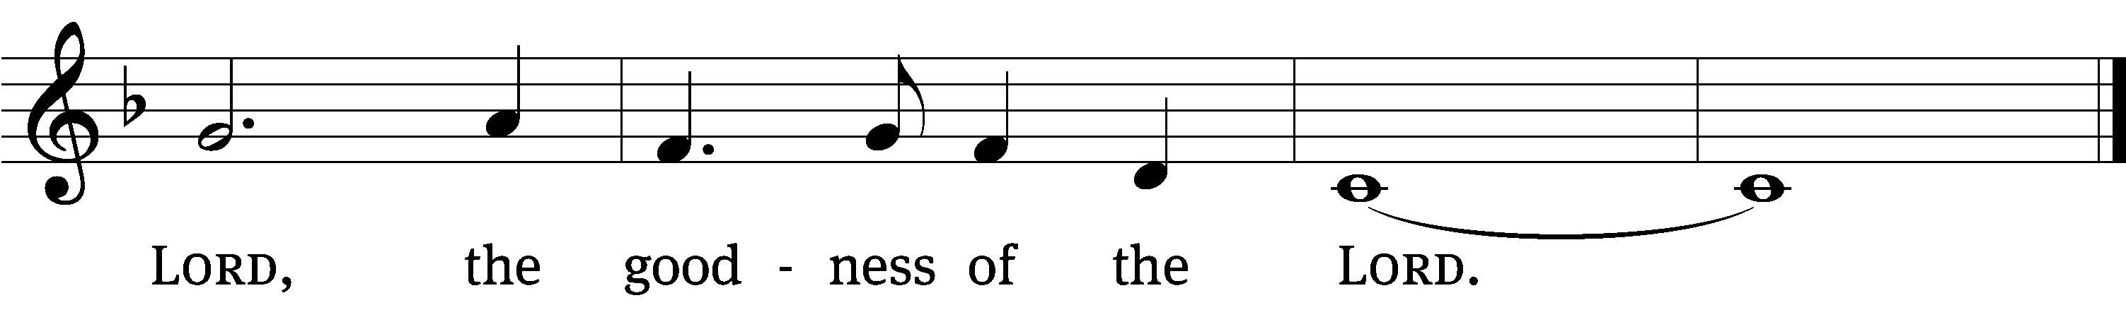
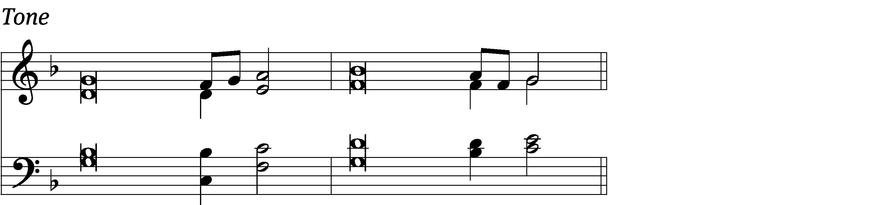

I will sing of the Lord’s great love for- / ever;
with my mouth I will make your faithfulness known through all gener- / ations.
I will declare that your love stands firm for- / ever,
that you have established your faithfulness in / heav’n itself.
The heavens praise your / wonders, Lord,
your faithfulness too, in the assembly of the / holy ones. Refrain

Who is like you, Lord God Al- / mighty?
You, Lord, are mighty, and your faithfulness sur- / rounds you.
Blessed are those who have learned to ac- / claim you,
who walk in the light of your / presence, Lord.
They rejoice in your name / all day long;
they celebrate your / righteousness.
Glory be to the Father and / to the Son
and to the Holy / Spirit,
as it was in the be- / ginning,
is now, and will be forever. / Amen. Refrain
Tune: Marty Haugen
Text: © 1969, 1981, 1997 ICEL (refrain). Used by permission: OneLicense no. 716626
Tune: © 1994 GIA Publications, Inc. Used by permission: OneLicense no. 716626
Setting: © 2011 Faith Alive Christian Resources. Used by permission: License no. 130353436

Second Reading Romans 1:1–7
1Paul, a servant of Christ Jesus, called to be an apostle and set apart for the gospel of God— 2the gospel he promised beforehand through his prophets in the Holy Scriptures 3regarding his Son, who as to his earthly life was a descendant of David, 4and who through the Spirit of holiness was appointed the Son of God in power by his resurrection from the dead: Jesus Christ our Lord. 5Through him we received grace and apostleship to call all the Gentiles to the obedience that comes from faith for his name’s sake. 6And you also are among those Gentiles who are called to belong to Jesus Christ.
7To all in Rome who are loved by God and called to be his holy people:
Grace and peace to you from God our Father and from the Lord Jesus Christ.

Children's Devotion Ages 3 through grade 5 are invited to come forward for a Bible lesson.

Children's Church During the service, parents may choose to take their children (ages 2-5) to Children’s Church. There they will hear a Bible story, and sing songs. They will return to the sanctuary during the offering.

496 Jesus! Name of Wondrous Love CW 496
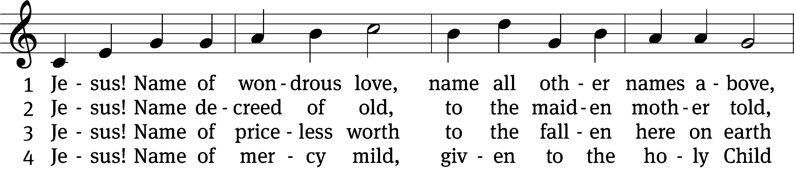
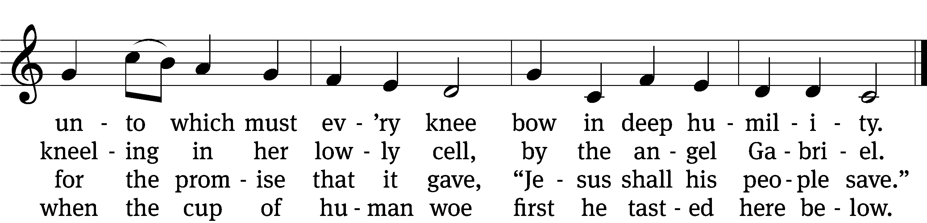

5 Jesus! Only name that’s giv’n
under all the mighty heav’n
whereby those to sin enslaved
burst their fetters and are saved.

6 Jesus! Name of wondrous love,
human name of God above;
pleading only this, we flee
helpless, O our God, to thee.
Text: William W. How, 1823–1897, alt.
Tune: Geist-reiches Gesang-Buch, Halle, 1704, ed. Johann A. Freylinghausen, alt.
Text and tune: Public domain

Sermon Matthew 1:18–25
18This is how the birth of Jesus the Messiah came about: His mother Mary was pledged to be married to Joseph, but before they came together, she was found to be pregnant through the Holy Spirit. 19Because Joseph her husband was faithful to the law, and yet did not want to expose her to public disgrace, he had in mind to divorce her quietly.
20But after he had considered this, an angel of the Lord appeared to him in a dream and said, “Joseph son of David, do not be afraid to take Mary home as your wife, because what is conceived in her is from the Holy Spirit. 21She will give birth to a son, and you are to give him the name Jesus, because he will save his people from their sins.”
22All this took place to fulfill what the Lord had said through the prophet: 23“The virgin will conceive and give birth to a son, and they will call him Immanuel” (which means “God with us”).
24When Joseph woke up, he did what the angel of the Lord had commanded him and took Mary home as his wife. 25But he did not consummate their marriage until she gave birth to a son. And he gave him the name Jesus.

“Immanuel comes near to you!”
Apostles’ Creed
I believe in God, the Father Almighty,
maker of heaven and earth.

I believe in Jesus Christ, his only Son, our Lord,
who was conceived by the Holy Spirit,
born of the Virgin Mary,
suffered under Pontius Pilate,
was crucified, died, and was buried.
He descended into hell.
The third day he rose again from the dead.
He ascended into heaven
and is seated at the right hand of God the Father Almighty.
From there he will come to judge the living and the dead.

I believe in the Holy Spirit,
the holy Christian Church,
the communion of saints,
the forgiveness of sins,
the resurrection of the body,
and the life everlasting. Amen.

Offering “We love because he first loved us.” 1Jn 4:19 God’s love in sending Jesus to live, to suffer, and to die for each of us motivates the members of Beautiful Savior to show their love and thanks by returning a portion of their income to the Lord. Through these free will offerings, this congregation and its ministries are maintained.
*If you would like to give your regular offering envelope, you can mail it to the church. If you would like to give securely online, scan this code or follow this link: bslclarksville.com

Prayer of the Church
Eternal Father, throughout the centuries you repeated and affirmed your promise to send the offspring of the woman to crush the head of the devil. Through your prophets of old you continued to direct the eyes of your people to the advent of their Savior.
We praise you, O Lord, for keeping your promise and sending your Son to destroy the works of the devil.

As we prepare to celebrate the birth of our King, use your mighty Word to shatter our pride and to rouse us from spiritual slumber and apathy.
Move us to take to heart the words of John the Baptist, “Repent, for the kingdom of heaven is near.”

You sent your Son to redeem us from sin. Let this good news be our joy and strength. Use it to cheer the lonely, encourage the fearful and give hope to the despairing. In these days before Christmas, spare us from the stress of deadlines and the frenzy of commercialism.
Fill our lives with the message of your peace and the music of your grace.

Direct our eyes not only to the manger, but also to the skies, where we will see your Son coming again, not as a lowly child, but as the King of kings.
Lift up our hearts in joyful anticipation of that day.

Come quickly Lord Jesus, in your grace, in your power and in your glory.
Come, Lord Jesus! Amen.
Lord’s Prayer
Our Father, who art in heaven,
hallowed be thy name,
thy kingdom come,
thy will be done
on earth as it is in heaven.
Give us this day our daily bread;
and forgive us our trespasses,
as we forgive those
who trespass against us;
and lead us not into temptation,
but deliver us from evil.
For thine is the kingdom
and the power and the glory
forever and ever. Amen.



320 As Angels Joyed with One Accord CW 320 sts. 1–4, 7
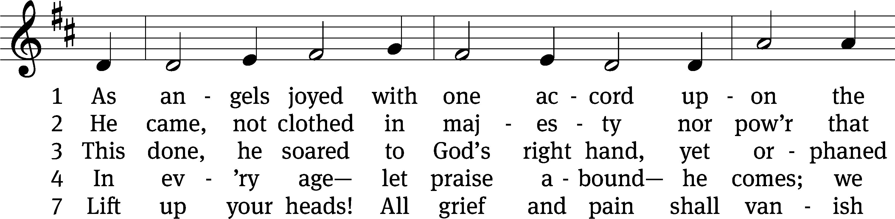
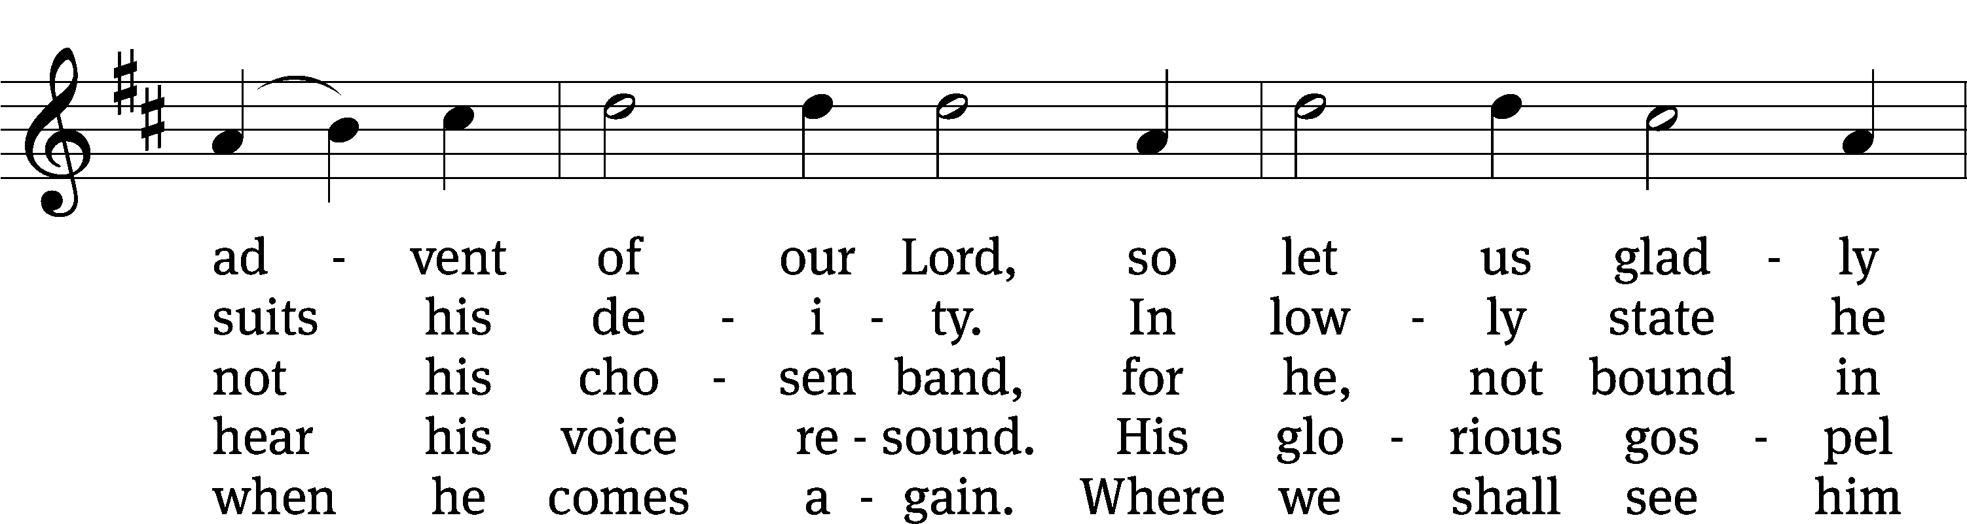
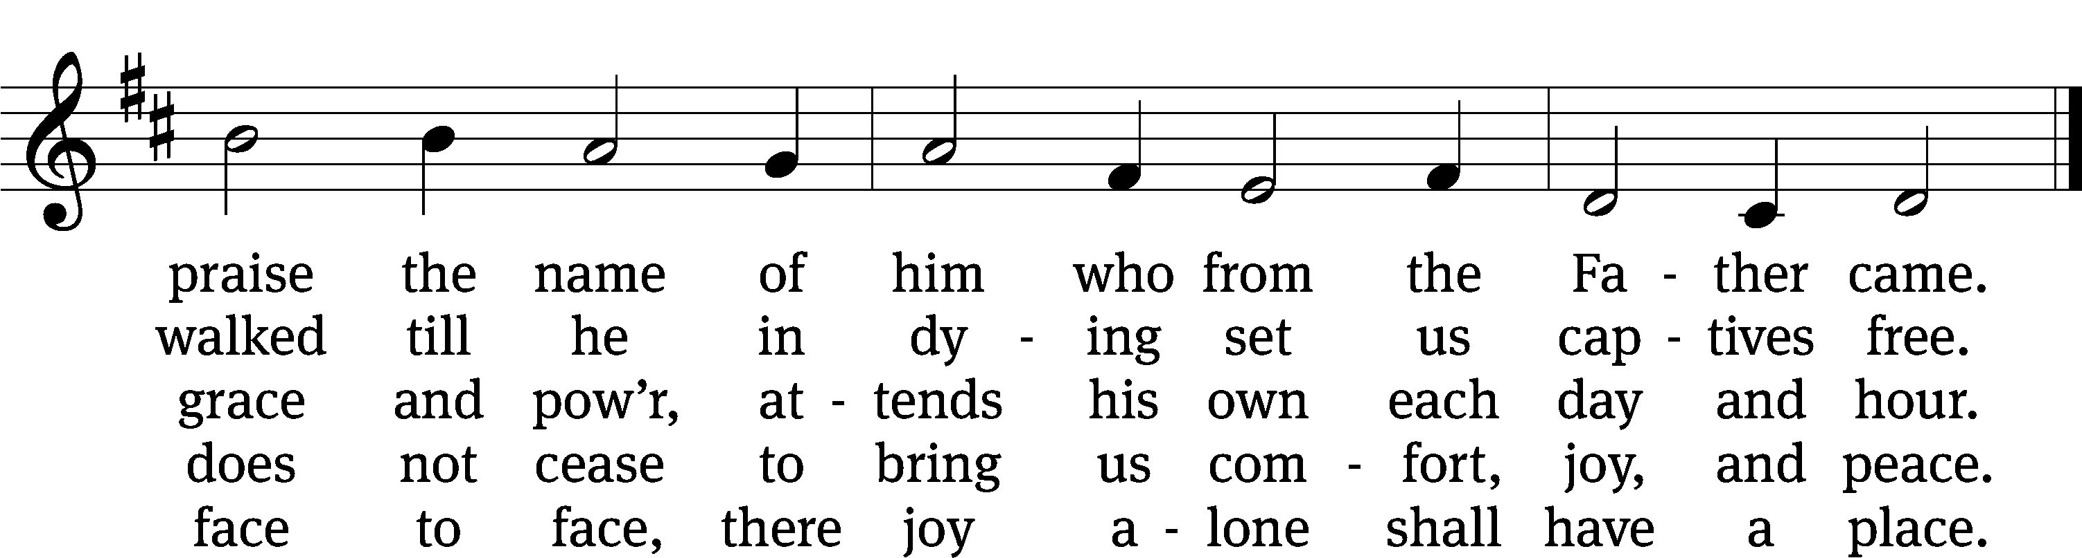
Text: Werner H. Franzmann, 1905–1996, abr., alt.
Tune: Latin, 15th cent., adapt. Michael Praetorius, 1571–1621
Text: © 1993 Werner H. Franzmann, admin. Northwestern Publishing House. Used by permission: OneLicense no. 716626
Tune: Public domain
Closing Prayer
Precious Savior, you first came into the world in utter poverty and deepest humility. Today you also came to us in your Word, in love, and in mercy. We know that you are going to come once again, in might and in majesty. Before that great day comes, implant your truth deeply in our hearts, so that all we attempt or achieve will serve to honor you, our Savior-King, who is worthy of all our praise.
Amen.
Blessing
The Lord bless you and keep you.
The Lord make his face shine on you and be gracious to you.
The Lord look on you with favor and T give you peace.
Amen.
330 Peace Came to Earth CW 330
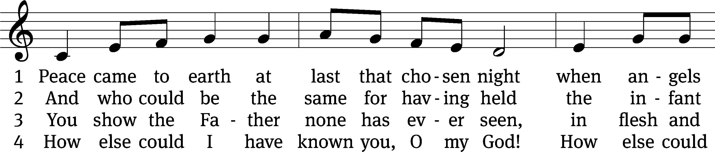
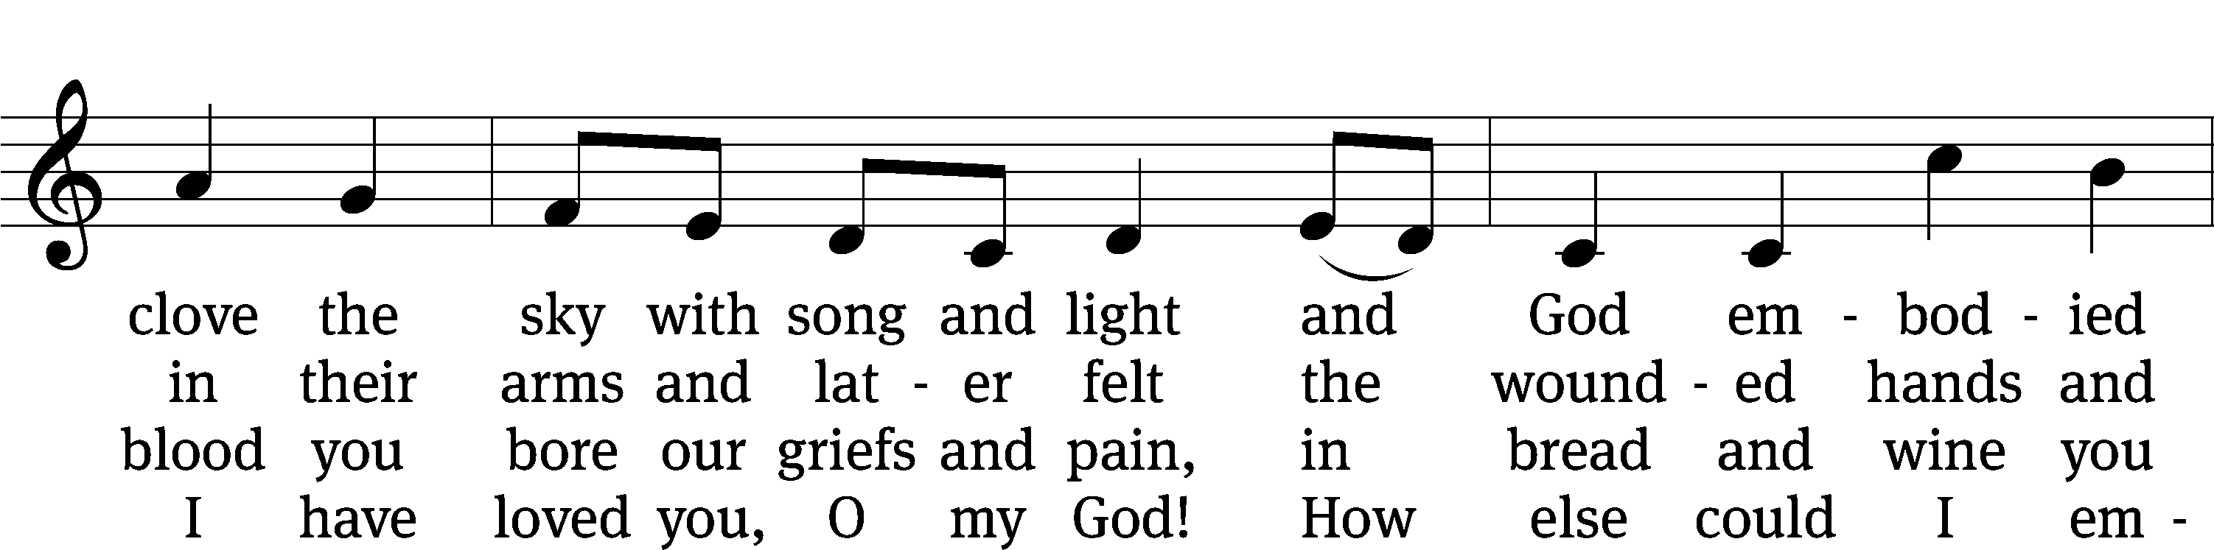
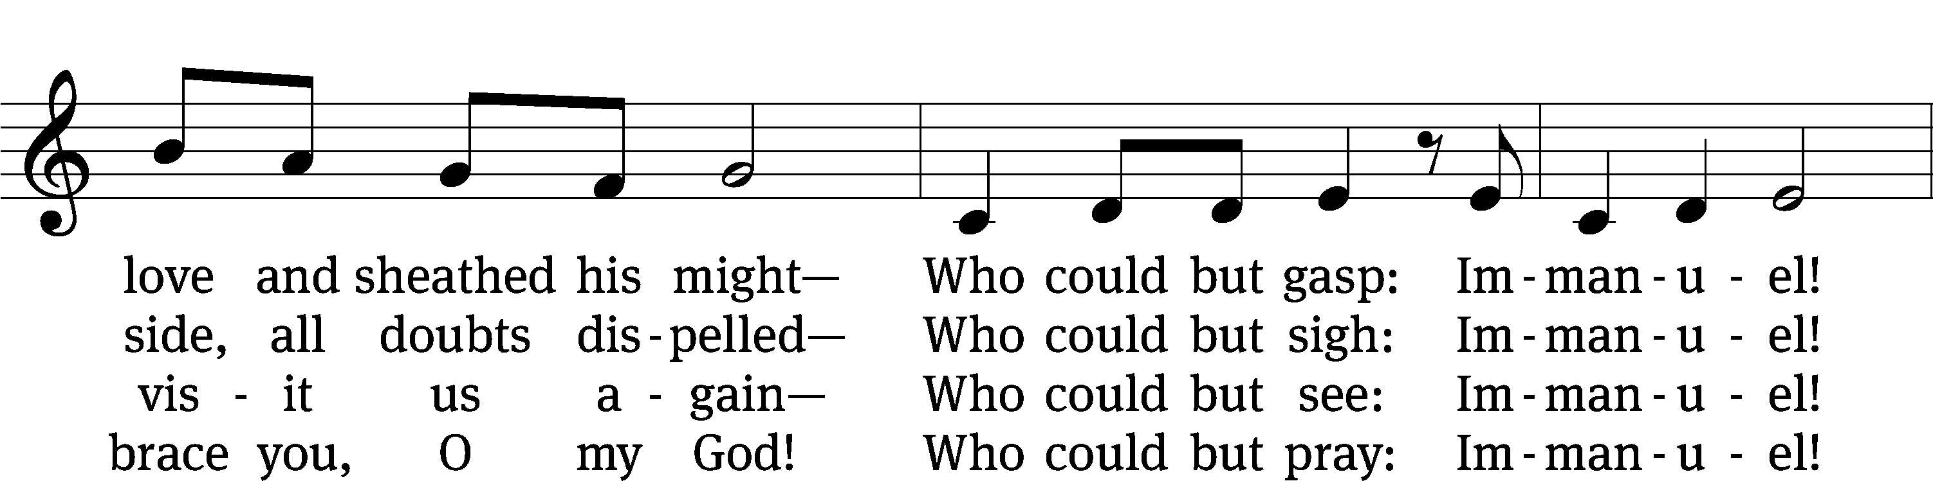
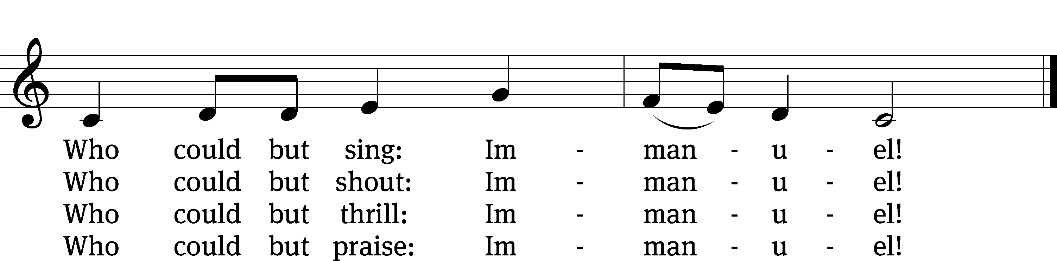
Text: Jaroslav J. Vajda, 1919–2008
Tune: arr. Mark Kellner, 1959–2015, alt.; Richard Jeffrey, b. 1952
Text: © 1984 Concordia Publishing House. Used by permission: OneLicense no. 716626
Tune: © 2000 MorningStar Music Publishers, Inc. Used by permission: OneLicense no. 716626
Acknowledgments
Setting One from Christian Worship
Unless otherwise indicated, Scripture quotations are from The Holy Bible, New International Version®, NIV®. Copyright © 1973, 1978, 1984, 2011 by Biblica, Inc.TM Used by permission of Zondervan. All rights reserved worldwide.
Software distributed in partnership with Northwestern Publishing House.
Created by Christian Worship: Service Builder © 2022 Concordia Publishing House.

Thank you
A big thanks for the FUEL donations that went to provide supplemental nutrition to students in need at Glenellen Elementary. The donation was greatly appreciated!

Next Week’s Worship
Our theme for worship: “A Savior Is Born to Change the World” Our readings will be: Micah 5:2-5, Titus 2: 11-14, Luke 2: 1-20 . We will sing the following hymns: 343 Once in Royal David’s City, 333 O Little Town of Bethlehem, 330 Peace Came to Earth, 344 What Child Is This, 350 Hark! The Herald Angels Sing, 361 Go, Tell It on the Mountain, and 337 Silent Night, Holy Night.

THIS WEEK AT BEAUTIFUL SAVIOR
† Today 9:30am Sunday School
10:30am Worship
12 pm Bible Information Class
† Wednesday 11:30am Lunch Bunch
† Saturday 5 pm Christmas Eve Candlelight Service
† Sunday 9:30am Sunday School
10:30am Christmas Worship

Christmas Eve –Children Participation
For our Christmas Eve service this year, we will be incorporating a few parts of the service where children of the congregation may participate. If you would like your child to be involved, please speak with Ruth Roehr here at church today.

Christmas Eve Candlelight
This year we will celebrate the birth of Our Savior with a Christmas Eve Candlelight Service. We will sing God’s praises and hear the angels’ glad tidings that The Savior has been born. The service will be at 5pm. If you would like to help usher, please speak with Pastor Holz. We will need 6 ushers.

Christmas Day Service
Since Christmas falls on a Sunday this year, our Sunday service on Dec. 25th will be a Christmas Day service in which we celebrate that God has kept his promise in sending the world, and each one of us, a Savior. The service will be at 10:30. There will not be Sunday School on the 25th.

New Year’s Eve
We will ring in the New Year and give thanks for the past with a special Vespers service on New Year’s Eve. There will be time for prayer, time in the Word of God, and time to receive the Lord’s Supper. The service will be at 6pm.

Advent Series: Come, Lord Jesus!
“Advent” is a Latin word that means “coming.” The season of Advent is the four week period before Christmas that the Church uses to connect the two “comings” of Christ. The first time the Lord came into our world it was as a tiny, helpless baby, born in a manger in Bethlehem. However, when Jesus comes again, it will be in all his power and glory with his angelic army behind him. He will be coming as judge at the end of time. Let us use these four weeks to pray: Come, Lord Jesus!

Fourth Sunday in Advent-12/18/2022- Come, Lord Jesus—as Immanuel!

Lunch Bunch
On Wednesday, December 21st at 11:30am, lunch will be served here at church for our older and/or retired members and friends. If you would like to attend
please sign up so the hosts can get an accurate headcount for the meal preparations. A free will offering will be taken to cover the cost of the meal. After the meal there will be a short devotion. If you have questions, please talk with Doris Harvey or Pastor Holz.

Sunday School/ Bible Study Schedule
There will not be youth or adult Sunday School on Sunday, Dec. 25th or Sunday, January 1st. Sunday School will resume on Sunday, January 8th.

WELS Teen Ski Trip
WHO: All youth ages 11-18
WHAT: An exciting weekend in the mountains of Gatlinburg! Activities include a scavenger hunt, skiing or snowboarding, games, Bible study, worship, meeting new friends, pool, hot tub, and lots of good food.
WHERE: Lodging is at the Edgewater Resort; Skiing / Snowboarding is at Ober Gatlingburg
WHEN: February 3-5, 2023 (Activities begin Friday night and go through Sunday afternoon). The deadline to register through your local church is December 15, 2022.
HOW: The cost for the entire weekend is all inclusive with all activities, meals, equipment rental, and a t-shirt for $200-215 / person. (The cost is determined by the type of activity. Each church will receive one invoice and send in one payment per group.)

Scan the QR code to take you to the registration page!





Prayer List
Thank the Lord for the safe return of all the soldiers who recently came home and all soldiers and their families who are facing deployment. Please keep in your prayers this week all soldiers who are currently deployed. Please also remember: Mark Lenz, father of Pamela Holz (recovery from tumor surgery); Caleb Westra, friend of the Holz family (Surgeries on his leg and foot after accident); Pat Bray, father of Allison Johnson (skin cancer and surgery); Josh Carter, friend of Adam Holz (recovery from car accident); Ed Scarano (cancer diagnosis and treatment); Stacy Schroeder, daughter of Jeff & Eileen Cleveland (melanoma diagnosis); Andy Hudson, friend of Mac McCoo (pneumonia & Covid); Autumn Potter & family, friends of Jessica Boulter (death of sister); Aimee Gerkhardt, sister in law of Jessica Church (breast cancer); Roger Chism, friend of Hilde Fox (diverticulitis); Steven Owens, father of Mark Owens, (cancer); Kathy Temple (cancer reoccurrence); Eric Smith, friend of Tim Donner (kidney surgery & complications); Brandon Vannoy, friend of Mac McCoo (seizures); Sheila Lynch, sister of Gayle Brooks (unable to walk); Drake Robideau, friend of Mary Daniel (strength & wellness); Mike LaFave (back problems); Linda Thomas, sister of Gayle Brooks, (physical rehab after injury); Ruth Amorth, twin sister of Hilde Fox (seriously ill); Gary Davis, husband of Angela Davis (seizures); Gidget Tate (Health issues); Maria Sauer, Friend of Karin Galvin. If you would like to have a name or situation included or if you would like to give an update on a prayer request, please contact Pastor Holz or call the church office at 931-905-1400.

Serving in God’s House

Ushers: Daniel L, Josh G
Greeters: Art & Sandy E
Kitchen: Charmaine S, Mary D
Piano: Barb
Fellowship: (N-S)

Ushers: Mac M, Art E
Greeters: Loretta W, Ernie R
Kitchen: Margareta S, Mary D
Piano: Deb
Fellowship: (T-Z)

