Beautiful Savior Lutheran Church

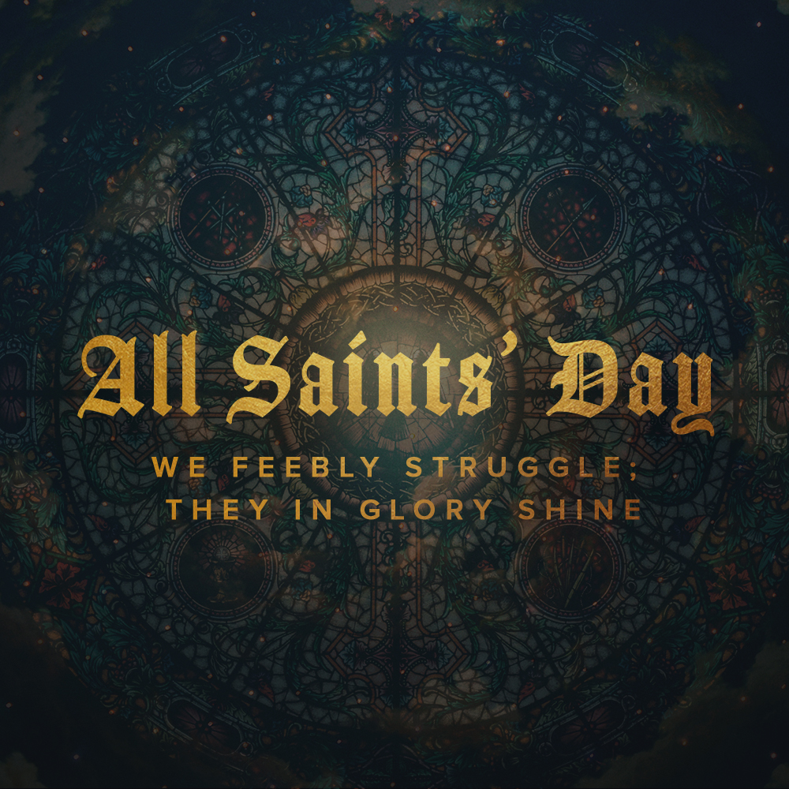

November 6, 2022 – All Saints’ Day

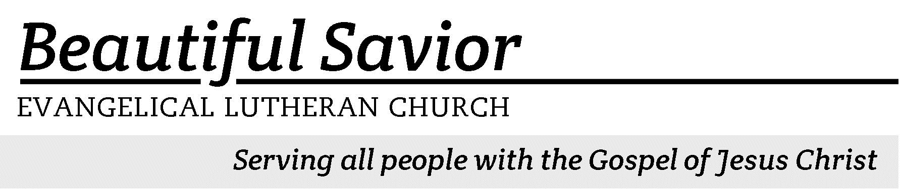


Welcome-- We are glad you could join us today! It is our hope that this service is a blessing to you. Please join us for worship again soon.

· Please save the last two rows of pews for parents with small children.

· Parents with little ones: If your child becomes restless during the service, that’s okay… We’re glad they’re here, and Jesus is pleased when they are brought to hear his Word: “Let the little children come to me.” If you need to be with your child in the Fellowship Hall, the service can be heard through a speaker.

· Five minutes before the worship service begins the usher will light the candles. This is our signal to quiet down and prepare our hearts for worship.

· Restrooms are conveniently located to the left as you exit the sanctuary.

· Please silence your cell phone before the start of the service.

Prayer for Worship
Lord Jesus Christ, you are the Resurrection and the Life. You have promised that those who believe in you will live, even though they die. Grant me the steadfast conviction that I will not die but fall asleep and on the Last Day, be raised with all believers to eternal life. Amen.

Beautiful Savior Lutheran Church
2526 Whitfield Road
Clarksville, TN 37040
931-905-1400
Website: www.bslclarksville.com
Kent Holz, Pastor
Bslc.clarksville@gmail.com
Barbara Noon, Preschool Director
beautifulsaviorpreschool@gmail.com

837 When Will I Walk CW 837
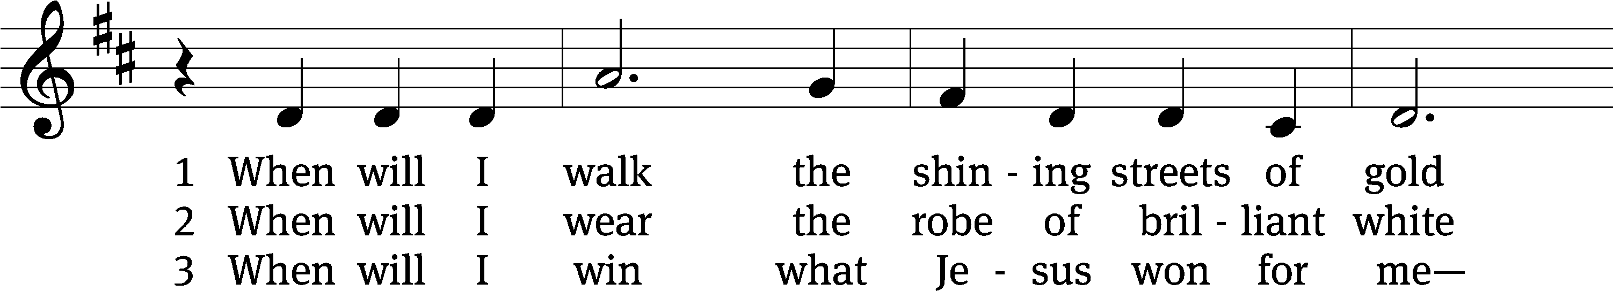
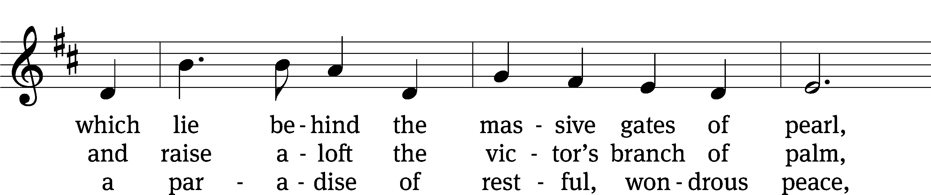
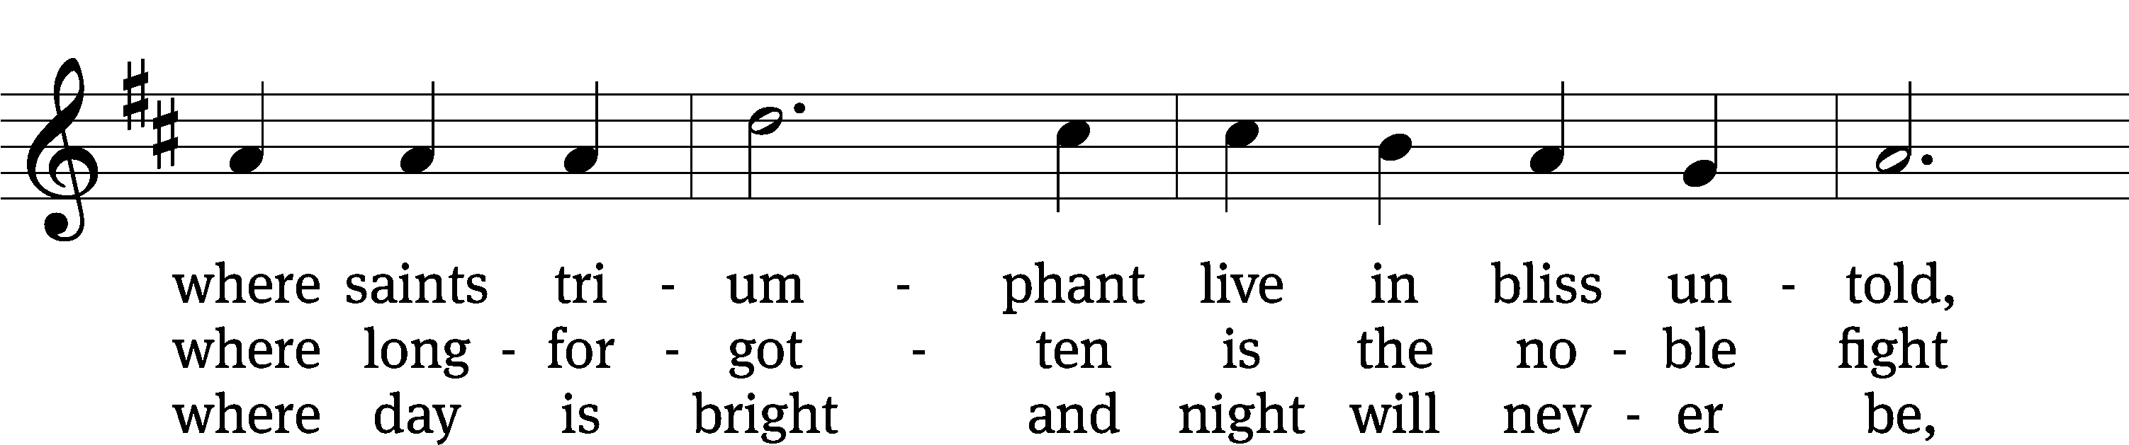
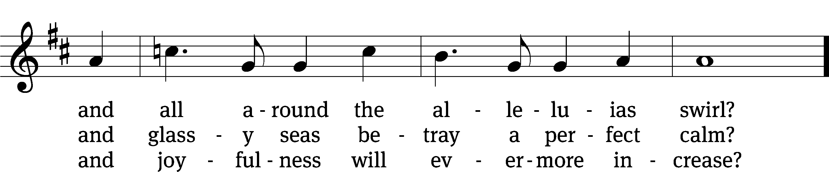
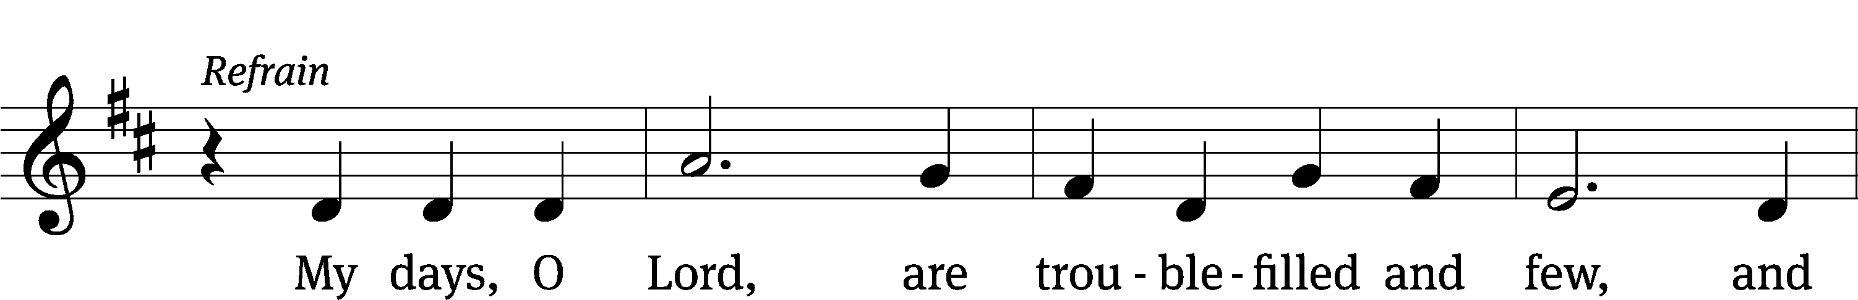
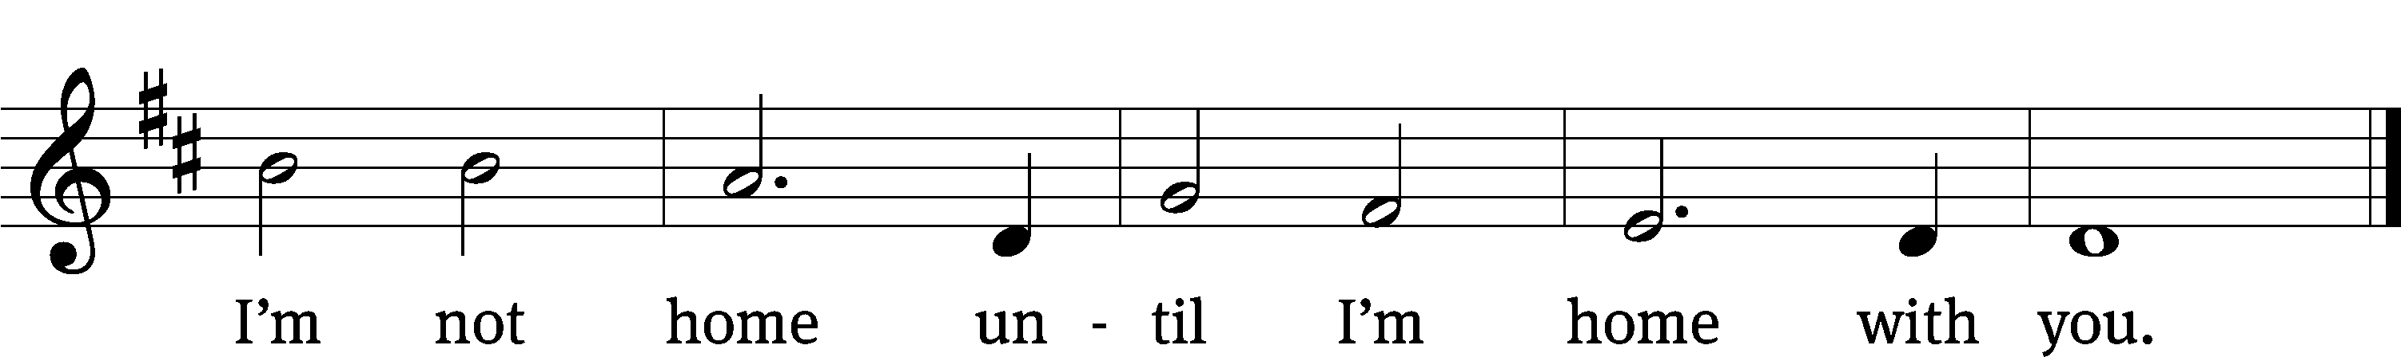
Text: Michael D. Schultz, b. 1963
Tune: Michael D. Schultz, b. 1963
Text and tune: © 2021 Michael D. Schultz, admin. Northwestern Publishing House. Used by permission: OneLicense no. 716626

In the name of the Father and of the T Son and of the Holy Spirit.
Amen.
Confession
If we claim to be without sin, we deceive ourselves and the truth is not in us.
If we confess our sins, God is faithful and just
and will forgive us our sins
and purify us from all unrighteousness.

Let us confess our sins to the Lord.
Holy God, gracious Father,
I am sinful by nature
and have sinned against you in my thoughts, words, and actions.
I have not loved you with my whole heart;
I have not loved others as I should.
I deserve your punishment both now and forever.
But Jesus, my Savior, paid for my sins
with his innocent suffering and death.
Trusting in him, I pray: God, have mercy on me, a sinner.

Our gracious Father in heaven has been merciful to us. He sent his only Son, Jesus Christ, who gave his life as the atoning sacrifice for the sins of the whole world. Therefore, as a called servant of Christ and by his authority, I forgive you all your sins in the name of the Father and of the T Son and of the Holy Spirit.
Amen.

Praise, My Soul, the King of Heaven CW 621 sts. 1–2, 4
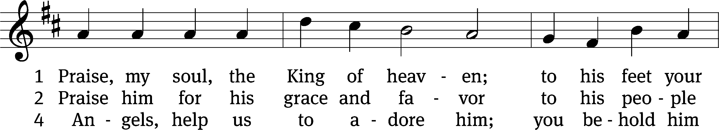
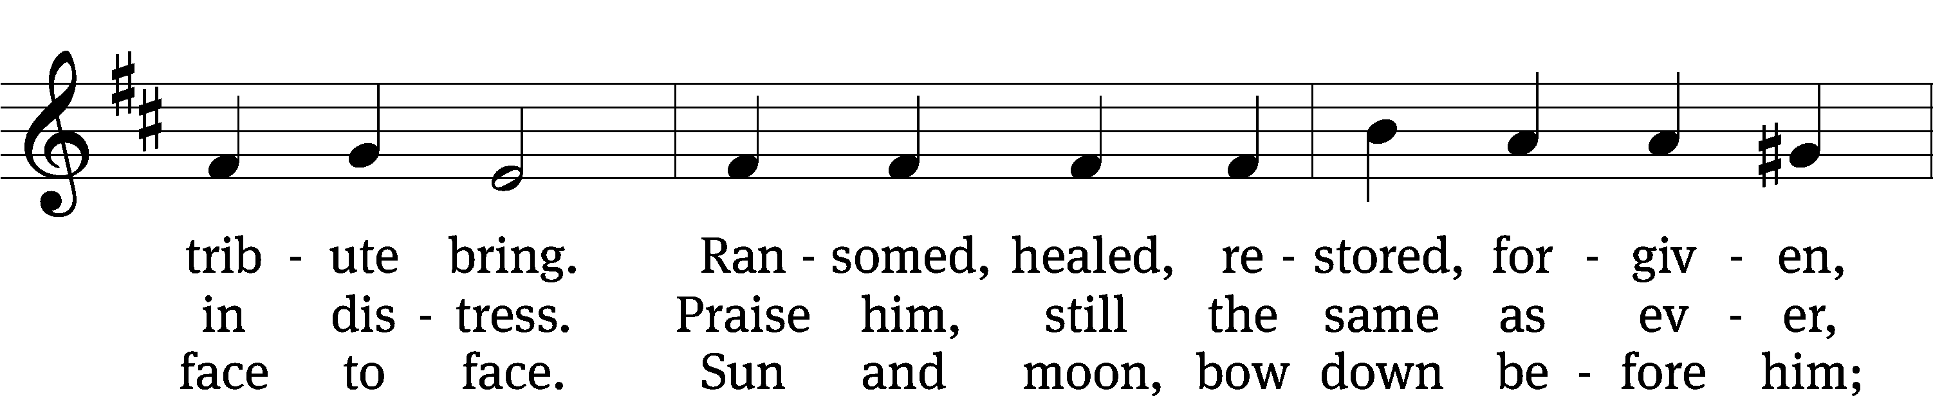
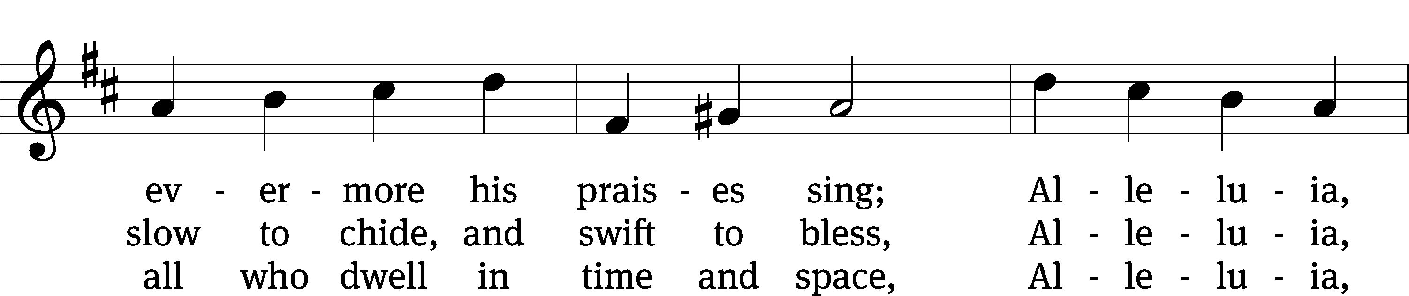
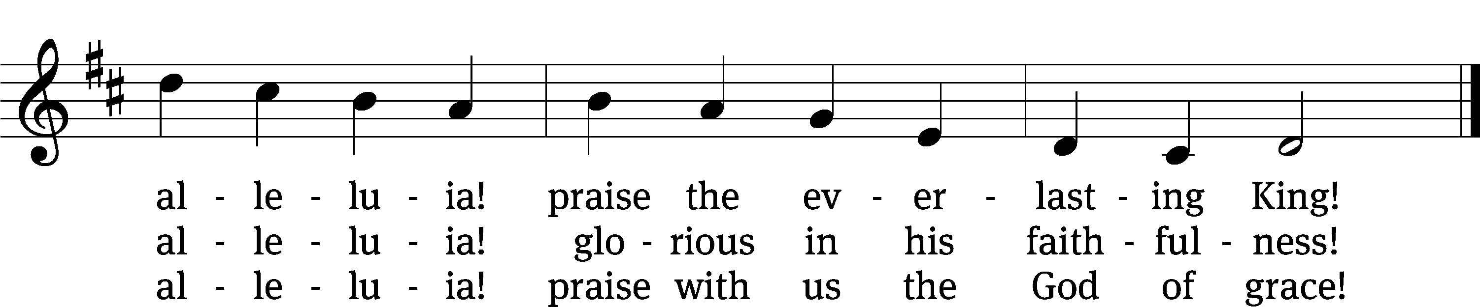
Text: Henry F. Lyte, 1793–1847
Tune: John Goss, 1800–1880
Text and tune: Public domain

Lord, Have Mercy
In peace let us pray to the Lord.
Lord, have mercy.

For the peace from above and for our salvation, let us pray to the Lord.
Lord, have mercy.

For the peace of the whole world, for the well-being of the Church of God, and for the unity of all, let us pray to the Lord.
Lord, have mercy.

For this holy house and for all who offer here their worship and praise, let us pray to the Lord.
Lord, have mercy.

Help, save, comfort, and defend us, gracious Lord.
Amen.

The Word

The Lord be with you.
And also with you.
Prayer of the Day
Let us pray.

Almighty God, you have knit your people together into one holy Church, the body of Christ our Lord. Grant us grace to follow the example of your blessed saints in lives of faith and willing service and with them at last inherit the inexpressible joys that you have prepared for those who love you; through your Son, Jesus Christ our Lord, who lives and reigns with you and the Holy Spirit, one God, now and forever.
Amen.

First Reading Hebrews 11:32–40
32And what more shall I say? I do not have time to tell about Gideon, Barak, Samson and Jephthah, about David and Samuel and the prophets, 33who through faith conquered kingdoms, administered justice, and gained what was promised; who shut the mouths of lions, 34quenched the fury of the flames, and escaped the edge of the sword; whose weakness was turned to strength; and who became powerful in battle and routed foreign armies. 35Women received back their dead, raised to life again. There were others who were tortured, refusing to be released so that they might gain an even better resurrection. 36Some faced jeers and flogging, and even chains and imprisonment. 37They were put to death by stoning; they were sawed in two; they were killed by the sword. They went about in sheepskins and goatskins, destitute, persecuted and mistreated— 38the world was not worthy of them. They wandered in deserts and mountains, living in caves and in holes in the ground.
39These were all commended for their faith, yet none of them received what had been promised, 40since God had planned something better for us so that only together with us would they be made perfect.

149A Sing to the LORD, Sing a New Song Psalm 149A
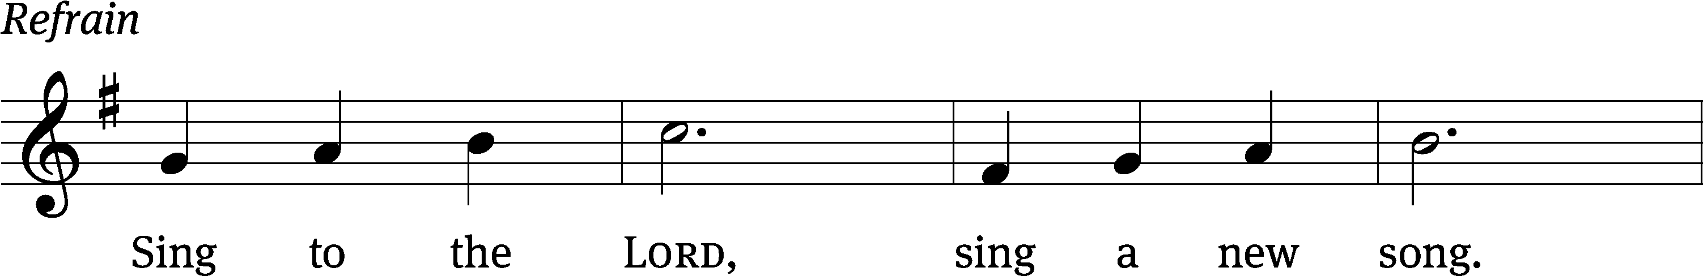
let 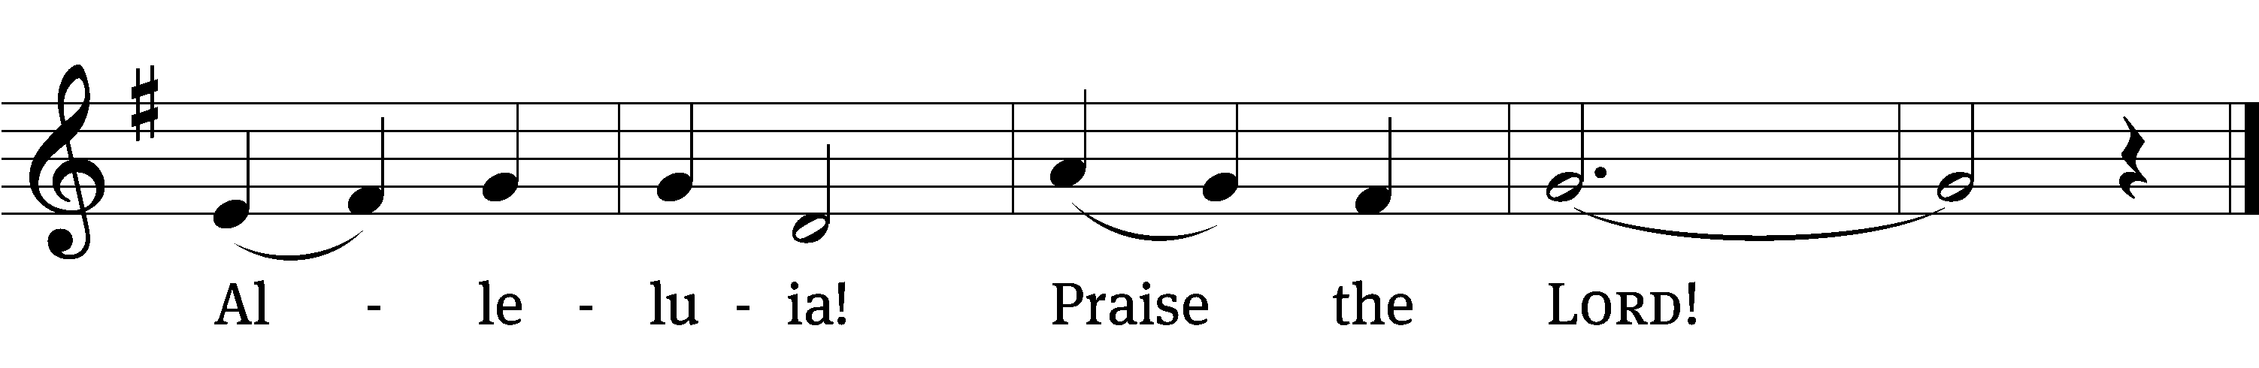
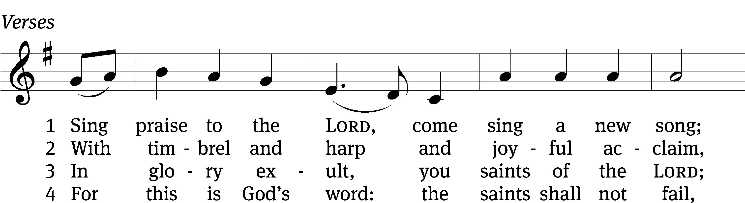
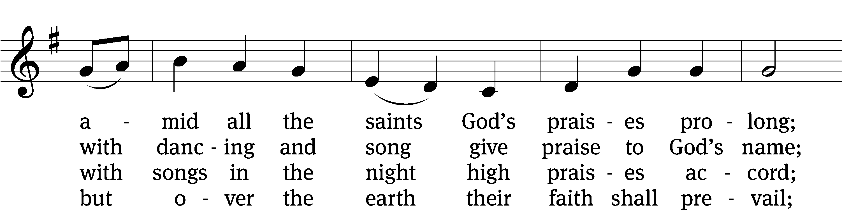
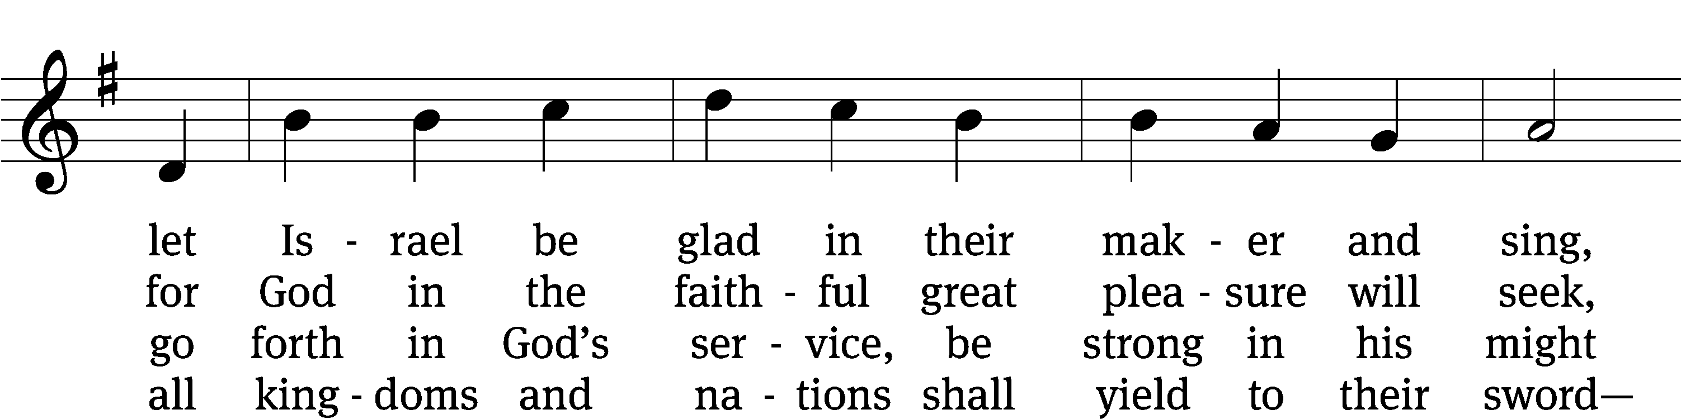
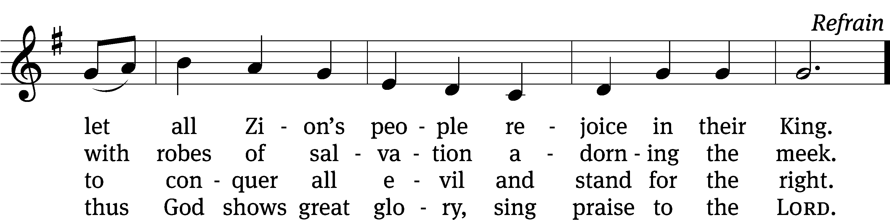
Text (sts. 1–4): Paslter, 1912, alt.; (Ref): Hal H. Hopson
Tune: Hal H. Hopson
Text (sts. 1–4) and tune: Public domain
Text (Ref) and tune: © 2008 Birnamwood/MorningStar Music Publishers. Used by permission: OneLicense no. 716626

Gospel Luke 6:20–23
20Looking at his disciples, he said:
“Blessed are you who are poor,
for yours is the kingdom of God.
21Blessed are you who hunger now,
for you will be satisfied.
Blessed are you who weep now,
for you will laugh.
22Blessed are you when people hate you,
when they exclude you and insult you
and reject your name as evil,
because of the Son of Man.
23“Rejoice in that day and leap for joy, because great is your reward in heaven. For that is how their ancestors treated the prophets.

Children's Devotion Ages 3 through grade 5 are invited to come forward for a Bible lesson.

Children's Church During the service, parents may choose to take their children (ages 2-5) to Children’s Church. There they will hear a Bible story, and sing songs. They will return to the sanctuary during the offering.

890 Jerusalem the Golden CW 890
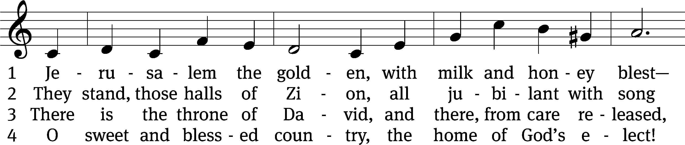
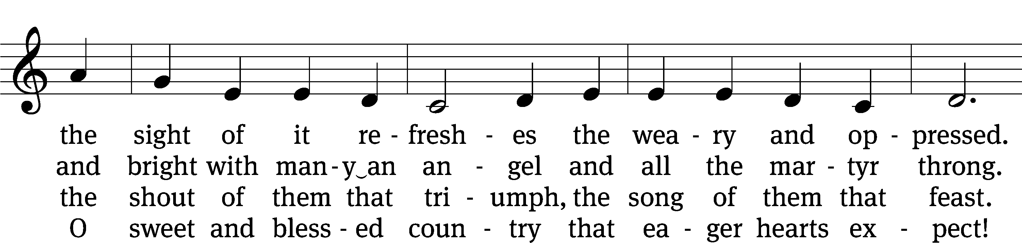
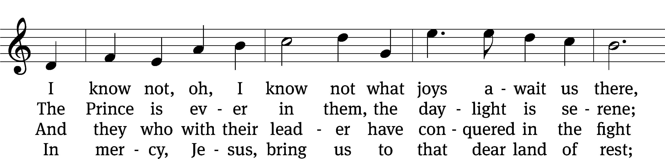
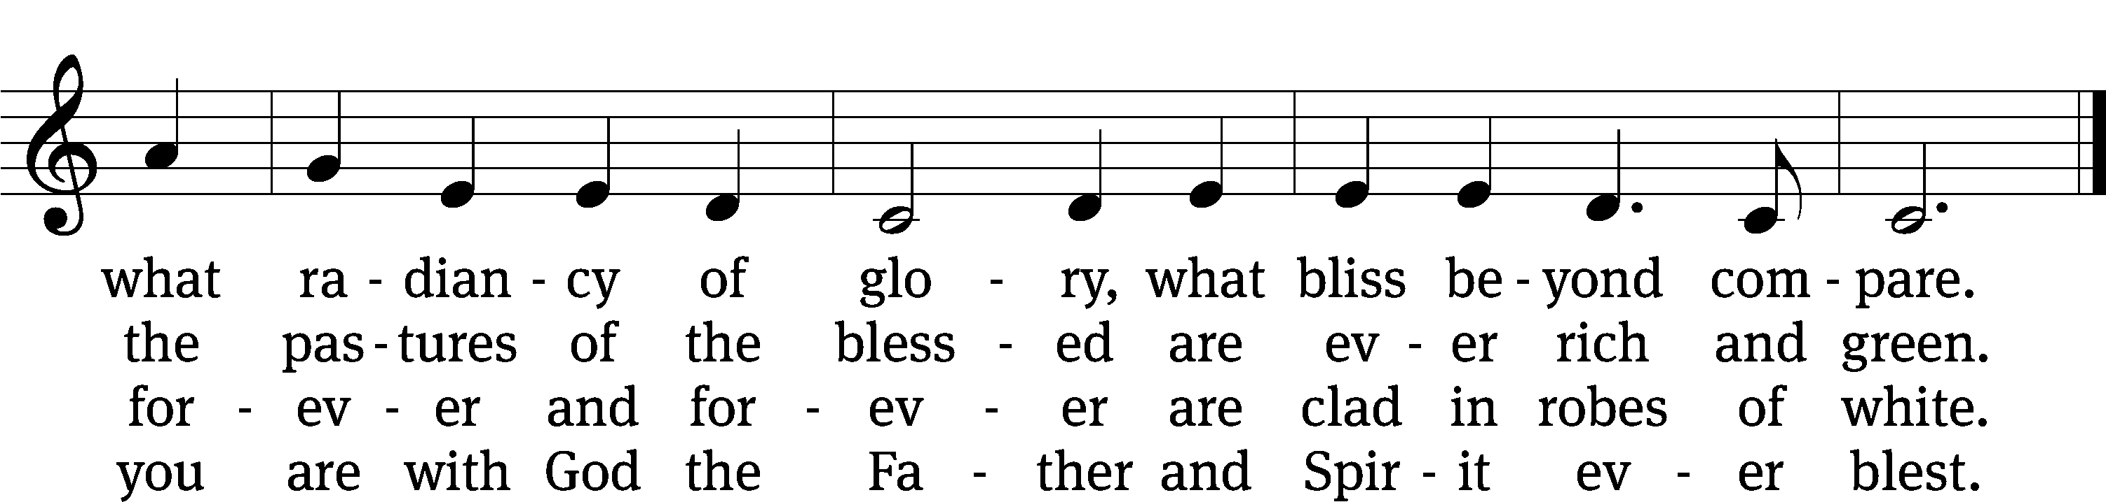
Text: tr. John Mason Neale, 1818–1866, alt.; Bernard of Cluny, 12th cent., abr.
Tune: Alexander C. Ewing, 1830–1895
Text and tune: Public domain

Sermon Revelation 21:1–6
1Then I saw “a new heaven and a new earth,” for the first heaven and the first earth had passed away, and there was no longer any sea. 2I saw the Holy City, the new Jerusalem, coming down out of heaven from God, prepared as a bride beautifully dressed for her husband. 3And I heard a loud voice from the throne saying, “Look! God’s dwelling place is now among the people, and he will dwell with them. They will be his people, and God himself will be with them and be their God. 4‘He will wipe every tear from their eyes. There will be no more death’ or mourning or crying or pain, for the old order of things has passed away.”
5He who was seated on the throne said, “I am making everything new!” Then he said, “Write this down, for these words are trustworthy and true.”
6He said to me: “It is done. I am the Alpha and the Omega, the Beginning and the End. To the thirsty I will give water without cost from the spring of the water of life.

“No more separation!”

Nicene Creed
We believe in one God, the Father, the Almighty,
maker of heaven and earth,
of all that is,
seen and unseen.

We believe in one Lord, Jesus Christ, the only Son of God,
eternally begotten of the Father,
God from God, Light from Light, true God from true God,
begotten, not made,
of one being with the Father.
Through him all things were made.
For us and for our salvation, he came down from heaven,
was incarnate of the Holy Spirit and the Virgin Mary,
and became truly human.
For our sake he was crucified under Pontius Pilate.
He suffered death and was buried.
On the third day he rose again in accordance with the Scriptures.
He ascended into heaven
and is seated at the right hand of the Father.
He will come again in glory to judge the living and the dead,
and his kingdom will have no end.

We believe in the Holy Spirit,
the Lord, the giver of life,
who proceeds from the Father and the Son,
who in unity with the Father and the Son
is worshiped and glorified,
who has spoken through the prophets.
We believe in one holy Christian and apostolic Church.
We acknowledge one baptism for the forgiveness of sins.
We look for the resurrection of the dead
and the life of the world to come. Amen.


Offering “We love because he first loved us.” 1Jn 4:19 God’s love in sending Jesus to live, to suffer, and to die for each of us motivates the members of Beautiful Savior to show their love and thanks by returning a portion of their income to the Lord. Through these free will offerings, this congregation and its ministries are maintained.
*If you would like to give your regular offering envelope, you can mail it to the church. If you would like to give securely online, scan this code or follow this link: bslclarksville.com

The Sacrament

Preface
The Lord be with you.
And also with you.

Lift up your hearts.
We lift them up to the Lord.

Let us give thanks to the Lord our God.
It is right to give him thanks and praise.

It is truly good and right that we should at all times and in all places give you thanks, O Lord, holy Father, almighty and everlasting God, through Jesus Christ our Lord, who in blessing his saints of the past has given us assurance and hope that, following their example, we may run the race marked out for us and receive the crown of glory that will never fade away. Therefore, with all the saints on earth and hosts of heaven, we praise your holy name and join their glorious song:

Holy, Holy, Holy (Sanctus)
V.1 O holy, holy, holy, Lord God of pow’r and might
Your glory, earth and heaven, In countless ways recite.
Hosanna! Come and save us, Lord God of hosts on high,
And in your grace and mercy, Receive our fervent cry.

V. 2 Hosanna in the highest! How truly blest is he
Who in God’s name is coming, to set his people free!
He comes to bring salvation, and with his blood outpoured
Deliver us from bondage, Hosanna Mighty Lord.

Words of Institution
Our Lord Jesus Christ, on the night he was betrayed, took bread; and when he had given thanks, he broke it and gave it to his disciples, saying, “Take and eat; this is my body, which is given for you. Do this in remembrance of me.”

Then he took the cup, gave thanks, and gave it to them, saying, “Drink from it, all of you; this is my blood of the new covenant, which is poured out for you for the forgiveness of sins. Do this, whenever you drink it, in remembrance of me.”

The peace of the Lord be with you always.
Amen.

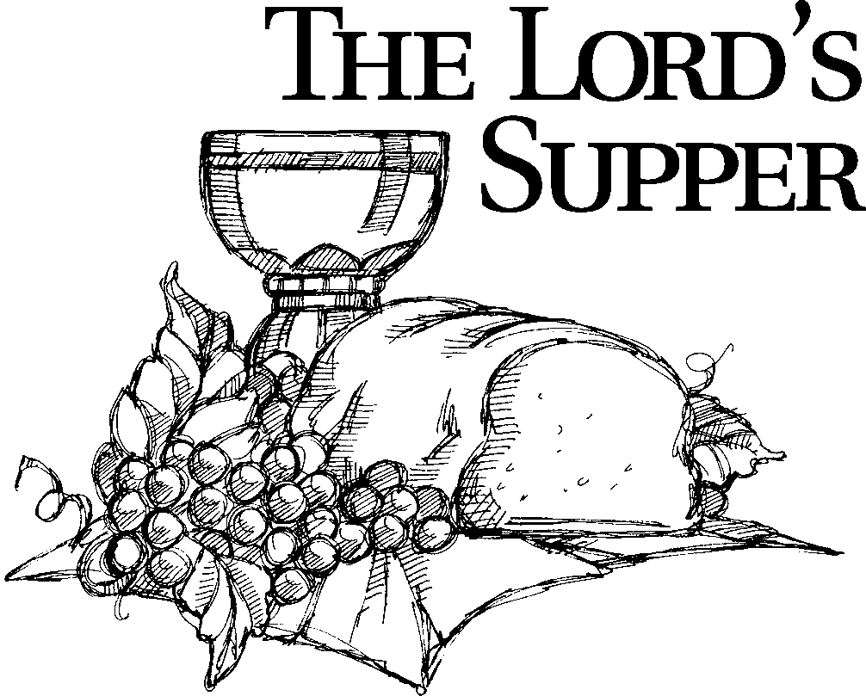

O Christ, Lamb of God
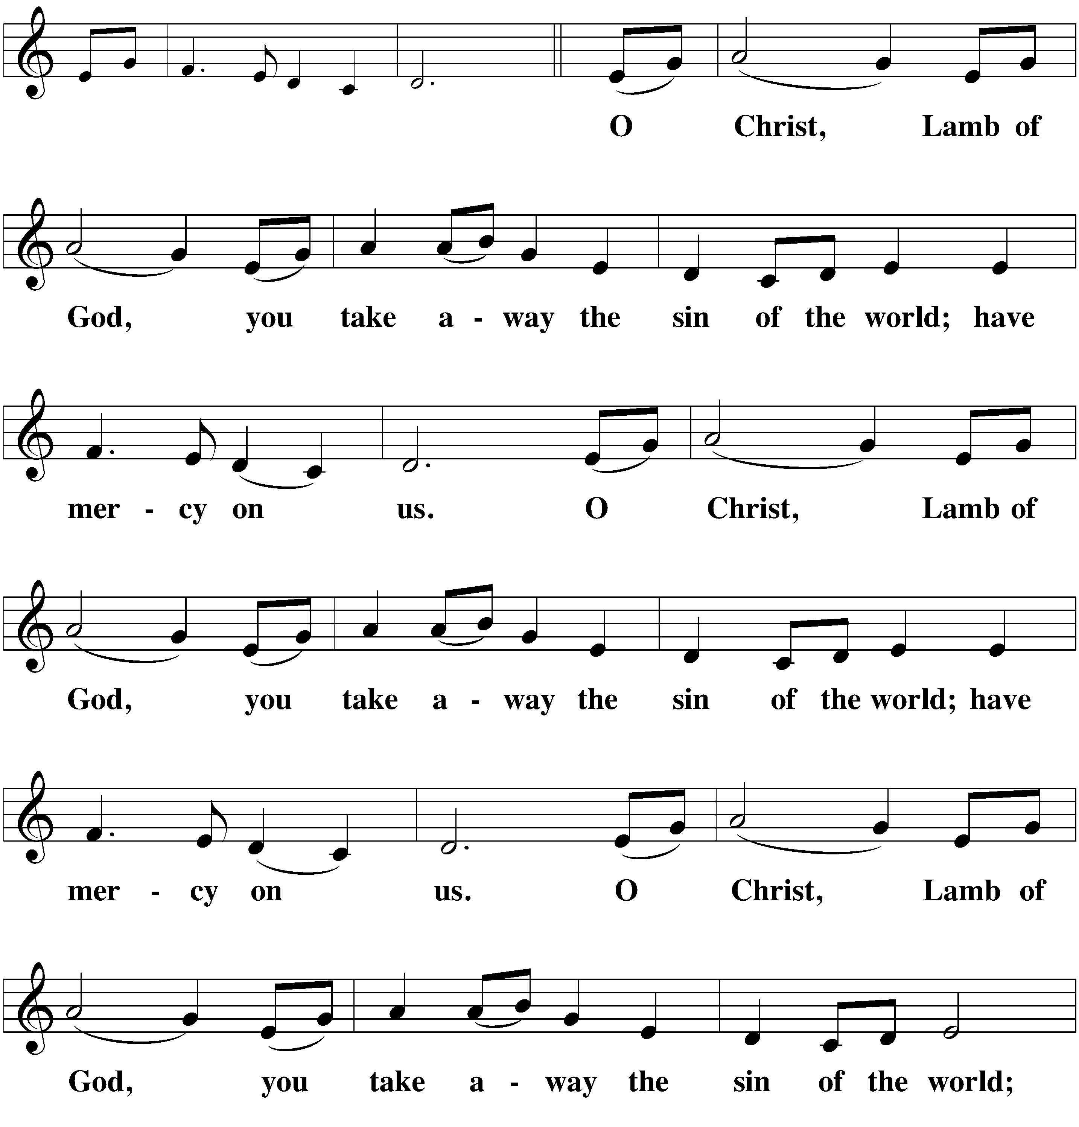

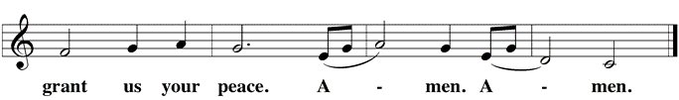

Distribution (When we come to the Lord’s Supper, we receive the body and blood of our Lord Jesus Christ for the personal assurance of forgiveness. But the Lord’s Supper is also a confessional act, by which we confess a oneness of faith. We therefore ask only those who are confirmed members of Beautiful Savior Lutheran Church or of sister Wisconsin Synod Lutheran churches to approach the altar. If anyone has a question about our communion practice or would like to become a communicant member of Beautiful Savior, please speak with the pastor after the service.)
886 Blessed Are They CW 886 sts. Ref–5
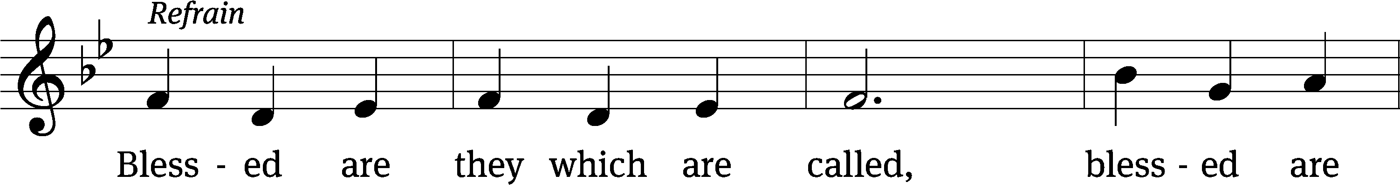
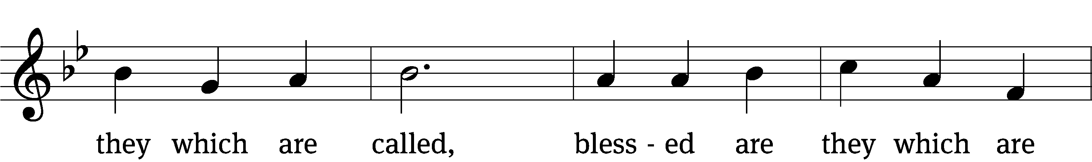
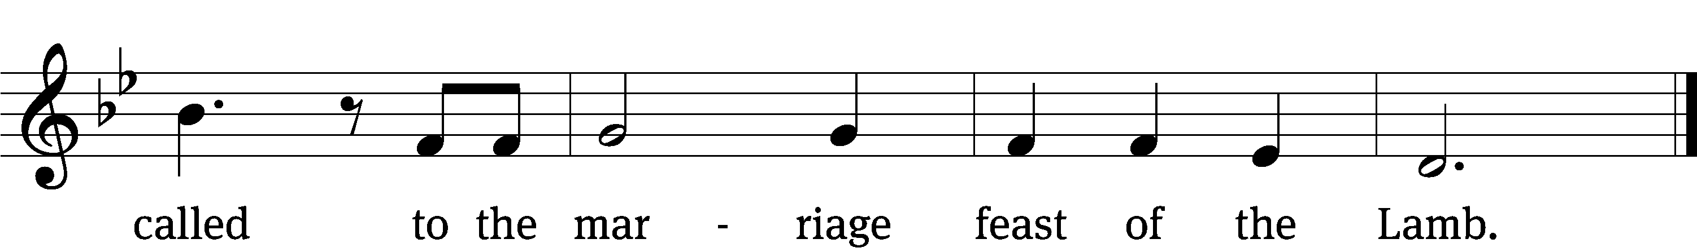
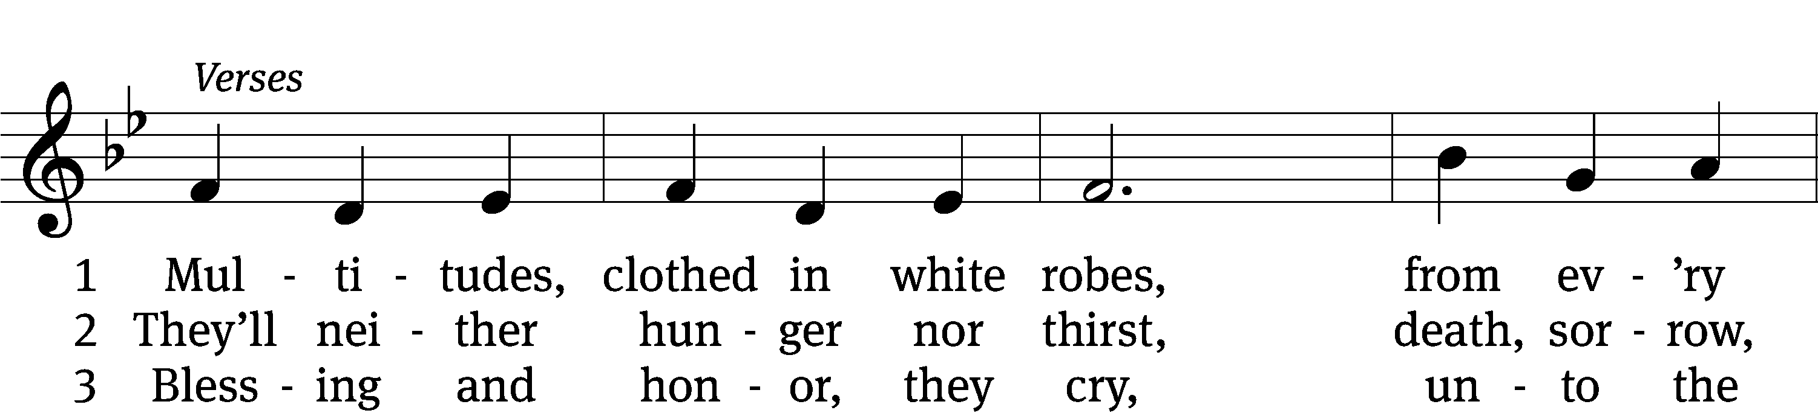
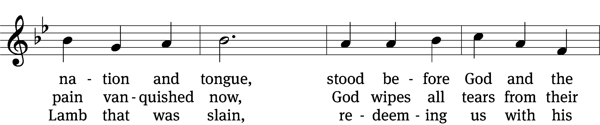
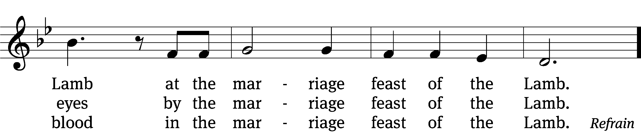

4 Servant, saint, martyr at rest,
sanctified, ransomed, restored,
thund’rously sing a new song
of the marriage feast of the Lamb. (v. 5)

5 Worthy are you, Lamb of God,
to receive glory and praise.
Alleluia and amen
for the marriage feast of the Lamb! (Refrain)
Text: Larry L. Fleming, 1936–2003, alt.
Tune: Larry L. Fleming, 1936–2003
Text and tune: © 1996 Birnamwood Publications, a div. of MorningStar Music Publishers, Inc. Used by permission: OneLicense no. 716626

Communion Blessing

The true body and blood of our Lord Jesus Christ strengthen and preserve you to life everlasting. Go T in peace.
Amen.
Prayer
Give thanks to the Lord, for he is good;
his mercy endures forever.

Whenever we eat this bread and drink this cup,
we proclaim the Lord’s death until he comes.

We give thanks, almighty God, that you have refreshed us with this saving gift. We pray that through it you will strengthen our faith in you and increase our love for one another. We ask this in the name of Jesus Christ our Lord, who lives and reigns with you and the Holy Spirit, one God, now and forever.
Amen.
Blessing
The Lord bless you and keep you.
The Lord make his face shine on you and be gracious to you.
The Lord look on you with favor and T give you peace.
Amen.

880 For All the Saints CW 880 sts. 1–3
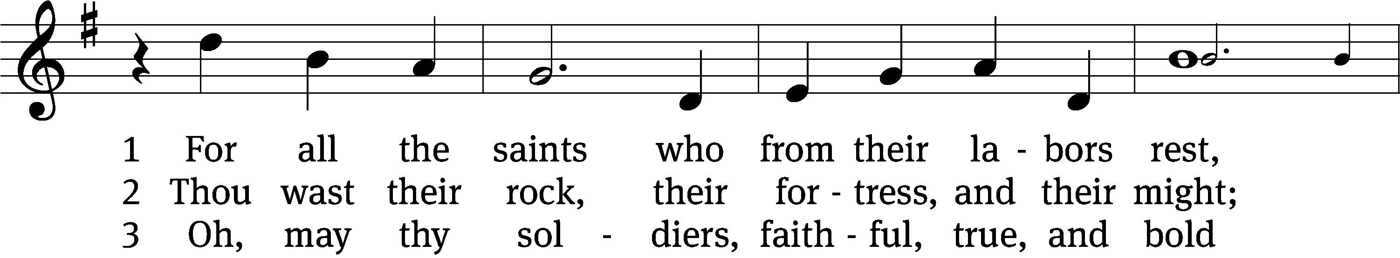
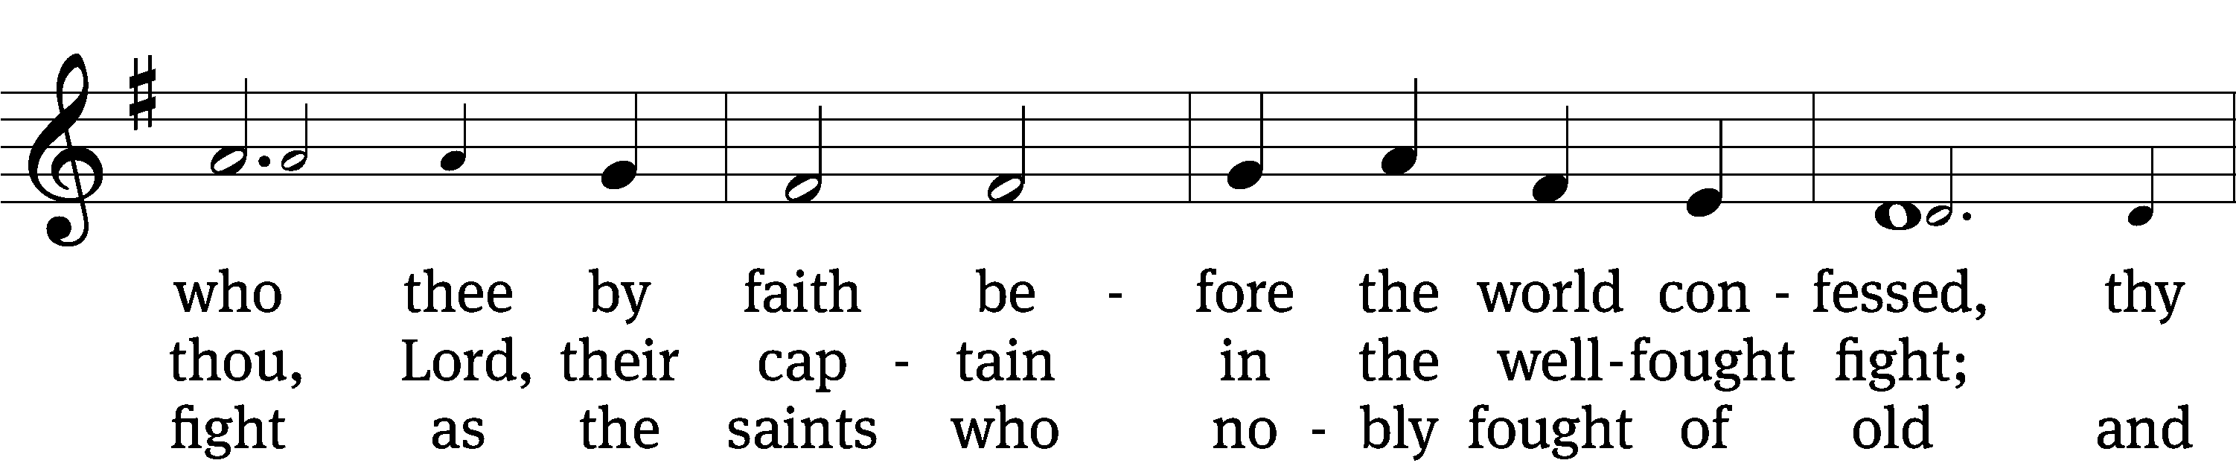
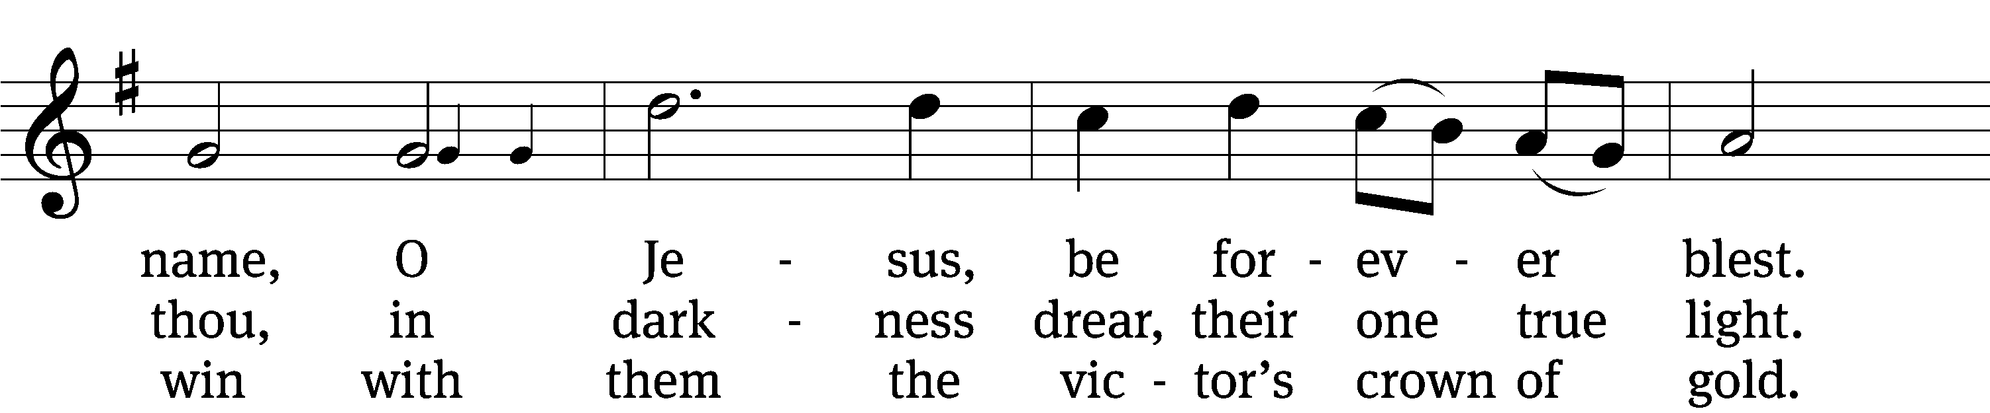
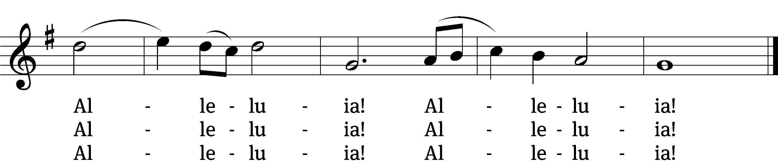
Text: William W. How, 1823–1897, alt.
Tune: Ralph Vaughan Williams, 1872–1958
Text and tune: Public domain

Acknowledgments
Setting One from Christian Worship
Unless otherwise indicated, Scripture quotations are from The Holy Bible, New International Version®, NIV®. Copyright © 1973, 1978, 1984, 2011 by Biblica, Inc.TM Used by permission of Zondervan. All rights reserved worldwide.
Software distributed in partnership with Northwestern Publishing House.
Created by Christian Worship: Service Builder © 2022 Concordia Publishing House.

Next Week’s Worship
Our theme for worship: “The Last Day: A Day of Deliverance that we Eagerly Await.” Our readings will be: Habakkuk 1: 1-3, 2:1-4; Revelation 22: 6-13; and Luke 12: 35-40. We will sing the following hymns: 563 My Hope Is Built on Nothing Less, 487 Lo! He comes with Clouds Descending, 559 If Your Beloved Son, O God, and 850 It is Well with My Soul.

THIS WEEK AT BEAUTIFUL SAVIOR
† Today 9:30am Sunday School
10:30am Worship
† Monday 9 and 10:30 am Mornings with Mommy
† Friday No preschool (Veteran’sDay)
† Saturday 10 am Women’s Group
† Sunday 9:30am Sunday School
10:30am Worship

Pumpkin Patch Thank You
A big thank you to everyone who helped out with the Pumpkin Patch this year, from unloading the truck, to setting up and taking down and watching over the patch during the week, we simply could not do it without the volunteer efforts of so many. Thank you!

Bible Information Class
Would you like to grow deeper in the Word of God? In our Bible Information Class we cover the main themes and teachings of the Bible, ask and answer questions about the Word of God, and grow together in the Word. It also serves as our pre-membership class. It will meet in the sanctuary. Questions? Please speak with Pastor Holz.

Voter’s Meeting Today
Following our service today, we will be holding our Congregational Voter’s Meeting. We will go over our plan of ministry for the church and preschool for 2023, and approve our budget for both the church and preschool. There will also be ministry updates, as well as elections for our church Secretary and Vice-President.

Mornings with Mommy

What is Mornings with Mommy? Mornings with Mommy isn’t preschool and it isn’t childcare. It’s something different. Mornings with Mommy is a fun and easy way for you to enjoy activities with your children and meet other moms. There will be age appropriate activities for infants, toddlers and preschoolers. The best part is, we do all the planning. You just sign up! Moms can mingle with each other and enjoy activities with their children, including: arts and crafts, sensory table, story time, music, educational toys and a snack. The program costs only five dollars per family per session and includes all snacks and activities. Pre-registration is required. If you would like to attend, please go to “Facebook: Mornings with Mommy – Clarksville

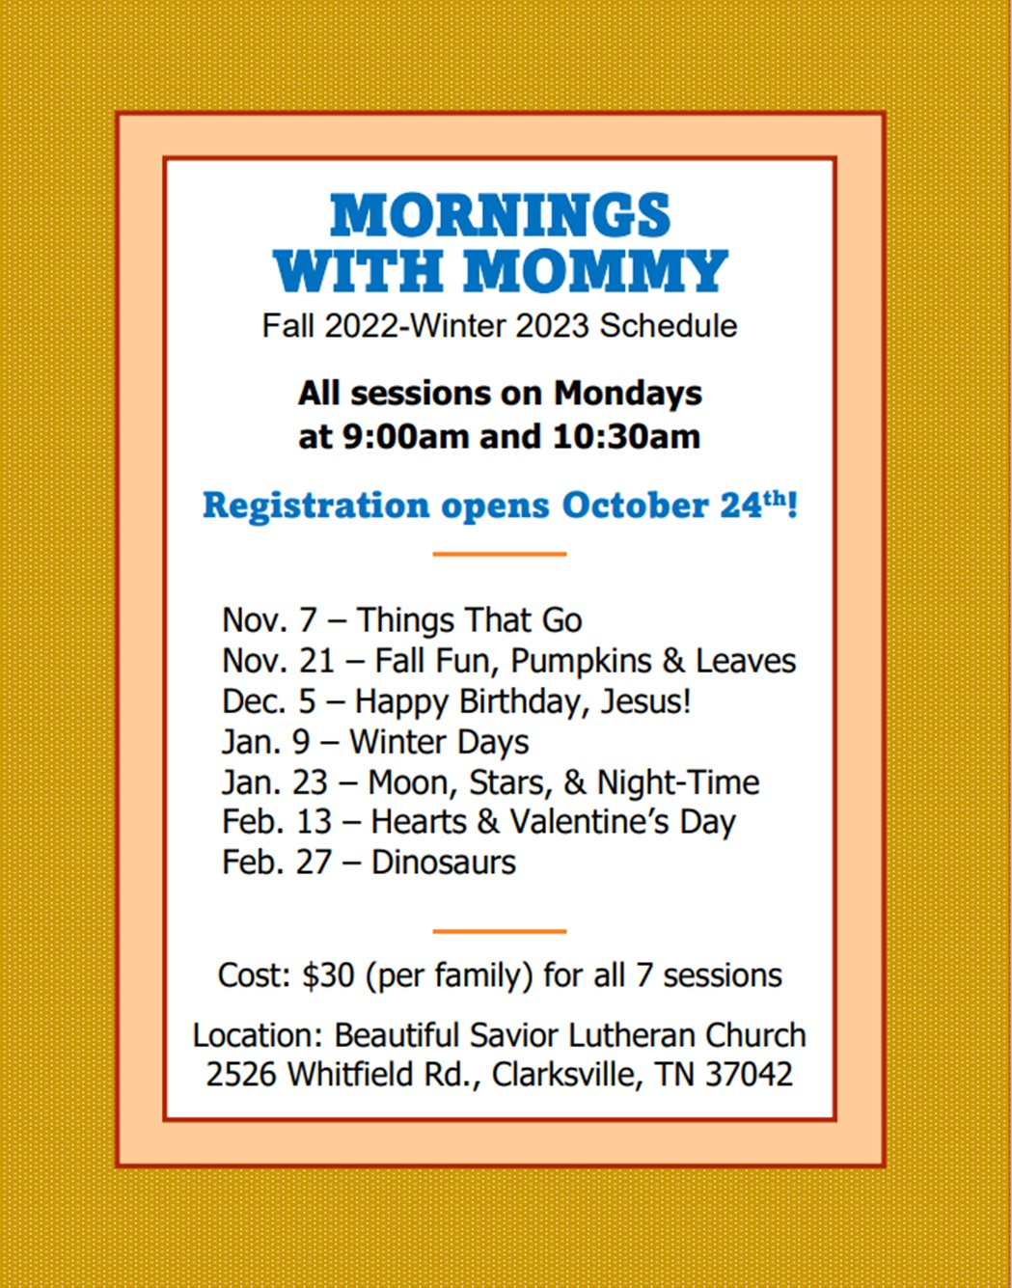

Seek First the Kingdom
Join in a new Sunday Bible Study series called, “Seek first the Kingdom.”
Sunday, Nov 13th, “Take Good Advice”
Sunday, Nov. 20th, “Understand you have Great Power”
Sunday, Nov. 27th, “Grow through Grief”
Sunday, Dec. 4th, “Get Tough with Temptation”
Sunday, Dec. 11th, “Don’t be Frightened if you Fail”
The Bible Study begins at 9:30 in the fellowship hall. Please join in!

Fill the Table for FUEL
November is a time of giving thanks. We are thankful for all the many blessings that the Lord has poured upon us in giving all that we need for our bodies and lives. But thanksgiving is also a time for us to think about those who are in need. One group in particular that we can help is the FUEL program. It provides high-protein meals to needy students over the weekends when they may be without adequate nutrition. Our congregation provides this important nutrition to 12 students at Glenellen Elementary School. Why not consider a donation to our FUEL food program here at church? We will have a table set up in the main entryway to deposit donations with some suggested food items.

· Cheese crackers
· Peanut butter crackers
· Handi-Snacks
· Cookies (individually packaged)
· Beef jerky
· Juice boxes (Must be 100% juice)
· Granola bars
· Cereal (individual boxes)
· Pop-tarts
· Chips (individual bags)
· Pudding cups
· Applesauce
· Fruit cups
· Raisins (individual boxes)
· Fruit roll-ups
· Nuts (individual packages)

WELS Teen Ski Trip
WHO: All youth ages 11-18
WHAT: An exciting weekend in the mountains of Gatlinburg! Activities include a scavenger hunt, skiing or snowboarding, games, Bible study, worship, meeting new friends, pool, hot tub, and lots of good food.
WHERE: Lodging is at the Edgewater Resort; Skiing / Snowboarding is at Ober Gatlingburg
WHEN: February 3-5, 2023 (Activities begin Friday night and go through Sunday afternoon). The deadline to register through your local church is December 15, 2022.
HOW: The cost for the entire weekend is all inclusive with all activities, meals, equipment rental, and a t-shirt for $200-215 / person. (The cost is determined by the type of activity. Each church will receive one invoice and send in one payment per group.)

Scan the QR code to take you to the registration page!





Scholastic Book Fair
The Scholastic Book Fair will be here et church this week and open today! The book fair will be open school mornings from 9-9:45, and school afternoons 2:30-3:15. All profits are earned as “Scholastic Dollars.” In the past the preschool has used the profits to purchase books, radios, rugs, bookshelves, and many more classroom items. We are grateful for the support.

Women’s Bible Study
Our Women’s Group will be meeting this Saturday, November 12, at 10 AM. All women are welcome to join in for time on the Word of God, fellowship, and fun. There will also be planning for future events and activities.

Prayer List
Thank the Lord for the safe return of all the soldiers who recently came home and all soldiers and their families who are facing deployment. Please keep in your prayers this week all soldiers who are currently deployed. Please also remember: Pat Bray, father of Allison Johnson (skin cancer and surgery); Josh Carter, friend of Adam Holz (recovery from car accident); Ed Scarano (cancer diagnosis and treatment); Stacy Schroeder, daughter of Jeff & Eileen Cleveland (melanoma diagnosis); Andy Hudson, friend of Mac McCoo (pneumonia & Covid); Jimmy Straw (health & wellness); Autumn Potter & family, friends of Jessica Boulter (death of sister); Aimee Gerkhardt, sister in law of Jessica Church (breast cancer); Roger Chism, friend of Hilde Fox (diverticulitis); Steven Owens, father of Mark Owens, (cancer); Kathy Temple (cancer reoccurrence); Eric Smith, friend of Tim Donner (kidney surgery & complications); Brandon Vannoy, friend of Mac McCoo (seizures); Sheila Lynch, sister of Gayle Brooks (unable to walk); Drake Robideau, friend of Mary Daniel (strength & wellness); Mike LaFave (back problems); Linda Thomas, sister of Gayle Brooks, (physical rehab after injury); Ruth Amorth, twin sister of Hilde Fox (seriously ill); Gary Davis, husband of Angela Davis (seizures); Gidget Tate (Health issues); Maria Sauer, Friend of Karin Galvin. If you would like to have a name or situation included or if you would like to give an update on a prayer request, please contact Pastor Holz or call the church office at 931-905-1400.

Serving in God’s House

Ushers: Mike Rathge, Trey Church
Greeters: Jeff & Eileen Cleveland
Kitchen: Gael I, Loretta W, Mary D
Piano: Barb Noon
Fellowship: A-G

Serving next week:

Ushers: David Johnson, Ernie Rautter
Greeters: Doris Harvey, Mac McCoo
Kitchen: Ingeborg H , Mary D
Piano: Deb White
Fellowship: H-M

