Beautiful Savior Lutheran Church

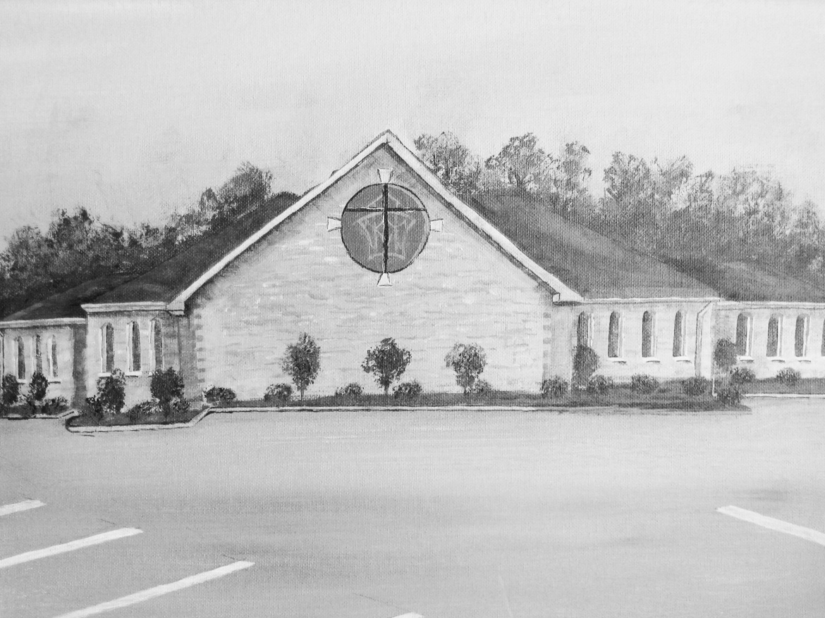

November 13th, 2022 – Twenty Third Sunday of Pentecost

Service Theme: The last day: a day of deliverance that we eagerly await


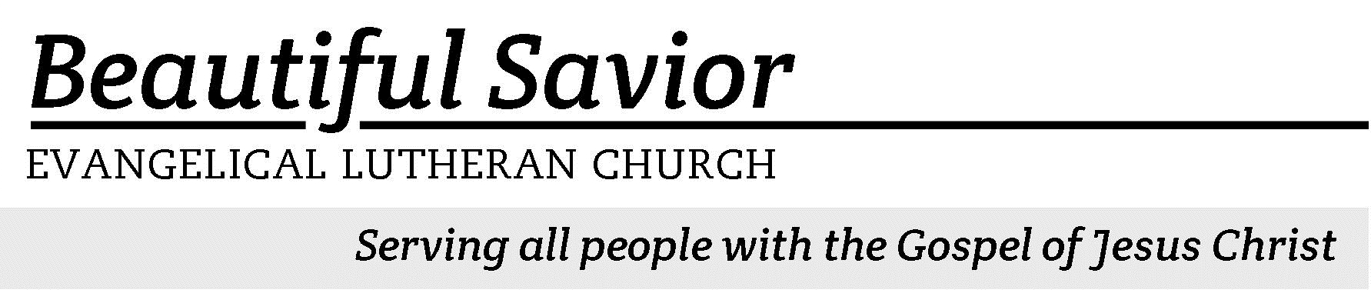

Welcome-- We are glad you could join us today! It is our hope that this service is a blessing to you. Please join us for worship again soon.

· Please save the last two rows of pews for parents with small children.

· Parents with little ones: If your child becomes restless during the service, that’s okay… We’re glad they’re here, and Jesus is pleased when they are brought to hear his Word: “Let the little children come to me.” If you need to be with your child in the Fellowship Hall, the service can be heard through a speaker.

· Five minutes before the worship service begins the usher will light the candles. This is our signal to quiet down and prepare our hearts for worship.

· Restrooms are conveniently located to the left as you exit the sanctuary.

· Please silence your cell phone before the start of the service.

Prayer for Worship
Dear Father, in your tender love, you have given me great and precious promises. Preserve me from the doubts that assail me and increase my faith. When life puzzles or disturbs me, teach me to fix my eyes on Jesus and to stand firm in the assurance of his promise to uphold and deliver me. Amen.

Beautiful Savior Lutheran Church
2526 Whitfield Road
Clarksville, TN 37040
931-905-1400
Website: www.bslclarksville.com
Kent Holz, Pastor
Bslc.clarksville@gmail.com
Barbara Noon, Preschool Director
beautifulsaviorpreschool@gmail.com

563 My Hope Is Built on Nothing Less CW 563 sts. 1, Ref, 2–3
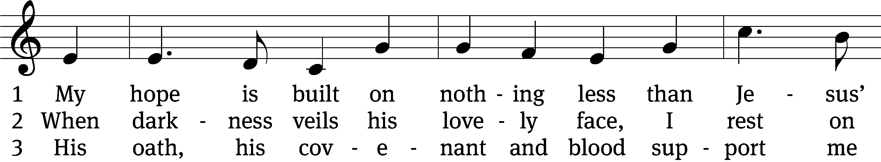
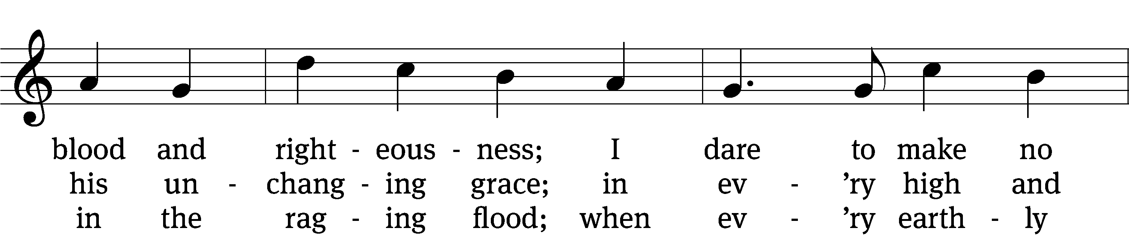
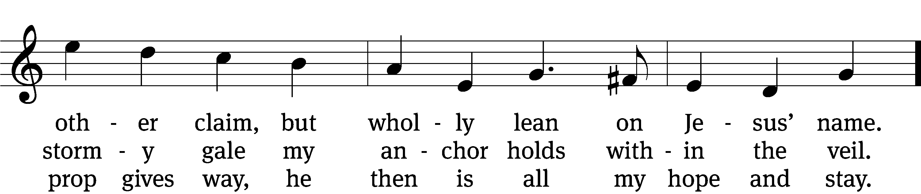
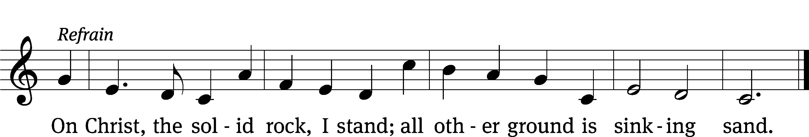
Text: Edward Mote, 1797–1874, alt.
Tune: John Stainer, 1840–1901, alt.
Text and tune: Public domain

In the name of the Father and of the T Son and of the Holy Spirit.
Amen.

Confession CW 154
If we claim to be without sin, we deceive ourselves and the truth is not in us.
If we confess our sins, God is faithful and just
and will forgive us our sins
and purify us from all unrighteousness.

Let us confess our sins to the Lord.
Holy God, gracious Father,
I am sinful by nature
and have sinned against you in my thoughts, words, and actions.
I have not loved you with my whole heart;
I have not loved others as I should.
I deserve your punishment both now and forever.
But Jesus, my Savior, paid for my sins
with his innocent suffering and death.
Trusting in him, I pray: God, have mercy on me, a sinner.

Our gracious Father in heaven has been merciful to us. He sent his only Son, Jesus Christ, who gave his life as the atoning sacrifice for the sins of the whole world. Therefore, as a called servant of Christ and by his authority, I forgive you all your sins in the name of the Father and of the T Son and of the Holy Spirit.
Amen.

563 My Hope Is Built on Nothing Less CW 563 sts. Ref, 4

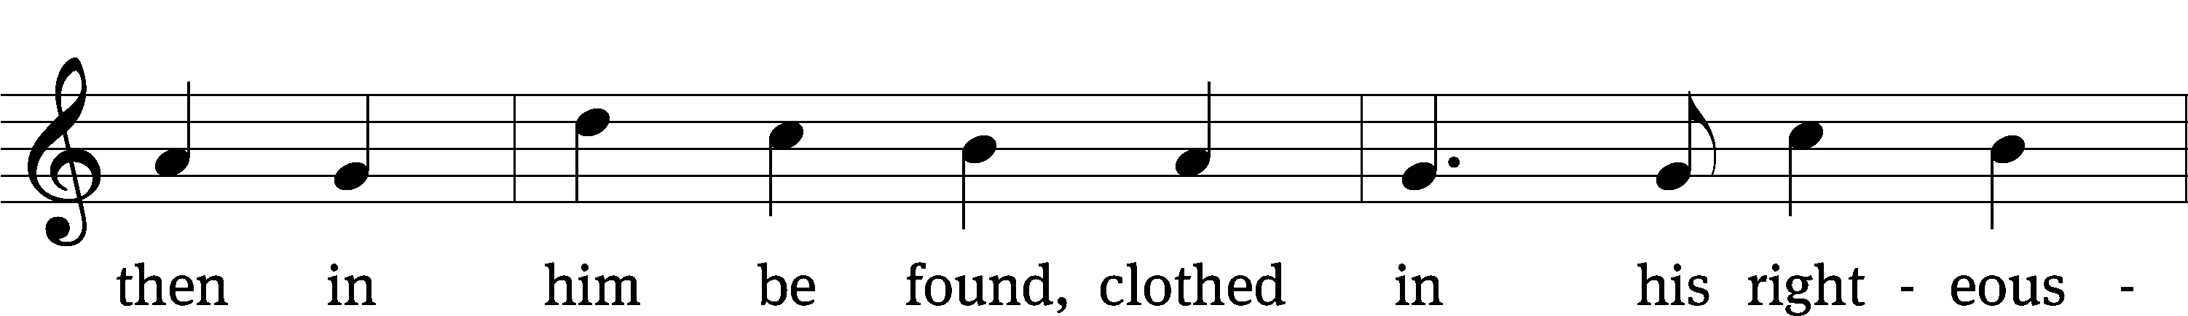

Text: Edward Mote, 1797–1874, alt.
Tune: John Stainer, 1840–1901, alt.
Text and tune: Public domain

Lord, Have Mercy
In peace let us pray to the Lord.
Lord, have mercy.

For the peace from above and for our salvation, let us pray to the Lord.
Lord, have mercy.

For the peace of the whole world, for the well-being of the Church of God, and for the unity of all, let us pray to the Lord.
Lord, have mercy.

For this holy house and for all who offer here their worship and praise, let us pray to the Lord.
Lord, have mercy.

Help, save, comfort, and defend us, gracious Lord.
Amen.

The Word

The Lord be with you.
And also with you.

Prayer of the Day
Let us pray.

Lord God Almighty, so rule and govern our hearts and minds by your Holy Spirit that we may always look forward to the end of this present evil age and the day of your righteous judgment. Keep us steadfast in true and living faith, and present us at last holy and blameless before you; through your Son, Jesus Christ our Lord, who lives and reigns with you and the Holy Spirit, one God, now and forever.
Amen.

First Reading Habakkuk 1:1–3; 2:1–4
1The prophecy that Habakkuk the prophet received.
2How long, Lord, must I call for help,
but you do not listen?
Or cry out to you, “Violence!”
but you do not save?
3Why do you make me look at injustice?
Why do you tolerate wrongdoing?
Destruction and violence are before me;
there is strife, and conflict abounds.
1I will stand at my watch
and station myself on the ramparts;
I will look to see what he will say to me,
and what answer I am to give to this complaint.
2Then the Lord replied:
“Write down the revelation
and make it plain on tablets
so that a herald may run with it.
3For the revelation awaits an appointed time;
it speaks of the end
and will not prove false.
Though it linger, wait for it;
it will certainly come
and will not delay.
4“See, the enemy is puffed up;
his desires are not upright—
but the righteous person will live by his faithfulness—

130A Out of the Depths Psalm 130A
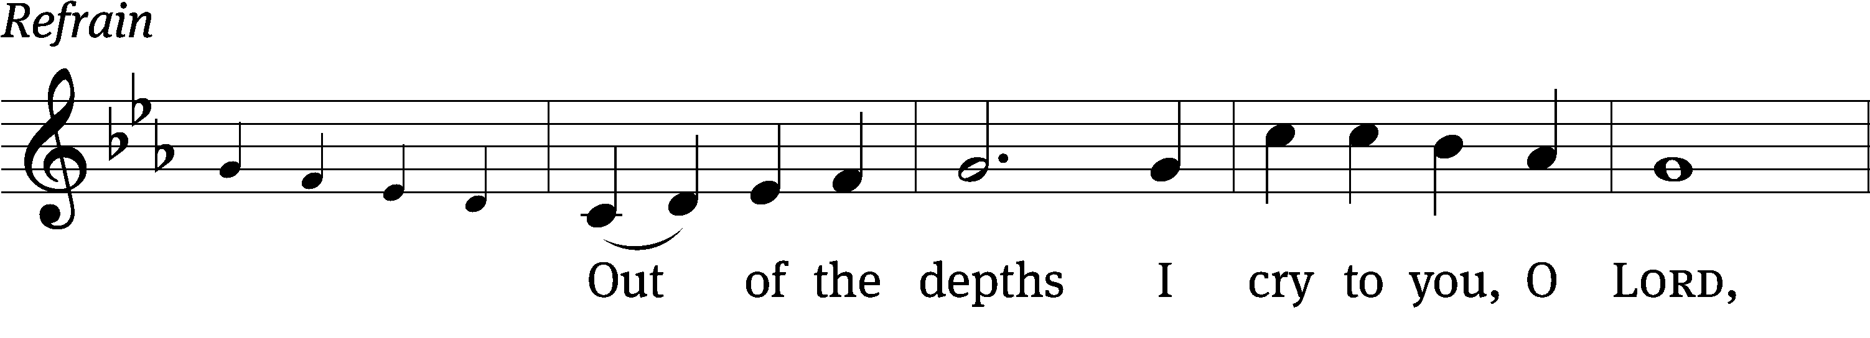
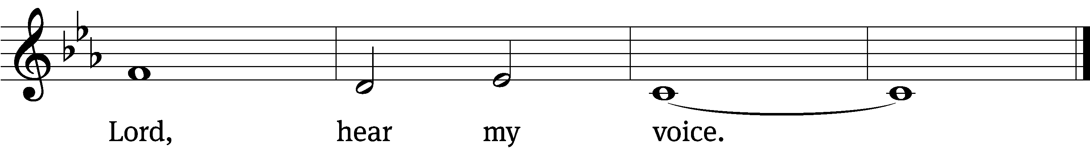
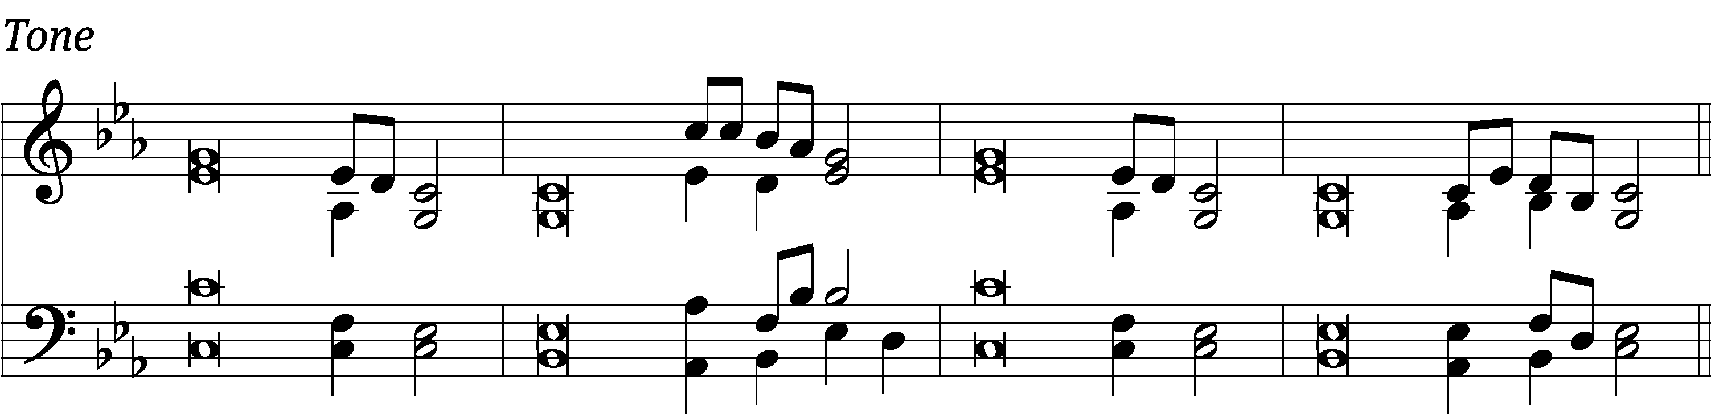

Out / of the depths
I / cry to you, O Lord;
Lord, / hear my voice.
Listen closely as I / call on you for help.

Lord, if you kept / track of sins,
O / Lord, then who could stand?
But with you there is for- / giveness,
in order / that you may be feared. Refrain

I wait for the Lord, my / soul waits,
and in his / word I put my hope.
More than watchers wait for / morning
my / soul waits for the Lord.

Israel, put your hope / in the Lord,
for with the / Lord is faithful love;
with him is complete re- / demption.
He will redeem Israel from the / guilt of all their sins.

Glory be to the Father and / to the Son
and to the / Holy Spirit,
as it was in the be- / ginning,
is now, and will be for- / ever. Amen. Refrain
Text: Michael D. Schultz; Lectionary for Mass
Tune: James J. Chepponis
Text: © 1969, 1981, 1997 ICEL (Refrain). Used by permission: OneLicense no. 716626
Text: © 2021 Northwestern Publishing House (Verse tr.). Used by permission: OneLicense no. 716626
Tune: © 1980 GIA Publications, Inc. Used by permission: OneLicense no. 716626
Setting: © 2021 Northwestern Publishing House. Used by permission: OneLicense no. 716626

Gospel Luke 12:35–40
35“Be dressed ready for service and keep your lamps burning, 36like servants waiting for their master to return from a wedding banquet, so that when he comes and knocks they can immediately open the door for him. 37It will be good for those servants whose master finds them watching when he comes.
Truly I tell you, he will dress himself to serve, will have them recline at the table and will come and wait on them. 38It will be good for those servants whose master finds them ready, even if he comes in the middle of the night or toward daybreak. 39But understand this: If the owner of the house had known at what hour the thief was coming, he would not have let his house be broken into. 40You also must be ready, because the Son of Man will come at an hour when you do not expect him.”

Children's Devotion Ages 3 through grade 5 are invited to come forward for a Bible lesson.
Children's Church During the service, parents may choose to take their children (ages 2-5) to Children’s Church. There they will hear a Bible story, and sing songs. They will return to the sanctuary during the offering
487 Lo! He Comes with Clouds Descending CW 487
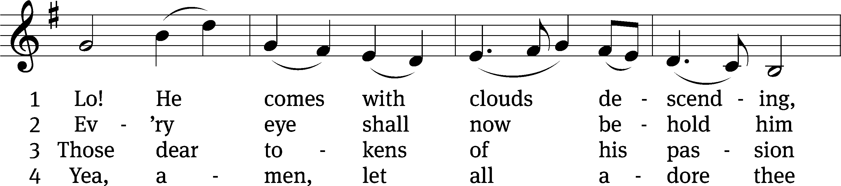
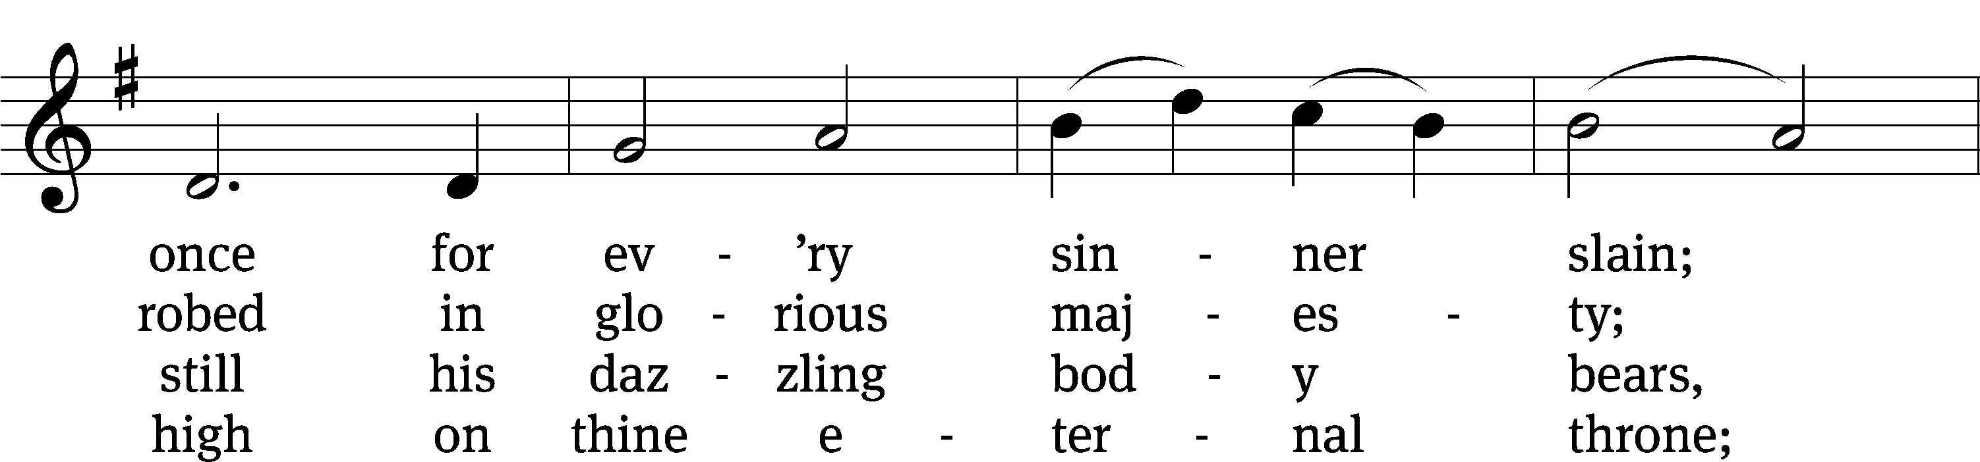
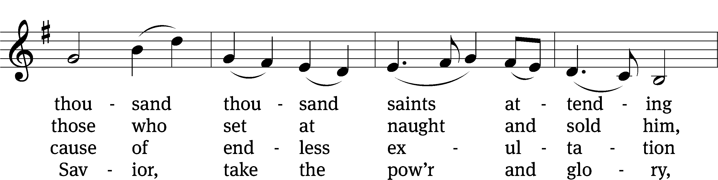
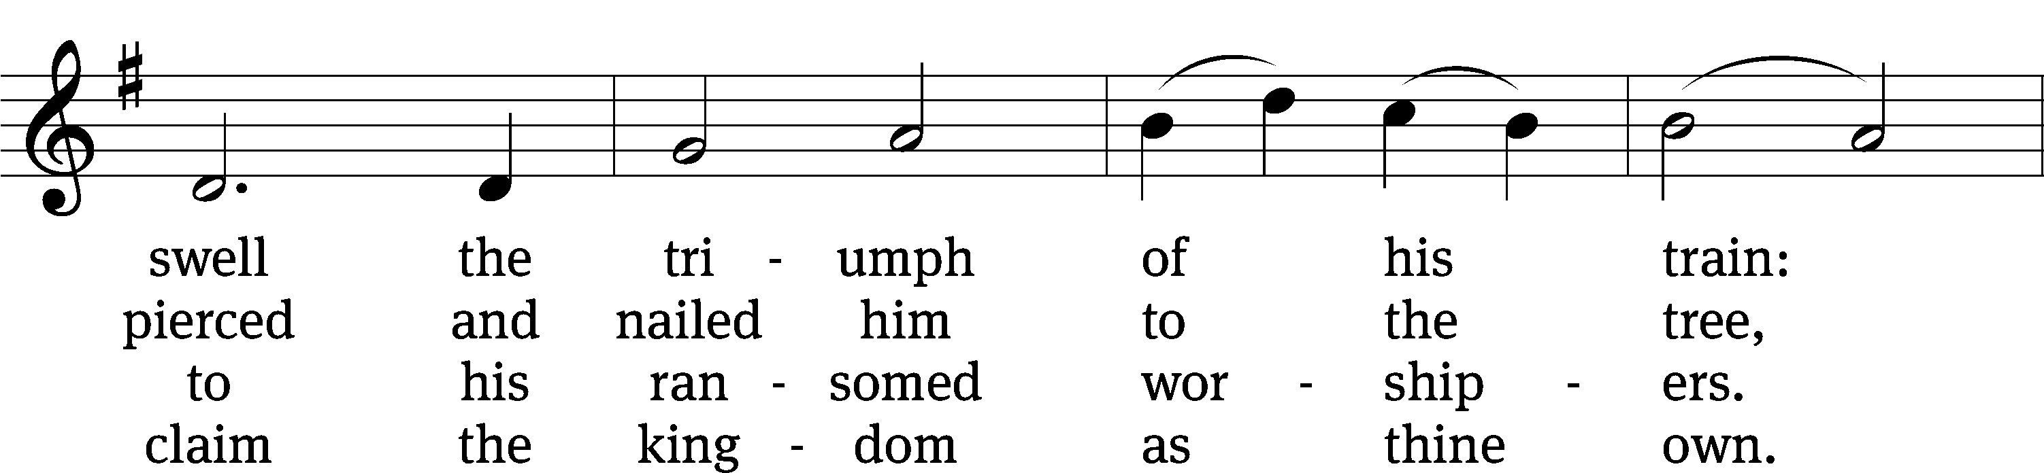
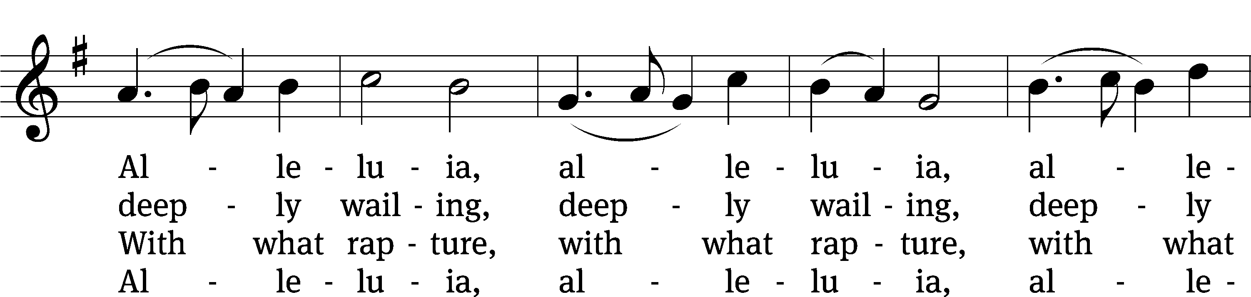
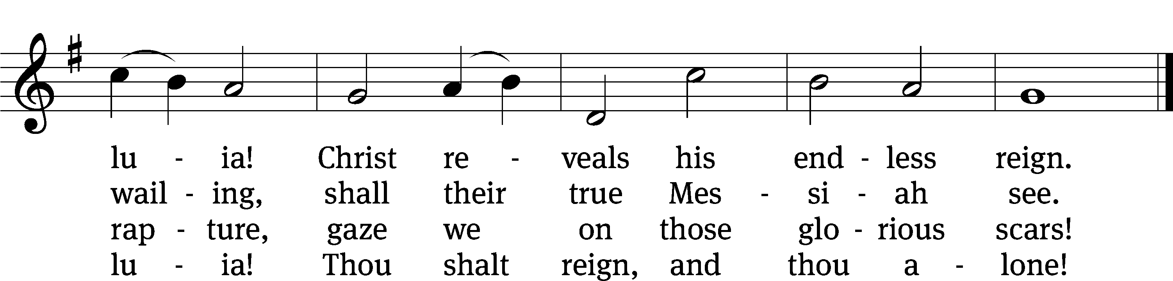
Text: Charles Wesley, 1707–1788, alt.
Tune: Thomas Olivers, 1725–1799
Text and tune: Public domain
Sermon 1 Peter 1:23–25
²³For you have been born again, not of perishable seed, but of imperishable, through the living and enduring word of God. ²⁴For,
“All people are like grass,
and all their glory is like the flowers of the field;
the grass withers and the flowers fall,
²⁵but the word of the Lord endures forever.”
And this is the word that was preached to you.

“Why are we confessional Lutherans?

Apostles’ Creed
I believe in God, the Father Almighty,
maker of heaven and earth.

I believe in Jesus Christ, his only Son, our Lord,
who was conceived by the Holy Spirit,
born of the Virgin Mary,
suffered under Pontius Pilate,
was crucified, died, and was buried.
He descended into hell.
The third day he rose again from the dead.
He ascended into heaven
and is seated at the right hand of God the Father Almighty.
From there he will come to judge the living and the dead.

I believe in the Holy Spirit,
the holy Christian Church,
the communion of saints,
the forgiveness of sins,
the resurrection of the body,
and the life everlasting. Amen.


Offering “We love because he first loved us.” 1Jn 4:19 God’s love in sending Jesus to live, to suffer, and to die for each of us motivates the members of Beautiful Savior to show their love and thanks by returning a portion of their income to the Lord. Through these free will offerings, this congregation and its ministries are maintained.
*If you would like to give your regular offering envelope, you can mail it to the church. If you would like to give securely online, scan this code or follow this link: bslclarksville.com

Prayer of the Church
Almighty God and Father, we thank you for all your mercies, especially for the gift of your Son, through whom you have revealed your gracious will. We praise you for the Holy Spirit and his working through the means of grace.
Plant your Word in our hearts, and cause it to produce fruit in our lives.

Strengthen and defend your Church, that by your Word and sacraments faith may grow and love toward all may increase.
Support all who spread the light of your truth throughout the world.

Keep our children in the grace of their baptisms. Enable their parents to train them in lives of faith.
Raise up Christians to serve you in the ministry of the Word and in all godly walks of life.

Preserve our nation in justice and honor. Guide and bless all who make, administer, and judge our laws.
Give them wisdom that they may promote justice and hinder evil.

Let your blessing rest on planting and harvest, commerce and industry, medicine and science, the arts and culture. Protect all who travel, and care for those whose work is difficult or dangerous.
Be with all who devote themselves to any useful task.

Comfort all who are in sorrow or need, sickness or adversity. Remember those who suffer persecution for the faith. Have mercy on those for whom death draws near.
Grant them your love, and take them into your tender care.

Hear us, Lord, as we pray in silence.

We remember with thanksgiving those who have loved and served you, who now rest from their labors. Console those who are mourning or living with sadness.
Keep us in the true faith, and bring us at last to the joys of heaven.

Grant us these things, Father, for the sake of Jesus, who died and rose again.
Amen.
559 If Your Beloved Son, O God CW 559 sts. 1–3, 5
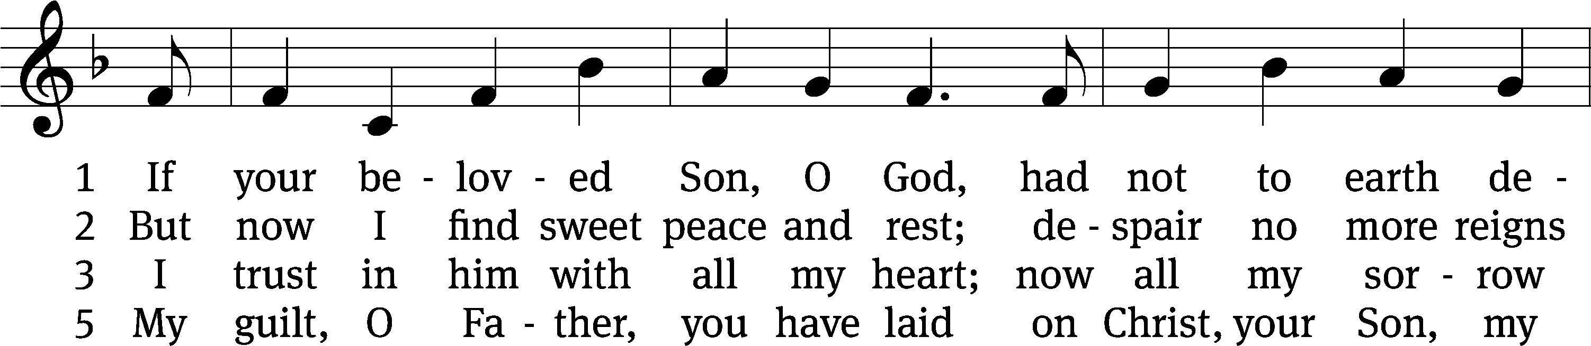
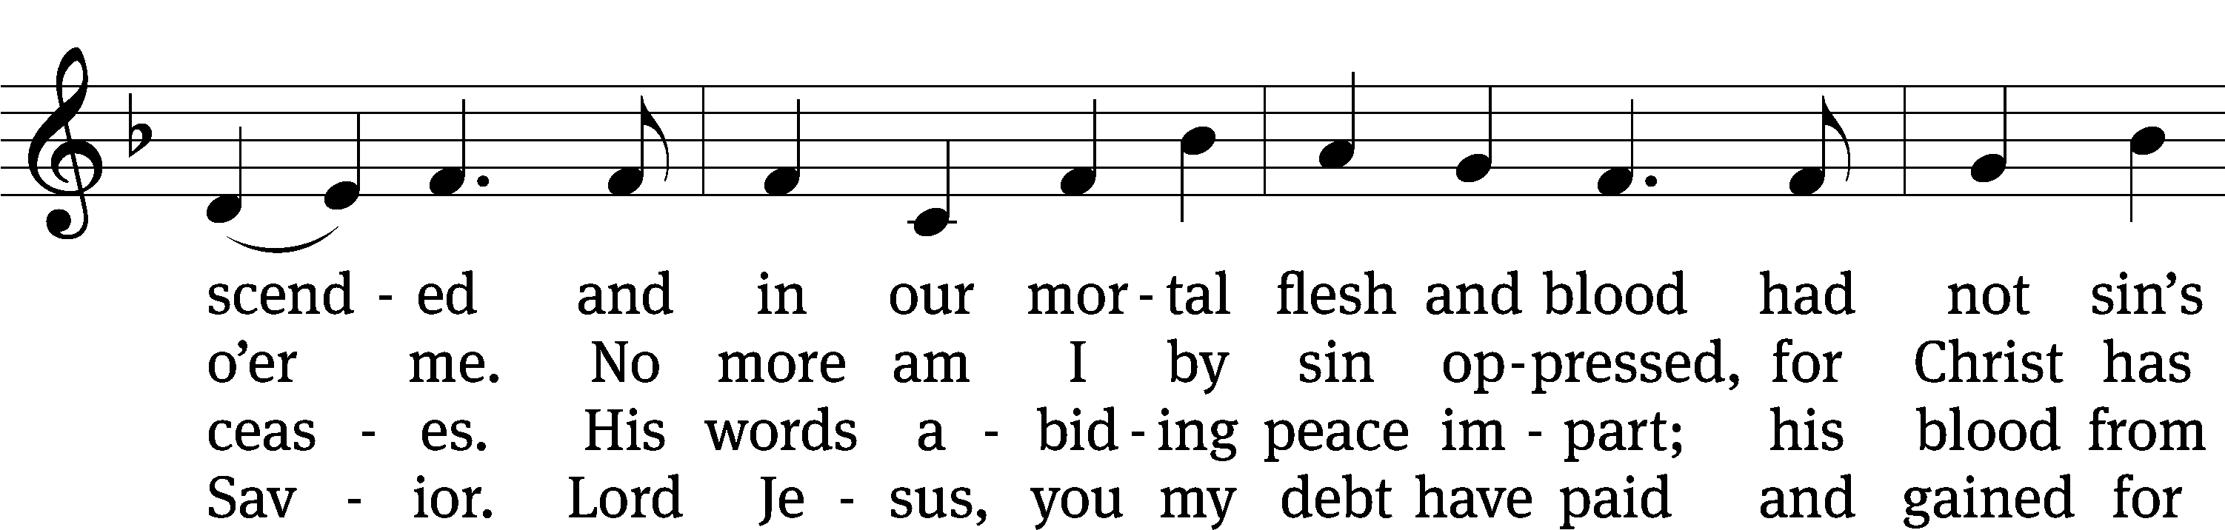
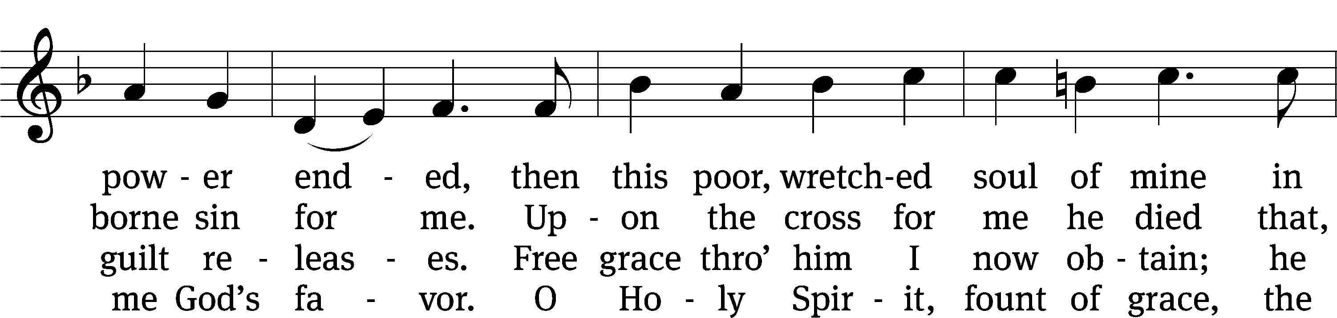
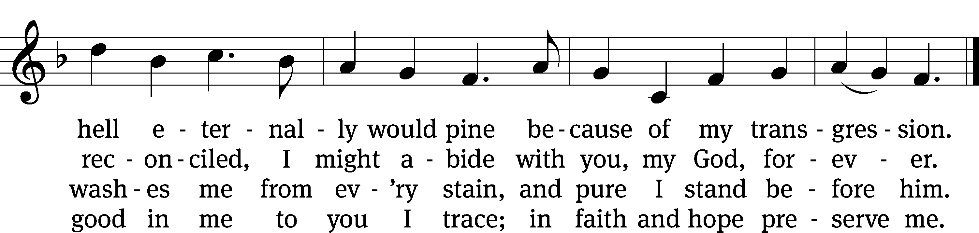
Text: tr. The Lutheran Hymnal, 1941; (sts. 1–3): Johann Heermann, 1585–1647, abr.; (st. 5): Neu-vermehrtes . . . Gesangbuch, Braunschweig, 1661
Tune: Etlich Cristlich lider, Wittenberg, 1524
Text and tune: Public domain

Closing Prayer
Merciful God, we thank you for once again having spoken to us through your Word. Let your Word be a light to our path, so that neither the attractions nor the worries of this life may be able to turn our thoughts from the life to come. As we now prepare to leave this house of God, let the Holy Spirit accompany us, so that we may be responsive to your voice speaking to our hearts. Give us forgiveness for yesterday, faith for today, and strength for tomorrow. We ask this of you in the name of Jesus, the name above every name.
Amen.

Blessing
The Lord bless you and keep you.
The Lord make his face shine on you and be gracious to you.
The Lord look on you with favor and T give you peace.
Amen.
850 It Is Well with My Soul CW 850
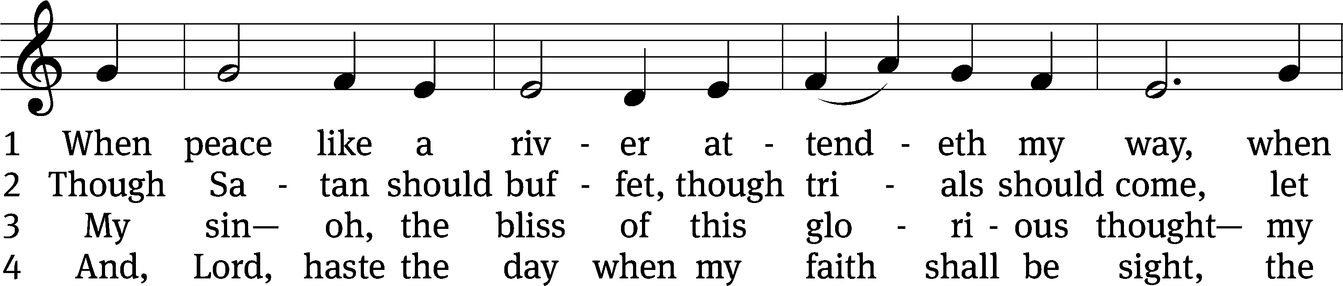
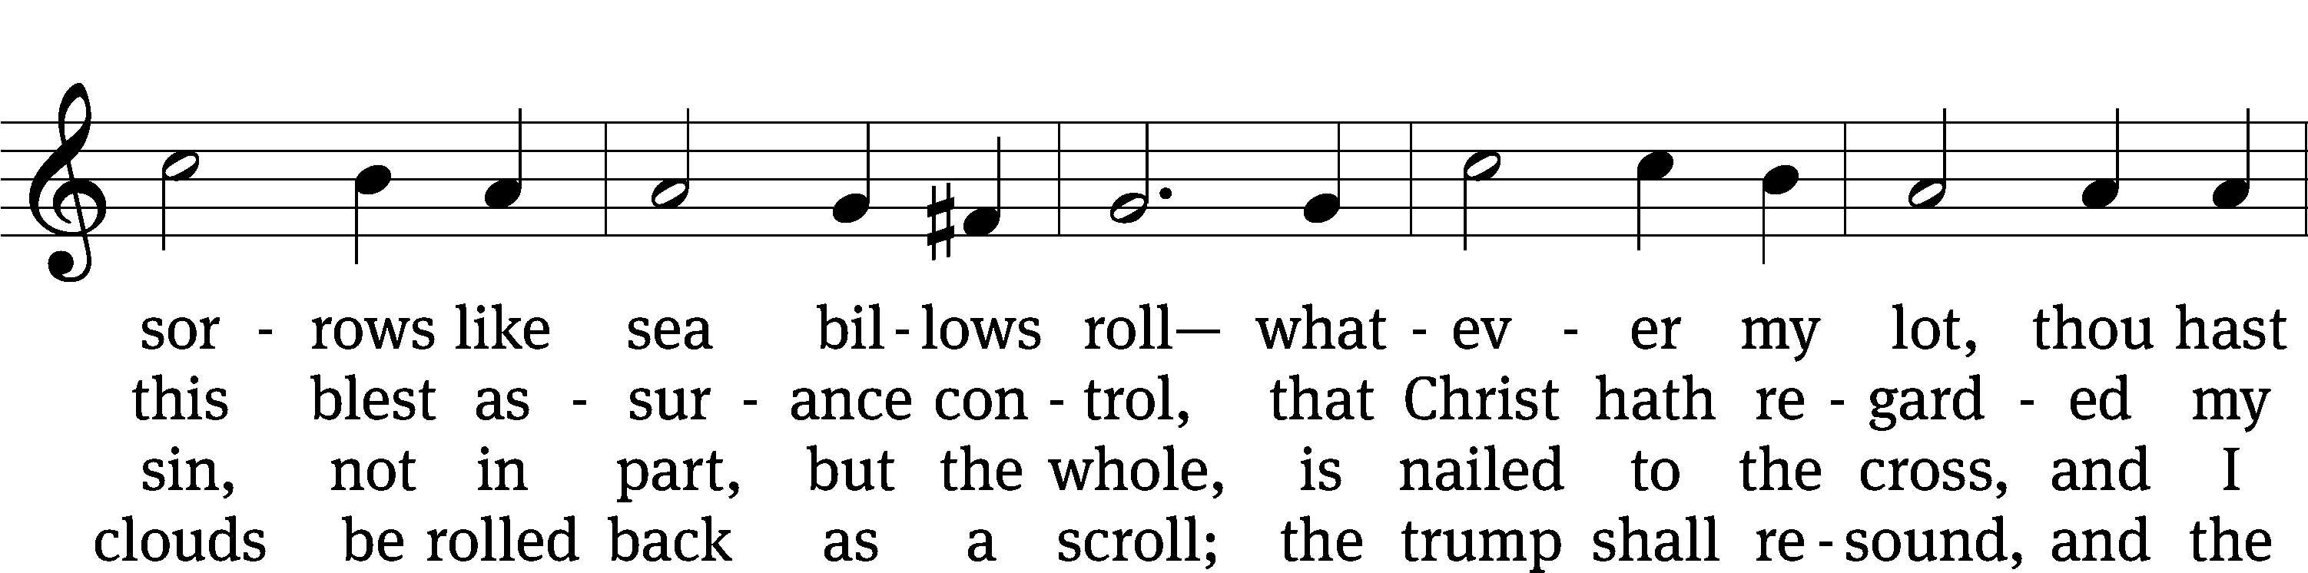
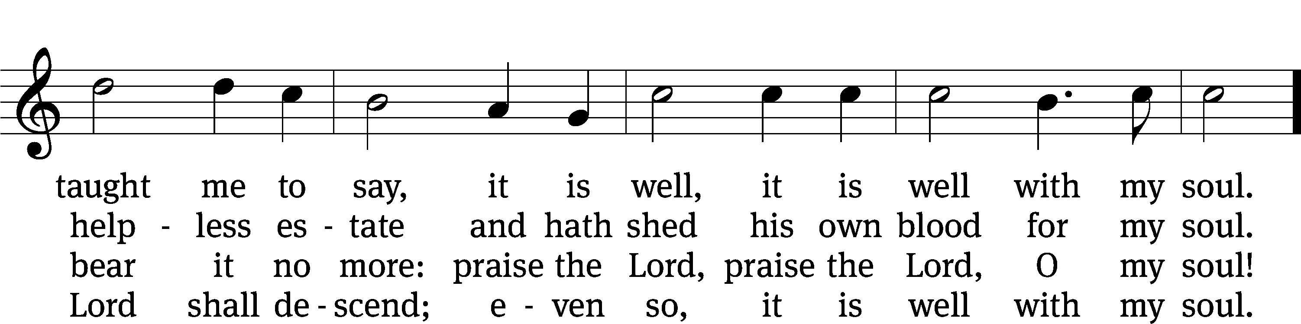
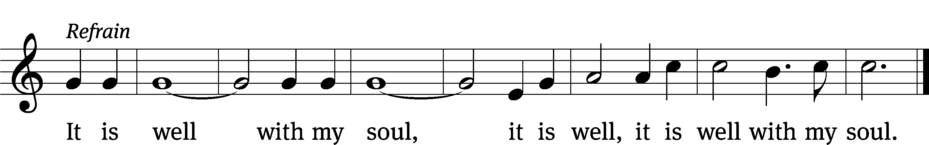
Text: Horatio G. Spafford, 1828–1888, alt.
Tune: Philip P. Bliss, 1838–1876
Text and tune: Public domain
Acknowledgments
Setting One from Christian Worship
Unless otherwise indicated, Scripture quotations are from The Holy Bible, New International Version®, NIV®. Copyright © 1973, 1978, 1984, 2011 by Biblica, Inc.TM Used by permission of Zondervan. All rights reserved worldwide.
Software distributed in partnership with Northwestern Publishing House.
Created by Christian Worship: Service Builder © 2022 Concordia Publishing House.

Next Week’s Worship
Our theme for worship: “A gracious God gives all.” Our readings will be: Genesis 8: 18-22, James 1: 16-18, and Luke 19: 1-10. We will sing the following hymns: 614 Immortal, Invisible, God Only Wise; 598 Now Thank We All Our God; 506 For the Fruits of His Creation; 609 We Praise You, O God, Our Redeemer

THIS WEEK AT BEAUTIFUL SAVIOR
† Today 9:30am Sunday School
10:30am Worship
† Tuesday 5:30pm Steering Committee
† Wednesday 11:30am Lunch Bunch
4:00pm Board of Education Meeting
† Sunday 9:30am Sunday School
10:30am Worship

Pumpkin Patch Thank You
A big thank you to everyone who helped out with the Pumpkin Patch this year, from unloading the truck, to setting up and taking down and watching over the patch during the week, we simply could not do it without the volunteer efforts of so many. Thank you!

Bible Information Class
Would you like to grow deeper in the Word of God? In our Bible Information Class we cover the main themes and teachings of the Bible, ask and answer questions about the Word of God, and grow together in the Word. It also serves as our pre-membership class. It will meet in the sanctuary. Questions? Please speak with Pastor Holz.

Lunch Bunch
On Wednesday, November 16th at 11:30am, lunch will be served here at church for our older and/or retired members and friends. If you would like to attend please sign up so the hosts can get an accurate headcount for the meal preparations. A free will offering will be taken to cover the cost of the meal. After the meal there will be a short devotion. If you have questions, please talk with Doris Harvey or Pastor Holz.

Thank you Pastor Lenz
Today we are grateful to have with us Pastor Mark Lenz to share God’s Word with us. Pastor Lenz is a retired pastor who has served congregations in Michigan, Illinois, and Minnesota, and also served many years as a professor of religion and history at our ministerial training college-Martin Luther College-in New Ulm, Minnesota. Pastor Lenz and his wife Esther are now retired and live in Mount Juliet, TN.

Pastor Holz Out of Town
Pastor Holz is at Ascension Lutheran Church in Crossville, Tn this weekend facilitating an Everyone Outreach Seminar. He will be back in the office on Monday, November 14th.

Lunch and Christmas Decorating
Come help decorate the Sanctuary and church for the Advent and Christmas seasons! We will be hanging wreaths and ornaments and putting up the tree starting at 12pm Sunday, November 20th. There will be lunch served after Worship. After lunch, all are welcome to stay and help with the Advent set-up.

Seek First the Kingdom
Join in a new Sunday Bible Study series called, “Seek first the Kingdom.”
Sunday, Nov 13th, “Take Good Advice”
Sunday, Nov. 20th, “Understand you have Great Power”
Sunday, Nov. 27th, “Grow through Grief”
Sunday, Dec. 4th, “Get Tough with Temptation”
Sunday, Dec. 11th, “Don’t be Frightened if you Fail”
The Bible Study begins at 9:30 in the fellowship hall. Please join in!

Mornings with Mommy
What is Mornings with Mommy? Mornings with Mommy isn’t preschool and it isn’t childcare. It’s something different. Mornings with Mommy is a fun and easy way for you to enjoy activities with your children and meet other moms. There will be age appropriate activities for infants, toddlers and preschoolers. The best part is, we do all the planning. You just sign up! Moms can mingle with each other and enjoy activities with their children, including: arts and crafts, sensory table, story time, music, educational toys and a snack. The program costs only five dollars per family per session and includes all snacks and activities. Pre-registration is required. If you would like to attend, please go to “Facebook: Mornings with Mommy – Clarksville
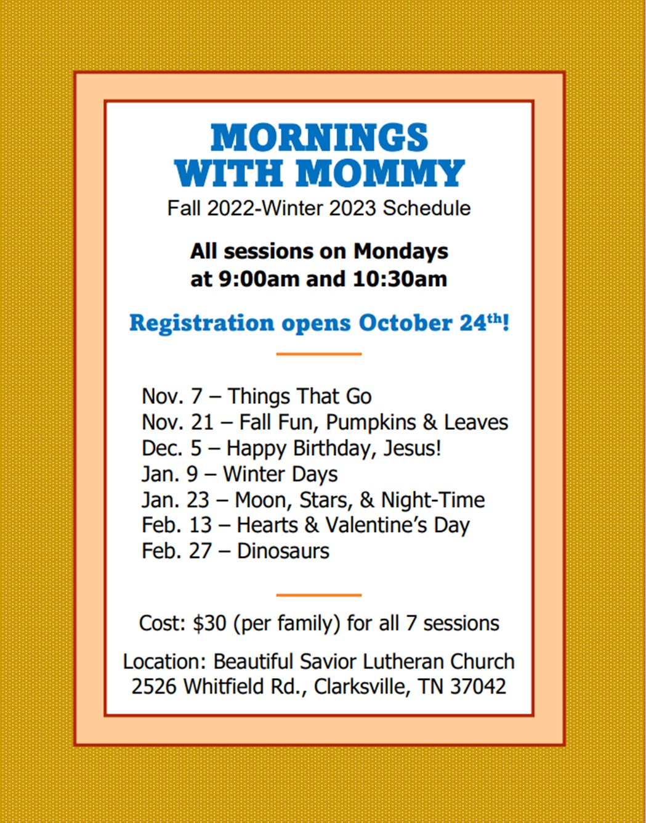

Fill the Table for FUEL
November is a time of giving thanks. We are thankful for all the many blessings that the Lord has poured upon us in giving all that we need for our bodies and lives. But thanksgiving is also a time for us to think about those who are in need. One group in particular that we can help is the FUEL program. It provides high-protein meals to needy students over the weekends when they may be without adequate nutrition. Our congregation provides this important nutrition to 12 students at Glenellen Elementary School. Why not consider a donation to our FUEL food program here at church? We will have a table set up in the main entryway to deposit donations with some suggested food items.

· Cheese crackers
· Peanut butter crackers
· Handi-Snacks
· Cookies (individually packaged)
· Beef jerky
· Juice boxes (Must be 100% juice)
· Granola bars
· Cereal (individual boxes)
· Pop-tarts
· Chips (individual bags)
· Pudding cups
· Applesauce
· Fruit cups
· Raisins (individual boxes)
· Fruit roll-ups
· Nuts (individual packages)

WELS Teen Ski Trip
WHO: All youth ages 11-18
WHAT: An exciting weekend in the mountains of Gatlinburg! Activities include a scavenger hunt, skiing or snowboarding, games, Bible study, worship, meeting new friends, pool, hot tub, and lots of good food.
WHERE: Lodging is at the Edgewater Resort; Skiing / Snowboarding is at Ober Gatlingburg
WHEN: February 3-5, 2023 (Activities begin Friday night and go through Sunday afternoon). The deadline to register through your local church is December 15, 2022.
HOW: The cost for the entire weekend is all inclusive with all activities, meals, equipment rental, and a t-shirt for $200-215 / person. (The cost is determined by the type of activity. Each church will receive one invoice and send in one payment per group.)

Scan the QR code to take you to the registration page!





Prayer List
Thank the Lord for the safe return of all the soldiers who recently came home and all soldiers and their families who are facing deployment. Please keep in your prayers this week all soldiers who are currently deployed. Please also remember: Pat Bray, father of Allison Johnson (skin cancer and surgery); Josh Carter, friend of Adam Holz (recovery from car accident); Ed Scarano (cancer diagnosis and treatment); Stacy Schroeder, daughter of Jeff & Eileen Cleveland (melanoma diagnosis); Andy Hudson, friend of Mac McCoo (pneumonia & Covid); Jimmy Straw (health & wellness); Autumn Potter & family, friends of Jessica Boulter (death of sister); Aimee Gerkhardt, sister in law of Jessica Church (breast cancer); Roger Chism, friend of Hilde Fox (diverticulitis); Steven Owens, father of Mark Owens, (cancer); Kathy Temple (cancer reoccurrence); Eric Smith, friend of Tim Donner (kidney surgery & complications); Brandon Vannoy, friend of Mac McCoo (seizures); Sheila Lynch, sister of Gayle Brooks (unable to walk); Drake Robideau, friend of Mary Daniel (strength & wellness); Mike LaFave (back problems); Linda Thomas, sister of Gayle Brooks, (physical rehab after injury); Ruth Amorth, twin sister of Hilde Fox (seriously ill); Gary Davis, husband of Angela Davis (seizures); Gidget Tate (Health issues); Maria Sauer, Friend of Karin Galvin. If you would like to have a name or situation included or if you would like to give an update on a prayer request, please contact Pastor Holz or call the church office at 931-905-1400.

Serving in God’s House

Ushers: David Johnson, Ernie Rautter
Greeters: Doris Harvey, Mac McCoo
Kitchen: Ingeborg H, Mary D
Piano: Deb White
Fellowship: H-M

Serving next week:

Ushers: Daniel L, Josh G
Greeters: Art and Sandy Ebbinger
Kitchen: Charmaine S, Mary D
Piano: Barb Noon
Fellowship: N-S

